APPLICATION FOR ADVERTISEMENT CONSENT
CASE OFFICER REPORT

APPLICATION REFERENCE: | PL/2026/02009
APPLICATION TYPE: | Consent to display an advertisement
SITE ADDRESS: | Town Bridge, Hill Street, Trowbridge, Wiltshire, BA14 8LD
DEVELOPMENT DESCRIPTION: | Install New Branding signage for Majestic to include new 3 sets of flat cut letters, with trough lighting illumination, projection sign & vinyls to windows
RECOMMENDATION: | Approve with Conditions

SITE DESCRIPTION/CONTEXT
The application site comprises a C20 former car showroom, which is a well-known landmark and representation of Trowbridge’s C20 commercial development.

There are three parts to the building; the formal highway-fronting 2-storey main section under a pitched roof, more modern flat roofed store rooms behind alongside the river, and the modern showroom to the east.

The store rooms first appear in the 2nd epoch mapping, the bulk infill in the 3rd epoch, and the showroom appearing post 1950.

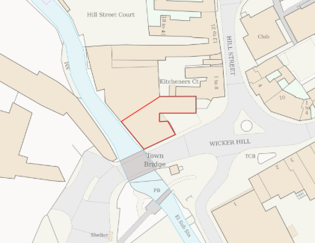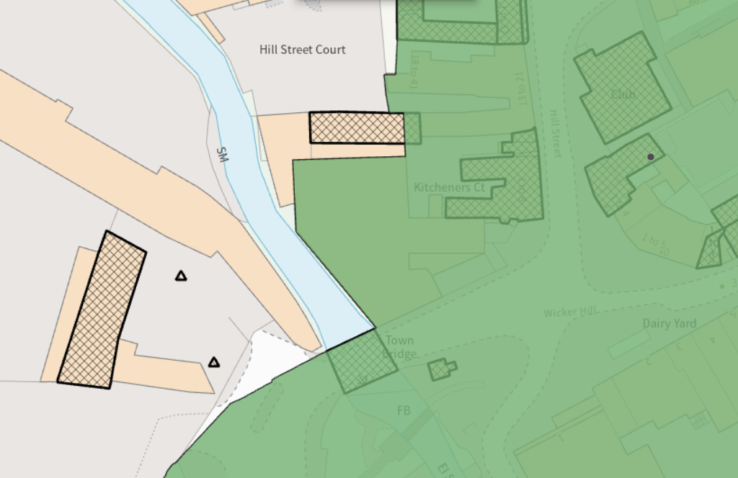
Location Plan and Map showing Conservation Area (green) and listed buildings (hatched)

The site is prominent, highly visible and surrounded by listed assets including the adjacent GII Town Bridge, GII notable former lock-up opposite, GII* Kitchener’s Arms, historic malthouse and oasthouse to the north and GII Innox woollen Mills to the east, and as such is included at the edge of Trowbridge Conservation Area.

The site is in a central location, beside the River Biss, previously occupied by industrial mills. It abuts disused factory buildings to the west (development approved), modern retail premises to the south and the historic core of Trowbridge to the north/east whose historic layout and character have been retained despite significant alterations .

PROPOSAL:
The application seeks advertisement consent to display advertisements between 25/03/2026 – 25/03/2031, namely:

3 sets of flat cut aluminium text on brass brackets, grey text on grape logo, static LED trough lighting, sizes: 0.2m x 1.5m and 0.6m x 2.7m.

Projecting sign 0.65m x 0.65m, aluminium with internal frame and LED trough lighting, grey background, illuminated white and green test,

Vinyls to windows – various widths and heights, green and black, grey frosting.
Window graphics internally applied, including blackout vinyl to the side elevation
Black out vinyl’s externally applied to stock room front elevation

All as per drawings below:
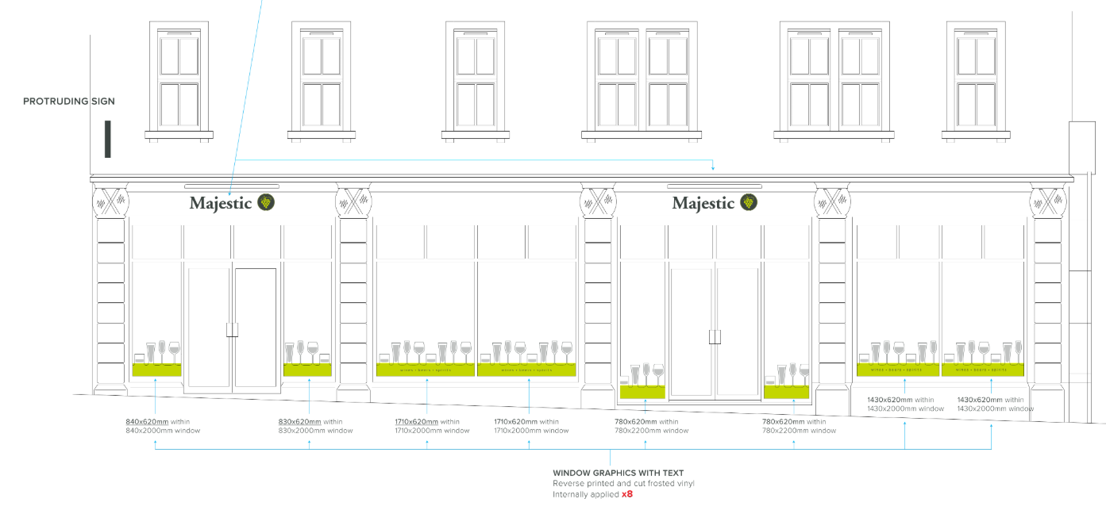
Proposed Front Elevation

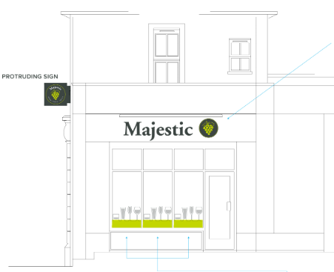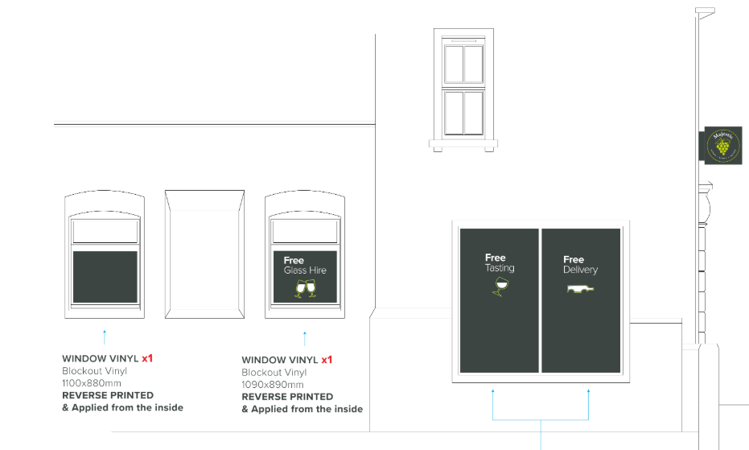
Proposed Front Right Elevation and Proposed Front Left Elevation

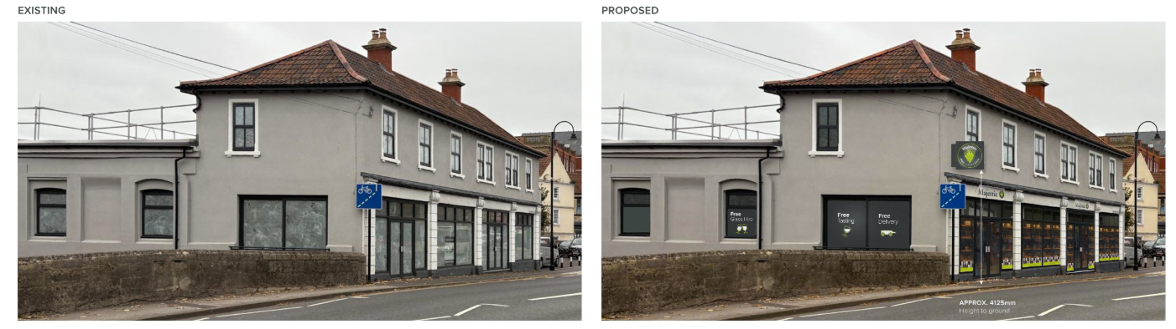
Existing Site Photo and Rendering of Proposed Front/Side Elevation

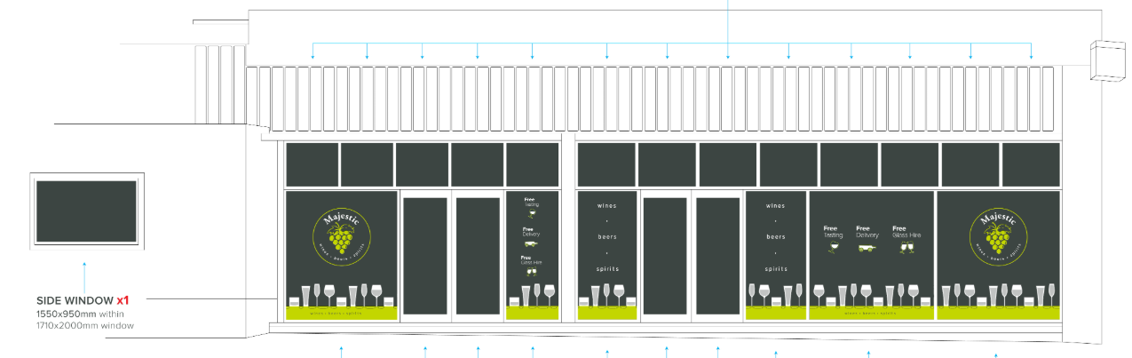
Proposed Stock Room Front Elevation

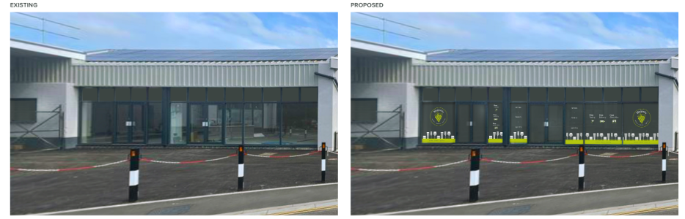
Existing Site Photo and Rendering of Proposed Stock Room Front Elevation

RELEVANT LEGISLATION, POLICIES AND GUIDANCE

The Town and Country Planning (Control of Advertisements) (England) Regulations 2007

National Planning Policy Framework (NPPF)
- Paragraph 141

Planning Practice Guidance (PPG)
- Advertisements

Wiltshire Core Strategy 2015 (WCS):
- Core Policy 57 Ensuring High Quality Design & Space Shaping
- Core Policy 58 Ensuring the Conservation of the Historic Environment
- Core Policy 62 Development Impacts on the Transport Network

Institute of Lighting Professionals: The Brightness of Illuminated Advertisements (2014) PLG 05.

RELEVANT PLANNING HISTORY:
14/07929/FUL - Full planning permission Decision - Approve with Conditions Date: 19/2/2015 – Change of use of buildings from former car showroom/garage (Sui Generis Use) to a depot for storage/sales/MOTcentre and flexible A1-A5 use to ground floor and flexible A2/B1(a) use to first floor. Demolition of concrete portico to forecourt of building an
PL/2023/02463 - Full planning permission Decision - Approve with Conditions Date: 22/5/2024 – Change of use from retail (Class E) and garage (sui generis) to a mixed use comprising of ground floor retail and ancillary storage (Class E); 3no. offices (Class E) at first floor; with operational development comprising: rear first floor extension;
PL/2025/09708 - Full planning permission Decision - Approve with Conditions Date: 9/2/2026 – Installation of pedestrian DDA compliant ramps for customer and delivery access and the installation of new double doors entrance doors to Unit 01.
W/74/00043/ADV - Consent to display an advertisement Decision - Refused Date: 14/10/1974 – Three illuminated signs
W/74/00321/HIS - Historic apps 1974 to 1983 Decision - Refused Date: 13/6/1974 – Car showroom, car parking, office accommodation and hotel
W/75/00006/ADV - Consent to display an advertisement Decision - Approved Date: 17/3/1975 – Single sided box signs
W/79/00018/ADV - Consent to display an advertisement Decision - Approved Date: 17/7/1979 – Illuminated individual fascia letters
W/79/00897/HIS - Historic apps 1974 to 1983 Decision - Approve with Conditions Date: 11/9/1979 – Construction of additional offices and reception
W/93/00373/ADV - Consent to display an advertisement Decision - Approved Date: 26/4/1993 – Illuminated and non-illuminated signs
W/95/01158/FUL - Full planning permission Decision - Approved Date: 21/12/1995 – 1.2 metre diameter satellite dish (option B siting)
W/97/00525/CON - Demolition in a conservation area Decision - Approved Date: 19/5/1997 – Removal of canopy area

ISSUES
The issues that are relevant to the consideration of an application for consent to display advertisements are the effects of the proposal on ‘amenity’ and ‘public safety’.

CONSULTEE RESPONSES
The following consultees were invited to comment on this application:

Trowbridge Town Council: no objection.

Wiltshire Council’s Highways Engineer: no objection.

Wiltshire Council’s Conservation Officer: no objection - The proposals are appropriately designed for the context and will assist in securing the future of this non designated heritage asset in a viable use. The impact on heritage assets will therefore be largely positive, and the requirements of current conservation legislation, policy or guidance are considered to be met.

Trowbridge Civic Society: no objection – supporting the viable use of a vacant historic building, with appreciation for proposed signage complement the area. Concerns regarding availability of customer parking and access to the busy road.

RESPRESENTATIONS
No representations received during the consultation period

ASSESSMENT
Regulation 3 of The Town and Country Planning (Control of Advertisements) (England) Regulations 2007 requires that local planning authorities exercise their powers in relation to the display of advertisements in the interests of amenity and public safety, taking into account the provisions of the development plan, in so far as they are material, and any other relevant factors.

The NPPF (141) is clear that the quality and character of places can suffer when advertisements are poorly sited and designed and should be subject to control only in the interests of amenity and public safety, also considering the cumulative impacts.

Impact on Amenity:
Policy Context
“Amenity” is not exhaustively defined in the Town and Country Planning (Control of Advertisements) (England) Regulations 2007 but is generally understood to include both visual and aural amenity. Factors relevant to amenity include the general characteristics of the locality, such as the presence of features of historic, architectural, cultural, or similar interest.

In broader planning terms, as reflected in the National Planning Policy Framework (NPPF), amenity refers to the quality or character of an area and the elements that contribute to the overall enjoyment and liveability of a place.

CP57 requires a high standard of design in all proposals, including (x) the sensitive design of advertisements and signage.

CP58 requires that “designated heritage assets and their settings will be conserved, and where appropriate enhanced, in a manner appropriate to their significance.”

The proposal site is surrounded by listed buildings and is prominent within the Conservation Area. The building itself is modern in character but considered a landmark building within a highly visible location.

The proposed signage is considered appropriately scaled and designed to highlight the architectural design, proportions and rhythm of fenestration of the subject building, avoiding visual clutter by minimal materials, colours and scale. All works reversible, fixings minimal and discrete.

These details ensure the proposed signage would not challenge or detract from the setting of listed buildings or the special character of the Conservation Area.

Consultee responses note that the proposed works will enable a viable future use of a long redundant building which will enhance the setting and character of the local area.

The proposed lighting is considered to be acceptable and given the nature of the locality is not considered to pose any harm.

The signs would be permanently fixed and so do not have the potential to create a noise disturbance and as such the proposals are acceptable in terms of aural and visual amenity impact.

It is considered that the proposed advertisement would not cause harm to the visual amenity of the area, noting the setting of the listed building, setting of neighbouring listed buildings and the character of the Conservation Area, and would therefore comply with the relevant provisions of the Town and Country Planning (Control of Advertisements) Regulations 2007.

Impact on Public Safety:
Policy Context
“Public safety” is not exhaustively defined in the Town and Country Planning (Control of Advertisements) (England) Regulations 2007, but it generally refers to the potential impact of a development or advertisement on the safe use and operation of public spaces, including roads, footpaths, and other areas accessible to the public.

In assessing public safety, the Local Planning Authority (LPA) may consider:
- Whether the proposal would obstruct visibility for road users or pedestrians;
- Whether it could distract, confuse, or mislead drivers, particularly near junctions or crossings;
- Whether it interferes with traffic signs, signals, or street lighting;
- Whether it poses a physical hazard, such as through poor structural integrity or inappropriate siting.

The National Planning Policy Framework (NPPF) also supports the principle that planning decisions should ensure developments create places that are safe, inclusive, and accessible, and that they do not undermine public safety or security.

CP62 advises that proposals should provide appropriate mitigating measures to offset any adverse impacts on the transport network at both the implementation and operational stages.

Due to the location of the site in an established commercial area and the signage replacing previous forms, with projecting signs at a height to not raise any concerns, the proposal is not considered to result in any public safety concerns.

The proposals include a considered combination of signs and lighting and in conjunction with nearby signage does not pose cumulative visual clutter.

There are no objections from Highways.

It is considered that the proposal would not result in an unacceptable impact on public safety, either individually or cumulatively, and would therefore satisfy the relevant provisions of the Town and Country Planning (Control of Advertisements) Regulations 2007.

It is considered that the proposal would not result in an unacceptable impact on public safety, either individually or cumulatively, and would therefore satisfy the relevant provisions of the Town and Country Planning (Control of Advertisements) Regulations 2007.

CONCLUSION:
The proposed advertisement has been assessed in accordance with the relevant provisions of the Town and Country Planning (Control of Advertisements) (England) Regulations 2007.

It is considered that the advertisement, by reason of its design, scale, siting, and method of illumination, would not result in harm to the visual amenity of the area. Furthermore, the proposal is not considered to pose a risk to public safety, either individually or cumulatively with other signage in the vicinity.

Subject to the recommended conditions, the proposal is therefore considered acceptable, and it is recommended that advertisement consent be granted.

RECOMMENDATION:
It is recommended that advertisement consent be GRANTED subject to conditions.

