APPLICATION FOR HOUSEHOLDER PLANNING PERMISSION
DELEGATED REPORT

APPLICATION REFERENCE: | PL/2026/02220
APPLICATION TYPE: | Householder planning permission
SITE ADDRESS: | 63 Fiander Lane, Bishopdown, Salisbury, SP1 3BD
DEVELOPMENT DESCRIPTION: | Single Storey Extension to Rear of Property
RECOMMENDATION: | That Planning Permission be GRANTED

PROPOSAL

The proposal seeks planning permission for a single storey rear extension to the rear of the host dwelling.

SITE DESCRIPTION/CONTEXT

The application site is a detached dwelling located within a recent housing development in Hampton Park in Salisbury. It is situated within the defined settlement boundary of the principal settlement of Salisbury, as defined by Wiltshire Core Strategy (WCS) policies CP1, CP2 and CP20. The site is located in Flood Zone 1 which has the lowest level of flood risk.

The application site is located within the Hampshire River Avon Catchment Area and the New Forest Protected Sites 13.8km recreation zone of influence. However, these ecological designations have no implication to this householder planning permission due to the nature of the proposed work.

The site is located on the edge of the housing development, it is bordered by the highway to the north, residential dwellings on the south and west and a rights of way footpath on the west with reference LAF011.

PLANNING HISTORY

Reference | Proposal / Summary | Decision
16/00048/FUL | Proposed formation of new country park, including new car park with access from Spire View (Roman Road), land re-profiling, and associated drainage. | Approve with Conditions
S/2012/0552 | Section 106A Application to modify planning obligations which limit use of land | Refused
S/2009/1943 | ERECTION OF 500 DWELLINGS, 4 NEW VEHICULAR ACCESSES OFF PEARCE WAY, ASSOCIATED LANDSCAPING AND PUBLIC OPEN SPACE, AND THE CREATION OF A COUNTRY PARK WITH ASSOCIATED PARKING, INFRASTRUCTURE AND FACILITIES | Approve with Conditions
S/1991/1666 | PROPOSED GOLF COURSE AND CLUBHOUSE TOGETHER WITH A REALIGNMENT OF THE A30 AND CONSTRUCTION OF NEW ROUNDABOUT AND ACCESS ROAD | Approve with Conditions
RELEVANT POLICIES AND GUIDANCE
Wiltshire Core Strategy:

Core Policy 1: Settlement Strategy
Core Policy 2: Delivery Strategy
Core Policy 20: Salisbury Community Area
Core Policy 41: Sustainable Construction and Low Carbon Energy
Core Policy 57 Ensuring High Quality Design and Place Shaping

Wiltshire Design Guide: Appendix D – Design Guidance for Householder extensions

The National Planning Policy Framework (NPPF)

The Planning Practice Guidance

National Design Guide

Salisbury Neighbourhood Development Plan 2020 to 2038

Wiltshire Local Transport Plan 2011-2026

CONSULTATION RESPONSES

Laverstock and Ford Parish Council: No Comment.

REPRESENTATIONS

1 comment from a neighbouring dwelling was received. A summary of their comments is as follows:
- Size of the extension will take up patio area which may lead to another patio area being erected in front of the extension.
- Back garden of the application site has a support bank which supports neighbouring dwelling’s garden. If bank is removed, then it may lead to collapse/subsidence.
- Water butts have been removed from the rear garden. The water runoff from the proposed extension might soak into the garden which would lead to soft ground which would affect the support bank.
- Concerned about the security of the garden border and fencing.

ASSESSMENT

Section 38(6) of the Planning and Compulsory Purchase Act 2004 states:

"If regard is to be had to the development plan for the purposes of any determination to be made under the planning Acts, the determination must be made in accordance with the plan unless material considerations indicate otherwise."

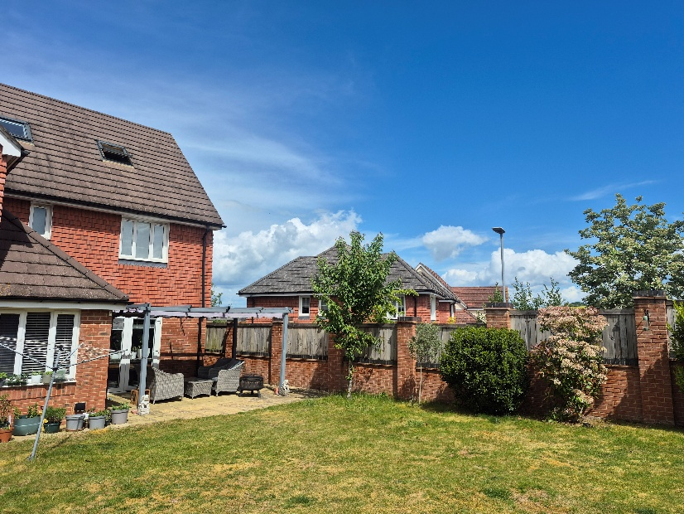
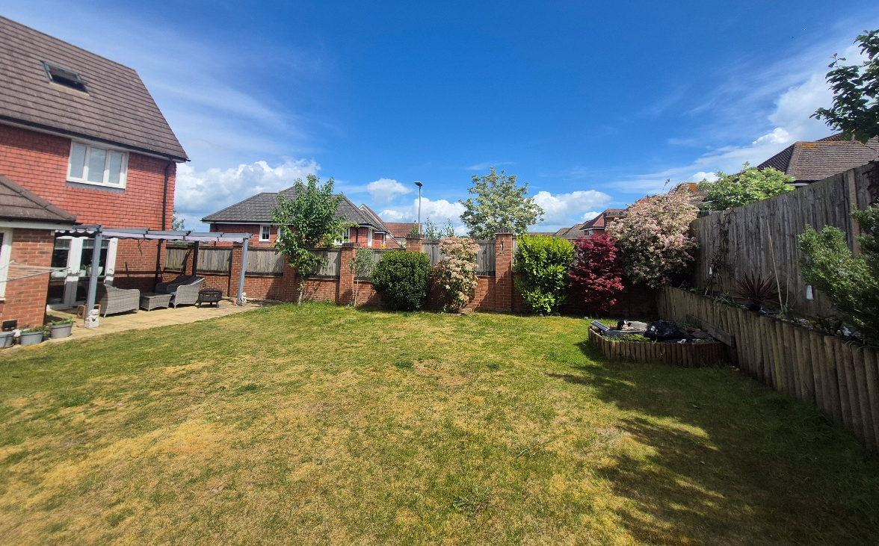
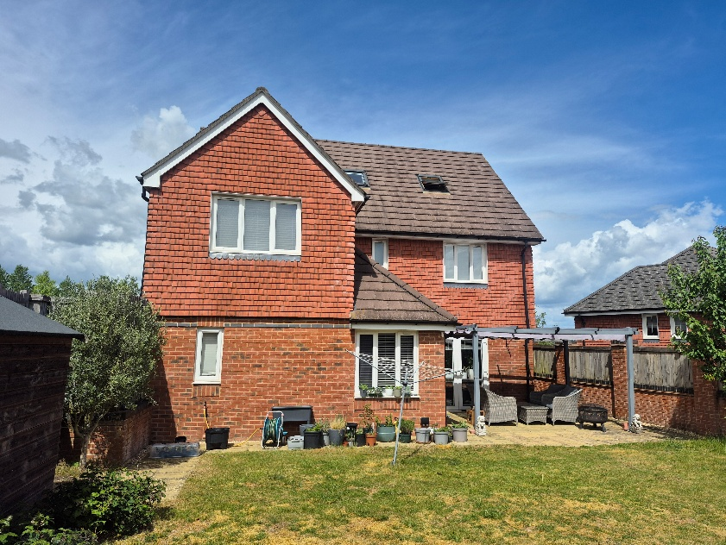
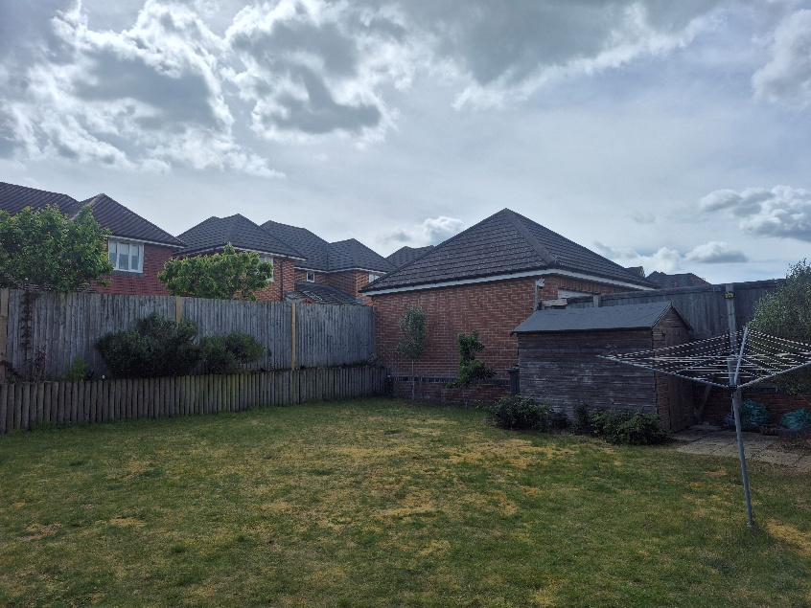
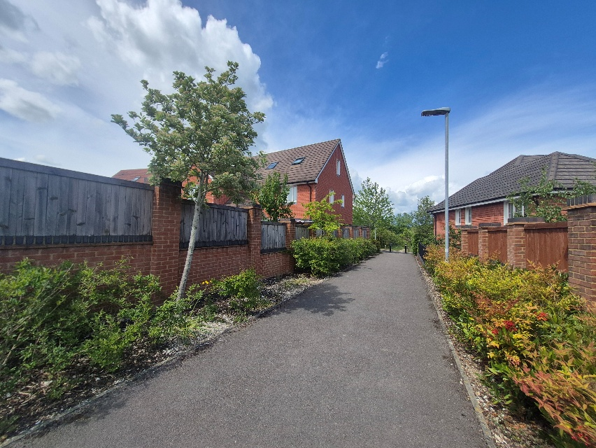
In accordance with this statutory requirement, this application has been assessed against the relevant policies of the Development Plan, including the adopted Wiltshire Core Strategy (2015) and, where applicable, any made Neighbourhood Plans.

Design and Impact upon the upon the character and context of the area
Core Policy 57 - Ensuring High Quality Design and Place Shaping of the Wiltshire Core Strategy seeks to ensure that all new development is of high design quality, reflecting local context, character, and distinctiveness.

The application site consists of a detached dwelling located in a cul de sac location surrounded by residential dwellings. The application proposes to construct a single storey rear extension measuring approximately 5.5 metres in length, 4.2 metres in width, 2.1 metres in height to the eaves and 3.2 metres in height to the ridge. The extension will have a hipped roof with insulated and glazed panels and will have red brick walls to match the host dwelling.

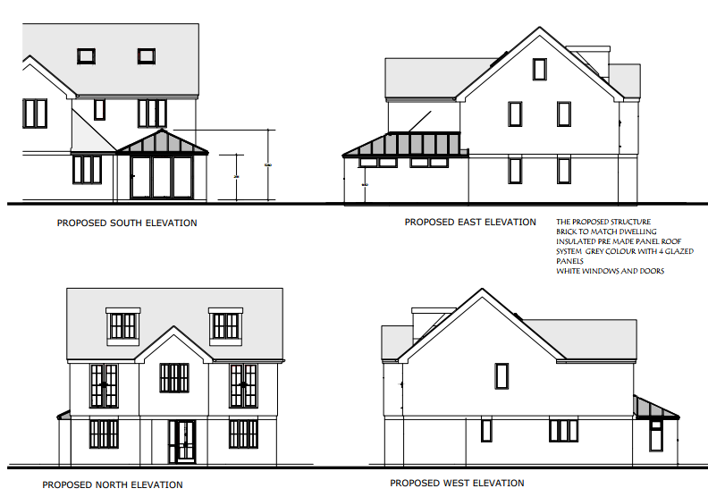
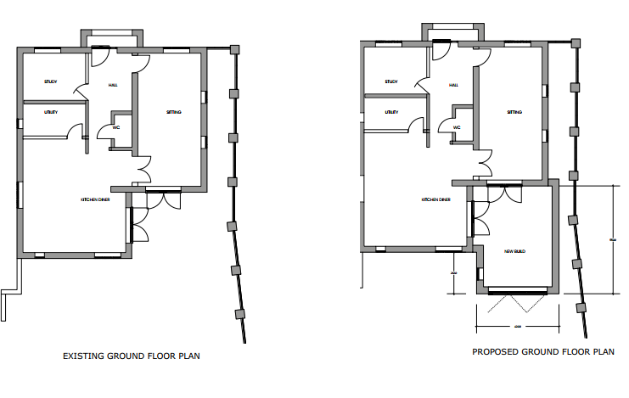
The proposed extension will be minimally visible from the rights of way footpath on the east; it won’t be visible from the highway on the north. It is considered that the proposed works are minimal in scale and remain subservient to the host dwelling and would not detract from the visual integrity of the existing building, the proposed materials and design of the extensions are not considered to be detrimental to the host dwelling nor the surrounding area. Having regard to the above, the proposal complies with the design principles set out in Core Policy 57 of the Wiltshire Core Strategy and Appendix D of the Wiltshire Design Guide.

Amenity
Point vii of Core Policy 57 - Ensuring High Quality Design and Place Shaping of the Wiltshire Core Strategy seeks to ensure that developments do not adversely affect neighbouring properties.

The National Planning Policy Framework (NPPF), particularly Paragraph 135(f), stresses that planning decisions should ensure developments provide a high standard of amenity for existing and future users.

The proposed development has been assessed in terms of its potential impact on the residential amenity of neighbouring properties, with particular regard to loss of light, overshadowing, loss of privacy, and overbearing effects.

In terms of overlooking, the proposed extension is single storey, therefore it is not considered that there would be any additional overlooking to the neighbouring dwellings as existing boundary fences and walls are higher in height that the proposed development. In terms of overshadowing, the proposed extension is located on the south side of the host dwelling, there are no direct adjacent dwellings or amenity spaces that the single storey proposed extension would detrimentally impact.

The neighbouring dwelling, no. 71 Burden Drive has raised their concerns regarding the size of the proposed extension over the existing patio area as a new patio area might be constructed to the front of this. Their concern is because of impacts proposed extensions, patios, removal of water butts, and water run off from the extension leading to cumulative impacts which would lead to the garden being soaked causing soft ground to impact the support bank to the rear of the garden and which supports the neighbouring dwelling. While the neighbour’s concerns are noted, the footprint of the proposed extension is approximately 10 metres from the southern boundary of the host dwelling where the bank is located. This application does not include any proposed works to the bank, as for water run-off, the extension has included reference of guttering around the proposed extensions, these issues will be covered by building control regulation requirements. It is not considered that the proposed single storey rear extension will impact the southern support bank and a refusal of planning permission on these grounds could not be supported. The proposal therefore accords with Core Policy 57 point vii in respect of safeguarding residential amenity and Appendix D of the Wiltshire Design Guide.
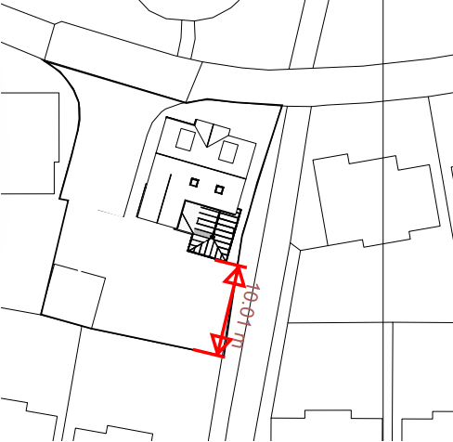

Biodiversity Net Gain
Householder planning applications are exempt from the requirement to deliver Biodiversity Net Gain under Schedule 7A, Section 4(2)(a) of the Town and Country Planning Act 1990, as inserted by the Environment Act 2021.

CONCLUSION
The proposed development is considered to be acceptable in terms of its design, scale, and relationship with the surrounding area. It would not result in any unacceptable harm to the character of the locality, the amenities of neighbouring occupiers, or the interests of highway safety, or ecology.

The proposal is therefore considered to comply with the relevant policies of the Wiltshire Core Strategy, the Wiltshire Local Plan, and the National Planning Policy Framework. As such, the application is recommended for approval, subject to the conditions set out below.

RECOMMENDATION: That Planning Permission be GRANTED subject to conditions.

1.The development hereby permitted shall be begun before the expiration of three
years from the date of this permission.

REASON: To comply with the provisions of Section 91 of the Town and Country
Planning Act 1990 as amended by the Planning and Compulsory Purchase Act
2004.

2.The development hereby permitted shall be carried out in accordance with the
following approved plans and documents:

Proposed Elevations (Existing Boundary Fence) Drawing No. AC/02/26 Received: 14 April 2026
Proposed Elevations (Fence Lines Omitted) Drawing No. AC/03/26 Received: 14 April 2026
Existing and Proposed Ground Floor Plan Drawing No. AC/04/26 Received: 14 April 202
Existing and Proposed Roof Plan Drawing No. AC/05/26 Received: 14 April 2026
Site Location and Block Plan Drawing No. AC/06/26 Received: 02 April 2026

REASON: For the avoidance of doubt and in the interests of proper planning.

3.Materials to be used in the construction of the works hereby permitted shall be as stated on the application form and in the submitted documents.

REASON: In the interests of visual amenity and the character and appearance of the area.

4. The windows in the Proposed East Elevation shall be glazed with obscure glass only [to an obscurity level of no less than level 5 and permanently fixed shut prior to the first occupation of the development hereby permitted and shall be permanently maintained in perpetuity.

REASON: In the interests of residential amenity and privacy.

