APPLICATION FOR VARIATION/REMOVAL OF CONDITION
CASE OFFICER REPORT

APPLICATION REFERENCE: | PL/2026/02264
APPLICATION TYPE: | Removal/variation of conditions
SITE ADDRESS: | Dower House, Compton Chamberlayne, Salisbury, SP3 5DD
DEVELOPMENT DESCRIPTION: | Vary Condition 2 on PL/2024/00024 - Demolish and rebuild kitchen and utility room to the north. Erection of a single storey extension to the west which, in part, fills the ‘U’ shape plan of the building. Rebuild existing terrace to the west. Renovation and alteration of an existing annex which provides ancillary accommodation and construction of garage and car port
RECOMMENDATION: | Approve

SITE DESCRIPTION/CONTEXT

The site is situated in the small village of Compton Chamberlayne outside of any defined settlement boundary as defined by Wiltshire Core Strategy (WCS) policies CP1, CP2. It lies within the conservation area of Compton Chamberlayne and in the Cranborne Chase & West Wiltshire Downs AONB and is within the Chilmark Bat SAC zone. The application site lies 0.2 miles from Compton Park House a Grade I listed property; Dower House was previously part of the wider Compton Park Estate. The west side of the application site is located in Flood Zone 3, there is a pond on the application site, a lake on the northern boundary of the site, 0.8 miles away from River Nadder and lies within the Hampshire River Avon Catchment.

The application site is a 17th century, unlisted, detached dwellinghouse located in Compton Chamberlayne. The dwellinghouse was previously part of Compton Park Estate, and housed the estate gamekeeper, the site was previously listed at grade III but was not upgraded to grade II in 1970. The existing dwellinghouse is a two-storey dwelling with rooms on the roof. The application site is accessed off the High Street in Compton Chamberlayne, and down a private unadopted road leading to the site. The application site is built into the landscape with a steeply sloping bank to the east, and a terrace to the west which looks out across the large garden and across the valley. The site is bordered by the access road on the east with pastureland rising upwards, Priory Lodge and Priory Cottage, semi-detached dwellings on the south, the lake associated with Compton Park on the north, and pastureland on the west which backs onto the row of residential houses of High Street.

PROPOSAL

This report considers a Section 73 application for the variation/removal of condition(s) imposed on planning permission PL/2024/00024. The application relates to the site at Dower House, Compton Chamberlayne, Salisbury, SP3 5DD and seeks to vary Condition 2 plans elevation. The original application allowed for alterations, demolitions and extensions to the host dwelling, renovation and alteration to an existing annex and construction of a garage and car port.

RELEVANT PLANNING HISTORY

PL/2024/00024 - Demolish and rebuild kitchen and utility room to the north. Erection of a single storey extension to the west which, in part, fills the ‘U’ shape plan of the building. Rebuild existing terrace to the west. Renovation and alteration of an existing annex which provides ancillary accommodation and construction of garage and car port. - Approve with Conditions

S/1986/1808 - Construction of En-tout-cas Playdek Tennis Court with 2.75 metres High Chainlink Surround Fence - Approve with Conditions

S/1987/0614 - Improvements/Alterations To External Elevations, Doors and Windows, Together with Minor Changes to Internal Layout, Bathroom and Kitchen Areas - Approved with Conditions

RELEVANT LEGISLATION, POLICIES AND GUIDANCE

Town and Country Planning Act. 1990 (as amended)

Section 73 of the Town and Country Planning Act. 1990 (as amended) relates to the determination of applications to develop land without compliance with conditions previously attached. It states that:

(2) On such an application the local planning authority shall consider only the question of the conditions subject to which planning permission should be granted, and—

- if they decide that planning permission should be granted subject to conditions differing from those subject to which the previous permission was granted, or that it should be granted unconditionally, they shall grant planning permission accordingly, and

- if they decide that planning permission should be granted subject to the same conditions as those subject to which the previous permission was granted, they shall refuse the application.

The National Planning Practice Guidance (PPG) states the following:

- Nature of the Application: A Section 73 application is treated as a new planning permission, although it does not alter the original permission itself. The original permission remains intact and can still be implemented unless it has expired or been superseded.

- Limitations:
  - Section 73 cannot be used to change the description of development or the operative part of the permission (e.g. the nature or extent of the approved use).
  - It cannot be used to extend the time limit for implementing the original permission.
  - If the proposed changes go beyond what can reasonably be considered under Section 73, a new planning application under Section 70 would be required.
- Decision-making: The local planning authority must consider the application only in relation to the conditions subject to which the original permission was granted. However, it may impose new or revised conditions if granting a new permission.
- Legal Agreements: Because a Section 73 application results in a new permission, any existing Section 106 agreement may need to be varied or replaced via a deed of variation to ensure obligations continue to apply to the new permission.

National Planning Policy:
- National Planning Policy Framework (NPPF)
- Planning Practice Guidance (PPG)
- National Design Guide
Development Plan:
The development plan for Wiltshire comprises the Wiltshire Core Strategy (WCS) (adopted January 2015) and any made neighbourhood plans, which remains the principal statutory planning document guiding development across the county. In line with Section 38(6) of the Planning and Compulsory Purchase Act 2004, planning decisions must be made in accordance with the development plan unless material considerations indicate otherwise.

Though the development plan is considered as a whole, those parts deemed to be particularly relevant to this application are listed below:

National Planning Policy Framework (NPPF)
2. Achieving sustainable development
4. Decision-making
12. Achieving Well-designed places
16. Conserving and enhancing the historic environment

Wiltshire Core Strategy (WCS)
Core Policy 1: Settlement Strategy
Core Policy 2: Delivery Strategy
Core Policy 51: Landscape
Core Policy 57: Ensuring High Quality Design and Place Shaping
Core Policy 58: Ensuring the Conservation of the Historic Environment

The Planning (Listed Building and Conservation Area) Act 1990
Section 72

ISSUES

The key considerations in the assessment of this application are as follows:

- Determining whether the proposed amendments fall within the scope of Section 73 of the Town and Country Planning Act 1990 which allows for the variation or removal of conditions attached to an existing planning permission.
- Assessing whether the development, as amended, remains in accordance with the relevant policies and provisions of the development plan, and whether the changes materially alter the nature or impacts of the approved scheme.

In terms of consultation responses, the extant application did not have any objections from consultees or third parties. For this application, the consultation responses are below.

CONSULTATION RESPONSES

Compton Chamberlayne Parish: None received.

Highways Officer: No Objection. This VAR does not alter access to and from the application site to the highway.

Conservation Consultation: No Objection. The conservation officer has noted that they are satisfied that the revisions are all relatively modest and raises no concerns with regard to the building's significant contribution to the character of the conservation area, which will be preserved in accordance with the aims of section 72 of the PLBCA Act 1990, NPPF and CP58.

REPRESENTATIONS
None received.

ASSESSMENT
Section 38(6) of the Planning and Compulsory Purchase Act 2004 states:

"If regard is to be had to the development plan for the purposes of any determination to be made under the planning Acts, the determination must be made in accordance with the plan unless material considerations indicate otherwise."

In accordance with this statutory requirement, this application has been assessed against the relevant policies of the Development Plan, including the Wiltshire Core Strategy (2015) and, where applicable, any made Neighbourhood Plans. Consideration has also been given to the policies of the National Planning Policy Framework (NPPF) as a material consideration in the assessment.

Principle of the Development – Do the proposed amendments fall within the scope of s73?

This variation of condition application has proposed the following amendments:

Site Plan: changes to the shape of the pond

Landscape Level: External stone steps omitted

Parking Area: External garden wall straightened adjacent to carport/garage

House:
- External basement steps omitted
- Projecting glass pay window omitted
- Canopy over the rear entrance door on the north elevation
- Replace larger rooflights on southern slope with two smaller rooflights and additional two smaller rooflights on northern slope of the single storey rear extension for the kitchen
- East elevation (front) retain existing external stone wall, previously proposed to demolish this and insert glazed windows.
- Rooflight over single storey infill extension to be amended to a central lantern from pitched glazed windows.
- Dining area columns revised to be natural stone and reduction in amount of glazing.
- First floor balcony of the south elevation retained rather than removed.
- Proposed pitched dormer window on the south elevation to match an existing adjacent pitched roof dormer.
- Addition of two conservation roofligths.

Garage/Carport: Proposed PV panels installed on the roof of the garage and revision to openings. Extant permission proposes two gates on either end of the building whereas this revision proposes two gates on the northern end.

Annex:

- The annex is proposed to be revised to have a flat roof porch on the east elevation.
- South elevation revised to have two windows rather than 1 central window.
- Changes to the rooflights revised from 1 large rooflight to 4 smaller roof lights 2 on either side of the roof.
- West Elevation is proposed to have two full height glazed windows with a canopy over.
- The north gable elevation is proposed to be glazed and to have external timber screening at the upper section.

The proposed amendments have been reviewed and are considered to fall within the scope of Section 73 of the Town and Country Planning Act 1990. The changes do not result in a fundamentally different development from that originally approved, nor do they seek to alter the description of development or extend the time limit for implementation. As such, the application is valid under Section 73 and can be determined as a variation of condition(s) attached to the original planning permission.
Compliance with the Development Plan

The proposed revisions to the development remains in accordance with the adopted development plan, including:

- Wiltshire Core Strategy (WCS) policies;
- Neighbourhood Plans (where applicable);
- The National Planning Policy Framework (NPPF).
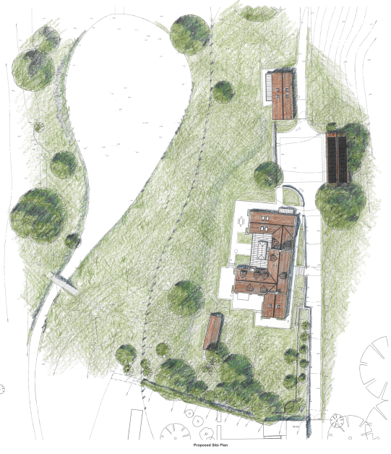
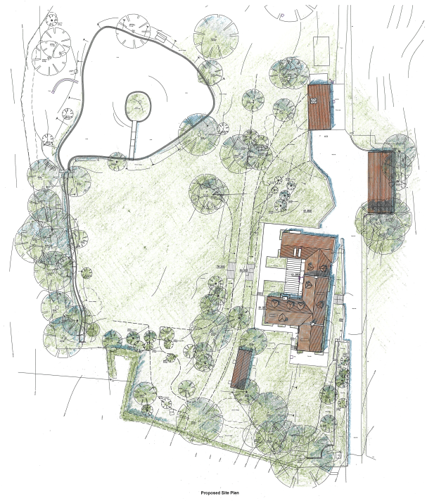

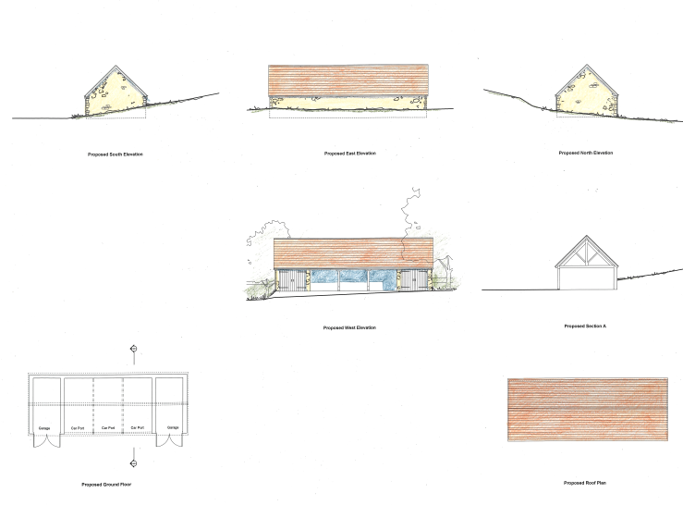
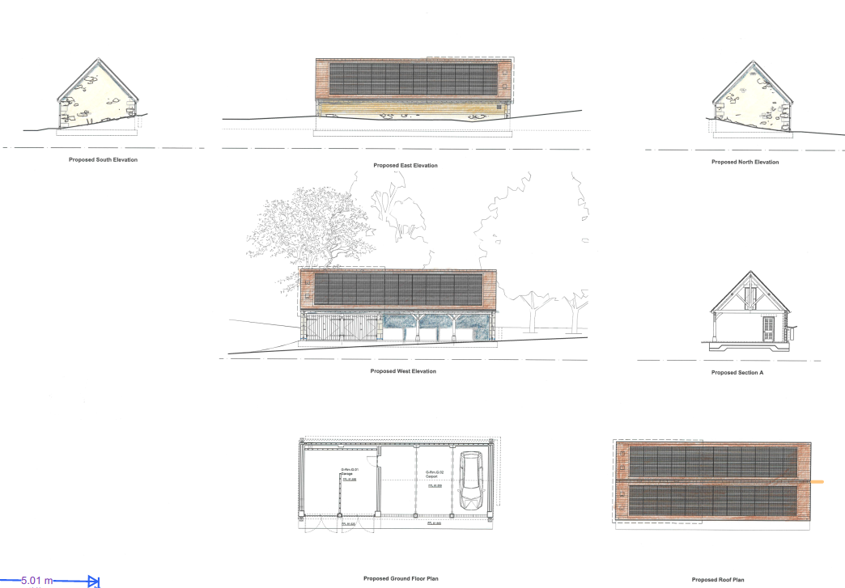
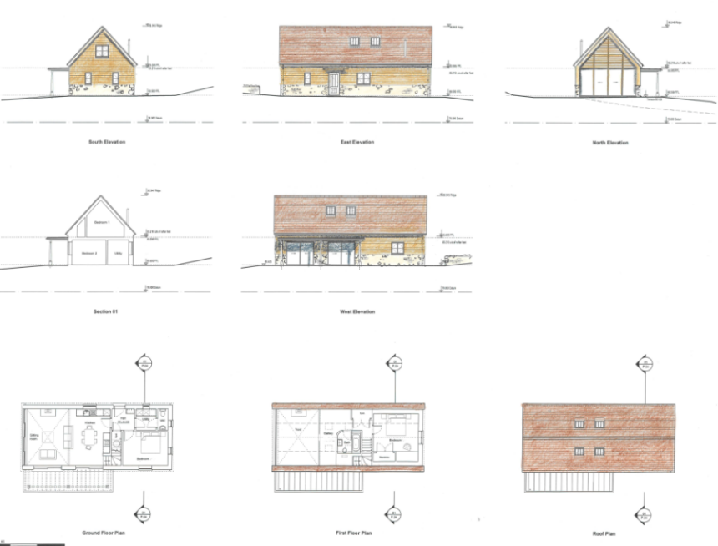
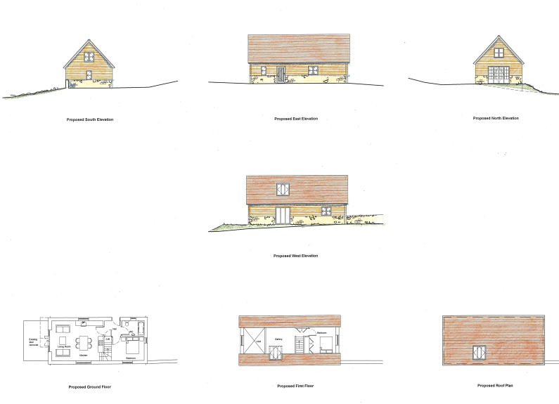

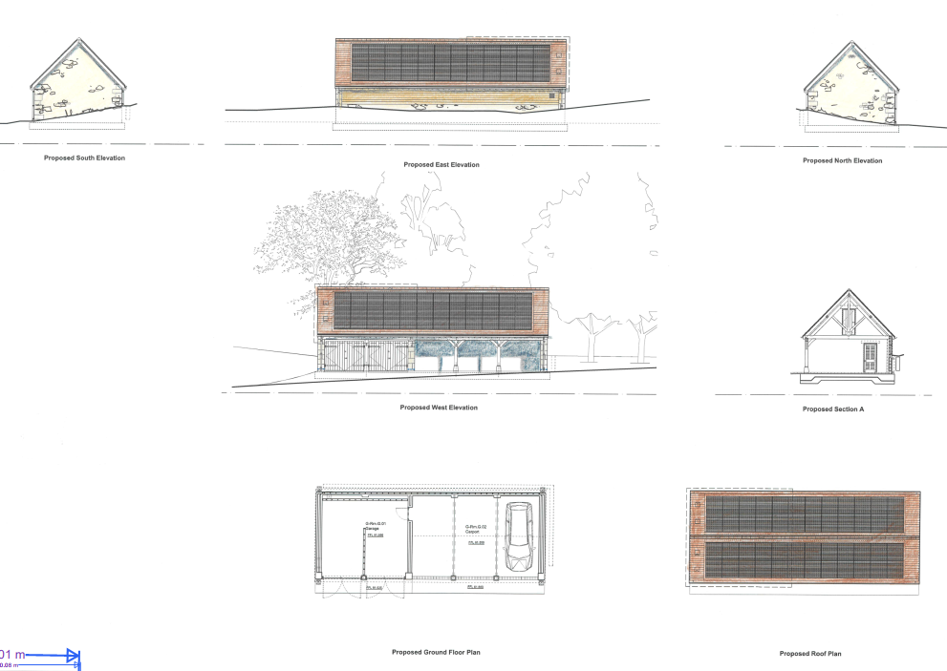
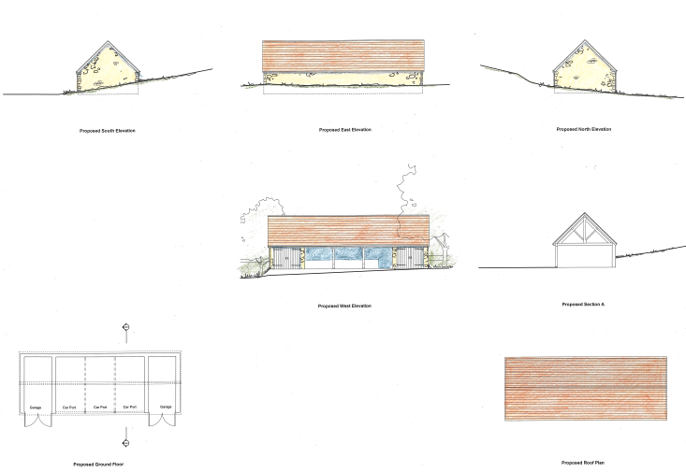
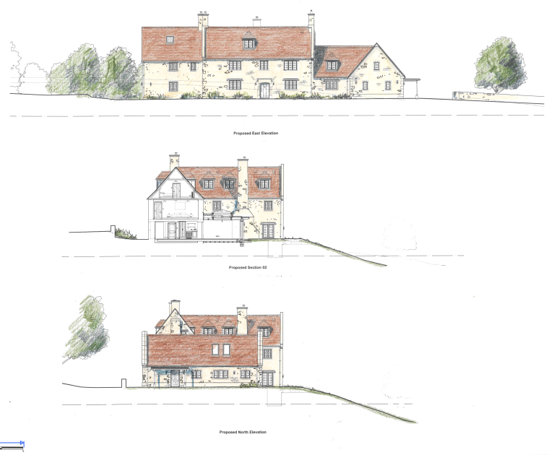
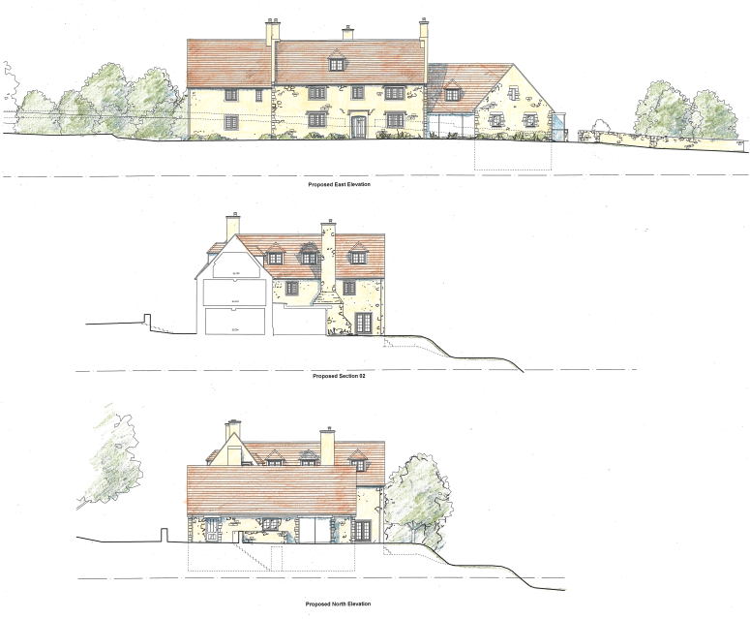
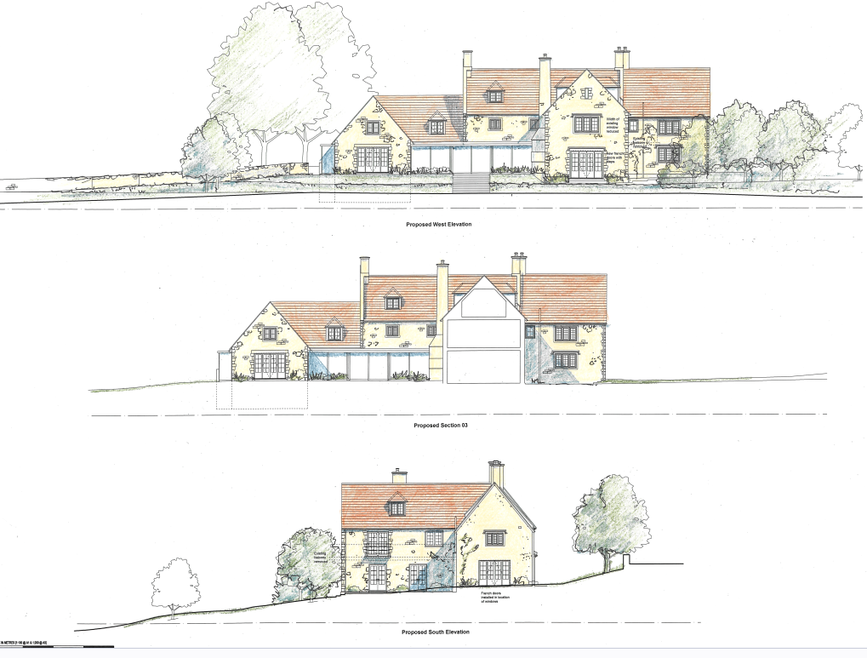
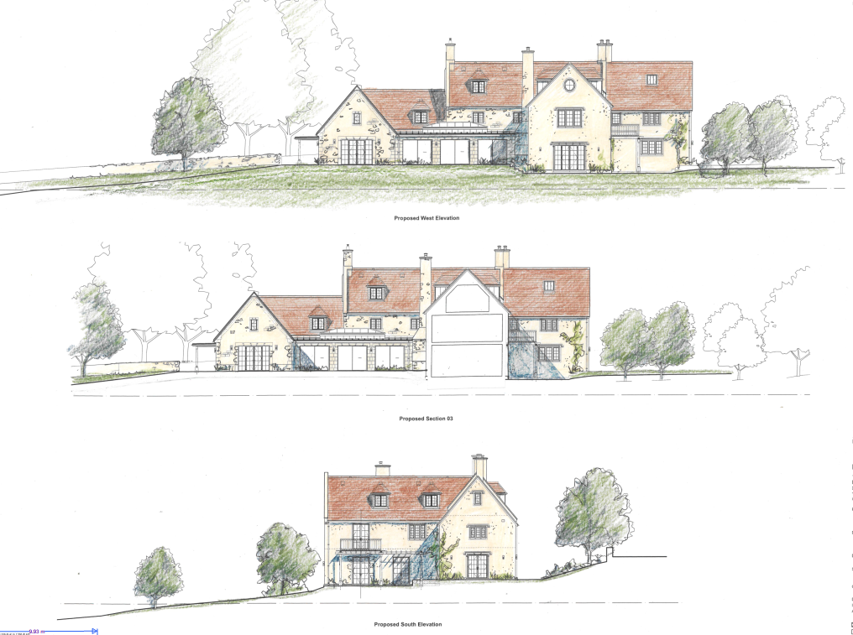
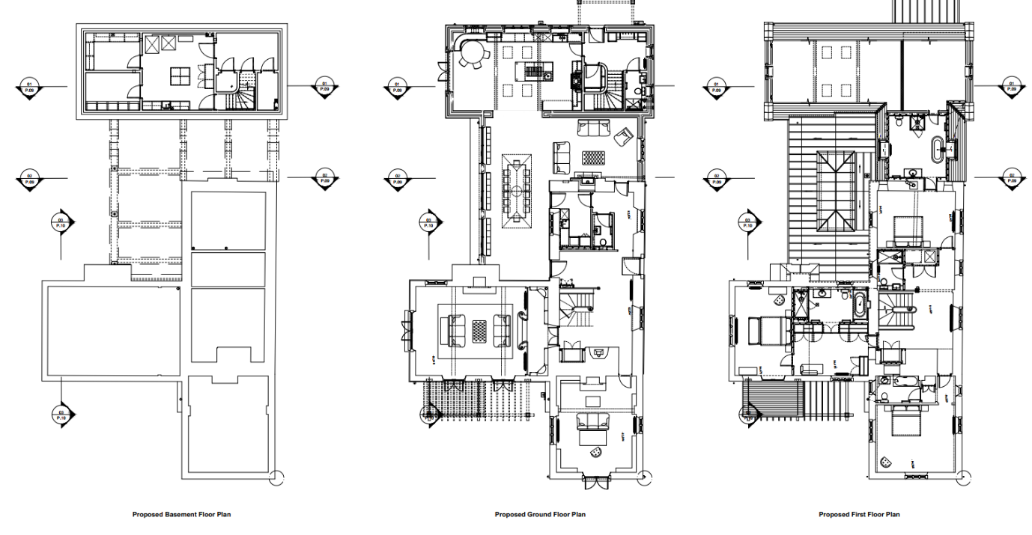
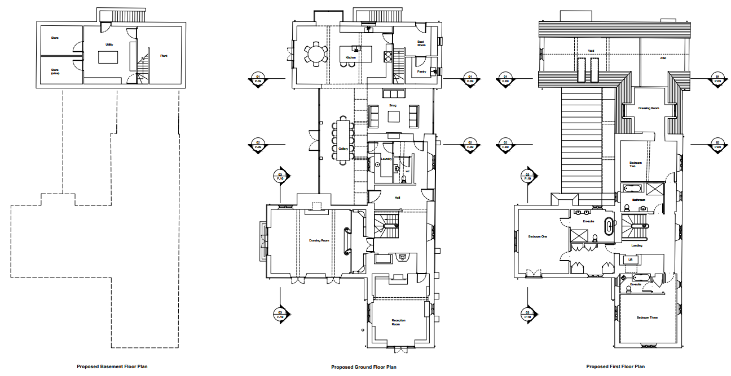
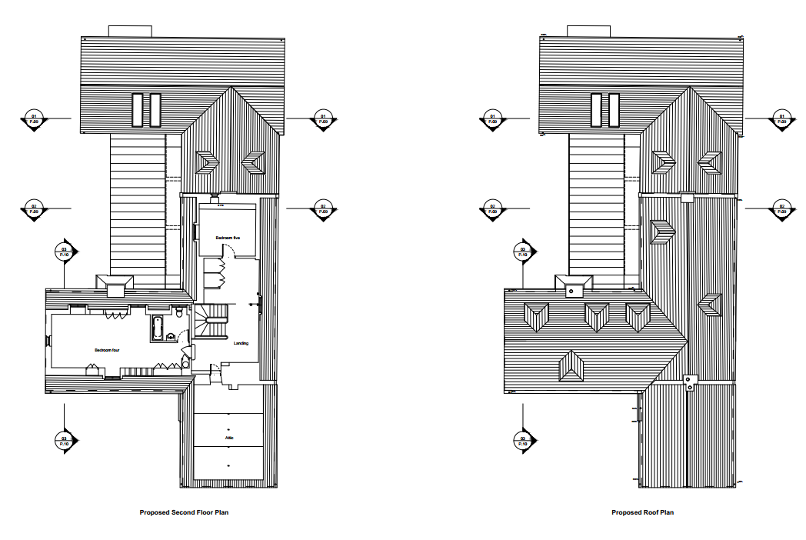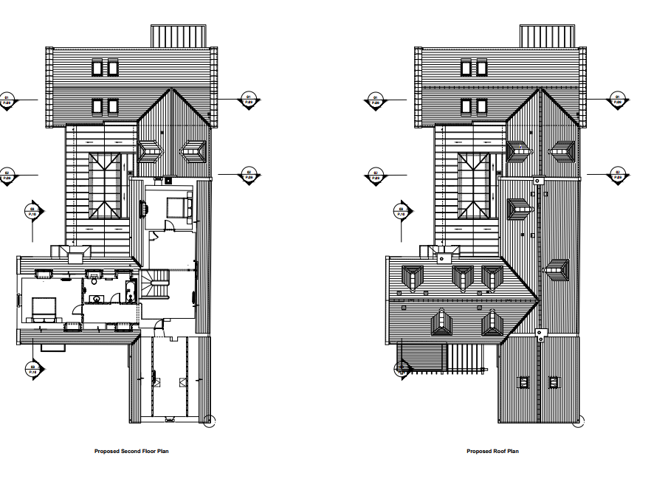

Assessment of Conditions

The revised proposal will not affect any other conditions aside from condition 2 the approved plans list. The list of conditions has been included in the recommendation below.

In terms of residential amenity, the changes to the works of the application site are not considered to detrimentally impact the neighbouring dwellings. The application site does not lie in close proximity to neighbouring dwellings and as such no overlooking, overbearing impacts nor overshadowing is considered to be generated by the revised proposal.

PLANNING BALANCE AND CONCLUSION
In determining this application under Section 73 of the Town and Country Planning Act 1990, the Local Planning Authority has considered whether the proposed amendments fall within the scope of Section 73. The proposed amendments have been assessed against the relevant policies of the Wiltshire Core Strategy, any applicable Neighbourhood Plan, and the National Planning Policy Framework. The assessment has also considered whether the development, as amended, materially alters the nature or impacts of the approved scheme.

In weighing the planning balance, the following factors have been considered:

- Benefits: The revised scheme proposes to retain larger areas of solid external walling of the host dwelling and reduces some areas of glazing. The proposed development as a whole allows for an existing dwelling to be upgraded and occupied with minimal impacts to the neighbouring dwellings and surrounding area.

The proposed variation of condition(s) is considered acceptable. The benefits of the proposal are judged to outweigh any identified harms, which can be appropriately mitigated through planning conditions or other controls. The proposal remains in accordance with the development plan and relevant national guidance, and there are no material considerations that indicate otherwise. Additionally, the conservation officer considers that the proposed changes are relatively modest and has no concerns regarding the impact on the proposed changes on the building’s significant contribution to the character of the conservation area which will be preserved in accordance with the aims of section 72 of the PLBCA Act 1990, NPPF and CP58.

RECOMMENDATION:
That Planning Permission be GRANTED subject to the following conditions:

1.The development hereby permitted shall be begun before the expiration of three years from the date of the extant permission PL/2024/00024 which was approved on: 18/03/2024.

REASON: To comply with the provisions of Section 91 of the Town and Country Planning Act 1990 as amended by the Planning and Compulsory Purchase Act 2004.

2. The development hereby permitted shall be carried out in accordance with the following
approved plans:

Design Access and Heritage Statement Received: 07/04/26
Bat Surveys Rev: V2 Received: 02/01/24
Proposed Site & Location Plan Drawing No. 607 P.02 Rev A Received: 07/04/26
Proposed Basement, Ground and First Floor Plans Drawing No. 607/P.07 Rev A Received: 07/04/26
Proposed Second floor plan and Roof Plan Drawing No. 607/P.08 Rev A Received: 07/04/26
Proposed East & North Elevations and section Drawing No. 607/P.09 Rev A Received: 07/04/26
Proposed West & South Elevations Drawing No. 607/P.10 Rev A Received: 07/04/26
Proposed General Arrangement Annex - elevations and floor plans Drawing No. 607 P.11 Rev A Received: 07/04/26
Proposed Garage - elevations and floor plans Coloured Drawing No. 607/ P.12 Rev A Received: 07/04/26

REASON: For the avoidance of doubt and in the interests of proper planning.

3. Materials to be used in the construction of the works hereby permitted shall be as stated on
the application form and submitted drawings.

REASON: In the interests of visual amenity and the character and appearance of the area.

4. Any new external stonework for the development hereby permitted (including any infill of walls) shall be constructed to match that of the existing stonework being green sandstone in terms of its colour, texture, sizes, jointing, mortar appearance and pointing.
REASON: In the interests of preserving the character and appearance of the building and its setting.
5. The proposed detached annex hereby approved shall only be used for purposes ancillary to the residential use of the dwelling known as Dower House and shall not at any time be occupied as an independent residential unit.
REASON: The detached garage is sited in a position where the Local Planning Authority, having regard to the reasonable standards of residential amenity, access, and planning policies pertaining to the area, would not permit a wholly separate dwelling.
6. All lighting provided on site shall be in accordance with the appropriate Environmental Zone standards set out by the Institute of Lighting Engineers in their publication GN01:2021, ‘Guidance for the Reduction of Obtrusive Light’ (ILP, 2021), and Guidance note GN08/23 “Bats and artificial lighting at night”, issued by the Bat Conservation Trust and Institution of Lighting Professionals.
REASON: In the interests of the amenities of the area and to minimize impacts on biodiversity caused by light spillage to areas above and outside the development site.
7. Before the dwelling, annex and garage are completed and occupied, bat and bird mitigation shall be incorporated into the development in accordance with the mitigation and enhancement details shown on the Bat survey report compiled by David Leach Ecology in Appendix E as well as specified on the report. Or as otherwise specified in a relevant European Protected Species Licence superseding this permission. The installation of the ecological features will be supervised by a professional ecologist. These features shall continue to be available for bats and birds for the lifetime of the development.
REASON: To mitigate for impacts to bats and birds arising from the development.
Informatives:
Bats
The roof space of property is used as a bat roost. Under the Conservation of Habitats and Species Regulations 2017, it is an offence to harm or disturb bats or damage or destroy their roosts. Planning permission for development does not provide a defence against prosecution under this legislation. The applicant is advised that a European Protected Species Licence will be required before any work is undertaken to implement this planning permission. Future conversion of the roof space to living accommodation or replacing the roof could also breach this legislation and advice should be obtained from a professional bat ecologist before proceeding with work of this nature.
Birds
The adults, young, eggs and nests of all species of birds are protected by the Wildlife and Countryside Act 1981 (as amended) while they are breeding. Please be advised that works should not take place that will harm nesting birds from March to August inclusive. All British birds, their nests and eggs are protected under Section 1 of the Wildlife and Countryside Act 1981 (as amended) and the Countryside and Rights of Way Act 2000 while birds are nesting, building nests and sitting on eggs. The applicant is advised to check any structure or vegetation capable of supporting breeding birds and delay removing or altering such features until after young birds have fledged. Damage to extensive areas that could contain nests/breeding birds should be undertaken outside the breeding season. This season is usually taken to be the period between 1st March and 31st August but some species are known to breed outside these limits.
Lighting
The habitat within the proposed development site and the surrounding area is suitable for roosting, foraging, and commuting bats. An increase in artificial lux levels can deter bats which could result in roost abandonment and/or the severance of key foraging areas. This will likely result in a significant negative impact upon the health of bat populations across the region. Artificial light at night can have a substantial adverse effect on biodiversity. Any new lighting should be for the purposes for safe access and security and be in accordance with the appropriate Environmental Zone standards set out by the Institute of Lighting Engineers in their publication GN01:2021, ‘Guidance for the Reduction of Obtrusive Light’ (ILP, 2021), and Guidance note GN08-18 “Bats and artificial lighting in the UK”, issued by the Bat Conservation Trust and Institution of Lighting Professionals. As specified in the approved bat report referred to above, any external lighting on this site should seek to meet the following requirements:
• Any lights will be aimed to illuminate only the immediate area required by using as sharp a downward angle as possible. A shield or hood will be used to control or restrict the area to be lit and limit “light spillage” on the site.
• Security lights will be on motion sensors and on for a maximum of 1 minute.
• Lighting units will be of low intensity - up to 15 watts, and red, amber or warm light with a maximum lighting colour temperature of 2700 K.
• White, blue, and green light sources including metal halide, mercury and CDO / CPO Ceramic Outdoor Lamps bulbs have a significant effect on bats and will not be used Please also refer to the AONB Position Statement on Light Pollution at www.ccwwdaonb.org.uk

