APPLICATION FOR PRIOR NOTIFICATION - AGRICULTURAL
CASE OFFICER REPORT

APPLICATION REFERENCE: | PL/2026/02836
APPLICATION TYPE: | Prior notification: Road (agricultural/forestry)
SITE ADDRESS: | Chaldicotts Farm, Semley, Shaftestbury, SP7 9AW
DEVELOPMENT DESCRIPTION: | Proposed forest tracks
RECOMMENDATION: | Prior Approval NOT required.

SITE DESCRIPTION/CONTEXT
The application site is located north and within Chaldicott’s Farm. The application site is located within the countryside and lies within Cranborne Chase and West Wiltshire Downs Area of Outstanding Natural Beauty/ National Landscape.

PROPOSAL
This application is a prior notification for a proposed formation of a new road for forestry use.

RELEVANT PLANNING HISTORY

Proposal / Summary
S/2008/0413 - Full planning permission Decision - Withdrawn Date: 13/5/2008 – ERECT EXTENSION FOR CYCLE STORE
S/2008/0415 - Full planning permission Decision - Approve with Conditions Date: 6/5/2008 – EXTENSION TO UNIT 10 FOR B2 USE
S/2008/0416 - Full planning permission Decision - Approve with Conditions Date: 6/5/2008 – ERECTION OF BUILDING FOR WAREHOUSING AND ANCILLARY OFFICES (B8)
S/1994/0930 - Full planning permission Decision - Approve with Conditions Date: 15/8/1994 – BELOW GROUND PRECAST CONCRETE SLURRY STORE
S/1998/1289 - Full planning permission Decision - Approve with Conditions Date: 23/10/1998 – NEW CATTLE BUILDING
S/2003/1502 - Full planning permission Decision - Refused Date: 3/11/2003 – COVERSION OF FARM BUILDINGS (UNITS 3,4,5,6 & 7) TO B1 USE UNITS 8,9 & 10 TO B1/B8 USES. CONVERSION OF UNIT 1 TO B1/A1 USE UNIT 2 TO RESIDENTIAL/B1 USE ALTERATIONS TO VEHICULAR ACCESS
S/2006/0474 - Full planning permission Decision - Approved Date: 20/4/2006 – CONSTRUCTION OF ROOF OVER PART OF FORMER SLURRY STORE; USE FOR B1 / B8; FORM ADDITIONAL CAR PARKING.
S/2005/0179 - Full planning permission Decision - Refused Date: 7/3/2005 – ERECTION OF TWO REPLACEMENT B1 / B8 (OFFICES/WAREHOUSING)BUILDINGS
S/2006/1519 - Full planning permission Decision - Approve with Conditions Date: 11/9/2006 – ERECT AGRICULTURAL / FORESTRY MACHINERY STORE (REMOVE EXISTING FIELD BARN)
S/2003/2673 - Full planning permission Decision - Approve with Conditions Date: 12/5/2004 – FARM CONVERSION PROJECT - PROPOSED CONVERSION AND ALTERATIONS FOR EMPLOYMENT AND RELATED USES
S/2006/0192 - Full planning permission Decision - Approve with Conditions Date: 22/3/2006 – CONVERSION OF BARN TO (B1) BUSINESS AND ASSOCIATED ALTERATIONS
S/2006/2358 - Full planning permission Decision - Approved Date: 12/1/2007 – CHANGE OF USE TO B2 (GENERAL INDUSTRY) FOR EPT EUROPE LTD (PLASTICS RECYCLING)
S/2005/0683 - Full planning permission Decision - Approve with Conditions Date: 11/5/2005 – DEMOLISH EXISTING BUILDING. ERECT NEW B1 / B8 UNIT IN NEW POSTION
S/2011/1562 - Full planning permission Decision - Approve with Conditions Date: 12/12/2011 – Roof-mounted PV arrays to existing units 8, 9, 10, 11 and 13, and ground-mounted PV arrays with change of use of waste land
S/2008/0766 - Full planning permission Decision - Approve with Conditions Date: 13/6/2008 – CHANGE OF USE OF EXISTING B8 UNIT TO B2 (GENERAL INDUSTRY) FOR RECYCLING OF ELECTRICAL AND LIGHT FITTINGS (UNIT 9)
S/2007/1599 - Full planning permission Decision - Approve with Conditions Date: 28/9/2007 – RE ROOF UNIT 1 IN NATURAL SLATE (AMENDMENT TO APPROVED CONVERSION S/2003/2673)
S/2008/0414 - Full planning permission Decision - Approve with Conditions Date: 6/5/2008 – ERECTION OF OFFICE BUILDING - UNIT 12
20/01082/FUL - Full planning permission Decision - Approve with Conditions Date: 5/5/2020 – Proposed erection of cafe building, and formation of additional parking area.
19/06573/FUL - Full planning permission Decision - Approve with Conditions Date: 27/8/2019 – Garden Room Single Storey Side Extension
20/06194/FUL - Full planning permission Decision - Approve with Conditions Date: 13/10/2020 – Form new vehicular access, erection of cafe building (revised design and siting) and the formation of additional parking area.
PL/2022/05982 - Full planning permission Decision - Approve with Conditions Date: 26/9/2022 – Proposed installation of two rapid electric vehicle charging stations within the car park of Chaldicotts Farm.
14/06835/FUL - Full planning permission Decision - Refused Date: 16/9/2014 – Erection of B2 General Industrial Unit
14/06982/FUL - Full planning permission Decision - Refused Date: 16/9/2014 – Erection of B2 General Industrial Unit
14/06987/FUL - Full planning permission Decision - Approve with Conditions Date: 16/9/2014 – Extension to B2 General Industrial Unit
14/10933/FUL - Full planning permission Decision - Approve with Conditions Date: 20/1/2015 – Erection of B2 General Industrial Unit (Resubmission of 14/06835/FUL)
18/02826/106 - Modification of Planning Obligation Decision - Approved Date: 29/8/2018 – Removal of Section 106 Agreement relating to S/2003/2673
PL/2021/07659 - Full planning permission Decision - Approve with Conditions Date: 3/11/2021 – Erection of 2 No. industrial units
S/1985/0089 - Full planning permission Decision - Refused Date: 27/3/1985 – TOURING CARAVAN SITE FOR UP TO 80 CARAVANS ANDALTERATION OF VEHICULAR ACCESS

RELEVANT LEGISLATION, POLICY AND GUIDANCE
This application is assessed under The Town and Country Planning (General Permitted Development) (England) Order 2015 (as amended), which grants planning permission for certain types of development described in Schedule 2 of the Order. The grant of permission is subject to the limitations, conditions, and provisions set out within the relevant Classes of permitted development.

Under Schedule 2, Part 6 of the Town and Country Planning (General Permitted Development) (England) Order 2015 (as amended), certain types of forestry development may be permitted, including:

A. The carrying out on agricultural land comprised in an agricultural unit of 5 hectares or more in area of—

(a)works for the erection, extension or alteration of a building; or

(b)any excavation or engineering operations,

which are reasonably necessary for the purposes of agriculture within that unit.

Development not permitted

A.1 Development is not permitted by Class A if—

(a)the development would be carried out on a separate parcel of land forming part of the unit which is less than 1 hectare in area;

No, the development will be carried out in a part of the unit 1 hectare in area or more.

(b)it would consist of the erection or extension of any agricultural building on an established agricultural unit (as defined in paragraph X of Part 3 of this Schedule) where development under Class Q or S of Part 3 (changes of use) of this Schedule has been carried out within a period of 10 years ending with the date on which development under Class A(a) begins;

No.

(c)it would consist of, or include, the erection, extension or alteration of a dwelling;

No.

(d)it would involve the provision of a building, structure or works not designed for agricultural purposes;

(e)the ground area which would be covered by—
(i)any works or structure (other than a fence) for accommodating livestock or any plant or machinery arising from engineering operations would exceed 1,000 square metres]; or
(ii)any building erected or extended or altered by virtue of Class A would exceed 1,500 square metres],
calculated as described in paragraph D.1(2)(a) of this Part;
No.

(f)the height of any part of any building, structure or works within 3 kilometres of the perimeter of an aerodrome would exceed 3 metres;

No.

(g)the height of any part of any building, structure or works not within 3 kilometres of the perimeter of an aerodrome would exceed 12 metres;

(h)any part of the development would be within 25 metres of a metalled part of a trunk road or classified road;

No.

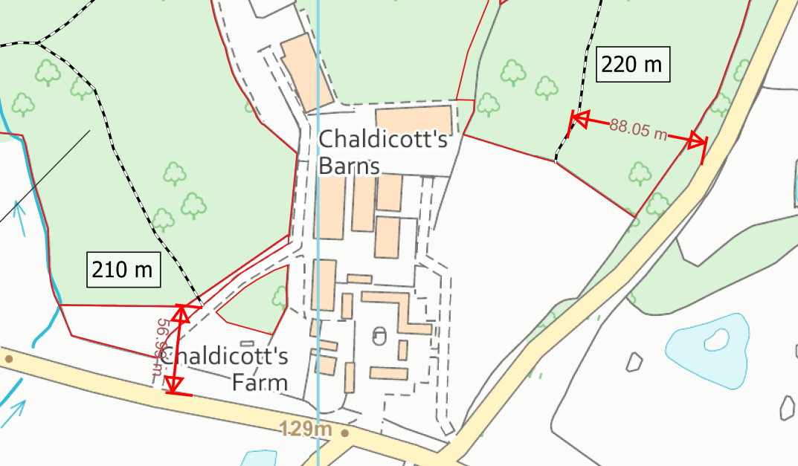

(i)it would consist of, or include, the erection or construction of, or the carrying out of any works to, a building, structure or an excavation used or to be used for the accommodation of livestock or for the storage of slurry or sewage sludge where the building, structure or excavation is, or would be, within 400 metres of the curtilage of a protected building;

No.

(j)it would involve excavations or engineering operations on or over article 2(4) land which are connected with fish farming;

No.

(k)any building for storing fuel for or waste from a biomass boiler or an anaerobic digestion system—

(i)would be used for storing waste not produced by that boiler or system or for storing fuel not produced on land within the unit; or

(ii)is or would be within 400 metres of the curtilage of a protected building or

No.

(l)the erection or extension of a building would be carried out on land or a building that is, or is within the curtilage of, a scheduled monument].

No.

Conditions
A.2—(1) Development is permitted by Class A subject to the following conditions—

(c)waste materials are not brought on to the land from elsewhere for deposit except for use in works described in Class A(a) or in the provision of a hard surface and any materials so brought are incorporated forthwith into the building or works in question.

(2) Subject to sub-paragraph (3), development consisting of—

(a)the erection, extension or alteration of a building;

No.

(b)the formation or alteration of a private way;

Yes.

(c)the carrying out of excavations or the deposit of waste material (where the relevant area, as defined in paragraph D.1(4) of this Part, exceeds 0.5 hectares); or

No.

(d)the placing or assembly of a tank in any waters,

No.

E. The carrying out on land used for the purposes of forestry, including afforestation, of development reasonably necessary for those purposes consisting of—

(a)works for the erection, extension or alteration of a building;

(b)the formation, alteration or maintenance of private ways;

(c)operations on that land, or on land held or occupied with that land, to obtain the materials required for the formation, alteration or maintenance of such ways;

(d)other operations (not including engineering or mining operations).

Development not permitted

E.1 Development is not permitted by Class E if—

(a)it would consist of or include the provision or alteration of a dwelling;
No.

(b)the height of any building or works within 3 kilometres of the perimeter of an aerodrome would exceed 3 metres in height;

No.

(c)any part of the development would be within 25 metres of the metalled portion of a trunk road or classified road; or

No.

(d)any building for storing fuel for, or waste from, a biomass boiler or an anaerobic digestion system would be used for storing waste not produced by that boiler or system or for storing fuel not produced on land which is occupied together with that building for the purposes of forestry.

No.

Where such development is proposed, the developer is required to apply to the local planning authority for a determination as to whether prior approval is needed. This prior approval process is limited in scope and relates only to the following matters:

- The siting and means of construction of the private way;

ASSESSMENT

Does the Proposal Qualify as Permitted Development?

Having assessed the proposed development against The Town and Country Planning (General Permitted Development) (England) Order 2015 (as amended), Schedule 2, Part 6, Class A and E, it is concluded that the proposed development qualifies as permitted development. The proposed forest tracks are located in land used for forestry for approximately 100 years and 12 months according to the application form. This application is for proposed forest tracks, all the tracks are located 25 metres beyond the C classified road Tokes Lane on the west and a road on the south.

It is concluded that the proposed development qualifies as permitted development under Schedule 2, Part 6, Class A and E of the Town and Country Planning (General Permitted Development) (England) Order 2015 (as amended), and the assessment may now proceed to consider the siting, design, and external appearance of the development as required by the GPDO.

Is Prior Approval Required?

- The siting and means of construction of the private way

The application notes that:

The forest tracks will be able to support vehicle access all year round, which will enable timely extraction of timber. This is important to ensure forest operations are economically viable and income isn’t delayed through timber being stuck in the forest. Forest tracks will be centrally located in compartments which will decrease the distance contractors are required to move timber to roadside.

The woodland has been heavily affected by ash dieback and the new forest tracks will facilitate the programme of felling dead ash trees and restocking with viable broadleaf species, as set out in the Forestry Commission approved 10 year Woodland Management Plan.

A geotextile membrane will be lain on top of the formation to achieve separation between it and the capping layer. Locally sourced well-graded granular material will make up the capping layer, compacted to a depth of 250mm. The surface material will ideally comprise of MOT Type 1,
compacted to a depth of 100mm.
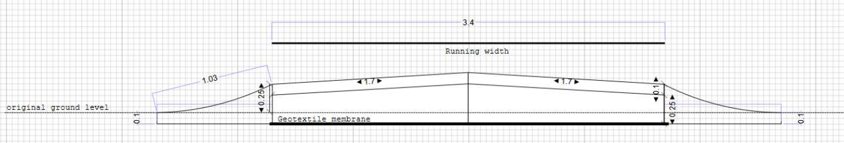

The proposed tracks measure a total of 860 metres and will have a width of 3.4 metres. The tracks are to be within existing forestry land and are proposed to support the existing forestry business. From the top view provided by google maps, the proposed location of the forest tracks is in locations where existing informal tracks are already located.

National Landscape

Core Policy 51 of the Wiltshire Core Strategy requires all development to protect, conserve, and where possible enhance the character and quality of Wiltshire’s landscapes, giving particular weight to designated areas such as National Landscapes.

The National Planning Policy Framework (NPPF), in Paragraph 189, states that “great weight” should be given to conserving and enhancing landscape and scenic beauty in National Landscapes (formerly Areas of Outstanding Natural Beauty). Development within or affecting the setting of a National Landscape must demonstrate that it will not result in unacceptable harm to the special qualities of that area.

The application site lies within the Cranborne Chase and West Wilshire Downs Area of Outstanding Natural Beauty (AONB)/ National Landscape (NL). The proposed sitting and design of the forestry tracks are located and constrained within an established forestry business. As such, it is not considered to harm the special qualities or scenic character of the wider Cranborne and Chase National Landscape. The development therefore complies with Core Policy 51 of the Wiltshire Core Strategy and Paragraph 189 of the NPPF in conserving and enhancing the National Landscape.
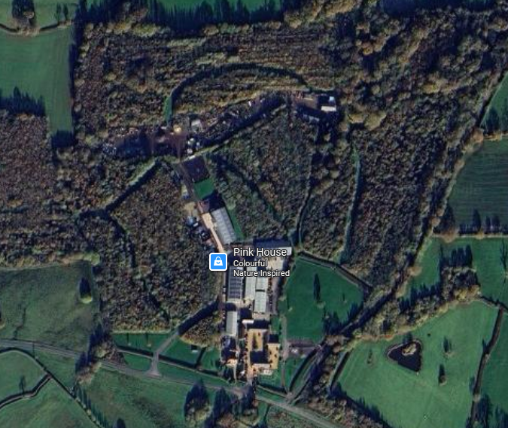
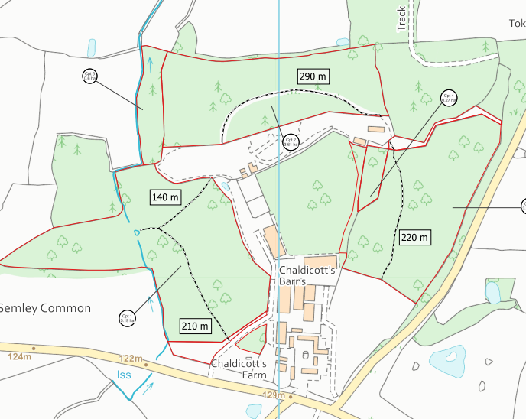
CONCLUSION
Prior Approval not Required
The proposed development has been assessed against the provisions, limitations, and conditions set out in Schedule 2, Part 6, Class A and Class E of the Town and Country Planning (General Permitted Development) (England) Order 2015 (as amended). Based on the submitted plans, supporting information, and the findings of this report, it is concluded that the proposal complies with the criteria for permitted development, and therefore falls within the scope of Class A and Class E. As such, the local planning authority has considered whether prior approval is required in relation to the siting, design, and external appearance of the development. It is considered that the creation of forestry tracks within the established agricultural unit is acceptable on sitting and design and is not considered to harm the special qualities or scenic character of the Cranborne and Chase National Landscape. In this case, it is concluded that prior approval is not required, and the development may proceed in accordance with the submitted details.

RECOMMENDATION:
That Prior Approval is NOT required.

