APPLICATION FOR FULL-PLANNING PERMISSION
CASE OFFICER REPORT

APPLICATION REFERENCE: | PL/2026/02355
APPLICATION TYPE: | Full planning permission
SITE ADDRESS: | Lane at Byde Mill Lane, Poulshot, Wiltshire
DEVELOPMENT DESCRIPTION: | Erection of standard field shelter for the purpose of providing shading to those club members attending the site in hot weather.
RECOMMENDATION: | Approve with Conditions

SITE DESCRIPTION/CONTEXT

Byde Mill Lane is a single track lane of informal aggregate construction. The first 200m is an adopted unclassified road, which thereafter is classified as a bridleway (POLU4) that terminates before it reaches Summerham Brook. It is thus not a through route. The application site is c.770m along the bridleway and comprises a c0.99 hectare area of previously agricultural land, now comprising a maintained grassed field surrounded by arable land.

In application 20/06487/FUL permission was granted to change the use of the agricultural land for the purpose of flying radio-controlled model planes. The site is officially used by the Wessex Model Flying club.

The site is within flood zone 1 and is not subject to any ground water flood risk. However, it is likely that the shelter would be located in an area of a 1:1000 year surface water flood risk.

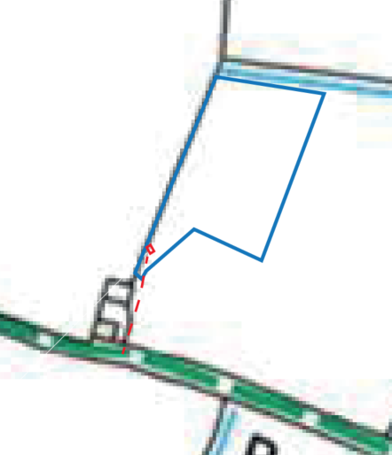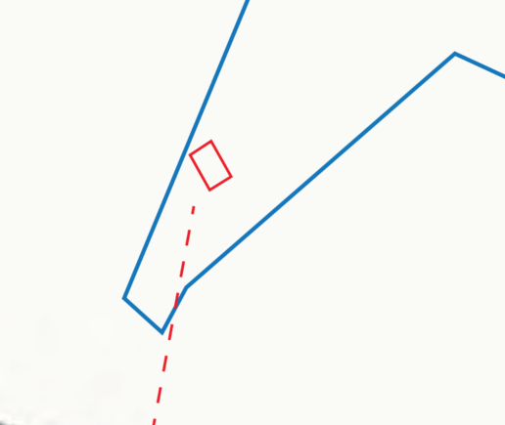

Site Location Plan and Block Plan

The site is not subject to any other policy designations. Note that the existing agricultural building is not within the application site (nor the blue outline). It cannot therefore be suggested as an alternative provision to this application.

PROPOSAL

The proposal would comprise of a simple timber shelter measuring 4.5m long by 2.8 deep (footprint of 12.6m). It would be 2.4m high sloping to 2m at eaves. The shelter would be used by the club as a means for shade and all other forms of shelter for the members.

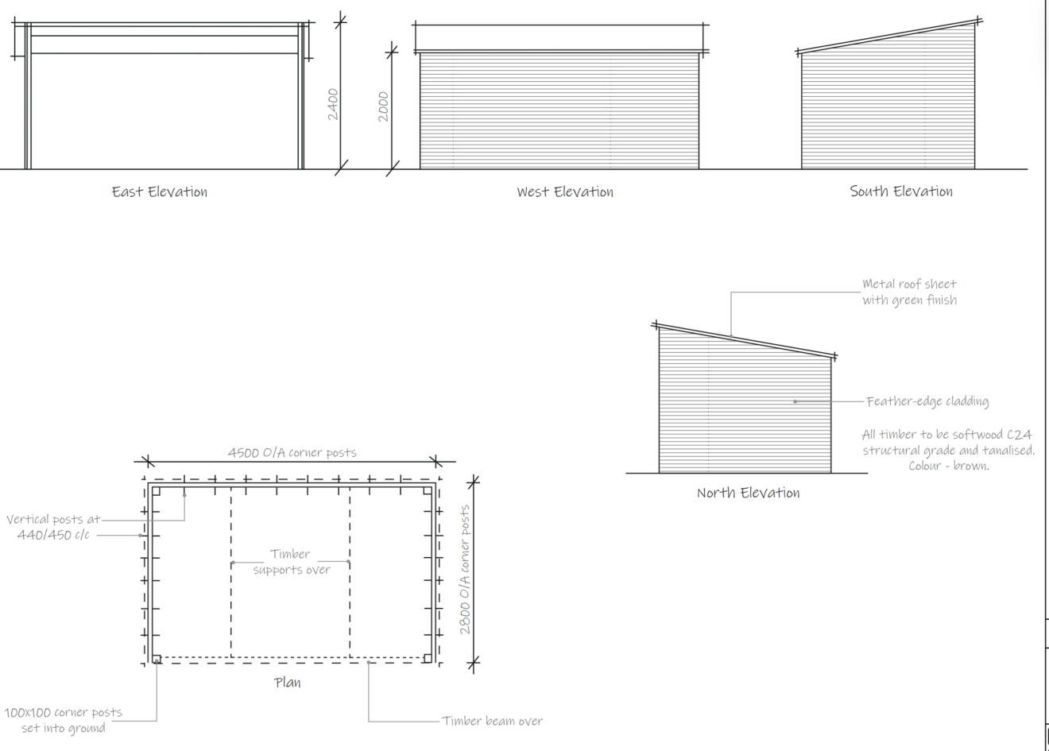

Proposed Elevations and Floor Plan

PLANNING HISTORY

Proposal / Summary
20/06487/FUL - Full planning permission Decision - Approve with Conditions Date: 20/10/2020 – Change of use from agricultural for the purpose of flying radio controlled model planes (retrospective).

RELEVANT LEGISLATION, POLICIES AND GUIDANCE

National Planning Policy:
- National Planning Policy Framework (NPPF)
- Planning Practice Guidance (PPG)
Development Plan:

The development plan for Wiltshire comprises the Wiltshire Core Strategy (WCS) (adopted January 2015) and any made neighbourhood plans, which remains the principal statutory planning document guiding development across the county. In line with Section 38(6) of the Planning and Compulsory Purchase Act 2004, planning decisions must be made in accordance with the development plan unless material considerations indicate otherwise.

Though the development plan is considered as a whole, those parts deemed to be particularly relevant to this application are listed below:

The adopted Wiltshire Core Strategy (WCS), with particular regard to:

- Core Policy 50 Biodiversity and Geodiversity;
- Core Policy 51 Landscape
- Core Policy 57 Ensuring High Quality Design and Place Shaping;

Neighbourhood Plan: Poulshot does not have a Neighbourhood Plan or area designation.

Supplementary Planning Documents and other Guidance:
- Wiltshire Design Guide (adopted April 2024)
- Wiltshire Strategic Flood Risk Assessments (2019 and 2024)

ISSUES

The main issues that need to be addressed in this case include:

- Whether the proposal constitutes EIA development
- Whether the development is acceptable in principle
- Whether the scheme constitutes high quality design (CP 57)
- Whether the scheme would have an acceptable impact upon the reasonable living conditions of the adjoining occupants (CP 57)
- Whether the scheme would have an acceptable landscape impact (CP 51)

CONSULTATION RESPONSES

Poulshot Parish Council: No objection

REPRESENTATIONS

In accordance with the requirements of the Town and Country Planning (Development Management Procedure) (England) Order 2015 (as amended), the application was publicised by way of:

- A site notice displayed near the site;

These methods were used to inform interested parties and provide a period of 21 days for comments to be submitted.

Below is a summary of the representations received during the consultation period.

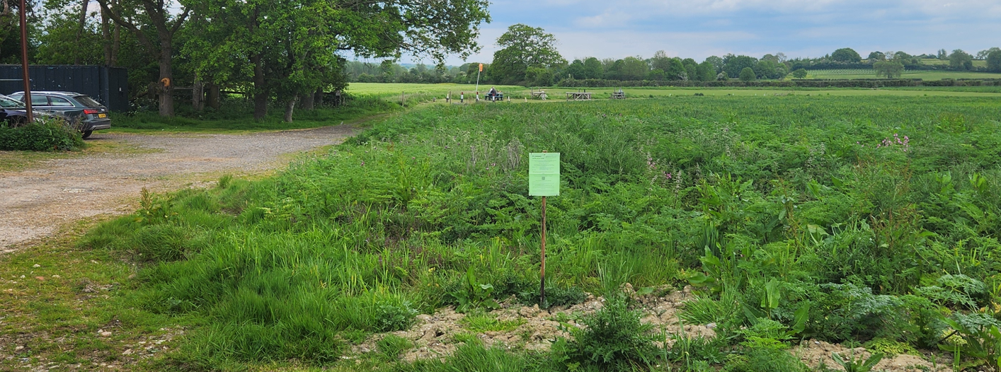

No comments received.

ASSESSMENT

Section 38(6) of the Planning and Compulsory Purchase Act 2004 states:

"If regard is to be had to the development plan for the purposes of any determination to be made under the planning Acts, the determination must be made in accordance with the plan unless material considerations indicate otherwise."

In accordance with this statutory requirement, this application has been assessed against the relevant policies of the Development Plan, including the Wiltshire Core Strategy (2015) and, where applicable, any made Neighbourhood Plans. Consideration has also been given to the policies of the National Planning Policy Framework (NPPF) as a material consideration in the assessment.

Environmental Impact Assessment (EIA) Screening

In accordance with the Town and Country Planning (Environmental Impact Assessment) Regulations 2017 (as amended), the local planning authority has considered whether the proposed development constitutes EIA development.

No Screening Opinion Issued
No formal screening opinion was requested or issued. However, the local planning authority has considered the scale and nature of the development as part of the application process and is satisfied that it does not constitute EIA development under the 2017 Regulations.

Principle of Development

The application site already benefits from the change of use application 20/06487/FUL and the proposed shelter would be used as part of that established use. Therefore, the principle of development is supported.

Design and Impact on the Character and Appearance of the Area
Policy Context
Core Policy 57 of the WCS requires high-quality design that:
- Enhances local character.
- Responds to the natural, historic, and built environment.
- Retains important features (e.g., trees, hedges).
- Supports sustainable construction and compatibility with surrounding uses.
- Creates safe, legible, and accessible spaces.

Section 12 of the NPPF emphasises design that is:
- Visually attractive.
- Functionally effective.
- Contributes to the quality of the built environment.

The Wiltshire Design Guide encourages sensitivity to local character, materials, and architectural styles and supports modern living standards while maintaining aesthetic and functional quality.

Assessment

The proposal is to erect a simple shelter that is enclosed on three sides to primarily provide shelter from the sun (or other weather conditions). The site and its immediate surroundings are open and free from development (other than the adjacent agricultural building) and due to the relatively flat topography, these open views are enjoyed along the Bridleway POUL4. Therefore, the introduction of a building within this landscape will cause some harm.

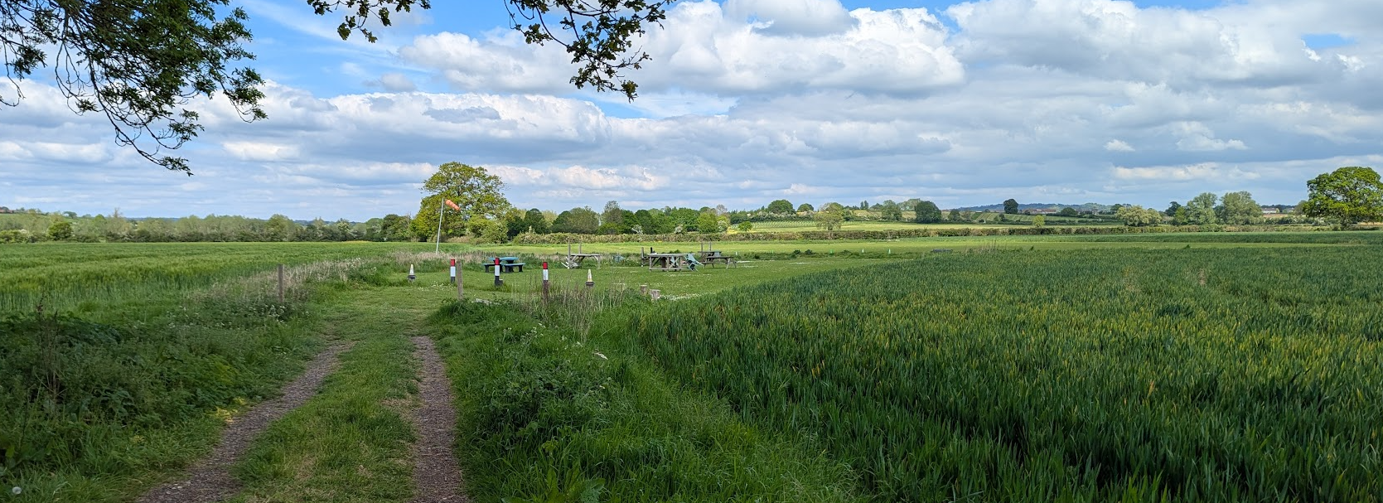

View from the agricultural barn looking towards proposed shelter location

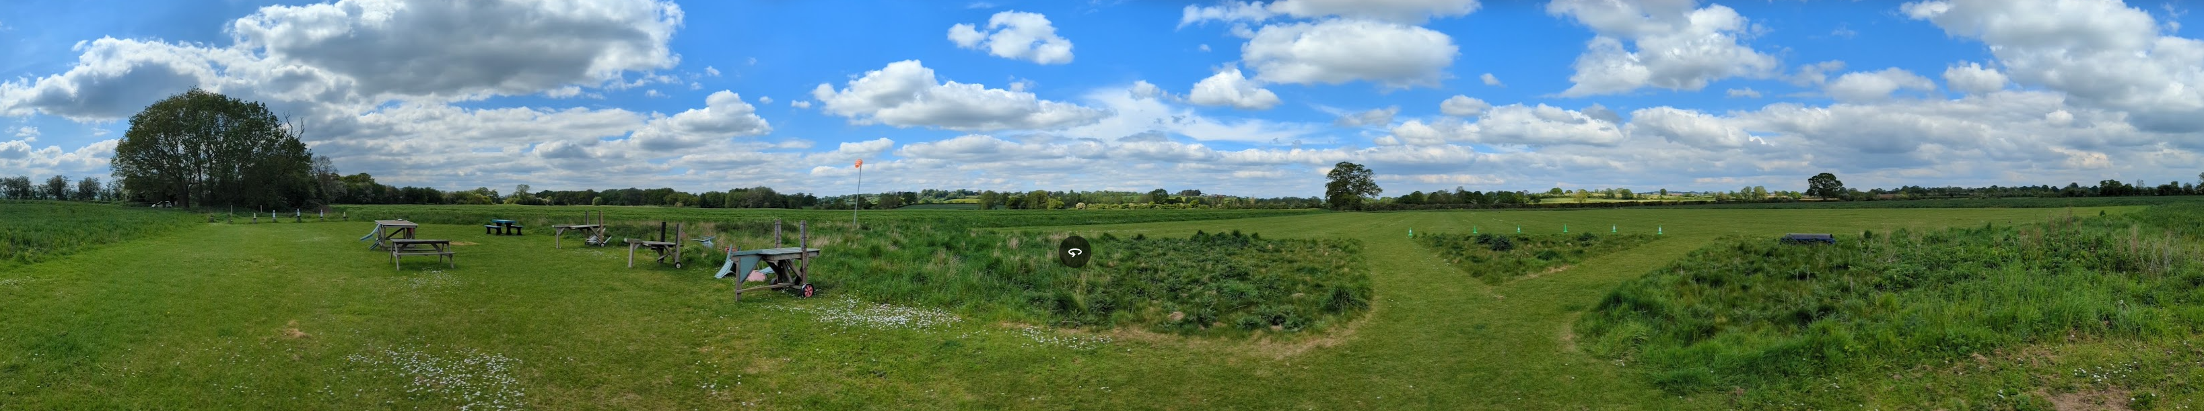

Panoramic view of the site

However, the building would be small and of agricultural appearance, which within this open countryside setting would not appear unduly out of character.

The club has various ‘chattels’ of table and chairs and work benches to place the models on, all of which have a domestic appearance.

The visual harm identified is localised and limited in magnitude, and is afforded limited weight in the overall planning balance.

Amenity

Policy Context
Core Policy 57 (Point vii) of the Wiltshire Core Strategy requires development to respect the amenity of existing occupants and ensure appropriate amenity levels for future residents.

The National Planning Policy Framework (NPPF), particularly Paragraph 135, reinforces the need for development to provide a high standard of amenity for both existing and future users.

These policies guide the assessment of amenity impacts, which will be considered in detail under the below headings.

No harm would be caused to neighbouring uses (open countryside) as it would be a small and passive outbuilding.

Ecology and Biodiversity

Policy Context
Core Policy 50 of the Wiltshire Core Strategy requires development to:

- Avoid harm to ecological assets.
- Deliver measurable Biodiversity Net Gain (BNG), in line with the Environment Act 2021.
- Support habitat restoration and connectivity.
- Integrate biodiversity into site design.

The Green & Blue Infrastructure Strategy (2022–2030) promotes nature recovery, ecosystem services, and habitat connectivity through development.

Unless exempt, National policy requires a minimum of 10% Biodiversity Net Gain (BNG) for major developments, demonstrated via:

- Biodiversity Metric calculations
- Ecological assessments (e.g. PEAs, Phase 1 surveys, protected species surveys)

Assessment

The proposal would only be located over existing grass over a small area of 12m2. It is considered that an ecology survey is not required.

Biodiversity Net Gain (BNG)

As of April 2024, any major planning application needs to demonstrate no net loss and a minimum of 10% net gain in biodiversity (BNG) on the site, in line with the requirements of the NPPF, PPG, WCS policy CP50 (Biodiversity and Geodiversity) and the Environment Act.

However, as the proposal is less that 25m2 in footprint, the proposal is exempt from BNG requirements.

Flood Risk and Drainage

Policy Context
Core Policy 67 of the Wiltshire Core Strategy and NPPF paragraphs 170–182 require:
- Avoidance of increased flood risk.
- Use of appropriate mitigation measures.
- Application of the sequential and exception tests for developments in Flood Zones 2 or 3.

Assessment

While surface water mapping indicates a low‑probability (1:1000 year) risk affecting the location of the proposed shelter, the development is small‑scale, involves no ground raising or impermeable surfacing, and would not displace floodwater or increase flood risk elsewhere. Having regard to the nature of the structure and its limited footprint, a site‑specific Flood Risk Assessment is not considered necessary in this instance.

PLANNING BALANCE AND CONCLUSION

The application has been assessed against the relevant policies of the Wiltshire Core Strategy and other material considerations. In accordance with Section 38(6) of the Planning and Compulsory Purchase Act 2004, the proposal should be approved where it accords with the development plan, unless material considerations indicate otherwise.
The principle of development is considered acceptable when assessed against the settlement strategy of the Wiltshire Core Strategy.

The proposal is broadly compliant with relevant local and national planning policies in respect of design, scale, neighbouring uses, landscape, highway safety, flood risk and drainage, ecology and biodiversity, and environmental impacts.

The development would deliver clear benefits, including providing occupants with an outside shelter which will enable them to use the site more often (subject to compliance with existing conditions) and in greater comfort. The social benefit of the scheme to outside recreation which weigh positively in the overall planning balance.

No material considerations have been identified that would significantly and demonstrably outweigh these benefits or indicate that permission should be refused, having regard to the assessment above and the representations received.

Accordingly, the proposal is considered acceptable in planning terms and in accordance with the Wiltshire Core Strategy, the National Planning Policy Framework, and all other relevant material considerations.

RECOMMENDATION:
That Planning Permission be GRANTED, subject to conditions

