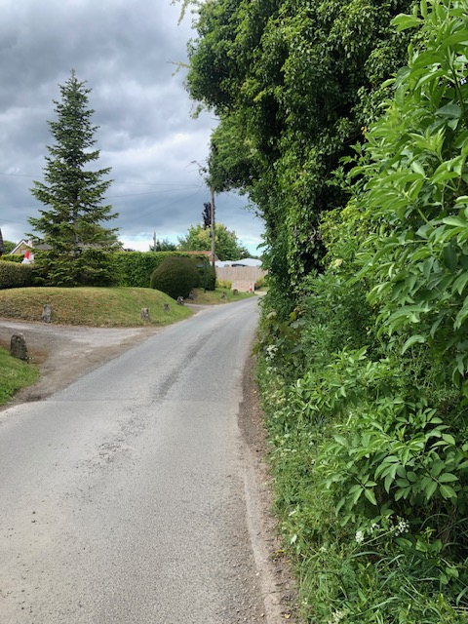
Christmas Cottage’s access is shown on the left hand side opposite where the proposed new access will be. As you can see the new access will be on the inside of a BLIND BEND
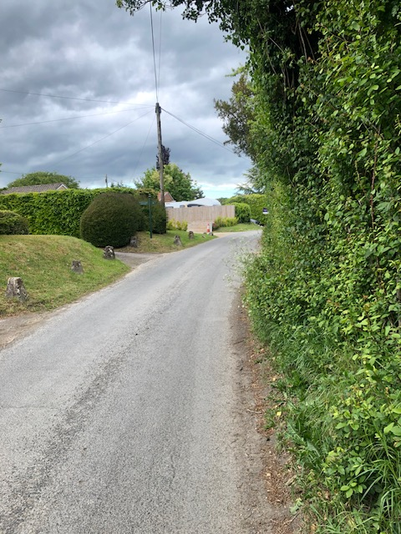
Same hedgerow but showing it slightly further up Park Lane
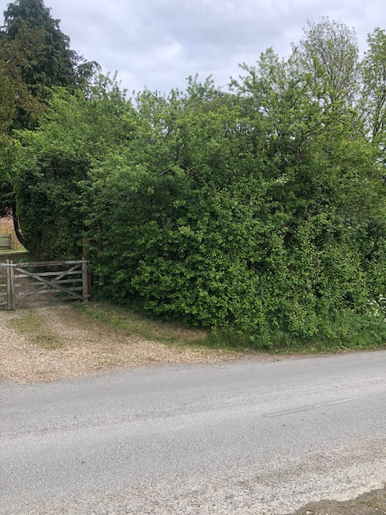
Showing the existing access to Tudor Cottage which is shared with the owner of the land adjacent to
Tudor Cottage. As you can see the hedgerow is now in full leaf and looks no different to the hedgerow the other side of the existing driveway which belongs to Tudor Cottage.
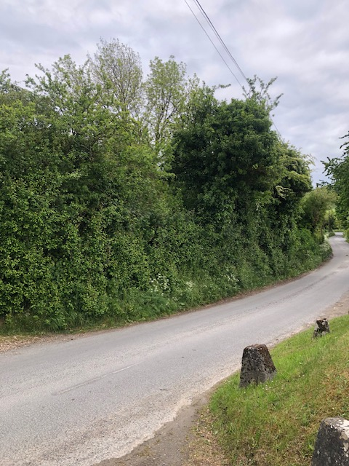
Showing a sharp blind bend where the proposed access would be, the new access would be only a few metres away from the existing shared driveway with Tudor Cottage. As you can see the hedgerow looks like any other rural hedging.
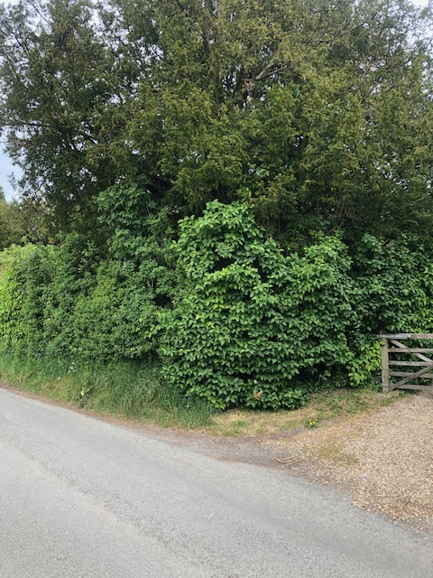
On the left hand side showing the hedgerow to Tudor Cottage.
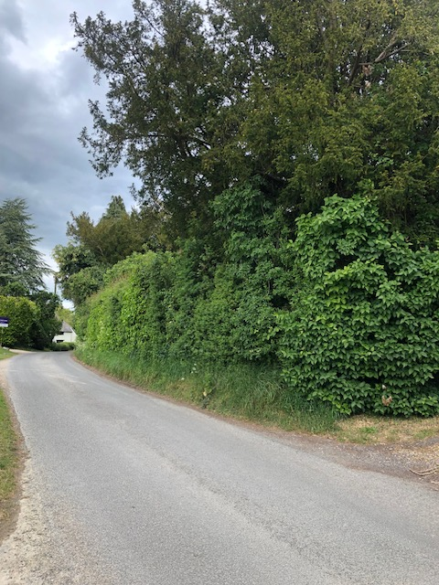
The hedgerow to the left of the existing driveway is no different to the applicant’s hedgerow to the right of the gateway.
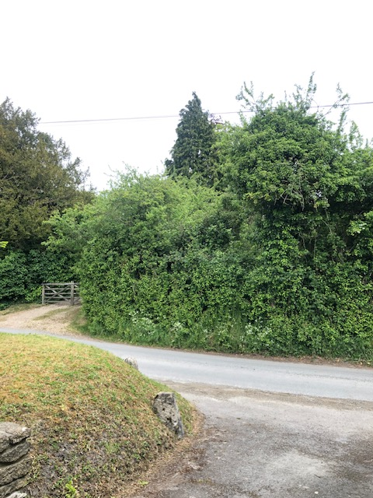
The driveway of Christmas Cottage which would be opposite any new access is shown at the bottom of the photo. The gateway on the left is the existing shared driveway.
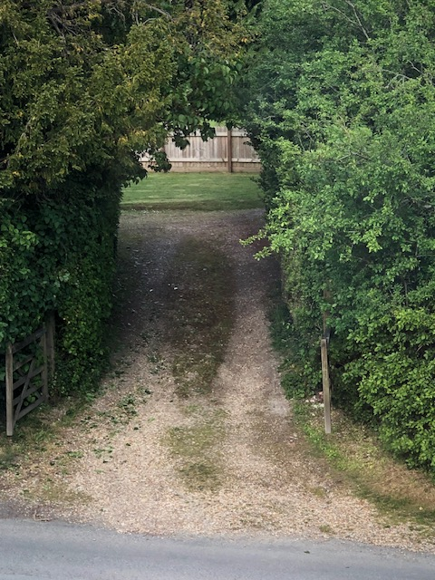
The existing shared driveway which belongs to Tudor Cottage is quite adequate for the applicant’s needs, especially now as the hedgerow has been trimmed back. Sometime ago, the applicant had a trial run with a cement lorry which appeared to have no problems getting to the site of the proposed house.

