

Design and Access Statement

Replacement Garage at Bibury, Lower Road, Erlestoke, Wiltshire, SN10 5UE
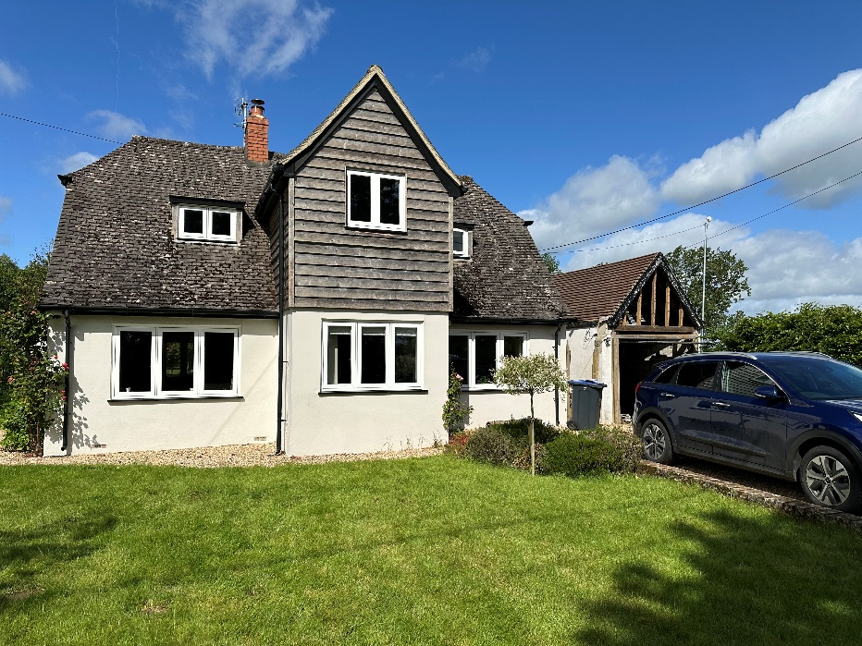

Prepared by:
Equestrian Blueprint
enquiries@equestrianblueprint.co.uk
https://equestrianblueprint.co.uk/
May 2025

Contents
1. Introduction 3
2. The Site 3
3. Existing Garage 3
4. Proposed Development 4
5. Design 4
6. Access and Parking 4
7. Ecology and Wildlife Considerations 5
8. Conclusion 5

1. Introduction
This statement has been prepared in support of a householder planning application for the replacement of an existing detached domestic garage at Bibury, Lower Road, Erlestoke, Wiltshire, SN10 5UE.
The proposal seeks to replace the existing dilapidated rendered blockwork garage with a modest timber clad garage positioned on the same footprint and serving the same incidental domestic function.
The proposal is domestic in scale and nature and relates solely to ancillary garaging and storage associated with the existing dwelling.

2. The Site
Bibury is a detached dwelling located on Lower Road, Erlestoke, within a rural setting characterised by detached dwellings, agricultural land and open countryside. The garage is positioned to the north of the dwelling adjacent to the existing gravel driveway.
The neighbouring land to the north comprises agricultural fields. The garage is well separated from neighbouring residential properties and is not materially overlooked. Access arrangements remain unchanged and continue to utilise the existing domestic driveway from Lower Road.
The site is not:
- a Listed Building;
- within a Conservation Area; or
- within a National Landscape / AONB.

3. Existing Garage
The existing garage comprises a small detached single garage constructed from rendered blockwork beneath a clay tiled roof with a live-edge timber clad front gable.
The structure is in a poor and deteriorating condition, with the roof covering and front cladding now removed. Internal inspection demonstrates that the building is lightweight, open and deteriorated in nature, with significant daylight penetration through the roof structure and no enclosed loft space or insulated voids.
The existing garage dimensions are:
- footprint: 2710 mm x 4460 mm
- eaves height: 2217 mm
- ridge height: 4150 mm

4. Proposed Development
The proposal is to replace the existing garage with a similarly scaled timber garage on the same footprint and in the same location.
The proposed garage dimensions are:
- footprint: 2700 mm x 4500 mm (4650mm including decorative front posts)
- eaves height: 2475 mm
- ridge height: 3225 mm
The replacement structure would incorporate:
- western red cedar cladding;
- eco slate roofing;
- oak frontage detailing;
- galvanised steel doors with timber inserts; and
- a small anthracite UPVC window.
The proposal remains purely incidental domestic garaging and storage with:
- no accommodation above;
- no plumbing;
- no heating; and
- no commercial use.
No additional external lighting is proposed.

5. Design
The proposal adopts a simple rural outbuilding appearance appropriate to its countryside context.
The scale and proportions remain modest and subordinate to the host dwelling. The use of timber cladding reflects the established character of the property, particularly the existing timber weatherboard features incorporated within the house itself.
Importantly, the proposal reduces the overall ridge height from approximately 4.15 m to 3.225 m, resulting in a visually lighter and less dominant structure than the existing garage.
The proposal therefore represents a visual enhancement over the existing deteriorating structure.

6. Access and Parking
Access arrangements remain unchanged and continue to utilise the established gravel driveway serving the dwelling.
No alterations are proposed to the vehicular access or parking arrangements.

7. Ecology and Wildlife Considerations
The applicants are keen conservationists and actively manage the site for wildlife enhancement. Existing ecological features within the property include:
- wildlife pond creation;
- wildflower meadow planting;
- pollinator-friendly planting;
- retained hedgerows;
- unmanaged wildlife areas; and
- pesticide-free gardening practices.
The dwelling has a known history of bats associated with purpose-built bat access features incorporated into the timber cladding of the main house. These features were created following ecological advice during earlier works to the dwelling.
The replacement garage proposal has been designed and undertaken with ecological sensitivity and is supported by a separate Bat Mitigation Statement.

8. Conclusion
The proposal represents a modest like-for-like replacement of an existing deteriorating domestic garage.
The replacement building:
- remains on the same footprint;
- reduces overall ridge height;
- improves the visual appearance of the site;
- retains the existing access arrangements;
- has no adverse neighbouring impacts; and
- appropriately considers ecological interests.
The proposal is therefore considered to represent an appropriate and proportionate form of domestic development within the site.

