APPLICATION FOR HOUSEHOLDER PLANNING PERMISSION
DELEGATED REPORT

APPLICATION REFERENCE: | PL/2026/02309
APPLICATION TYPE: | Householder planning permission
SITE ADDRESS: | Homestead, Durlett Road, Rowde, Devizes, SN10 1SX
DEVELOPMENT DESCRIPTION: | Garage conversion and rear extension for ancillary accommodation
RECOMMENDATION: | That Planning Permission be GRANTED

PROPOSAL

The proposal seeks planning permission for Garage conversion and rear extension for ancillary accommodation at Homestead, Durlett Road, Rowde, Devizes.

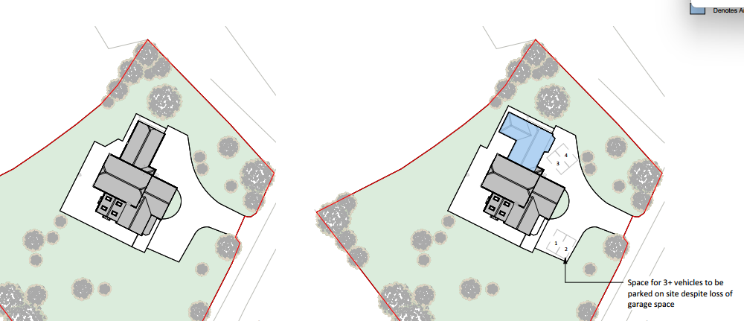

Existing and Proposed Site Plan

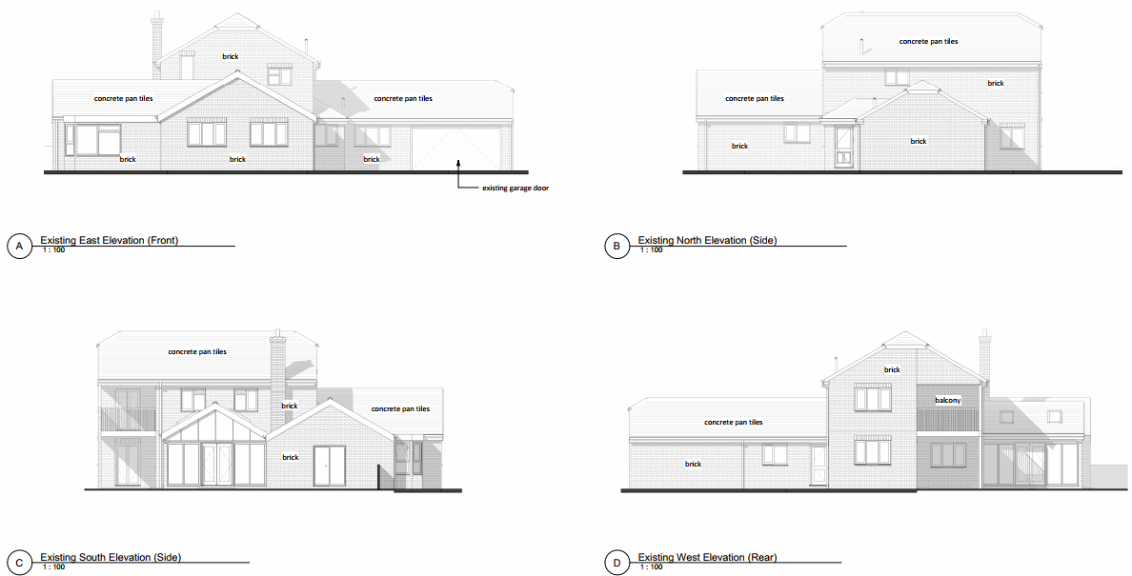

Existing Elevations

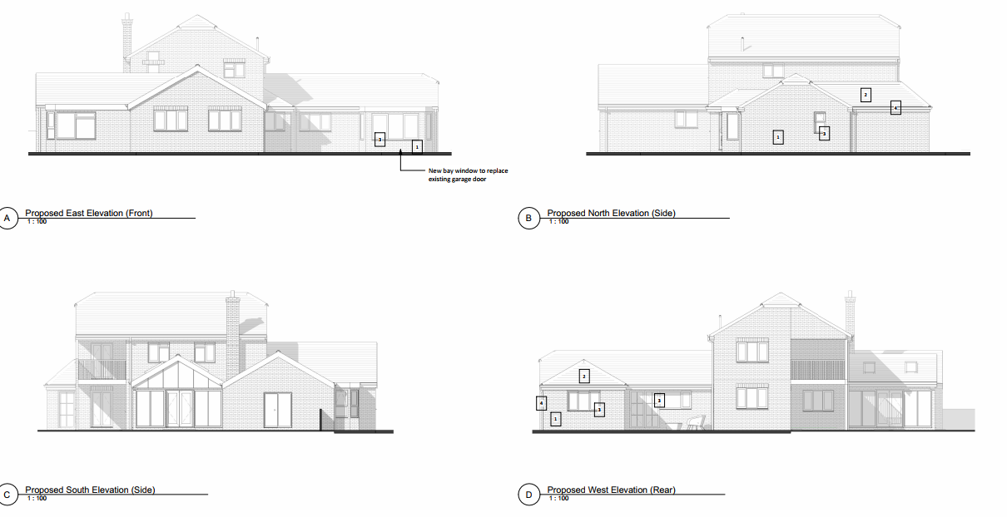

Proposed Elevations

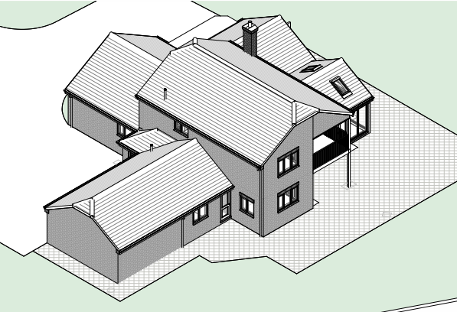

Existing Isometric view

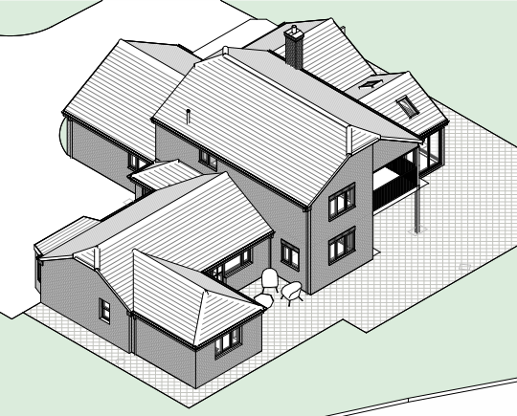

Proposed Isometric View

The proposal would convert the existing garage and extend it on the rear elevation to accommodate a one-bedroom annexe. A bay window would also be added on the front elevation of the converted garage.

The applicant has submitted internal photographs of the existing garage (which are on file) and a flood risk assessment (FRA) using the Council’s standard FRA Householder form.

SITE DESCRIPTION/CONTEXT

Homestead is a fairly large detached two storey dwelling with 4 separate single storey sections/extensions. It also sits in a reasonably large plot surrounded by open countryside. Adjacent to the site (and outside of the red outline) there is a building, but it does not have an address point. Planning application K/13830 gave permission for a change of use from agriculture to storage of building materials.

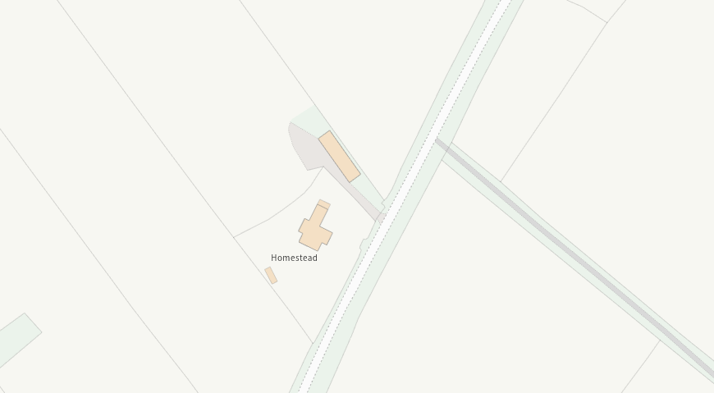

Wiltshire Council Mapping Image

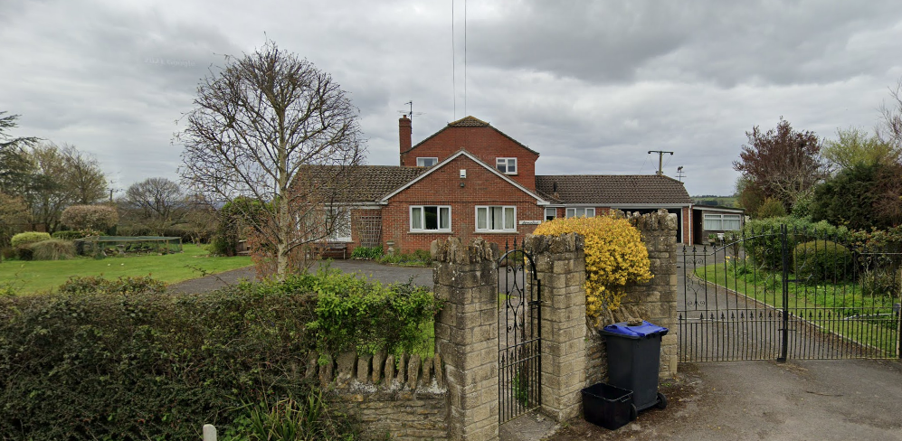

Google Street View April 2021 image

The site is not within a conservation area and there are no nearby listed buildings and there are no public rights of way that pass alongside the application site.

The application site is subject to the following planning policy constraints:

- LHS Core Roost Buffer
- The site is shown to be within two different ground water areas. The blue colour shows the zone to be of negligible risk from ground water whereas the orange is modelled to be within 0.025m and 0.5m of the surface (the second highest risk category). Over 75% of the application site is within this second highest risk category.

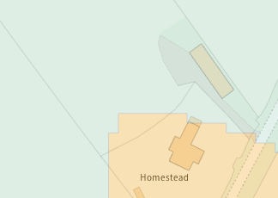

Image taken from Appendix G – Ground Water Levels

PLANNING HISTORY

There is no recent and relevant planning history. The history relates to applications for the extensions to the original building circa 1980-90.
RELEVANT POLICIES AND GUIDANCE

National Context:

The National Planning Policy Framework (NPPF)

The Planning Practice Guidance

Local Context:

Wiltshire Core Strategy:

- Core Policy 50: Biodiversity and Geodiversity
- Core Policy 57 Ensuring High Quality Design and Place Shaping
- Core Policy 67: Flood Risk

Rowde does not have a Neighbourhood Plan or Area Designation

Wiltshire Design Guide: Appendix D – Design Guidance for Householder extensions

CONSULTATION RESPONSES

Rowde Parish Council: No comments received

Wiltshire Council Ecology Officer: No objection

REPRESENTATIONS

The application has been advertised by site notice (erected on a telegraph pole opposite the site) and by neighbour notification letters.

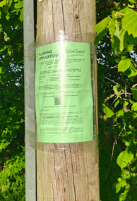

No comments were received.

ASSESSMENT

Section 38(6) of the Planning and Compulsory Purchase Act 2004 states:

"If regard is to be had to the development plan for the purposes of any determination to be made under the planning Acts, the determination must be made in accordance with the plan unless material considerations indicate otherwise."

In accordance with this statutory requirement, this application has been assessed against the relevant policies of the Development Plan, including the adopted Wiltshire Core Strategy (2015) and, where applicable, any made Neighbourhood Plans.

Principle of Development

The proposed development comprises an annexe ancillary to the host dwelling. Within the open countryside, new isolated dwellings would normally be contrary to the spatial strategy; however, accommodation that remains ancillary to the main dwelling is generally acceptable in principle where it does not form a separate planning unit.

In this case, the annexe is modest in scale, physically associated with the host dwelling, and would not result in the creation of a separate curtilage or independent access. Whilst it includes facilities typical of living accommodation, its siting and relationship to the main dwelling indicate that it would function as ancillary accommodation.

To ensure the development remains ancillary and does not form a separate unit of accommodation, a planning condition will be imposed restricting occupation and preventing separate sale or letting.

Subject to the aforementioned condition, the proposal is considered acceptable in principle having regard to Core Policy 57 of the Wiltshire Core Strategy.

Design and Impact upon the character and context of the area

Core Policy 57 - Ensuring High Quality Design and Place Shaping of the Wiltshire Core Strategy seeks to ensure that all new development is of high design quality, reflecting local context, character, and distinctiveness.

Homestead is a detached dwelling located in a reasonably isolated location with a single adjoining commercial storage building. Furthermore, the extension would be on the rear elevation behind the existing garage. The extension would be single storey, relatively small in relation to the host building and would cause no visual harm to the host building or with the character of the area.

Other works include the formation of a bay window to replace the existing garage door in the principal elevation. These works would result in the formation of a small flat roof addition to the principal elevation of the property. Given that the works amount to a bay window, and not an extension per se, it is considered that the window can be easily accommodated and would not result in any material planning harm in design terms.

Having regard to the above, the proposal complies with the design principles set out in Core Policy 57 of the Wiltshire Core Strategy and Appendix D of the Wiltshire Design Guide.

Amenity

Point vii of Core Policy 57 - Ensuring High Quality Design and Place Shaping of the Wiltshire Core Strategy seeks to ensure that developments do not adversely affect neighbouring properties.

The National Planning Policy Framework (NPPF), particularly Paragraph 135(f), stresses that planning decisions should ensure developments provide a high standard of amenity for existing and future users.

The proposed development has been assessed in terms of its potential impact on the residential amenity of neighbouring properties, with particular regard to loss of light, overshadowing, loss of privacy, and overbearing effects.

The proposal would not cause any harm to the adjacent use of the open countryside or the commercial storage building. There are no nearby neighbouring residential properties that stand to be impacted as a result of the proposed development, with the nearest properties sited at least 150m to the north-east.

The proposal therefore accords with Core Policy 57 point vii in respect of safeguarding residential amenity and Appendix D of the Wiltshire Design Guide.

Highways Impact

Core Policy 57 (xiv) of the Wiltshire Core Strategy seeks to ensure that development must meet the requirements of Core Policy 61. This policy requires proposals to be capable of being served by safe access to the highway network. Core Policy 64 seeks to ensure compliance with parking standards set out in the Local Transport Plan.

The National Planning Policy Framework (NPPF), particularly Paragraph 115 and 116, requires that development proposals do not have an unacceptable impact on highway safety and that safe and suitable access to the site can be achieved for all users.

The proposed development would not result in any adverse impact on highway safety. Adequate parking and turning provision is provided in accordance with Wiltshire’s adopted parking standards, and access arrangements are acceptable.

The proposal is therefore considered to comply with Core Policies 57 (xiv), 61 and 64 of the Wiltshire Core Strategy, the NPPF, and the Wiltshire Local Transport Plan.

Ecology Impact

Core Policy 50 of the Wiltshire Core Strategy seeks to protect and enhance biodiversity and geodiversity, including through ensuring that development avoids harm to protected species and habitats.

The National Planning Policy Framework (NPPF), in Paragraphs 193, requires that development minimises impacts on and provides net gains for biodiversity, including ensuring mitigation is secured where harm cannot be avoided.

The Council’s Ecology Officer has commented:

“It is concluded that including a bat informative is appropriate and proportionate approach for this application should you be minded to grant permission.

The site falls within a consultation zone of the Bath and BoA bat SAC therefore the LPA must give due consideration to this.

Therefore, a test of likely significance has been carried out by the relevant Competent Authority (Wiltshire Council) as required by Regulation 63 of the Conservation of Habitats and Species Regulations 2017 (as amended). This concluded that given the scale and nature of the development combined with the separation of between the core roost (associated with the SAC) and the application site, there is no mechanism for adverse effect. The HRA has concluded that the application is not likely to have significant impacts on the SAC and subsequently the application is screened out of Appropriate Assessment.”

As such, the development complies with Core Policy 50 of the Wiltshire Core Strategy and the relevant provisions of the NPPF.

Drainage and Flood Risk
The site lies within Flood Zone 1 and is therefore at low risk from fluvial flooding. However, the Council’s Strategic Flood Risk Assessment identifies the site as having an increased risk of groundwater flooding, and therefore the site cannot be considered wholly free from flood risk.
In accordance with paragraph 176 of the NPPF, householder development is exempt from the sequential and exception tests. However, as the site is identified in the SFRA as being at increased risk from other sources of flooding, a site-specific flood risk assessment is required and has been submitted.
The submitted Flood Risk Assessment identifies a precautionary approach, including setting finished floor levels at or above existing ground levels, use of flood resistant materials, and raising electrical services. Given the scale of development and its domestic nature, these measures are considered proportionate and appropriate.
Subject to securing these measures by condition, the development would be safe for its lifetime without increasing flood risk elsewhere, in accordance with Core Policy 67 of the Wiltshire Core Strategy and the NPPF.
Biodiversity Net Gain

Householder planning applications are exempt from the requirement to deliver Biodiversity Net Gain under Schedule 7A, Section 4(2)(a) of the Town and Country Planning Act 1990, as inserted by the Environment Act 2021.

CONCLUSION

The proposed development is considered to be acceptable in terms of its design, scale, and relationship with the surrounding area. It would not result in any unacceptable harm to the character of the locality, the amenities of neighbouring occupiers, or the interests of highway safety, flood risk, or ecology.

The proposal is therefore considered to comply with the relevant policies of the Wiltshire Core Strategy, the Wiltshire Local Plan, and the National Planning Policy Framework. As such, the application is recommended for approval, subject to the conditions set out below.

RECOMMENDATION: That Planning Permission be GRANTED subject to conditions.

