APPLICATION FOR HOUSEHOLDER PLANNING PERMISSION
DELEGATED REPORT

APPLICATION REFERENCE: | PL/2026/02381
APPLICATION TYPE: | Householder planning permission
SITE ADDRESS: | Great Thornham Farm, Trowbridge Road, Seend, Melksham, SN12 6PN
DEVELOPMENT DESCRIPTION: | Demolition of 1no. existing domestic curtilage outbuilding and lean-to shed. Extension and external alterations to farmhouse including new porch, terrace and veranda.
RECOMMENDATION: | That Planning Permission be GRANTED

PROPOSAL

The proposal seeks planning permission for Demolition of 1no. existing domestic curtilage outbuilding and lean-to shed. Extension and external alterations to farmhouse including new porch, terrace and veranda at Great Thornham Farm, Trowbridge Road, Seend, Melksham, SN12 6PN. The outbuilding to be demolished is used for domestic storage and is within what Officers would consider to be the existing residential curtilage of the farmhouse.

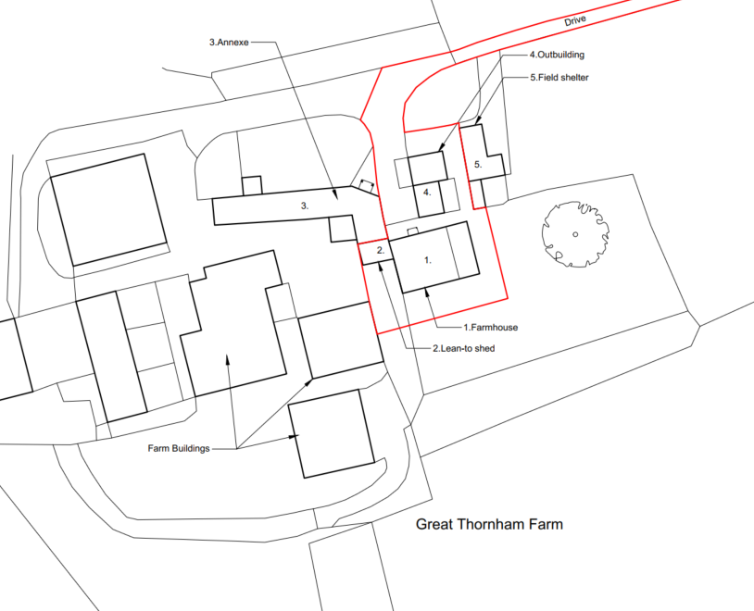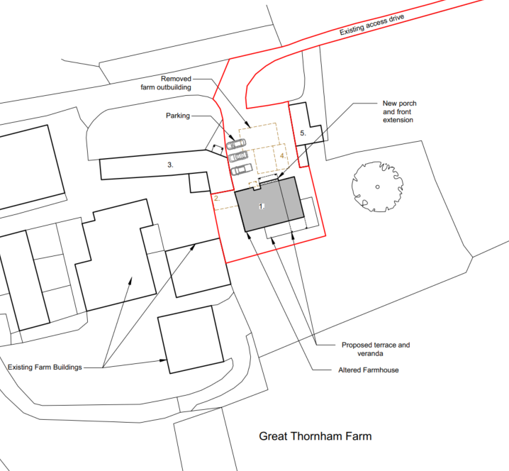

Existing and Propose Block Plan

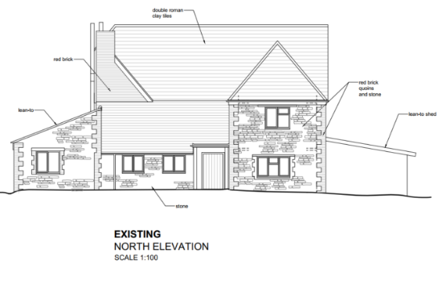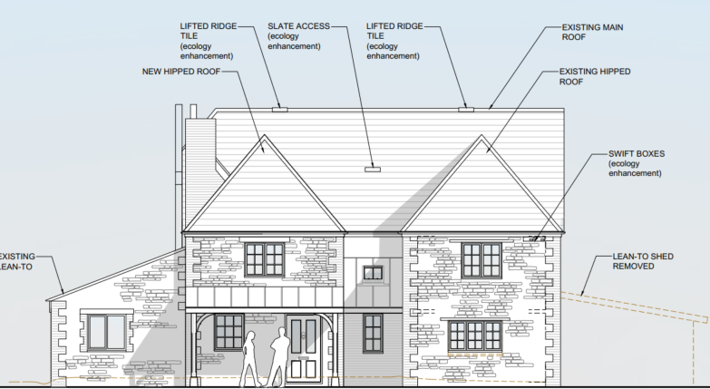

Existing and Proposed Front (North) Elevation Plan

The proposal would require the demolition of a detached outbuilding (stone built with tiled roof). Historic mapping shows great Thornham Farm (that farmhouse, the annex and outbuilding) to have been built between 1868-1899. The building is not listed nor within a conservation area. It is noted that footprint of the farmhouse is in line with the southern end of the ‘L’ shaped annex, meaning that the existing single and two storey sections on the farmhouse may be original features on the building.

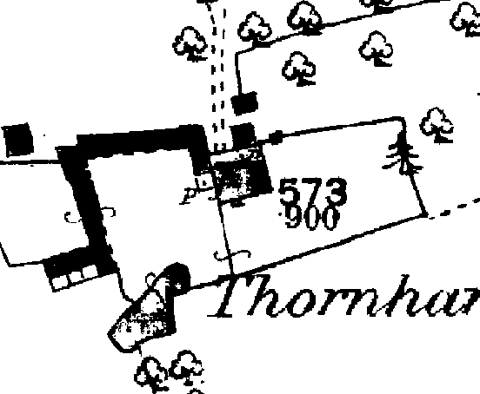

Historic Mapping Image from 1868-1899

The demolition would allow for a second two storey hipped roof extension on the front elevation and for the creation of a dedicated driveway.

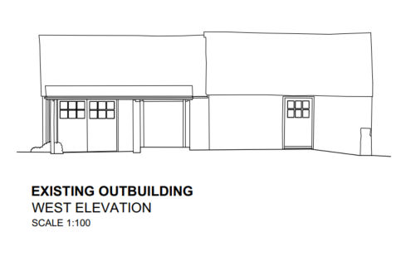

Existing Outbuilding to be demolished (stone built, tiled roof)

SITE DESCRIPTION/CONTEXT

Great Thornham Farm is a small farm complex located in the rural countryside with long countryside views in all directions. As such it is not visible from public roads but is from Public Right of Way SEEN37 which passes immediately in front of the farmhouse. The farmhouse is not currently being resided in with the applicants living in the adjacent annexe (which is within the blue outline of the application site and is within the same planning unit as the farmhouse). The farmhouse has a low head height front door and a number of low beams in the structure, which are quite unfit for modern living standards.

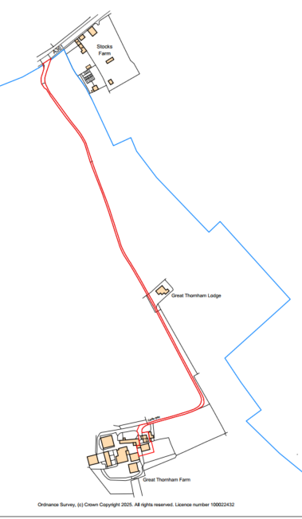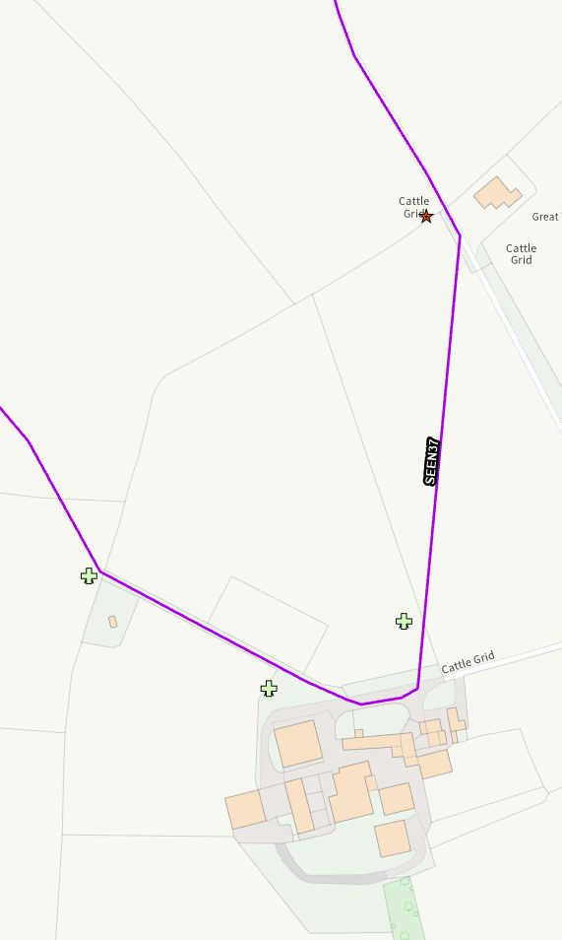

Site Location Plan and Council Mapping Image of the site showing the proximity of the Public Right of Way SEEN37

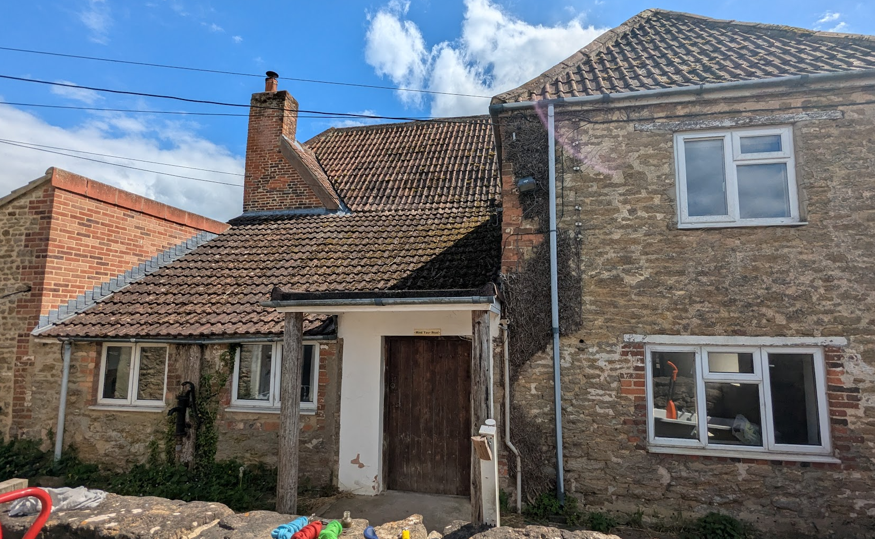

Photo of front (north) elevation

The application site is subject to the following planning policy constraints:

- 2km Core Roost Buffer – Seend Head Hill

The site is not a listed building, or conservation area. The site is not subject to ground water or surface water flood risk

PLANNING HISTORY

K/12368 - CONVERSION OF SHED AND GARAGE TO FORM BEDROOM ACCOMMODATION – Approved with conditions

RELEVANT POLICIES AND GUIDANCE

National Context:

The National Planning Policy Framework (NPPF)

The Planning Practice Guidance

Local Context:

Wiltshire Core Strategy:

- Core Policy 50: Biodiversity and Geodiversity
- Core Policy 57 Ensuring High Quality Design and Place Shaping
- Core Policy 58: Ensuring the Conservation of the Historic Environment

Seend Neighbourhood Plan 2021

Wiltshire Design Guide: Appendix D – Design Guidance for Householder extensions

CONSULTATION RESPONSES

Seend Parish Council: No objection

Wiltshire Council Ecology Officer: No objection subject to conditions

Wiltshire Council Public Rights of Way Officer: No objection

REPRESENTATIONS

The application was publicly advertised for 21 days with 4 neighbour notification letters being sent out as well as a site notice erected at the site entrance (by the A361).

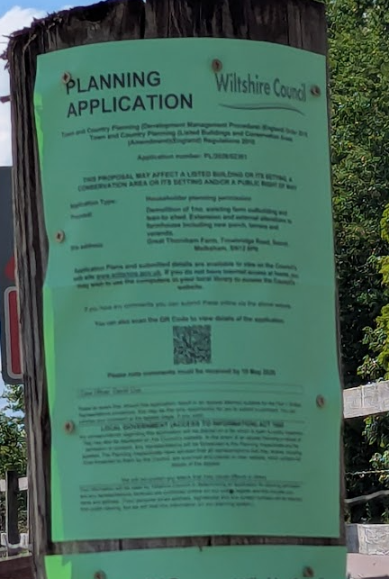

No comments were received.

ASSESSMENT

Section 38(6) of the Planning and Compulsory Purchase Act 2004 states:

"If regard is to be had to the development plan for the purposes of any determination to be made under the planning Acts, the determination must be made in accordance with the plan unless material considerations indicate otherwise."

In accordance with this statutory requirement, this application has been assessed against the relevant policies of the Development Plan, including the adopted Wiltshire Core Strategy (2015) and, where applicable, any made Neighbourhood Plans.

Design and Impact upon the character and context of the area

Core Policy 57 - Ensuring High Quality Design and Place Shaping of the Wiltshire Core Strategy seeks to ensure that all new development is of high design quality, reflecting local context, character, and distinctiveness.

The farmhouse is a 19th-century building. A visual inspection suggests that it has undergone numerous extensions and alterations over time, as illustrated in the photograph in the introduction. However, its overall footprint broadly corresponds with that shown on the 1868–1899 historic mapping.
The side lean-to additions, along with the single-storey front lean-to and two-storey sections, are likely later extensions to the original building, albeit constructed prior to 1899.

Despite this historic evolution, the host building now presents a convoluted, disjointed, and unbalanced appearance.

The proposed development seeks to remove one of the side lean-to sections and introduce a second front extension to the principal elevation. This would also obscure views of the remaining exposed side lean-to. Collectively, these changes would reduce the prominence of these disjointed elements and help to rebalance the overall form of the building.

There is a degree of risk that the alterations could result in a more modern appearance, diminishing the traditional farmhouse character. However, any such harm would be limited and mitigated through the use of appropriate matching materials. Furthermore, the traditional farmhouse character would be retained on the rear elevation.

Having regard to the above, the proposal complies with the design principles set out in Core Policy 57 of the Wiltshire Core Strategy and Appendix D of the Wiltshire Design Guide.

Amenity

Point vii of Core Policy 57 - Ensuring High Quality Design and Place Shaping of the Wiltshire Core Strategy seeks to ensure that developments do not adversely affect neighbouring properties.

The National Planning Policy Framework (NPPF), particularly Paragraph 135(f), stresses that planning decisions should ensure developments provide a high standard of amenity for existing and future users.

The proposed development has been assessed in terms of its potential impact on the residential amenity of neighbouring properties, with particular regard to loss of light, overshadowing, loss of privacy, and overbearing effects.

There are no nearby neighbours and therefore no harm would be caused to neighbouring amenity.

The proposed changes to the layout of the dwelling will provide improved living conditions for the future occupiers of the dwelling.

The proposal therefore accords with Core Policy 57 point vii in respect of safeguarding residential amenity and Appendix D of the Wiltshire Design Guide.

Ecology Impact

Core Policy 50 of the Wiltshire Core Strategy seeks to protect and enhance biodiversity and geodiversity, including through ensuring that development avoids harm to protected species and habitats.

The National Planning Policy Framework (NPPF), in Paragraphs 193, requires that development minimises impacts on and provides net gains for biodiversity, including ensuring mitigation is secured where harm cannot be avoided.

The Council’s Ecology Officer has stated:

“The application site is located within a lesser horseshoe bat consultation zone associated with the Bath & Bradford on Avon Bats Special Area of Conservation (SAC) and therefore has potential to result in significant adverse impact on the special features of that site. A test of likely significance has been carried out by the relevant Competent Authority (Wiltshire Council) as required by Regulation 63 of the Conservation of Habitats and Species Regulations 2017 (as amended). This concluded that given the scale and nature of the development, that no vegetation is prosed for removal and no horseshoe bats have been recorded roosting in buildings where impacts are proposed, there is no mechanism for adverse effects.

The HRA has concluded that the application is not likely to have significant impacts on the SAC and subsequently the application is screened out of Appropriate Assessment.”

Therefore, it is considered that the proposed development would not cause significant harm to biodiversity. No objections have been raised by the Council’s Ecologist.

As such, the development complies with Core Policy 50 of the Wiltshire Core Strategy and the relevant provisions of the NPPF.

Biodiversity Net Gain

Householder planning applications are exempt from the requirement to deliver Biodiversity Net Gain under Schedule 7A, Section 4(2)(a) of the Town and Country Planning Act 1990, as inserted by the Environment Act 2021.

CONCLUSION

The proposed development is considered to be acceptable in terms of its design, scale, and relationship with the surrounding area. It would not result in any unacceptable harm to the character of the locality, the amenities of neighbouring occupiers, or the interests of highway safety, heritage, or ecology.

The proposal is therefore considered to comply with the relevant policies of the Wiltshire Core Strategy, the Wiltshire Local Plan, and the National Planning Policy Framework. As such, the application is recommended for approval, subject to the conditions set out below.

RECOMMENDATION: That Planning Permission be GRANTED subject to conditions.

