APPLICATION FOR FULL PLANNING PERMISSION DELEGATED REPORT

APPLICATION REFERENCE: | PL/2026/01922
APPLICATION TYPE: | Full planning permission
SITE ADDRESS: | Snaggs Farm, East Knoyle, Salisbury, SP3 6AU
DEVELOPMENT DESCRIPTION: | Erect new detached barn (Barn B) over an area of existing concrete yard
RECOMMENDATION: | That Planning Permission be GRANTED

PROPOSAL

The proposal seeks planning permission for the erection of a new detached barn within an existing open area within an existing farm yard.

Proposed elevations, location plan and site plan included below.

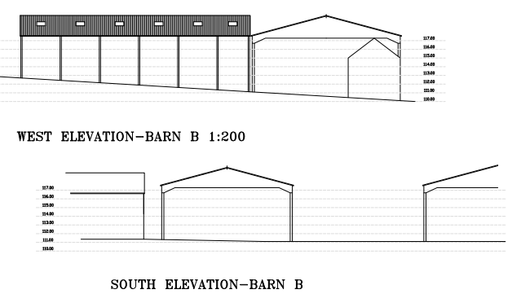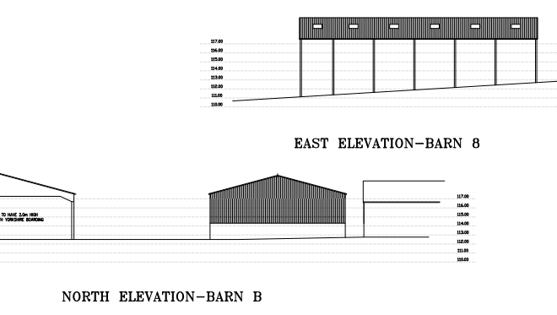

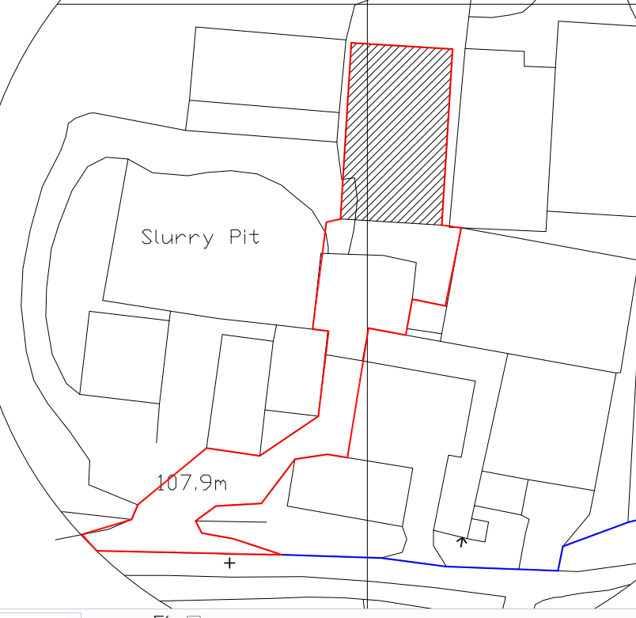

This application is one of three concurrent applications for new barns on the application site, these are labelled as barns A, B and C on the separate applications. This current application relates to barn B.

SITE DESCRIPTION/CONTEXT

The application site relates to an existing working dairy farm enterprise known as Snaggs Farm located in a fairly isolated rural location on the outskirts of East Knoyle. The site comprises a number of existing agricultural buildings and associated farm yard and fields.

The site is located within the Special Landscape Area but lies outside of the National Landscape which is shown on the map extract below as a light green wash edged in black.

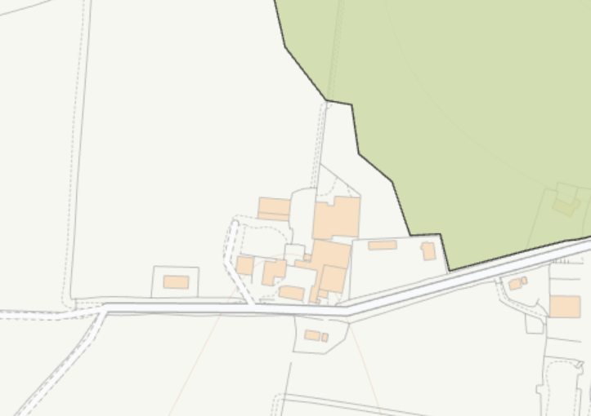

PLANNING HISTORY

Proposal / Summary
S/2000/0714 - Full planning permission Decision - Approve with Conditions Date: 26/6/2000 – erection of hay / straw / machinery barn
S/1998/0078 - Full planning permission Decision - Approve with Conditions Date: 29/4/1998 – erect a building over existing cattle yard (open concrete)
S/2009/0775 - Full planning permission Decision - Approve with Conditions Date: 23/7/2009 – alterations to existing calf rearing house
S/2009/0399 - Full planning permission Decision - Prior Approval Required Date: 15/4/2009 – application to determine whether prior approval of certain details is required for the erection of an agricultural storage barn and for alterations to an existing calf rearing house
PL/2026/01919– Erect new detached barn (Barn A) over an area of existing concrete yard to cover slurry/manure storage area. UNDER CONSIDERATION
PL/2026/01923 - Full planning permission – Demolition of existing barn and erect new detached barn (Barn C)- UNDER CONSIDERATION

RELEVANT POLICIES AND GUIDANCE

The National Planning Policy Framework (NPPF)
The Planning Practice Guidance
National Design Guide

Wiltshire Core Strategy:

Core Policy 1 Settlement Strategy
Core Policy 2 Delivery Strategy
Core Policy 17 Spatial Strategy for the Mere Community Area
Core Policy 50 Biodiversity and Geodiversity
Core Policy 51 Landscape
Core Policy 57 Ensuring High Quality Design & Space Shaping

Saved Policy C6 – Special Landscape Area

Wiltshire Design Guide:
Creating Places Design Guide
East Knoyle Village Design Statement

CONSULTATION RESPONSES

Parish Council: Support

Highways: No objection

REPRESENTATIONS

No comments were received.

ASSESSMENT

Section 38(6) of the Planning and Compulsory Purchase Act 2004 states:

"If regard is to be had to the development plan for the purposes of any determination to be made under the planning Acts, the determination must be made in accordance with the plan unless material considerations indicate otherwise."

In accordance with this statutory requirement, this application has been assessed against the relevant policies of the Development Plan, including the adopted Wiltshire Core Strategy (2015) and, where applicable, any made Neighbourhood Plans.

Principle

The site is located within the open countryside within an established farming unit where the principal of erecting agricultural buildings is considered acceptable providing proposals meet the requirements of Core Policies 51 and 57.

Design and Impact upon the character and context of the area including National Landscape

Core Policy 57 - Ensuring High Quality Design and Place Shaping of the Wiltshire Core Strategy seeks to ensure that all new development is of high design quality, reflecting local context, character, and distinctiveness.

The building is to be sited within an established farmyard context, surrounded by existing agricultural structures of a similar scale and function, and will therefore read as a natural extension of the existing group of buildings. The aerial photo shown below provides a good view of the character of the immediate farm locality with the yellow arrow showing the existing open yard (with cattle penned in) where the proposed barn B will be constructed.

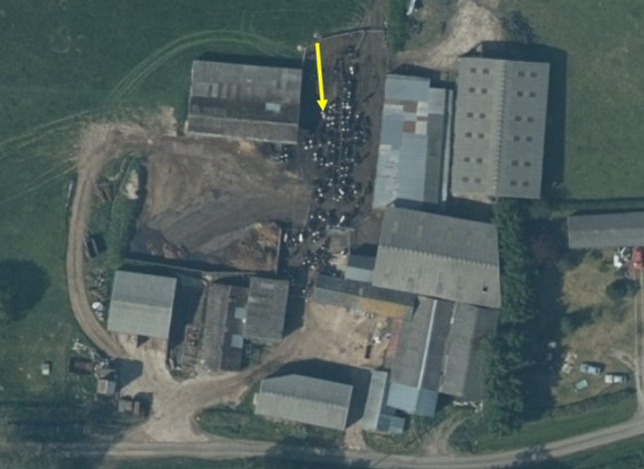

The design, scale and utilitarian appearance of the proposed barn are consistent with the operational requirements of the holding and reflect the prevailing agricultural character of the site. The development is therefore considered to conserve and reinforce the rural character of the area in accordance with Core Policy 57, whilst also supporting the ongoing operation and viability of the agricultural enterprise whilst having no adverse impact on the rural landscape in line with Core Policy 51 of the Wiltshire Core Strategy and saved policy C6 from Salisbury District Local Plan.

As previously mentioned, there are two other applications currently under consideration for barns A and C on Snaggs Farm, both these barns are also located within the existing farmyard and in close proximity to each other and barn B. The location of barns A and C are also shown on the aerial photo below for context, whilst the three barns have been submitted as separately there is the cumulative impact of two new barns and a replacement barn to consider. In this instance as all three barns are located within the existing yard, surrounded by and amongst other similar agricultural buildings they can be read as one unit and are not considered to have a cumulative adverse visual impact on the rural landscape and character of the area.

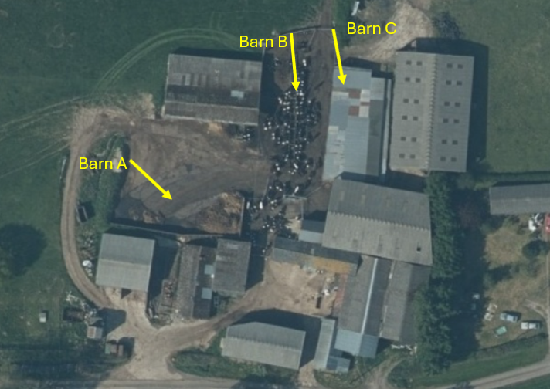

Amenity

Point vii of Core Policy 57 - Ensuring High Quality Design and Place Shaping of the Wiltshire Core Strategy seeks to ensure that developments do not adversely affect neighbouring properties.

The National Planning Policy Framework (NPPF), particularly Paragraph 135(f), stresses that planning decisions should ensure developments provide a high standard of amenity for existing and future users.

The proposed development has been assessed in terms of its potential impact on the residential amenity of neighbouring properties.

The site is in a fairly isolated rural location with sporadic residential dwellings in the locality. The application site has three nearby residential dwellings marked with a black dot on the map extract below. The location of barn B within the existing yard will be separated from the nearby dwellings by the existing barns on site, the location for barn B is to cover an existing open area within the yard where the cattle are kept at times in a pen.

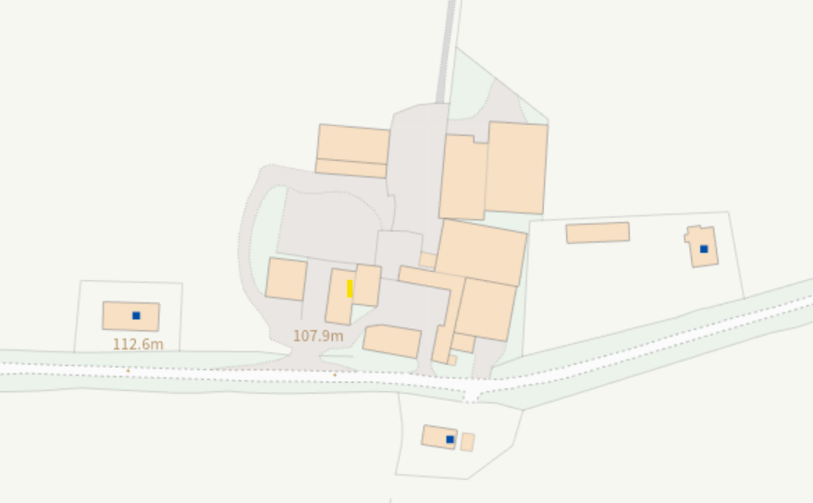

It is therefore not considered that barn B will have adverse amenity impacts given its siting within an established dairy farm within an existing farm yard and adjacent to a number of other existing agricultural buildings.

The proposal therefore accords with Core Policy 57 point vii in respect of safeguarding residential amenity and the relevant provision of the NPPF.

Biodiversity Net Gain

The effect of paragraph 13 of Schedule 7A to the Town and Country Planning Act 1990 is that planning permission granted for development of land in England is deemed to have been granted subject to the condition (biodiversity gain condition) that development may not begin unless:

(a) a Biodiversity Gain Plan has been submitted to the planning authority, and
(b) the planning authority has approved the plan.

The planning authority, for the purposes of determining whether to approve a Biodiversity Gain Plan, if one is required in respect of this permission would be Wiltshire Council. There are statutory exemptions and transitional arrangements which mean that the biodiversity gain condition does not always apply.

Based on the information available this permission is considered to be one which will not require the approval of a biodiversity gain plan before development is begun because prior to validation of the application, advice was sought from the Council’s ecologist to establish if a BNG metric was required as part of a formal submission. The pre-development baseline value is 0.0 with the pre-development baseline maps showing the land as developed at 0.0 value which aligns with aerial photos (and the case officers’ photos). The development therefore meets the de-minimis exemption.

CONCLUSION

The proposed development is considered to be acceptable in terms of its design, scale, and relationship with the surrounding area. It would not result in any unacceptable harm to the character of the locality or the amenities of neighbouring occupiers. The proposal is therefore considered to comply with the relevant policies of the Wiltshire Core Strategy, the Wiltshire Local Plan, and the National Planning Policy Framework. As such, the application is recommended for approval, subject to the conditions set out below.

RECOMMENDATION: That Planning Permission be GRANTED subject to conditions.

1. The development hereby permitted shall be begun before the expiration of three years from the date of this permission.

REASON: To comply with the provisions of Section 91 of the Town and Country Planning Act 1990 as amended by the Planning and Compulsory Purchase Act 2004.

2. The development hereby permitted shall be carried out in accordance with the following approved plans:

Application form received 21/04/2026
Location plan, existing block plan, sections Drg no 2731/2 received 30/03/2026
Proposed floor plan Drg no 2731/9 received 20/04/2026
Proposed elevations and roof plan Drg no 2731/10 received 20/04/2026
Location plan and proposed block plan Drg no 2731/11 received 20/04/2026

REASON: For the avoidance of doubt and in the interests of proper planning

Informative to Applicant

BNG does not apply

The effect of paragraph 13 of Schedule 7A to the Town and Country Planning Act 1990 is that planning permission granted for development of land in England is deemed to have been granted subject to the condition (biodiversity gain condition) that development may not begin unless:

(a) a Biodiversity Gain Plan has been submitted to the planning authority, and
(b) the planning authority has approved the plan.

The planning authority, for the purposes of determining whether to approve a Biodiversity Gain Plan, if one is required in respect of this permission would be Wiltshire Council.

There are statutory exemptions and transitional arrangements which mean that the biodiversity gain condition does not always apply.

Based on the information available this permission is considered to be one which will not require the approval of a biodiversity gain plan before development is begun because one or more of the statutory exemptions or transitional arrangements is considered to apply.

