APPLICATION FOR FULL-PLANNING PERMISSION
CASE OFFICER REPORT
APPLICATION REFERENCE: | PL/2025/08648
APPLICATION TYPE: | Approval of reserved matters
SITE ADDRESS: | Land North of Melksham Road, Holt
DEVELOPMENT DESCRIPTION: | Reserved Matters Application for appearance, landscaping, layout and scale for 55 Residential Dwellings following Outline Planning permission ref PL/2024/05435
RECOMMENDATION: | Approve with Conditions

Proposed development site and surroundings
Site location
The site measures approximately 3 hectares, sits to the East of Holt and encompasses an existing agricultural field which is roughly rectangular in shape. The site is approximately 3.01 hectares and has mature hedgerow and tree boundaries. The land is accessed via an existing field gate from the B3107 Melksham Road.

The site abuts existing residential properties to the West. To the East is an existing water pumping station operated by Wessex Water. The site sits on a slope with the Northern end being the highest. The southern part of the site borders the B34107 Melksham Road which links the large village of Holt with the Town of Melksham. To the South of the site is the recently approved housing development of 90 dwellings which was approved at an appeal.

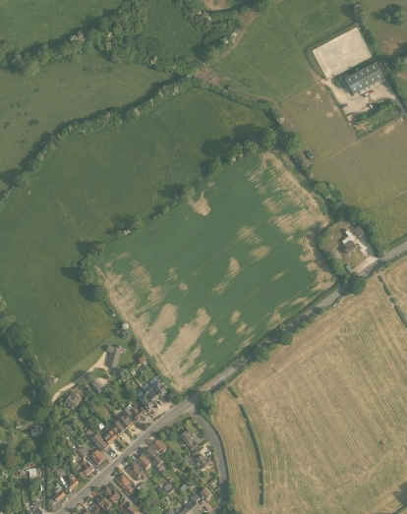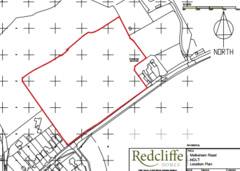

There are several underground pipes linked to the pumping station to the East which are predominantly located along the eastern boundary although there is one that cuts through the site from East to West.

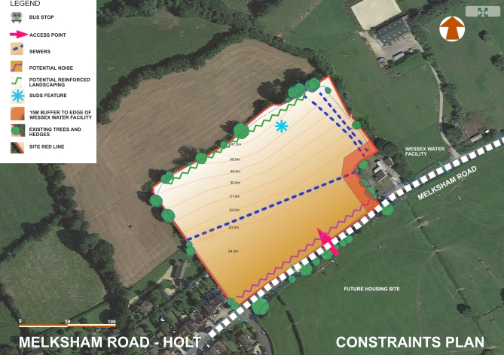

The Holt Conservation Area is located approximately 450 metres southwest of the site at its closest point which has a Grade II* listed Church and several Grade II listed buildings within it. The Broughton Gifford Conservation Area lies approximately 775 metres northeast of the site. A grade II Registered Park and Garden, Great Chalfield Manor lies approximately 850 metres to the Northwest of the site.

Proposal

This is a reserved matters application for appearance, landscaping, layout and scale for 55 Residential Dwellings (approximately 18 dwellings per hectare) following an approved Outline Planning permission ref PL/2024/05435 consisting of 2, 3, 4 bedrooms and single and two storey buildings.

The summary of accommodation is as follows:

Market Housing: 2 x 2 bed, 19 x 3 bed, 12 x 4 bed

Affordable Housing: 4 x 1 bed, 11 x 2 bed, 6 x 3 bed and 1 x 4 bed

The proposed layout is as follows:

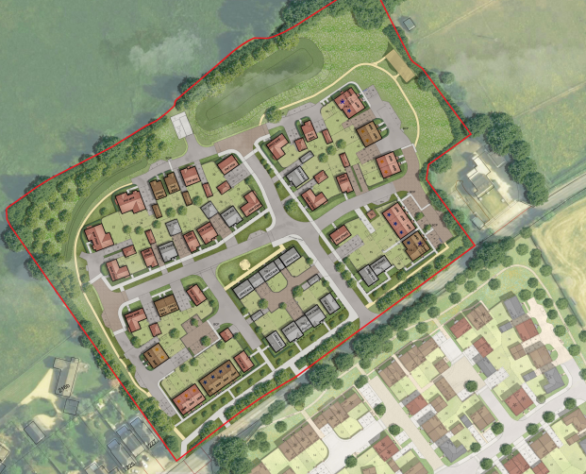

Relevant planning history

PL/2024/05435 - Outline planning permission: Some matters reserved Decision - Approve with Conditions Date: 17/10/2025 – Outline planning permission to provide up to 55 residential (Use Class C3) units with all matters reserved except for access

Relevant planning legislation, policies and guidance

National Planning Policy:
- National Planning Policy Framework (NPPF)
- Planning Practice Guidance (PPG)
- National Design Guide
Development Plan:
For the purposes of housing development, the development plan for Wiltshire comprises the Wiltshire Core Strategy (WCS) (adopted January 2015), any made neighbourhood plans, together with the Wiltshire Housing Site Allocations Plan, the Chippenham Site Allocations Plan. These remain the principal statutory planning document guiding development across the county.

In line with Section 38(6) of the Planning and Compulsory Purchase Act 2004, planning decisions must be made in accordance with the development plan unless material considerations indicate otherwise. Though the development plan is considered as a whole, those parts deemed to be particularly relevant to this application are listed below:

The adopted Wiltshire Core Strategy (WCS), with particular regard to :
- Core Policy 1 Settlement Strategy;
- Core Policy 2 Delivery Strategy;
- Core Policy 3 Infrastructure Requirements;
- Core Policy 7 Spatial Strategy Bradford On Avon
- Core Policy 41/42 Sustainable Construction and Low-Carbon Energy;
- Core Policy 43 Providing Affordable Homes
- Core Policy 45 Meeting Wiltshire’s Housing Needs;
- Core Policy 46 Meeting the Needs of Wiltshire’s Vulnerable and Older People;
- Core Policy 50 Biodiversity and Geodiversity;
- Core Policy 51 Landscape
- Core Policy 52 Green Infrastructure
- Core Policy 56 Contaminated Land;
- Core Policy 57 Ensuring High Quality Design and Place Shaping;
- Core Policy 58 Ensuring the Conservation of the Historic Environment;
- Core Policy 60 Sustainable Transport;
- Core Policy 61 Transport & Development;
- Core Policy 64 Demand Management
- Core Policy 67 Flood Risk;

Appendix D of WCS – Relevant Saved Policies
Saved Policies from the West Wiltshire District Local Plan (1st Alteration):
U1a - Foul Water Disposal, U2 - Surface Water Disposal, I1 – Implementation

Neighbourhood Plan: Holt Neighbourhood Plan Adopted 2017

Given that the principle of residential development on the site has been established by the outline permission, the Holt Neighbourhood Plan is applied insofar as its policies are relevant to the assessment of reserved matters such as design, landscaping, amenity and infrastructure. These matters are considered in detail below.

Supplementary Planning Documents/Guidance:

- Wiltshire Design Guide (adopted April 2024)
- LTN1/20 – Cycle Infrastructure Design (July 2020)
- Wiltshire Council Waste Collection Guidance for New Development
- Wiltshire Landscape Character Assessment
- Wiltshire Local Transport Plan 2011-2026, adopted 2015 - including the Car Parking Strategy and Cycling Strategy, adopted 2015

Summary of consultation responses

WC Arboricultural Officer: No objection subject to conditions

WC Archaeology: No objection

WC Highways: No objection

WC Open Space: No objection

WC Public Protection: No objection subject to conditions

WC Landscape: No objection

WC Ecology: No objection subject to conditions

WC Urban Design: No objection

WC Drainage: No objection

WC Public Rights of Way: No objection

WC Affordable Housing: No objection

WC Education: No objection

WC Waste and recycling: No objection

Environment Agency: This application does not fall within the criteria set out in our External Consultation Checklist which defines the planning applications we should be consulted on. We therefore consider we should not be consulted, and we will not be providing any comments on this proposal.

Natural England: No objection

Salisbury and Wilton Swifts: The submitted documents do not show the required bird nesting provision previously requested

Summary of representations

Holt Parish Council: Acknowledge that some amendments have been made but they do not resolve some fundamental issues.
- Pre-app was for 40 dwellings, this proposal has been driven by the retention of 55 dwellings rather than the sites constraints
- Visitor parking near plots 47-52 have been removed which will place pressure on parking locally due to the one 1-bed maisonettes.
- LAP is better reflected but it is located within constrained area around the Wessex water main crossing which is contrary to Wessex Water advice
- The 30mph limit should be introduced when the reserved matters application is agreed. Without early implementation the development would introduce additional vehicle movements and pedestrian activity in a 50mph area that would not be safe
- No EV charging as required by Condition 6
- Only 8 visitor spaces have been provided instead of the 11 required and it is not evenly distributed across the site
- The village green should not be shared with vehicle parking
- There is no clarity that the bird/bat boxes and hedgehog access gaps will be provided
- The delivery and ongoing management of the landscape scheme will be critical to ensuring the development integrates successfully
- There is a potential connection shown beyond the site boundary that has no place in this submission and only acts as a gateway into open countryside
- The Bewley Homes site opposite reduced their overall number of dwellings to achieve a more balanced site – the same should be happening here to make the development policy compliant.

Councillor Carbin: Withdrawn the call in for the application to go to committee following confirmation that 11 visitor parking spaces will be provided and that garages cannot be converted into habitable accommodation.

Third party comments: 3 letters from third parties have been received. Their comments are summarised below:

Impact on highways safety and parking
- Object to a future access sketch
- Access is not safe as it is on a blind bend
- Already too much traffic entering the village causing damage to roads
- The road is too narrow and there is too much congestion
- Cars are parked on the pavements so pushchairs cant get through
- Increase in pollution

Impacts on ecology of area
- Street lighting will have an adverse impact on many nocturnal creatures
- Loss of wildlife

Flooding and drainage issues
- The land is waterlogged most of the year due to saturated clay
- It will be unacceptable for excessive water to flood nearby land and brook

Other
- Not viable
- Vibration from heavy traffic causing problems to houses
- Holt is a country village – not Melksham
- Not enough infrastructure in Holt to serve hundreds of more people

Planning considerations

In accordance with Section 70 (2) of the Town and Country Planning Act 1990, Section 38(6) of the Planning and Compulsory Purchase Act 2004 states:

"If regard is to be had to the development plan for the purposes of any determination to be made under the planning Acts, the determination must be made in accordance with the plan unless material considerations indicate otherwise."

In accordance with this statutory requirement, this application has been assessed against the relevant policies of the Development Plan, including the Wiltshire Core Strategy (2015) and, where applicable, any relevant made, or emerging, Neighbourhood Plans. Consideration has also been given to the policies of the National Planning Policy Framework (NPPF) as a material consideration in the assessment.

Key issues

The main issues that need to be addressed in this case include:

- Principle, policy, any development history of site
- Design and visual impact
- Amenity impacts
- Impact on historic environment/landscape, heritage assets
- Landscape impact
- Impact on parking and highway safety, including if there is sufficient parking for the proposed development
- Drainage and Flood risk
- Impacts on protected species or habitats
- Any other planning issues

Principle of development, policy and planning history

The site falls outside of the limits of development and has not been brought forward through either a Neighbourhood Plan or through an allocation in a development plan document for the area and as such the proposal does not comply with the requirements of Core Policies 1, 2 and 7 of the WCS as well as Neighbourhood Plan Objective 3 and Policy H3.1.

However, under application reference number PL/2024/05435 the tilted balance of paragraph 11 (d) of the NPPF was used and outline planning permission was granted at the Strategic Planning Committee of 15th April 2025. Following the completion of the associated S106 Legal Agreement the application was issued on 17th October 2025.

Summary

Given the planning history of the site, the principle of dwellings on this site has already been approved and as such there is no objection raised regarding principle when assessing this reserved matters application.

The outline application required a housing mix strategy to be included with the reserved matters application which has been submitted and achieves the Affordable Housing requirements/needs of the area and provides a good mix of 2, 3, 4 bed market housing units.

Design and impact on the character and appearance of the area

Policy Context

The National Planning Policy Framework (NPPF), particularly Chapter 12: Achieving well-designed places, stresses the importance of good design in development proposals. Paragraph 135 of the NPPF indicates that planning policies and decisions should ensure that developments are visually attractive, functionally effective, and contribute to the overall quality of the built environment, and result in healthy communities. Good design should be an integral part of the planning process and should ensure that developments complement their surroundings. The National Design Guide also builds on these aims.

Wiltshire Core Strategy Core Policy 57: Ensuring High Quality Design emphasises that all new developments, must demonstrate a high standard of design that enhances the local character of Wiltshire. Major developments should include detailed design statements that reflect the local context. The adopted Wiltshire Design Guide expands on policy CP57, and provides a framework to ensure that development is sensitive to the distinctive character of Wiltshire’s built and natural environment.

HNP policy H2.1 requires all development to demonstrate good quality design and make generous provision for open green spaces which are accessible to the public. It must respect the character and appearance of the surrounding area. Development that fails to take the opportunities available for enhancing the local character and quality of the area and the way it functions shall not be permitted. All new development will:
a) be built from good quality materials sympathetic to the local style;
b) be of a scale and size to fit with existing housing (as opposed to commercial buildings) within the village;
c) be well-spaced and landscaped and include gardens;
d) be sustainable and incorporate appropriate green technologies;

HNP policy E1 states that proposals for new development will be supported provided they create open green spaces and safe play areas, where appropriate; preserve and/or replace existing trees and hedges as far as possible; plant new trees on green spaces and play areas, where appropriate; create cycleways and pedestrian friendly routes, where appropriate; and support green energy.

Assessment

In terms of character the immediate area is characterised by a mix of single storey, two storey and two ½ storey dwellings which are terraced, semi-detached and detached. The materials see a mix of stone, render, red brick, under grey, red and brown roofs.

The proposal provides the following mix (55 dwellings with 40% affordable housing) which complies with the requirements of the Councils Affordable Housing Officer:
Open Market (33 units): 2 x 2bed, 19 x 3bed, 12 x 4bed
Social Rent (13 units): 4 x 1 bed 2 person maisonette, 5 x 2bed 4 person, 3 x 3bed 5 person, 1x 4 bed 7 person
Shared Ownership (9 units): 6 x 2bed 3person, 3 x 3bed 5 person

The affordable housing is located in two parts of the site (south-east and west) and the Councils Affordable Housing Officer has confirmed that the proposed mix reflects current local demonstrable need and that the locations are acceptable. The location of the affordable housing is shown as follows:

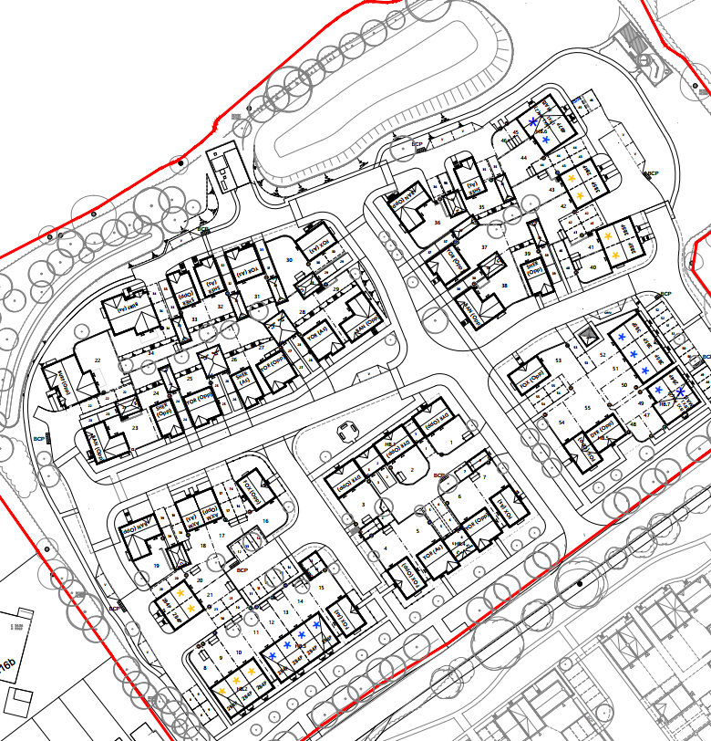

The proposed density would be approximately 18 dwellings per hectare which is considered to be acceptable to the immediate area and given its rural edge location.

The proposal sees single storey with the majority being two storey dwellings that are to be built with rendered walls, natural stone, recon stone, red brick, cream windows, black upvc fascias and rainwater goods under red/grey or brown roof tiles. Traditional brick bond patterns and stone quoins have been incorporated to ensure there is a nod to the local character. The proposed materials are considered to be appropriate especially as they are similar to the materials that have been approved on the opposite site (Bewley Homes) which saw recon stone in natural light, recon stone golden buff, red brick, roughcast off-white render, dark timber boarding, grey, brown and red tiles.

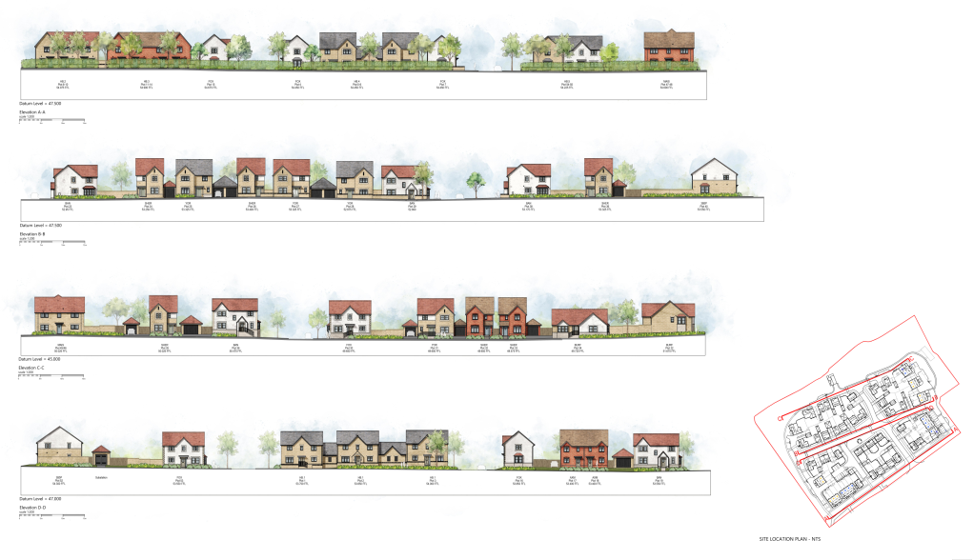

The existing hedgerows are to be retained and enhanced particularly along Melksham Road with additional trees being planted along this road-side behind the existing hedge. Tree-lined streets with grass verges from part of the primary road network and planting uses native and locally appropriate species with rain garden being used across the verge areas. Small green spaces are included alongside a central green space which includes a large specimen tree to establish a strong entrance focal point.

The proposal sees a cul-de-sac design which are further liked by surfaced pedestrian/cycle paths which ensure that all streets are connected and corner elevations have well-proportioned windows that complement the house and enhance visual interest whilst also offering natural surveillance through an active frontage.

The Council’s Urban Design officer is of the opinion that the proposal would comply with the requirements of Building for a Healthy Life, CP57 and the Wiltshire Design Guide as the internal streets are well connected, the proposal retain and strengthen existing boundary vegetation trough additional tree and shrub planting which also enhances the site ecological and visual character. The proposal successfully integrates the water main/easements by providing a central green corridor that provides a focal point and enhances connectivity whilst also introducing a landscaped village street character using native planting and traditional boundary treatments. The building designs use the local vernacular through stone detailing, varied rooflines and proportionate window arrangements.

Summary

The proposal is considered to achieve the aims of the NPPF, National Design Guide, Wiltshire Design Guide and Development Plan design policies

Climate change and sustainable design features

Chapter 14 of the NPPF, paragraphs 161 - 169 deals with climate change related matters. In particular, paragraph 163 indicates that proposals should take into account the full range of potential climate change impacts, and paragraph 164 stipulates that new development should avoid vulnerability to the range of impacts, and help to reduce greenhouse gas emissions. In determining applications, paragraph 169 indicates that new development should comply with any development plan policies for decentralised energy supply, and the layout of the development and the buildings should minimise energy consumption. Adopted policies CP41 & 42 of the WCS deal with these matters.

The HNP has 2 relevant policies which are as follows:
Policy EN.1: The installation of renewable energy projects and energy efficiency measures on existing housing stock will be supported, provided they do not adversely impact on the character or appearance of the built environment within the village.
Policy EN.2: Proposals for renewable and low carbon energy generation will be supported provided that they have an acceptable visual impact on the immediate locality and the wider area and have an acceptable effect on the living conditions of nearby residents, or that any other harmful impact can be satisfactorily mitigated.

Condition 6 of the outline application required an up-to-date Sustainable Energy Strategy to be submitted with the application.

Assessment
The application has been submitted with an up-to-date Energy Statement which demonstrates the proposed dwellings are to be built with energy efficient building fabric and insulation to all heat loss floors, walls and roofs alongside high performing glazing. Low-energy lighting is to be installed alongside water-efficient fixtures and fitting to minimise water demands to achieve a water consumption rate of 110 litres per person per day. Intermittent extract fans alongside individual air source heat pumps are also to be installed for each property and space heating controls. An additional plan demonstrating EV charging points across the site has been submitted.

Summary
The proposal is therefore considered to accord with the national and local planning policy aims (CP41) regarding sustainable development.

Impact on Heritage Assets

Policy Context

The main statutory tests are set out within the Planning (Listed Building and Conservation Areas) Act 1990. Section 16 (Listed Building Consent)/Section 66 (Planning Permission) requires that special regard be given to the desirability of preserving listed buildings, their settings or any features of special architectural or historic interest which they possess. Section 72(1) of the Act requires the Council to pay special attention to the desirability of preserving or enhancing the character or appearance of designated Conservation Areas.

Chapter 16 of the NPPF 'Conserving and enhancing the historic environment' sets out the Government's high-level policies concerning heritage and sustainable development. In particular:

Paragraphs 212 of the NPPF requires “great weight” to be given to an asset’s conservation “irrespective of whether any potential harm amounts to substantial harm, total loss or less than substantial harm to its significance. Paragraph 213 advises that harm to the significance of a designated heritage asset should require “clear and convincing justification”.

Paragraph 208 requires LPAs should “avoid or minimise any conflict” between the heritage asset’s conservation (which includes achieving its optimum viable use) and any aspect of a proposal. Paragraph 210 requires local planning authorities should take account of the desirability of sustaining and enhancing the significance of heritage assets and putting them to viable new uses and of new development making a positive contribution to local character and distinctiveness.

Paragraph 220 advises that not all elements of a Conservation Area or World Heritage Site will necessarily contribute to its significance. Loss of a building (or other element) which makes a positive contribution to the significance of the Conservation Area or World Heritage Site should be treated either as substantial harm or less than substantial harm as appropriate.

The Planning Practice Guidance provides guidance on interpreting the NPPF.

WCS CP 57 relates to design matters, and indicates that a proposal should respond to the value of the natural and historic environment and be sympathetic to and conserving historic buildings and landscapes. WCS CP58 indicates that the conservation of the historic environment’ requires that designated and non-designated heritage assets and their settings will be conserved, and where appropriate enhanced, in a manner appropriate to their significance and encourages proposals which improve the condition of heritage assets at risk.

Assessment & Conclusion

The proposed development lies approximately 630 metres west of Holt Conservation Area. Within this Conservation Area there are also a number of Grade II, Grade II* Listed Buildings. Ozen Leaze Farmhouse which is Grade II Listed lies to the southeast approximately 310 metres away.

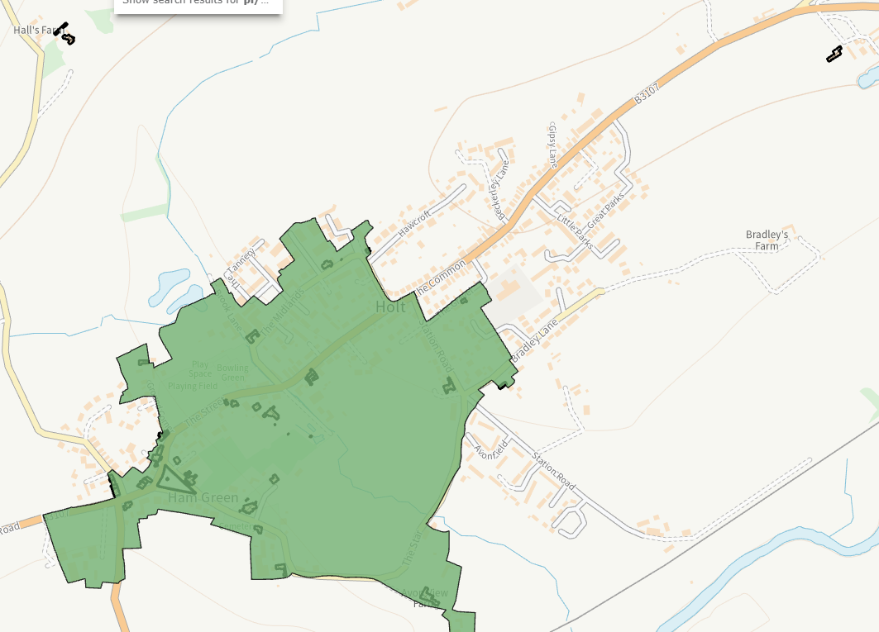

Given the distances between the proposed site and the heritage assets it was considered at outline planning stage that the proposal would have a neutral impact and would not harm their settings and as such would comply with the relevant policies noted above. The reserved matters application would not change this opinion.

The Council’s Archaeologist has made no objections to the application which saw a geophysical survey submitted at the outline stage.

Summary

The proposal therefore accords with the aims of the NPPF and policy CP58 of the WCS.

Landscape and Visual Impact

Policy Context

Core Policy 51 of the Wiltshire Core Strategy (WCS) requires that development protects, conserves, and where possible enhances the character and quality of Wiltshire’s landscapes. In line with the NPPF and PPG, particular weight is given to proposals that may affect National Landscapes (formerly Areas of Outstanding Natural Beauty), locally valued landscapes, and the sensitive edges of settlements. WCS Policy CP57 and the adopted Wiltshire Design Guide SPD (2024) provides further guidance on integrating development into the landscape. The Council’s Green & Blue Infrastructure Strategy (2022–2030) also supports the protection and enhancement of landscape character.

Policy E.1 of the HNP ensures significant new development is well-designed, sustainable and reinforces Holts village character and delivers maximum positive outcomes for the environment. It continues at E.1: Proposals for new development will be supported provided they:
• create open green spaces and safe play areas, where appropriate
• preserve and/or replace existing trees and hedges as far as possible
• plant new trees on green spaces and play areas, where appropriate
• create cycleways and pedestrian friendly routes, where appropriate and
• support green energy.

Assessment
The site sits in the Malmesbury-Corsham Limestone Lowland (16A) of the Wiltshire Landscape Character assessment and the Broughton Gifford Limestone Lowland (A3) of the West Wilts Landscape Character Area. The Wiltshire LCA (1:50,000) notes the area as being of good condition, moderate strength of character, with a strategy to conserve and strengthen. The more detailed West Wilts LCA (1:25,000) notes inherent landscape sensitivities as:
• Peaceful, rural nature of the area.
• The extensive views.
• Landscape setting, vernacular character and small scale of the villages.
• Areas of ecological value including ancient woodland copses.
• The remaining traditional field pattern
The site sits outside the settlement boundary of Holt and does not sit within any designated landscape such as Special Landscape Area, National Landscape and is outside of the nearby Bristol and Bath Greenbelt. The existing topography falls from south to north.

The submitted landscaping scheme follows on from the outline consent and sees a tree lined border to the front of the site with dwellings being stepped back away from the road. The majority of the new trees are proposed along the northern and western boundary (which face onto existing dwellings). A community orchard is located to the North East of the site and an area of green space has been provided in the centre of the site with appropriate seating. The existing hedge that fronts the site with the main road is to be translocated slightly north to accommodate the necessary visibility splays. This was agreed at outline planning stage.

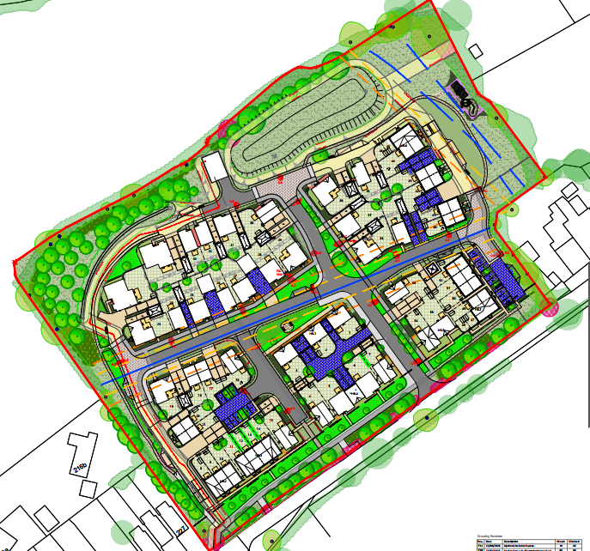

An Arboricultural Impact Assessment and Arboricultural Method Statement were submitted with the application that demonstrate the vegetation clearance required and also how existing vegetation that will remain will be protected by the construction period. The Councils Arboriculturalist has raised no objections to these statements subject to conditioning the submitted reports. However, these reports will be submitted to discharge condition 12 on the outline consent and as such it is not necessary to condition them at this stage.

Holt Parish Council have stated that the delivery and ongoing management of the landscape scheme will be critical to ensuring that the development integrates successfully with this sensitive rural edge. There is a condition on the outline application (condition 17) that will ensure the hard and soft landscaping is carried out in a timely manner. A landscape masterplan and landscape strategy have been submitted with this application which the Councils Landscape Officer has made no objection to. A condition was attached to the outline application to ensure that the soft landscaping is carried out in the first planting season following the first occupation of an approved dwelling. Hard landscaping was conditioned to be carried out prior to the first occupation. This outline condition is considered to be sufficient to ensure that the landscaping is carried out.

A Local Area of Play (LAP) has been provided to the eastern side of the site and includes a double swing, stepping logs, a balance trail and a mini tunnel which has been supported by the Councils Play Officer. Holt Parish Council were concerned that this is located on a Wessex Water easement, however the Applicant has confirmed that this can be carried out by applying for a build over permit from Wessex Water. The S106 secured at outline stage requires this LAP to be provided before 70% of the residential units (39 dwellings) are occupied.

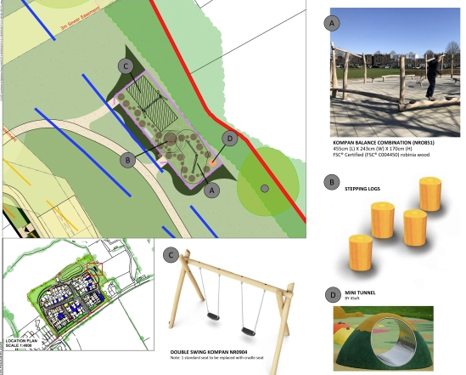

Also proposed is a community orchard which is located to the ?? of the site.

Summary
The Councils Landscape Officer, Play Officer and Arboriculturalist have raised no objections to the proposal and as such is considered to accord with the aims of the NPPF, other biodiversity related guidance, and the adopted WCS policies CP51 and CP57.

Loss of Agricultural Land (Best and Most Versatile Land)

Policy Context

The National Planning Policy Framework (NPPF) sets out the requirement to protect agricultural land from unnecessary development. Chapter 15, paragraph 187(b) recognises the economic and other benefits of BMV land. Some guidance is also contained in the PPG at Paragraph: 001 Reference ID: 8-001-20190721

Assessment & Summary

The Agricultural Land Classification for the site in question is grade 3. However, its loss was deemed acceptable at outline stage and therefore there is no need for further commentary under this REM application.

Impact on Amenity of nearby properties

Policy Context

The National Planning Policy Framework (NPPF), particularly Paragraph 135, stresses that planning decisions should ensure developments provide a high standard of amenity for existing and future users.

Point vii of Core Policy 57 of the Wiltshire Core Strategy requires new development to have regard to the compatibility of adjoining buildings and uses, regard to the impact on the amenities of existing occupants, and ensure that appropriate levels of amenity are achievable within the development itself, including the consideration of privacy, overshadowing, vibration, and pollution (e.g. light intrusion, noise, smoke, fumes, effluent, waste or litter).

The above policies include considering the impacts on privacy, light, outlook and noise for both existing and future occupants. These issues will be addressed in turn below.

Assessment

2 existing two storey dwellings (227 Melksham Road with 216b behind) lie to the southwest (North of the B3107) which would be the closest dwellings to the site. There are windows and a dormer window on the side elevation of 227 Melksham Road facing onto the site

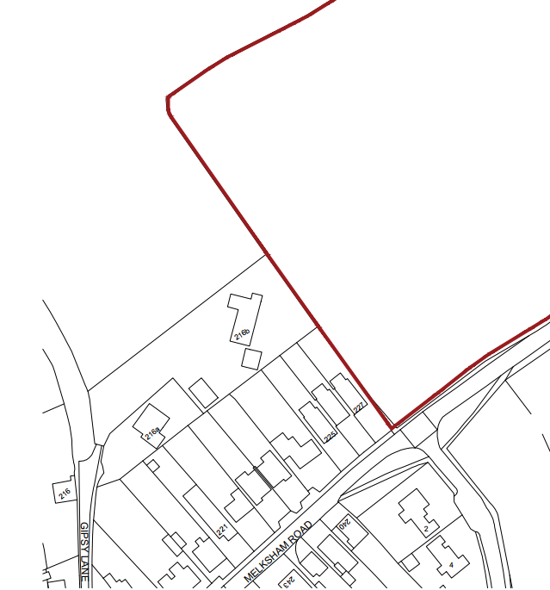

Melksham Road currently enjoys an open outlook across the field and to respect this position, the proposal provides an 18-metre buffer between number 227 and plot 18 which has no side facing windows. Plots 20 and 21 are also located approximately 18 metres from the rear boundaries of 216b and 227. To protect the views from 216b, single storey bungalows have been proposed in this location (plot 22 and 34). It is therefore considered that these existing dwellings would not be adversely impacted upon in terms of amenity from the proposed development.

The application submission demonstrates that the proposed dwellings meet the minimum sizing requirements of the Governments Technical Guidance and gardens are at least equal to the ground floor of the dwelling the serve. The proposed layout demonstrates that dwellings are located a sufficient distance away from each other not to cause any amenity concerns with overlooking, overshadowing or overbearing.

Consideration has also been given to the impact the proposal would have on the newly approved development on the opposite side of the road (Bewley development) however given the distances between the proposed dwellings together with the landscaping and the main road in between it is considered that there would be no adverse impact in terms of amenity.

A Noise Impact Assessment which details the noise acoustic scheme and demonstrates how future occupiers would not be subject to any undue harm from noise. This is through the erection of 1.8 metre high fences (albeit plot 47 and 48 will have 2.2 metres), trickle vents on windows, high performing sound insulated glazing noise compliant air source heat pumps (not exceeding 35dB at the façade of the nearest noise sensitive window). The Council’s Public Protection officer has commented on the scheme and largely supports however is not comfortable with the details submitted regarding the windows serving the dwelling that front the main road. As such, this additional information can be requested by an additional condition requiring this information to be submitted.

Summary
The concerns of third parties regarding amenity impacts have been fully considered. The proposal is considered to accord with the aims of policy CP57 and the PPG subject to a condition.

Wider Environmental Considerations (Noise, Air Quality, Contaminated Land, etc.)

Policy Context

The National Planning Policy Framework (NPPF) and Planning Practice Guidance (PPG) reinforce the need for planning decisions to prevent new and existing development from contributing to, being put at unacceptable risk from, or being adversely affected by unacceptable levels of pollution. Core Policies 55 and 56 of the Wiltshire Core Strategy (WCS) seek to ensure that development does not result in unacceptable impacts on the environment or the health and well-being of existing or future occupants. The Council’s Air Quality Supplementary Planning Document (SPD) provides detailed guidance on assessing and mitigating air quality impacts, particularly in or near Air Quality Management Areas (AQMAs).

Adopted policy CP57 also relates to impacts on amenity including the potential for development to generate or be exposed to pollutants such as noise, air pollution, odour, vibration, light spill, and land contamination.

Assessment

Although the site is greenfield, the Local Planning Authority would need to be ensure that there is no historic use that could cause a source of potential contamination to future occupiers. As such a land contamination condition was secured at the outline planning stage (Condition 9).

Summary

The proposal therefore accords with the aims of the NPPF, other biodiversity related guidance, and the adopted WCS policies

Highway Safety and Parking

Policy Context

The NPPF covers this matter in Chapter 9. In particular, paragraph 110 and 115 are “key policy” for the purposes on paragraph 11d footnote 9, and indicate that significant development should be focussed in sustainable locations which offer a genuine choice of transport modes, and where safe and suitable access can be achieved for all users. Paragraph 117 also prioritises these issues. Paragraph 116 does however confirm that development should only be prevented or refused on highway grounds if there would be an unacceptable impact on highway safety, or the residual cumulative impacts on the road network, following mitigation, would be severe, taking into account all reasonable future scenarios.

Core Policies 60 to 64 of the Wiltshire Core Strategy (WCS) set out the overarching transport and accessibility framework for development across the county. These policies require that development proposals:

- Provide safe and suitable access for all users;
- Do not result in severe residual cumulative impacts on the transport network;
- Promote sustainable transport modes and reduce the need to travel by car;
- Include appropriate levels of car and cycle parking in accordance with adopted standards;
- Safeguard and enhance public rights of way and active travel routes.

The Wiltshire Local Transport Plan (2011–2026), including the Car Parking Strategy and Cycling Strategy, provides further guidance on the design and provision of transport infrastructure. The Wiltshire Local Cycling and Walking Infrastructure Plan (LCWIP) and associated design standards (2022) set out expectations for the delivery of high-quality active travel infrastructure in new developments.

Proposals should also demonstrate compliance with national design guidance, including the National Design Guide and associated documents including LTN 1/20: Cycle Infrastructure Design (DfT, 2020), which sets out principles for safe, coherent, and inclusive cycling networks.

Policy P.1 of the HNP states that any housing developments must be completely self-sufficient in terms of off-road parking area, which means:
- Development proposals will be supported only if they include the maximum level of off-street parking consistent with the standards set out in the Wiltshire Core Strategy;
- developments that reduce the amount of off-street parking currently available will only be supported if they make enforceable provision for off-street parking nearby;
- c) parking spaces provided will need to be made available in perpetuity

Assessment
The site is currently accessed via a field gate off Melksham Road (B3107) and a new proposed access consisting of a priority-controlled T junction was approved at the same location at the outline planning stage.
A separate pedestrian access along the internal southern boundary of the site was also approved at outline planning stage. This path connects the site with the existing footpath behind a translocated hedge with a link to the proposed bus stop on the east bound carriageway.

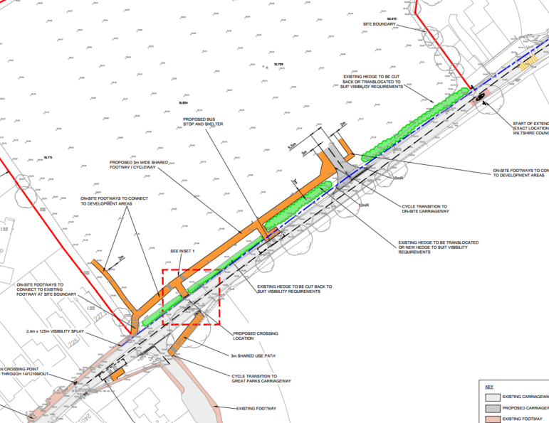

A proposed pedestrian crossing point was also approved and is as follows:
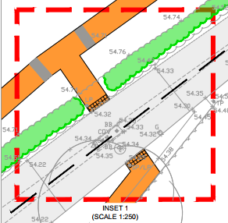

The proposed access and bus stop with high access kerbs were conditioned on the outline application (condition 18)to be put in place prior to the occupation of the first dwelling.

Also approved at outline planning stage as part of the S106 Legal Agreement was a Traffic Order to reduce the speed limit to 30mph and relocate the village gateway. This is to be completed prior to first occupation. It has been confirmed by the Applicant that a Traffic Order will be applied for once planning permission has been secured (outline and reserved matters) as they don’t currently own the site. The Parish Council have confirmed that they would like to see this implemented upon approval of the reserved matters application, however as it was agreed in the S106 Legal Agreement at outline stage this is not able to be changed.

The application has been submitted with a Highways Condition Survey of the road, Construction Management Statement, road lighting plan, engineering layouts, refuse collection layout, parking layout, site layout, garage/car port details and a travel plan.
Car parking has been proposed in accordance with the Council policies (1 space per 1 bedroom unit, 2 spaces per 2–3-bedroom unit and 3 spaces per 4 bedroom unit). Each of the garages are slightly larger than required to accommodate cycle storage.

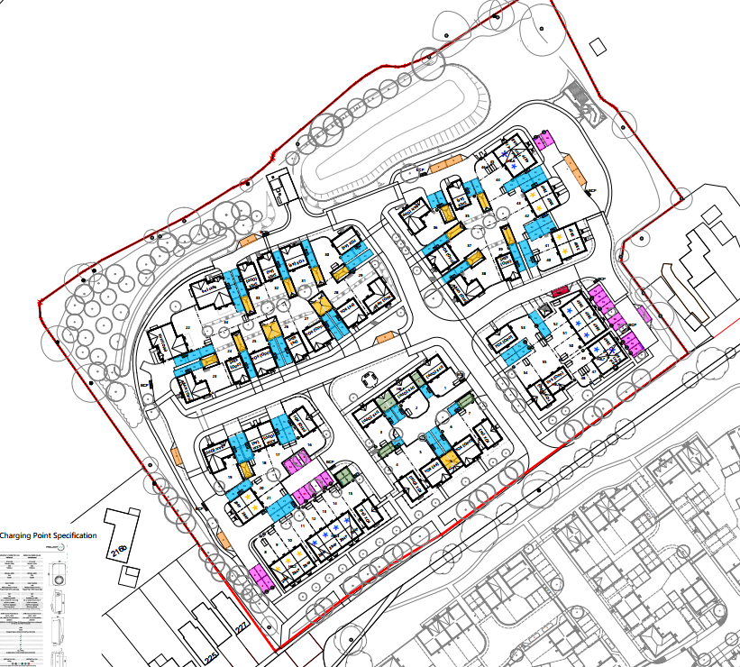

8 parking spaces across the site have been allocated to visitor parking and are distributed across the site but do not meet the requirements of 0.2 spaces per dwelling. 11 spaces should be provided resulting in 3 additional spaces being required. The Councils Highways Officer has assessed the submitted information and is of the opinion that due to the widths of the roads (which are wider then required) the proposal is acceptable. Given the widths of the internal road layout, the lack of 3 visitor parking spaces is not considered to warrant a reason to refuse the application.

Although the submitted layout initially showed a shortfall of three visitor spaces, the applicant has agreed to provide a total of 11 visitor spaces at the request of the Parish Council through a pre-commencement condition. With this amendment secured, the development is considered to accord with parking standards and to result in no unacceptable impact on highway safety.

The lack of EV charging shown on the submitted has been raised as a concern by Holt Parish Council, however it is a requirement of Building Regulations that EV charging is installed for each dwelling and as such this is not a matter that would result in a reason for refusal, however the Applicant has submitted a plan detailing EV charging points across the site to satisfy the Parish Council

A future access plan has raised concern from Holt Parish Council and third parties that detailed an access into the field to the West of the site. This plan has been removed from the submission.

Concerns have been raised by third parties concerning the access not being safe, there already being too much traffic/congestion/pollution in the village which are matters that were assessed at the outline planning stage and as such are not reasons to refuse this reserved matters application.

Another concern raised is due to cars parking on the existing pavements on the High Street so that pedestrians are not able to pass – especially those with pushchairs and mobility scooters. This is an existing problem that cannot be solved through this reserved matters application. It is an offence to park on the pavement and the Parish Council have previously been advised to speak to the Councils Highway Department regarding this matter.

There are no Public Rights of way located within the development site and the site is poorly connected to the Public Rights of Way network. As such the Councils Public Rights of Way Team secured a Section 106 contribution to improve the Public Rights of Way network within the Parishes of Holt, Atworth and Broughton Gifford.

Summary
Third party concerns regards the impacts of the proposal have been fully considered as noted above and the application has been supported by the Councils Highway Officer.

The proposal therefore accords with the aims of the NPPF, and in particular the “key policies” 110 & 115 for transport matters highlighted by footnote 9, and the WCS transport policies 60-64.

Ecology and Biodiversity

Policy Context

NPPF Paragraph 11d footnote 7 highlights assets or areas of particular importance to be protected including irreplaceable habitats site and SSSI’s.

In accordance with national policy and guidance, including the NPPF (Chapter 15: Conserving and Enhancing the Natural Environment, paragraph 187 indicates that developments are required to minimise impacts on, and provide net gains for biodiversity, including by establishing coherent and resilient ecological networks, and incorporate features which support priority species. Paragraphs 193 and 194 relate to principles to be used when determining applications, and paragraph 195 of the NPPF indicates that the presumption in favour of sustainable development does not apply where a plan or project is likely to have a significant effect on a habitats site, unless an appropriate assessment has concluded that the proposal would not adversely affect the integrity of the habitats site. Legislation requires that all major developments submitted since February 2024 deliver a minimum of 10% biodiversity net gain.

Core Policy 50 of the Wiltshire Core Strategy (WCS) seeks to conserve and enhance biodiversity across the county. It requires that development avoids harm to ecological assets and delivers some biodiversity net gain (BNG) improvement, in line with the statutory requirements of the Environment Act 2021.

The Council’s Green & Blue Infrastructure Strategy (2022–2030) sets out a strategic framework for protecting and enhancing Wiltshire’s natural capital. It identifies priorities for habitat connectivity, ecosystem services, and nature recovery, and encourages development that contributes positively to these objectives.

Policy E.1 of HNP states that proposals will be supported provided they “preserve and/or replace existing trees and hedges as far as possible” and “plant new trees on green spaces and play areas, where appropriate”.

Assessment

The site offers limited suitability for protected/notable species. A small population of common reptiles is present in hedgerow bases, but hedgerows are of limited potential for dormice. No badger setts were noted. There is potential for breeding birds within the hedgerows, and bats use the network of hedgerows around the Site for commuting and foraging. Furthermore, a number of trees on the north and western boundaries support features with suitability for roosting bats (PRFs).

The application was submitted with a construction environmental management plan (CEMP) and a habitat management and monitoring plan (HMMP) which highlight the sensitive ecological features and demonstrate how the Applicant proposes to protect ecological habitat and features during construction.

The submitted plans demonstrate a large buffer on the northern, eastern and western boundaries which incorporates features such as new planting, a community orchard and a SuDS feature which will benefit the site in ecological terms. Dark corridors of at least 10m have been designed into the development predominantly around the edge of the site and a road lighting plan has been submitted with the application demonstrating lux contours for the boundary hedgerows which demonstrate all peripheral dark corridors are <0.5 lux which has been considered to be acceptable.

A Construction Environment Management Plan has been submitted alongside a Habitat Management and Monitoring Plan which demonstrates locations of habitat piles, hedgehog gaps, bat boxes and swift boxes. All of which has been considered acceptable by the Council Ecologist.

Under Schedule 7A of the Town and Country Planning Act 1990 (as inserted by Schedule 14 of the Environment Act 2021) this application is required to deliver 10% Biodiversity Net Gain (BNG). The Biodiversity Gain Plan condition will automatically apply if approval is forthcoming.

A completed statutory metric calculation (REF 26.02.2026) confirming the baseline and predicted post- development biodiversity units of the site has been submitted (including the condition assessment sheets and maps). Information in the completed on-site baseline habitat tabs is accepted as accurate based on the information submitted. An Ecology contribution was secured in the S106 Legal Agreement to cover the cost monitoring BNG on the land for a period of 30 years on the outline planning consent.

The Council Ecologist has raised no objections to the proposed submission.

In order for the council to fulfil its BNG monitoring responsibilities, a Biodiversity Net Gain On-site 30 year Monitoring Fee of £11165 was secured on the outline planning application through the S106 Legal Agreement.

The Salisbury and Wilton Swifts comment related to the lack of information on the submitted plans regarding nest boxes etc. This has been supported by Holt Parish Council. However, there is a condition on the outline planning consent that requires this information to be submitted for approval prior to the commencement of works on site. The details have been submitted within the submitted Habitat Management and Monitoring Plan which confirms that there will be approximately 1 externally mounted box per 2 dwellings for swifts (17 – blue triangle), 1 mounted box per 2 dwellings for bats (27 – red circles), hedgehog holes (shown as x) are to be inserted into close boarded fences alongside 3 habitat piles. These are shown on the following submitted plan:
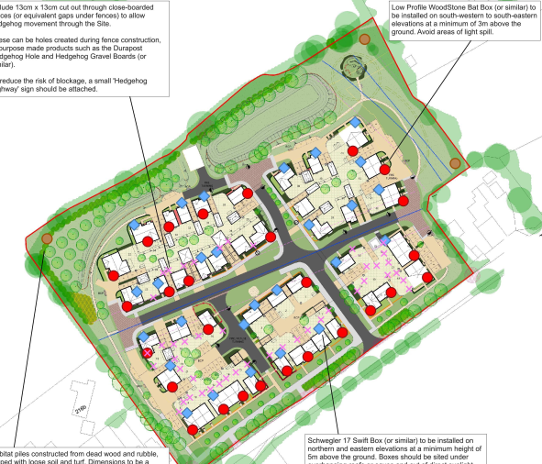

Summary

Third party concerns have been fully considered. The proposal is considered to address the aims of the NPPF, other biodiversity related guidance, and the adopted WCS policy CP50 and there are no objections from the Council’s ecology officer subject to conditions.

Flood Risk and Drainage

Policy Context

Paragraph 11d footnote 7 highlights assets or areas of particular importance to be protected including areas at risk of flooding. Chapter 14 paragraphs 170 – 182 refers to this matter. In particular paragraphs 174 - 178 outline the sequential test and indicate that if it is not possible for the development to located in areas with a lower risk of flooding (taking into account wider sustainability development objectives), then the exceptions test can be applied. Paragraph 180 indicates that where applications come forward on allocated sites through the sequential test, then applicants need not apply the sequential test again. However, the exception test may need to be reapplied if relevant aspects of the proposal had not been considered when the test was applied at the plan making stage, or if more recent information about existing or potential flood risk should be taken into account.

Paragraph 181 of the NPPF makes clear that when determining any planning applications, local planning authorities should ensure that flood risk is not increased elsewhere.

Core Policy 67 of the Wiltshire Core Strategy (WCS), requires that development avoids increasing flood risk and incorporates appropriate mitigation measures. Development proposals located within Flood Zones 2 or 3 must be subject to the sequential test, and where necessary, the exception test, to ensure that more vulnerable uses are directed to areas of lowest flood risk.

E.2 of the HNP states that proposals for new development will be supported provided they satisfactorily address their impact on energy and water supply, drainage, waste disposal, traffic and transport routes and the school

Assessment

The site lies within Flood Zone 1 which is the least likely to flood. The site is also located within an area of very low risk of surface water flooding.
The site drainage has been designed to accommodate the surface water flows up to and including the 1 in 100 year storm even plus 45% for climate change.
Surface water from the proposed development is to be directed to two lined swales and surface water sewers to an infiltration basin located in the northeast of the site. This will then drain into a water course of which approval will need to be sought from the Local Lead Flood Authority (Wiltshire Council).
Foul drainage will be connected to the foul sewer on Melksham Road. Profiled ground levels and raised finished floor levels of the proposed dwellings will protect future occupiers from any further risk.
This reserved matters application which includes an updated drainage technical note aligns with the details submitted at the outline planning stage to which Wessex Water and Wiltshire Council Drainage Officers made no in principle objections and relevant conditions were secured. While the Council’s Drainage Officer has identified that additional information is required to fully discharge condition 11 of the outline permission, this matter is capable of being addressed through the existing outline condition. Subject to compliance with that condition, the reserved matters details are considered acceptable in drainage and flood risk terms.

Summary
The proposal is considered to address the aims of the NPPF and the adopted WCS policy CP67 and there are no objections from the Council’s Drainage Officers.

S106 Heads of Terms

Wiltshire Council has a Planning Obligations Supplementary Planning Document, which should be read in conjunctions with the WCS (primarily Core Policy 3 ‘Infrastructure Requirements’) and the Wiltshire CIL charging schedule. This SPD identifies the planning obligations that will be sought by the council for development that generates a need for new infrastructure and should be a material consideration in planning applications. It is essential to demonstrate that each obligation meets the three Regulation 122 tests under the Community Infrastructure Levy (CIL) Regulations 2010. Paragraph 58 of the National Planning Policy Framework reiterates the three tests as:

- Necessary to make the development acceptable in planning terms
- Directly related to the development; and
- Fairly and reasonably related in scale and kind to the development

The infrastructure items listed below were considered to be relevant to the application site and were raised by consultees as necessary in order to mitigate the impact of the proposed scheme.

The S106 contributions that were secured during the outline planning stage are as follows:
- 40% Affordable Housing
- 1921.04m2 of public open space on site
- 97.35m2 of equipped play on site
- 1298m2 sport pitches and courts (£12,9800.00) prior to commencement
- 6 Early years places (£105,132.00) prior to commencement
- 9 Secondary school places (£206,460) prior to commencement
- Waste containers (£5,555.00) prior to commencement
- Off road cycle route (£61,100.00) prior to commencement
- Adding journeys to public transport (£9165.00) prior to commencement
- Traffic Order (278 Agreement)
- Improvements to public rights of way (£150 per dwelling - £8,250) prior to commencement
- BNG monitoring (£11,165.00) prior to commencement
- Art Contribution (£16,500) prior to commencement
- Management Company to be set up
- S106 Monitoring fee

Community Infrastructure Levy

The Community Infrastructure Levy (CIL) is a charge that local authorities in England and Wales can put on new development in their area to raise funds to help deliver the infrastructure necessary to support development. The development will represent chargeable development under the Community Infrastructure Levy Regulations 2010 (as amended) and Wiltshire Council’s CIL Charging Schedule
Planning Balance / Conclusion
Notwithstanding that the principle of residential development on the site has been established through the grant of outline planning permission, it remains necessary to consider whether the detailed matters of appearance, landscaping, layout and scale are acceptable in planning terms.

The assessment above identifies a limited number of residual concerns, most notably in relation to the distribution of visitor parking across the site and the sensitivity of the site’s rural edge location. However, these matters are not considered to result in unacceptable harm. The visitor parking issue is capable of being satisfactorily addressed through a pre-commencement condition securing the provision of the agreed number of visitor spaces, and the layout, landscaping and boundary treatments proposed ensure that the development integrates appropriately with the surrounding countryside and existing residential properties.

Significant weight is given to the quality of the submitted details, including the comprehensive landscaping strategy, retention and enhancement of boundary vegetation, provision of public open space and play facilities, and the delivery of biodiversity net gain secured through the outline permission and associated legal agreement. The proposal also demonstrates an appropriate housing mix, protects the amenity of neighbouring occupiers through separation distances and mitigation measures, and delivers safe access, parking and internal movement arrangements in accordance with adopted standards.

When considered as a whole, and subject to the conditions imposed and the obligations already secured through the Section 106 Agreement, the detailed reserved matters proposals are considered to adequately mitigate identified impacts and to accord with the relevant policies of the development plan and national planning guidance. On this basis, the planning balance weighs in favour of approval of the reserved matters.

RECOMMENDATION: That planning permission be GRANTED, subject to conditions.

