APPLICATION FOR HOUSEHOLDER PLANNING PERMISSION DELEGATED REPORT

APPLICATION REFERENCE: | PL/2026/02255
APPLICATION TYPE: | Householder planning permission
SITE ADDRESS: | 6 Sycamore Drive, Bishopdown, Salisbury, SP1 3GZ
DEVELOPMENT DESCRIPTION: | Single storey side extension
RECOMMENDATION: | That Planning Permission be GRANTED

PROPOSAL

The proposal seeks planning permission for the erection of a single storey side extension. The proposed extension will comprise a shallow mono pitch roof and will be constructed using material to match the existing dwelling.

Proposed elevations included below

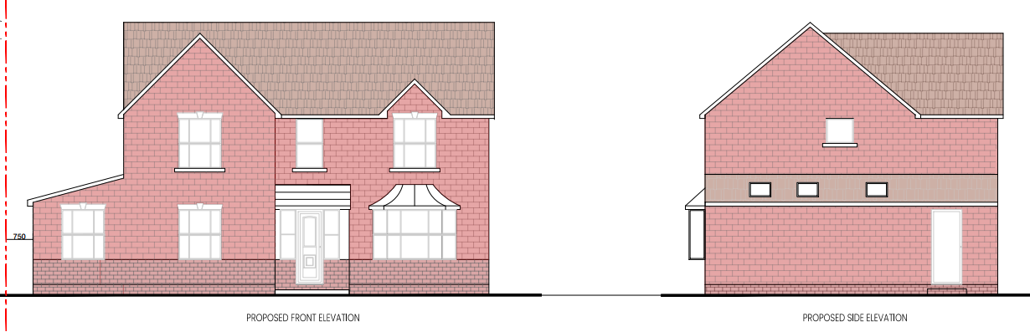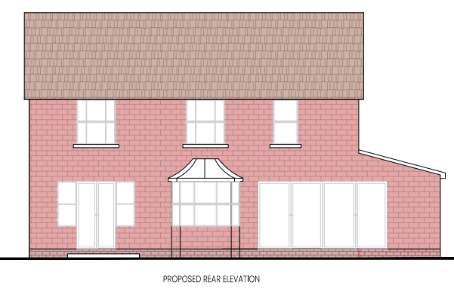

Existing ground floor plan and roof plan included below

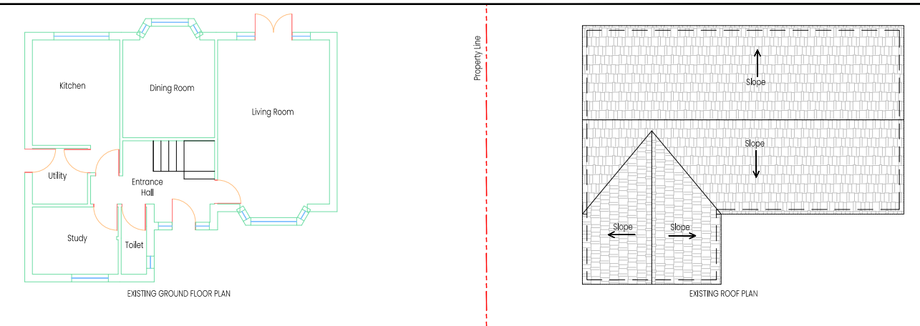

Proposed ground floor plan and roof plan included below

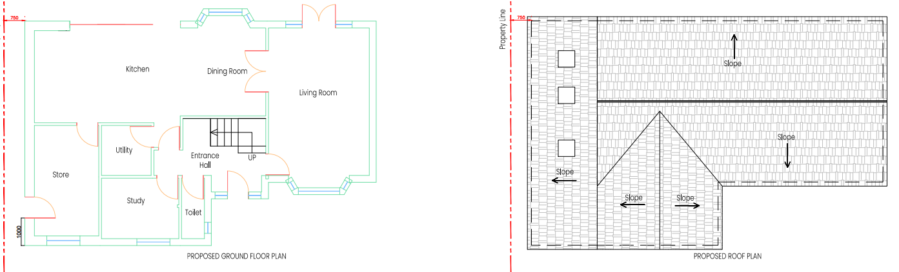

SITE DESCRIPTION/CONTEXT

The application site relates to a four bedroom detached two storey dwelling located within an established modern housing estate in Bishopdown. Bishopdown is located within the settlement boundary for the Principal Settlement of Salisbury as defined by WCS policies CP1 (Settlement Strategy), CP2 (Delivery Strategy) and CP20 (Salisbury Community Area). It is located in Flood Zone 1, within the Hampshire River Avon Catchment and is within the New Forest Protected Sites 13.8 km Recreation zone of influence.

PLANNING HISTORY

Proposal / Summary
S/1994/1565 - Reserved Matters Decision - Approve with Conditions Date: 13/4/1995 – APPROVAL OF RESERVED MATTERS - CONSTRUCTION OF 43 HOUSES WITH GARAGES, ROADS, FOOTPATHS AND ALL ANCILLARY WORKS

RELEVANT POLICIES AND GUIDANCE

The National Planning Policy Framework (NPPF)
The Planning Practice Guidance
National Design Guide

Wiltshire Core Strategy:

Core Policy 1: Settlement Strategy
Core Policy 2: Delivery Strategy
Core Policy 20: Spatial Strategy- Salisbury Community Area
Core Policy 50: Biodiversity and Geodiversity
Core Policy 57 Ensuring High Quality Design and Place Shaping

Salisbury neighbourhood plan

Wiltshire Design Guide
Creating places design guide

CONSULTATION RESPONSES

Parish Council: No comment

REPRESENTATIONS

No comments were received.

ASSESSMENT

Section 38(6) of the Planning and Compulsory Purchase Act 2004 states:

"If regard is to be had to the development plan for the purposes of any determination to be made under the planning Acts, the determination must be made in accordance with the plan unless material considerations indicate otherwise."

In accordance with this statutory requirement, this application has been assessed against the relevant policies of the Development Plan, including the adopted Wiltshire Core Strategy (2015) and, where applicable, any made Neighbourhood Plans.

Design and Impact upon the character and context of the area

Core Policy 57 - Ensuring High Quality Design and Place Shaping of the Wiltshire Core Strategy seeks to ensure that all new development is of high design quality, reflecting local context, character, and distinctiveness.

The proposals relate to a modest single storey side extension which will not be prominent within the streetscene due it its siting and design including a shallow mono pitched roof . The use of materials to match the host dwelling will further enable the extension to integrate with the existing dwelling and will be in keeping with the overall character of the area.

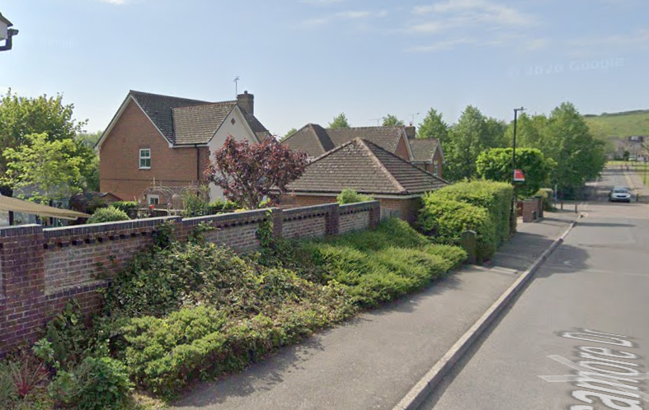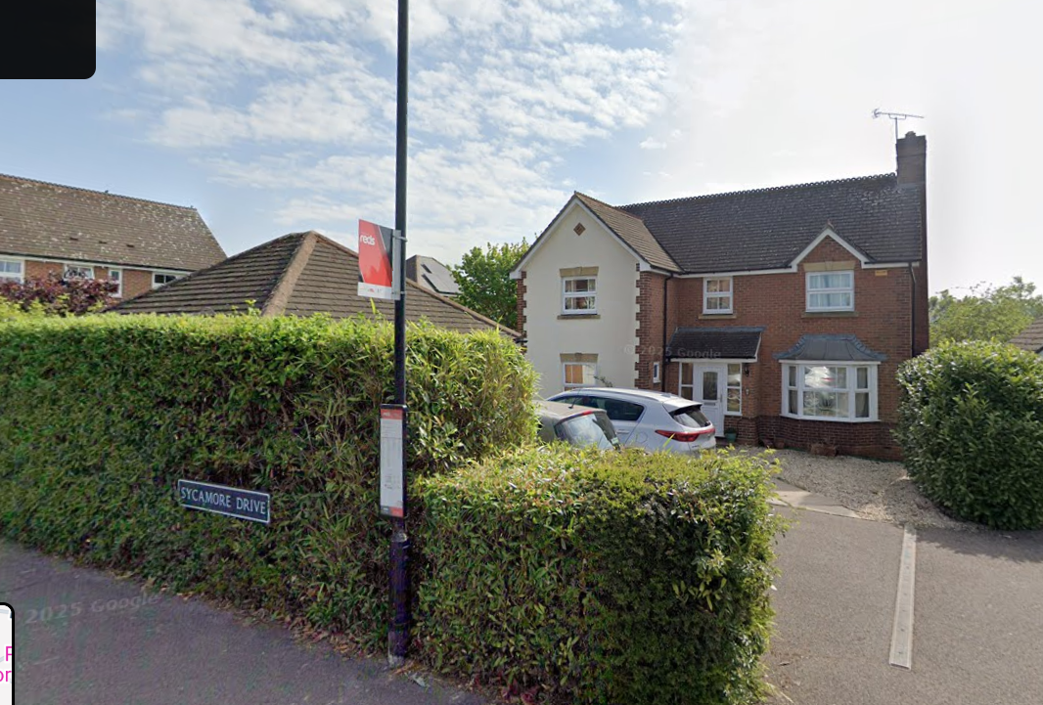

Having regard to the above, the proposal complies with the design principles set out in Core Policy 57 of the Wiltshire Core Strategy and Appendix D of the Wiltshire Design Guide.

Amenity

Point vii of Core Policy 57 - Ensuring High Quality Design and Place Shaping of the Wiltshire Core Strategy seeks to ensure that developments do not adversely affect neighbouring properties.

The National Planning Policy Framework (NPPF), particularly Paragraph 135(f), stresses that planning decisions should ensure developments provide a high standard of amenity for existing and future users.

The proposed development has been assessed in terms of its potential impact on the residential amenity of neighbouring properties, with particular regard to loss of light, overshadowing, loss of privacy, and overbearing effects.

Given the scale, design and siting of the proposed side extension, it is not considered that there will be adverse amenity impacts created through overbearing, overshadowing or loss of privacy.

The proposal therefore accords with Core Policy 57 point vii in respect of safeguarding residential amenity and Appendix D of the Wiltshire Design Guide.

Biodiversity Net Gain

Householder planning applications are exempt from the requirement to deliver Biodiversity Net Gain under Schedule 7A, Section 4(2)(a) of the Town and Country Planning Act 1990, as inserted by the Environment Act 2021.

CONCLUSION

The proposed development is considered to be acceptable in terms of its design, scale, and relationship with the surrounding area. It would not result in any unacceptable harm to the character of the locality, the amenities of neighbouring occupiers or ecology.

The proposal is therefore considered to comply with the relevant policies of the Wiltshire Core Strategy, the Wiltshire Local Plan, and the National Planning Policy Framework. As such, the application is recommended for approval, subject to the conditions set out below.

RECOMMENDATION: That Planning Permission be GRANTED subject to conditions.

1. The development hereby permitted shall be begun before the expiration of three years from the date of this permission.

REASON: To comply with the provisions of Section 91 of the Town and Country Planning Act 1990 as amended by the Planning and Compulsory Purchase Act 2004

2. The development hereby permitted shall be carried out in accordance with the following approved plans:

Application form received 07/04/2026
Existing and Proposed floor plans Drg no BR-01 received 20/04/2026
Proposed elevations Drg no BR-03 received 20/04/2026
Location Map and Site Block Plan Drg no BR-04 received 22/04/2026

REASON: For the avoidance of doubt and in the interests of proper planning.

3. The materials to be used in the construction of the external surfaces of the development hereby permitted shall match in material, colour and texture to those detailed on the application form and approved plans and to match the existing dwelling.

REASON: For the avoidance of doubt and in the interests of visual amenity and the character and appearance of the area.

