Stourhead Garden Pathway Improvement – Phase 1 Written Scheme of Investigation
Steve Timms - 8th December 2025
Author/editor | Version | Date created | Amends
Steve Timms, Archaeologist, NT | Version 1 | 8 Dec 2025 | Version 1 issue
Jo Flye, Project Manager, NT | Version 2 | 12 Dec 2025 | Edits to dates/phasing, addition of version control, removal of Appendix B (not required)

Introduction
This document forms a short method statement (WSI) to cover a programme of archaeological monitoring at Stourhead House, Stourton, Wiltshire, BA12 6SH (NGR ST 77448 34093). The monitoring is required to meet a condition attached to planning permission to improve the historic garden paths in the landscape gardens (PL/2025/07553). The work is not anticipated to disturb significant archaeological deposits and the scheme has been written to reflect this. This WSI covers Phase 1 of the pathway improvements project. Separate method statements will be issued for subsequent phases as appropriate.
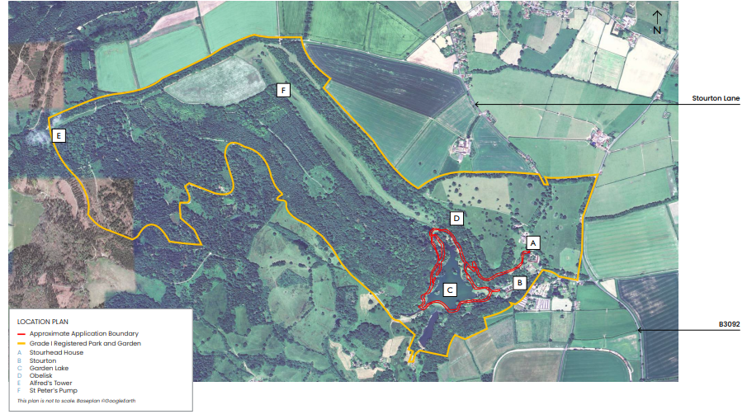
Figure 1 site location
Overview
The Stourhead Estate was acquired by Henry Hoare in 1717 who after making his fortune from the collapse of the South Sea Bubble in 1720 demolished Stourton Castle and constructed a fine country house in the Palladian style in its place. He died before the project was finished and was succeeded by his son Henry Hoare II. Henry completed the house and following his return from Italy in 1741 oversaw the creation of a impressive, landscaped garden in the valley to the west. The garden included two ornamental lakes, several classical structures and was characterised a winding path from which the property and surrounding landscape could be experienced in a series of vistas. The 18th century gardens were extended and improved by Henry’s grandson, Richard Coalt Hoare and by the end of the 18th century were considered one the finest in England.
The estate was bequeathed to the National Trust in 1947, and the gardens are designated as a Grade I Registered Garden (1000471).
Reasons for Improvements
The gardens are a key feature of the property and one of the main attractions for visitors. Erosion of the pathways around the garden and lakes has been a recurring issue for many years. This has been caused by a combination of visitor traffic and poor drainage on the site, the latter exacerbated by an increasingly wetter climate.
Previous Archaeological Work
The gardens have been the subject of extensive studies over the last ten years. The most notable and informative is that of Judith Teasdale (Teasdale 2022). Her report Stourhead Garden Paths Historic Development and Significance was used to inform the Heritage Impact Assessment for the planning application (Purcell 2025) and is a seminal work in understanding the historical layout and development of Stourhead.
Figure 2 shows the date and significance of the paths in the garden.
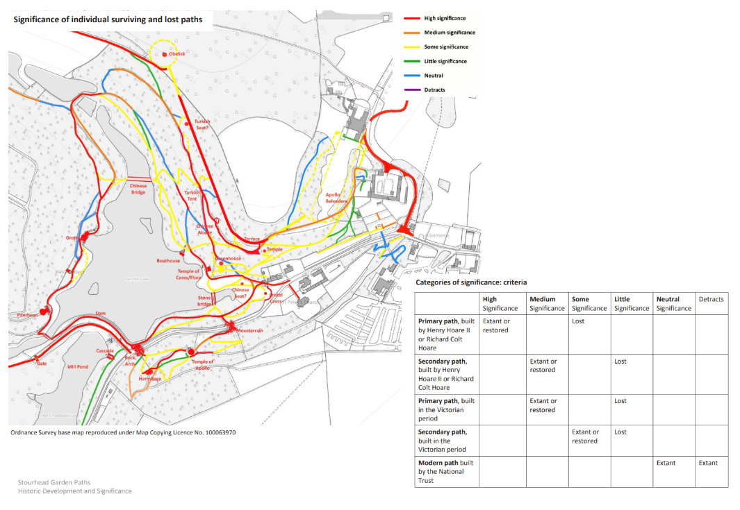
Figure 2 significance of paths recorded in historic mapping (Teasdale 2022)
The Proposed Works
Following extensive consultation, the National Trust has put forward a series of proposals to improve the pathways at Stourhead in a sympathetic and sustainable way. They comprise remodelling and resurfacing the path along its length to provide a durable and resistant surface which is still in keeping with the garden and its setting. The works also include limited improvements to drainage on the site as well and the insertion of path edges where appropriate.
Phasing
The works for the whole gardens will be carried out over several phases subject to available funding and seasonality. The extent of Phase 1 is shown in Figure 3. Most of the pathways in Phase 1 correspond with those from the early garden layout and are identified as being of High Significance in the Judith Teasdale’s report.
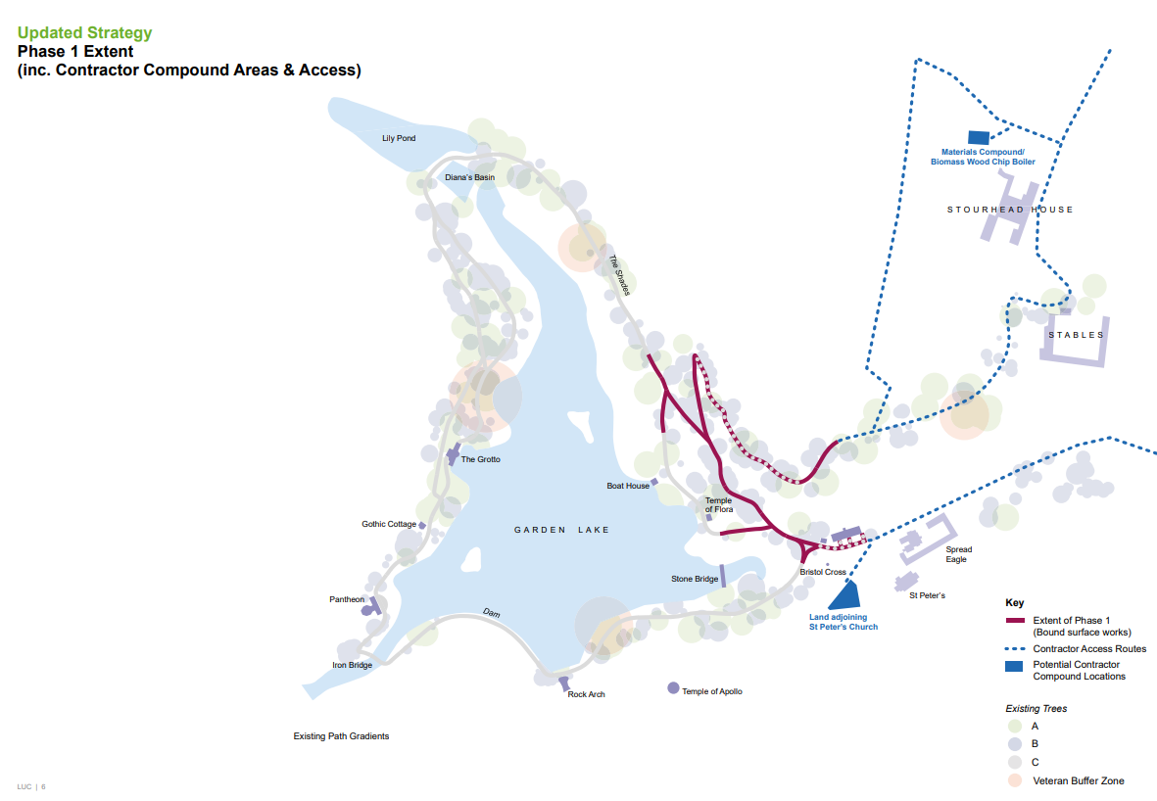
Figure 3 Phase 1 works
Groundworks
The work will be a combination of laying down an unbound surface for sections where the path is level and a bound surface where there is a slope. Existing path makeup will be excavated by hand or machine in order to lay a new subbase. In some areas the existing gradient of the path will be remodelled to assist drainage. Similarly some sections of the path will be edged with either metal or wood to contain the new surface and define the pathway for future maintenance.
The impact of the works is considered to be low and the groundworks are likely to be limited to between 50mm and 100mm from the current surface.
This being said it is possible that remains of the 18th century path surfaces, associated features or drainage may survive in working areas. As a result a watching brief is proposed for relevant sections of the path network.
Aims and Objectives
The aim of the watching brief will be to record and sample any surviving remains of the historic path network and associated features exposed during the groundworks. The exercise will also provide an opportunity to identify and characterise any materials used in the post medieval landscaping and add to our knowledge of this part of the Stourhead Estate. Priority will be given to recording and recovering material of a 18th century date.
Methodology
The archaeological watching brief will be carried out by an experienced archaeologist from the National Trust.
Archaeological monitoring will be considered for all sections of the path network which are identified as being of High Significance in the Teasdale report (Figure 2). The level of disturbance for each section will be established in consultation with gardens team and contractor carrying out the work. Where it is decided that an archaeological watching brief is not warranted by the proposed works (i.e. due to depth of excavation etc) the reasons will be recorded and included in the watching brief report.
Where ground disturbance will extend below the subbase of the current path archaeological monitoring will be carried out as set out in this WSI.
Due to the nature and depth of the excavations an archaeologist will not need to be present during the removal of modern surface material or subbase. The archaeologist will be present to view and record the underlying strata once it has been exposed. By working closely with the contractor this will be achieved in a series of site visits as opposed to having a continuous presence on site.
The watching brief will also be undertaken for other groundworks associated with the pathway improvements where they are predicted to disturb below ground deposits in areas of High Significance (Figure 2) (e.g. drainage)
Where archaeological deposits, surfaces or features are exposed they will be recorded and sampled as set out in this WSI.
Iterative Approach
The archaeological watching brief will be an iterative process and subject to regular review by the National Trust archaeologist. Where monitoring for each section shows
- that the groundworks are not exposing possible archaeological layers and/or
- it is clear that no archaeological horizons/remains/deposits are present
the watching brief will be curtailed for that section. Where this occurs the decision and rationale will be recorded and included in the report and the archaeologist at Wiltshire Council will be informed.
In the event that archaeological deposits are exposed or disturbed a compensatory record will be made in accordance with the methods and standards set out in the Appendix A.
The work will be carried out in accordance with the relevant CIfA guidelines and standards (Universal guidance for archaeological monitoring and recording 2023)
Reporting
A short report setting out the results of the investigation will be submitted to the archaeologist at Wiltshire Council (WC) within six weeks of the completion of the work. This will include as a minimum
- Non-technical summary
- Location plan
- Location of areas affected by the works
- Factual report outlining methodology, results and discussion
- Relevant figures and photographs
- Archive catalogue
- Specialist reports
Timing
Phase 1 of the work is scheduled for 2026-2027.
Archive
The archive resulting from the project will be retained and stored at the National Trust in accordance with current best practice and CIFA guidelines.
OASIS
A relevant entry will be made on the OASIS database for the investigation within six weeks of the fieldwork.

Appendix A Standard Watching Brief Methodology
An archaeological watching brief will be maintained on all ground works carried out during the preparatory stage of the project.
Should archaeological deposits be present then sufficient time will be afforded within the programme for the archaeologist to investigate and record them in accordance with the standards set out in this WSI and current best practice (CIfA 2023)

Hand Excavation and Sampling Strategy
All features of whatever origin requiring clarification will be cleaned by hand and recorded in plan at an appropriate scale. Where appropriate soil features will be investigated by hand in accordance with the following sampling strategy.
- Linear features Field boundaries/land divisions - 20% by length, recorded sections to include all terminals, intersections and other relationships.
- Structural components (including kilns) -100% excavation, recorded sections to include all terminals, intersections and other relationships.
- Discrete archaeological features – 100% by number, 50% excavation.
- Human Remains – 100% excavated where necessary (see below), under MOJ of licence and in consultation with osteologist where appropriate
- Post-holes - 100% by number, recorded in half section.
- Horizontal deposits Layers/spreads/ stratified deposits - 100% excavation, recorded in running sections, half sections or on a grid system and excavated in spits, as appropriate.
- Tree throws -100% mapped with 10% excavated and recorded in half section.

Human Remains
In the event that human remains are encountered on the site the necessary authorities will be informed (including Timothy Havard at Wiltshire Council). Following appropriate consultation their removal (if necessary) will be carried out in accordance with the current legislation and under a Ministry of Justice Licence. Human remains will be subject to further assessment and analysis by a qualified osteologist.

Recording
All archaeological features and deposits encountered during the mitigation works will be recorded using pro forma recording sheets and a continuous unique numbering system. Plans at appropriate scales will be prepared, showing the areas investigated and their relationship to more permanent topographical features. The plans will show the location of contexts observed and recorded in the course of the investigation. Other plans, sections and elevations of archaeological features and deposits will be drawn as necessary at scales of 1:10, 1:20 and 1:50 as appropriate.
All features will be located using a Total Station instrument or GPS. The spot height of all principal features and levels will be calculated in metres relative to Ordnance Datum correct to two decimal places. Plans, sections and elevations will be annotated with spot heights as appropriate. All features will be included on an overall site plan, tied to the Ordnance Survey (OS) National Grid and datum.

Photography
All excavated features and deposits will be photographed using a digital SLR camera with a minimum of a 10-megapixel resolution and available in RAW format as well as jpeg. Photographs will be in clear focus and adequately lit and will contain a scale and board. Additional site photographs should be taken as appropriate to place excavated features within their wider context.

Environmental Sampling
Environmental sampling will be undertaken from appropriate contexts in accordance with a sampling strategy developed in consultation with John Carrot of Palaeoecology Research Services Ltd (PRS). The sampling strategy will be in accordance with the latest guidelines (Historic England 1). During site work additional advice will be sought from other specialists (see below) where necessary and appropriate.

Unexpected or Important Discoveries
In the highly unlikely event that important unexpected remains are found during the watching brief Timothy Havard will be informed and invited to attend a site meeting to determine an appropriate course of action.

Samples for Dating
Samples of suitable material that appears to be of medieval date or earlier will be retained for radiocarbon dating except where contexts can be closely dated by artefactual or other means. Where kiln or oven structures are recorded they will be subject to archaeomagnetic dating where appropriate. The dating will be carried out by specialists from GeoQuest.

Finds Collection
Objects relating to human exploitation of the area that are exposed in the course of excavation will be recovered or, where recovery is impracticable, recorded. All finds will be recorded by context and significant objects will be recorded in three dimensions. All recovered objects will be retained unless they are undoubtedly of modern or recent origin. The presence of modern objects will, however, be noted on context records. In these circumstances sufficient material will be retained to elucidate the date and function of the deposit from which it was recovered. Animal bone samples will be recovered by hand during excavation and processed as part of the finds assemblage. Animal bone recovered from bulk samples will also be retained for analysis.

Finds Treatment
All finds will be processed to current best practice. All artefacts will, as a minimum, be washed, counted, weighed and identified. Spot dating of finds will be undertaken during the course of the fieldwork in order to inform excavation strategy. Provision will be made for liaison with external finds specialists, including site visits, as appropriate.
Objects that require immediate conservation treatment to prevent deterioration will be treated according to guidelines laid down in First Aid for Finds (Watkinson and Neal, 1998). Full records will be made of any conservation treatment; these records will form part of the archive. Provision will be made for the on-site conservation of particularly fragile or unstable materials, including attendance by a specialist conservator, as appropriate. Specialist work on any metalwork, bone (including worked bone, human remains and other organic remains), industrial waste, ceramic material, glass and lithic material will be carried out as necessary. All metalwork will be X-rayed and stored in a stable condition along with other fragile and delicate material.

Treasure
Any finds discovered during the evaluation that could be considered treasure under the terms of the Treasure Act (1996) will be immediately reported to the Finds Liaison Officer at Wilshire Council and Timothy Havard so that it is properly reported to the appropriate Coroner within 14 days of discovery. Where possible any such items will be excavated and moved to a safe place on the day of their discovery. Where this is not possible security arrangements will be implemented to ensure the site is secured until their recovery is possible.

Project Personnel
The project will be executed by Stephen Timms from the National Trust.
Specialist advice will be sought where necessary from external specialists.

Specialists
It is proposed to use the following specialist for the project;
Subject | Specialist | Organisation
Pottery | Rachel Hall  Lorraine Mepham | Freelance specialist  Freelance specialist
Lithics | Peter Bellamy | Terrain Archaeology
Glass | Alice Lyons | Lyons Archaeology
Conservation |  | Wiltshire Council Conservation & Museum Advisory Service
Human Remains | Dr Claire Randall
Environmental Archaeology | John Carrot | Palaeoecology Research Services
Geoarchaeology | John Carrot | Palaeoecology Research Services
Animal Bones | Dr Claire Randall

Monitoring
The heritage representative at Wiltshire Council will be notified:
- by email one week in advance of any fieldwork taking place, giving the name and contact details of the supervising archaeologist, and will be allowed on site to inspect and monitor the work at any reasonable time.
- immediately where Human Remains, and important remains (i.e. of more than local significance) are encountered; and
- On completion of the watching brief

Health and Safety
All work will be undertaken within the terms of the Health and Safety at Work etc. Act 1974 and the Health and Safety Management Regulations 1992 and in accordance with the SCAUM (Standing Conference of Archaeological Unit Managers) health and safety manual Health and Safety in Field Archaeology (1997). Copies of Health and Safety Policies and Risk Assessments will be supplied to North Lincolnshire Council at request. Additional advice will be sought as necessary from the HSE.

Reporting
On completion of the fieldwork a report for the archaeological works will be prepared. This will include as appropriate.
The reports will include as appropriate;
- an executive summary including dates of fieldwork and a brief summary of the result including details of any significant finds
- Site code/project number
- Planning reference number and SMR casework number
- Dates for fieldwork
- Grid reference
- A location plan, with scale
- A plan of the application site, with scale, showing the areas that have been investigated and indicating the location of archaeological features that were recorded.
- Section and plan drawings of archaeological features and deposits with ground level, Ordnance Datum and vertical and horizontal scales
- General site photographs as well as photographs of any significant archaeological deposits or artefacts that are encountered
- A written description and analysis of the methods and results of the archaeological fieldwork, in the context of the known archaeology of the area a discussion placing the site in its local and historical context
- Specialist artefact and environmental reports, as necessary
- A review of the research questions and objectives of the investigation with recommendations for the subsequent mitigation phase.
If merited an Interim Report will be prepared and copied to the North Lincolnshire Council HER and include an assessment of need for post-excavation analysis. All analysis recommended in the report to be carried out in the Post-Excavation Assessment contained within the interim report will be carried out within 6 months of the completion of archaeological work on site.

Oasis
An OASIS online record will be initiated prior to the start of fieldwork. Details of the fieldwork and the report will be uploaded to the OASIS online database within of the completion of the final report.

Archive
During the course of the project the archive will be stored at the National Trust.
The written archive will be prepared on clean, stable materials, and will be suitable for photocopying. The materials used will be of the standard recommended in Guidelines for the Preparation of Excavation Archives for Long-term Storage (Walker 1990). The archive will be prepared in accordance with procedures outlined in Standards in the Museum Care of Archaeological Collections (Museum and Galleries Commission, 1992) and in accordance with the requirements of the National Trust.

