APPLICATION FOR HOUSEHOLDER PLANNING PERMISSION
DELEGATED REPORT

APPLICATION REFERENCE: | PL/2026/02099
APPLICATION TYPE: | Householder planning permission
SITE ADDRESS: | The Outpost, Little London, Broad Chalke, Salisbury, SP5 5HL
DEVELOPMENT DESCRIPTION: | Proposed side extension to create new carport and store with attic store over.
RECOMMENDATION: | That Planning Permission be GRANTED

PROPOSAL

The proposal seeks planning permission for a proposed two storey side extension to create a carport on the ground floor and an attic on the first floor.

SITE DESCRIPTION/CONTEXT

The application site lies outside the large village of Broad Chalke as defined by the settlement boundary according to the Wiltshire Core Strategy (WCS) policies CP1, CP2 and CP33. The application site lies within the Broad Chalke Conservation Area and within the Cranborne Chase and West Wiltshire Downs Area of Outstanding Natural Beauty (AONB) National Landscape (NL). River Ebble is located north of the application site; it lies within the lowest risk of flooding at Flood Zone 1.

The site is situated within the Hampshire River Avon Catchment area; however, this ecological designation has no implication to this householder planning permission due to the nature of the proposed work.

The application site is accessed off an unclassified road accessed off South Street. The unclassified road is a rights of way bridleway with reference: BROA13. The application site is bordered by the highway to the west, a residential dwelling on the north, and the countryside on the south. To the east is the residential garden of the neighbouring dwelling.

PLANNING HISTORY

Reference | Proposal / Summary | Decision
PL/2025/07976 | Installation of 10 Solar Panels on sloping natural slate roof covering 2 storey dwelling house | Approve with Conditions
S/2011/1097 | Erection of 2 storey side extension | Approve with Conditions
S/1985/0209 | Addition of Storeroom Larder and WC | Approved
S/80/0195 | Two storey extension and double garage and construction of new access | Approved

RELEVANT POLICIES AND GUIDANCE

National Planning Policy Framework (NPPF)
2. Achieving sustainable development
4. Decision-making
12. Achieving Well-designed places
15. Conserving and enhancing the natural environment
16. Conserving and enhancing the historic environment

Wiltshire Core Strategy (WCS)
Core Policy 1: Settlement Strategy
Core Policy 2: Delivery Strategy
Core Policy 33: Spatial Strategy: Wilton Community Area
Core Policy 41: Sustainable construction and low-carbon energy
Core Policy 51: Landscape
Core Policy 57: Ensuring High Quality Design and Place Shaping
Core Policy 58: Ensuring the conservation of the historic environment.

Broad Chalke Neighbourhood Plan 2019- 2026
Policy 3B Design and Character

The Planning (Listed Building and Conservation Area) Act 1990
Section 66
Section 72

CONSULTATION RESPONSES

Ebbesbourne Wake Parish Council: None Received.
Highways: No Objection – Subject to condition.
Rights of Way: None received.

REPRESENTATIONS

No comments were received.

ASSESSMENT

Section 38(6) of the Planning and Compulsory Purchase Act 2004 states:

"If regard is to be had to the development plan for the purposes of any determination to be made under the planning Acts, the determination must be made in accordance with the plan unless material considerations indicate otherwise."

In accordance with this statutory requirement, this application has been assessed against the relevant policies of the Development Plan, including the adopted Wiltshire Core Strategy (2015) and, where applicable, any made Neighbourhood Plans.

Design and Impact upon the character and context of the area, conservation area and Core policy 51

Core Policy 57 - Ensuring High Quality Design and Place Shaping of the Wiltshire Core Strategy seeks to ensure that all new development is of high design quality, reflecting local context, character, and distinctiveness.

This application is an unlisted building located within the conservation area of Broad Chalke Section 66 of the Planning (Listed Buildings and Conservation Areas) Act 1990 requires ‘special regard’ to be given to the desirability of preserving a listed building or its setting. In addition, Section 72 of the Act states that in the exercise of any functions, with respect to any buildings or other land in a conservation area, special attention shall be paid to the desirability of preserving or enhancing the character or appearance of that area. In having ‘special regard’ (in relation to listed buildings) and/or in paying ‘special attention’ (in relation to conservation areas) the NPPF states that regard must be had as to whether the proposal will cause ‘substantial harm’, ‘less than substantial harm’ or no harm to the asset.
Core Policy 58 aims to ensure that Wiltshire’s heritage assets such as the conservation area are protected and enhanced in order that they continue to make an important contribution to Wiltshire’s environment and quality of life. It also, however, confirms that the designation of a Conservation Area or listed building does not necessarily preclude the possibility of new development, and the Council is committed to working pragmatically with owners to find positive solutions which will allow adaptations of such buildings to reflect modern living aspirations.

Core Policy 51 seeks to protect, conserve and enhance Wiltshire’s distinctive landscape character. The term ‘landscape’ here is used to refer to the built, historic and natural environment in urban, peri-urban and rural areas. The application site is located within the Cranborne Chase and West Wiltshire Downs Landscape Character Assessment area.

The application site consists of a two-storey detached dwelling with an existing vehicular access on the south of the application site. This application proposes to erect a two-storey extension measuring approximately 8.1 metres in width and 6.48 metres in length. To facilitate the extension, an existing oil tank is proposed to be relocated. A new driveway entrance from the highway is proposed to lead to the proposed parking area. The ground floor of the side extension is proposed to be a three-sided carport for two vehicles, a utility area, workshop and a staircase to the first floor. The first floor is proposed to be an attic workspace which is proposed to have two rooflights facing the west and two dormer windows on the east. The side extension is proposed to be constructed using horizontal timber weather boarding and a slate roof. The ridge height of the side extension is subservient to the host dwelling.

The application site is bordered by the neighbouring residential dwelling on the north and west with the proposed side extension surrounded by the residential dwelling’s residential garden. The proposed extension is proposed to be set back from the boundary by approximately 0.75 metres to 1.4 metres on the north and approximately 1.4 metres on the west.
The proposed side extension would be visible from the bridleway located west of the host dwelling. While the application site is located in the open countryside and a national landscape, the extension will be located to the north of the host dwelling and adjacent to the neighbouring dwelling. This minimises residential creep into the open countryside as the extension is within the established residential curtilage of the host dwelling being a side garden area between two dwellings.

The application documents also indicate that the existing driveway area on the south is proposed to be dug down to create a larger patio area. This patio area is currently at a lower height than the existing driveway with external steps leading from the driveway to the patio area.

The proposed works are considered to be subservient in scale, will utilise suitable materials, and would not be of harm to the visual amenity of the streetscape. The proposed alterations will not cause any significant impact on the wider area or the setting of the conservation area or national landscape and are acceptable accordingly. Having regard to the above, the proposal complies with the design principles set out in Core Policy 57 and 58 of the Wiltshire Core Strategy and Appendix D of the Wiltshire Design Guide.
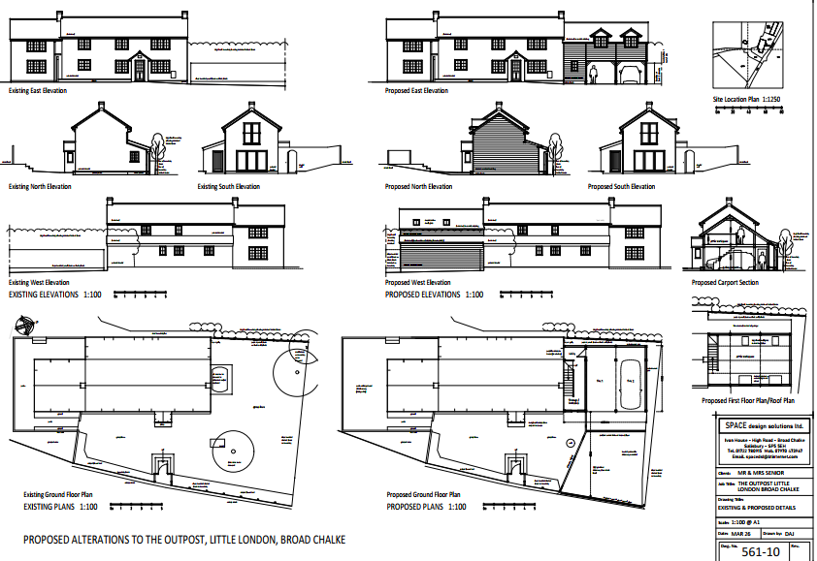

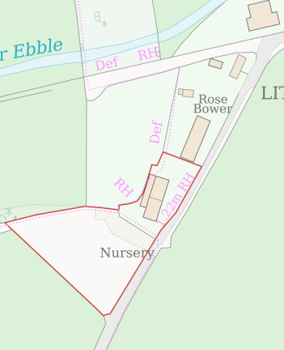

Amenity

Point vii of Core Policy 57 - Ensuring High Quality Design and Place Shaping of the Wiltshire Core Strategy seeks to ensure that developments do not adversely affect neighbouring properties.

The National Planning Policy Framework (NPPF), particularly Paragraph 135(f), stresses that planning decisions should ensure developments provide a high standard of amenity for existing and future users.

The proposed development has been assessed in terms of its potential impact on the residential amenity of neighbouring properties, with particular regard to loss of light, overshadowing, loss of privacy, and overbearing effects.

The application site is a detached dwelling located in the open countryside; the closest neighbour is Rose Bower on the north. The proposed two storey side extension is located on the north side of the host dwelling and would like directly adjacent to the boundary of the neighbouring dwelling.

The neighbouring dwelling was consulted on the application and no correspondence was received. The south elevation of the neighbouring dwelling faces the application site and proposed side extension; the neighbouring dwelling has no fenestrations on this elevation. The proposed side extension does not propose any fenestrations on the north elevation which would face the neighbouring dwelling. A condition has been included in this recommendation to prevent any windows from being inserted on the first-floor north elevation without planning permission as there is potential for overlooking to occur from a height to the neighbouring residential dwelling if a window were to be inserted on this elevation. Two dormer windows are proposed on the east elevation; this would face the highway and potentially create minimal oblique overlooking to the front garden of the neighbouring dwelling. On the proposed west elevation, two rooflights are proposed. These face the residential garden of the neighbouring dwelling. However, the host dwelling has existing first floor windows which face the residential garden of the neighbouring dwelling, therefore these would not introduce new overlooking instances different from the existing situation.

In terms of overshadowing, as the proposed side extension lies to the south of the neighbouring dwelling, as the sun travels from east to west there is the potential for overshadowing from the proposed side extension to the residential garden of the neighbouring dwelling. However, as the boundary between the dwellings are characterised by mature trees as existing these would generate a certain level of overshadowing as existing. The neighbouring dwelling benefits from having a substantial residential garden area, majority of which would not be affected by overshadowing from the proposed development.

The proposal therefore accords with Core Policy 57 point vii in respect of safeguarding residential amenity and Appendix D of the Wiltshire Design Guide.

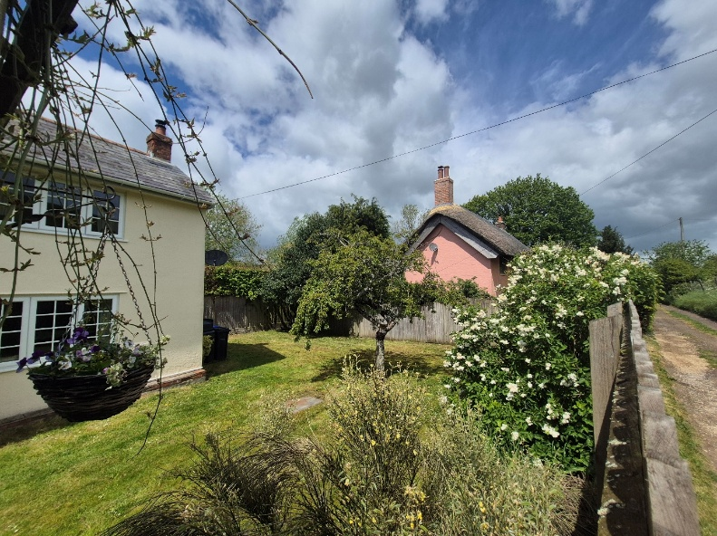
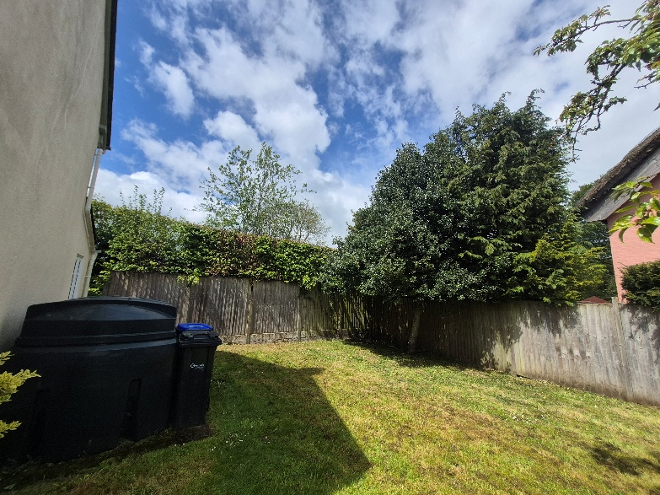

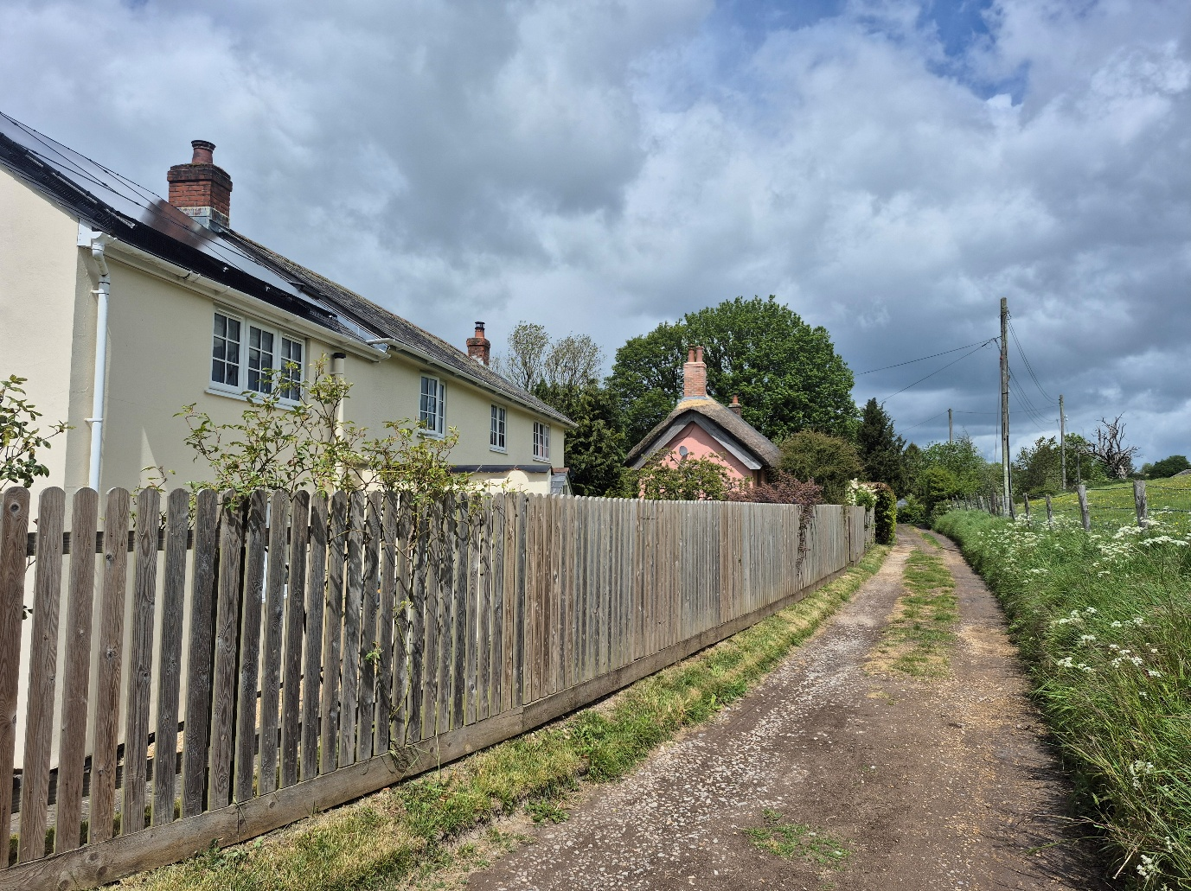

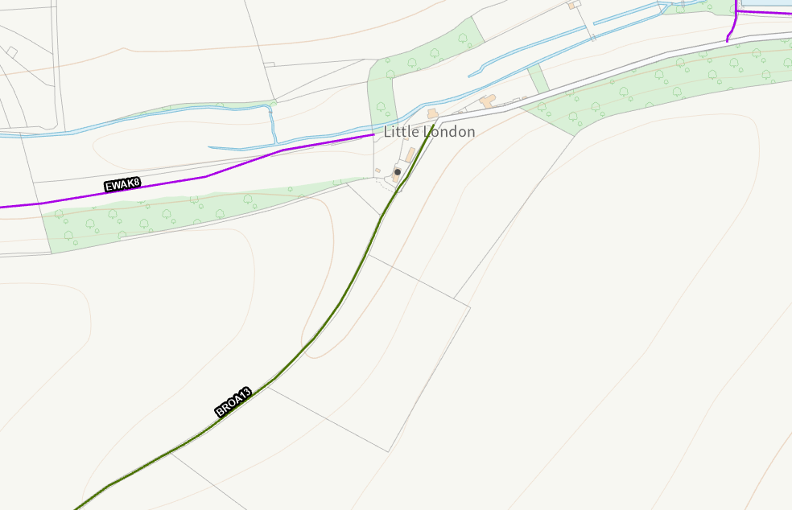

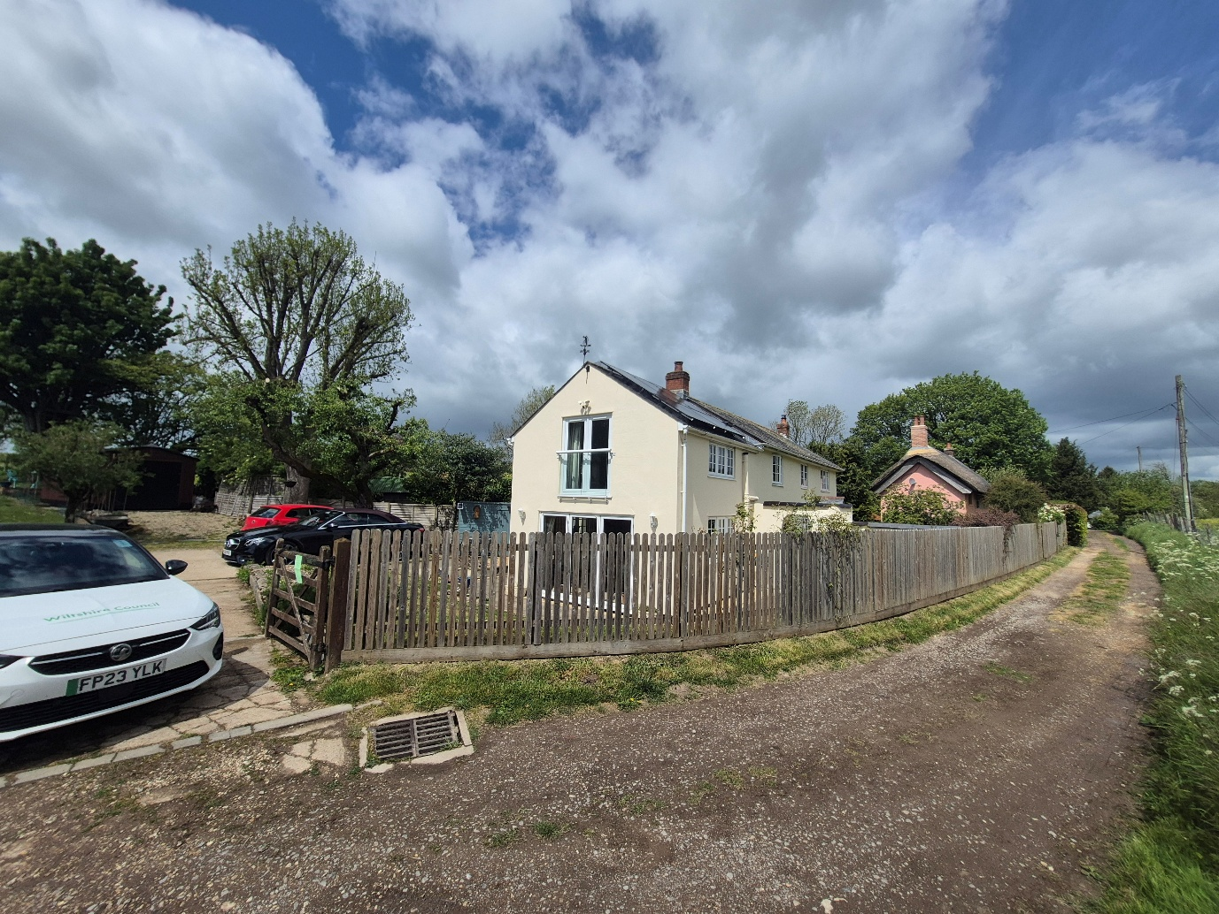Rights of Way and Highways Impact
Core Policy 57 (xiv) of the Wiltshire Core Strategy seeks to ensure that development must meet the requirements of Core Policy 61. This policy requires proposals to be capable of being served by safe access to the highway network. Core Policy 64 seeks to ensure compliance with parking standards set out in the Local Transport Plan.

The National Planning Policy Framework (NPPF), particularly Paragraph 115 and 116, requires that development proposals do not have an unacceptable impact on highway safety and that safe and suitable access to the site can be achieved for all users.

As is highlighted above, the application site is bordered and accessed from an unclassified road which becomes a rights of way bridleway BROA13. The application site has an existing driveway access from the on the south of the host dwelling. This application proposes to create a new vehicular access on the north of the host dwelling.

The highways officer has been consulted on the application and has no objection to the proposed development subject to conditions. Their consultation response is as follows:

The site is located at the end of an adopted no through unclassified public road that turns into Bridleway BROA13 just after the site, therefore it is likely that the route onto which the proposed driveway will exit will be used by walkers, dogs and horses, it is therefore important that inter-pedestrian visibility is provided from the proposed new vehicle access. The width of the access is approximately 10m and therefore I am satisfied that providing vehicles exit from the centre of the access, inter-pedestrian visibility will be adequate.

The highway at the point of the proposed access is relatively narrow being approximately 3m in width and I would not want vehicles to have to perform shunting manoeuvres to turn out of the driveway, however as the driveway is wide, vehicles should be able to make this manoeuvre easily. I raise no highway objection providing conditions are imposed.

The rights of way officer were consulted on this application and no correspondence was received. Access to the site is through Bridleway BROA13, while the application proposes a new access and driveway and proposes to close the existing access and driveway to the host dwelling, it is considered that there is no proposed additional impact to the rights of way road as the proposal would result in 1 access to the host dwelling which is similar to the existing access, as such it is not considered that the proposed works would warrant a refusal subject to the conditions and informative attached to this decision.

The proposed development would not result in any adverse impact on highway safety. Adequate parking and turning provision is provided in accordance with Wiltshire’s adopted parking standards, and access arrangements are acceptable.

The proposal is therefore considered to comply with Core Policies 57 (xiv), 61 and 64 of the Wiltshire Core Strategy, the NPPF, and the Wiltshire Local Transport Plan.

National Landscape
Core Policy 51 of the Wiltshire Core Strategy requires all development to protect, conserve, and where possible enhance the character and quality of Wiltshire’s landscapes, giving particular weight to designated areas such as National Landscapes.

The National Planning Policy Framework (NPPF), in Paragraph 176, states that “great weight” should be given to conserving and enhancing landscape and scenic beauty in National Landscapes (formerly Areas of Outstanding Natural Beauty). Development within or affecting the setting of a National Landscape must demonstrate that it will not result in unacceptable harm to the special qualities of that area.

The application is for a proposed extension to an existing residential dwelling and lies within the established residential curtilage of the dwelling. The proposal, by virtue of its scale, siting, and design, would not harm the special qualities or scenic character of the Cranborne and Chase National Landscape.

The development therefore complies with Core Policy 51 of the Wiltshire Core Strategy and Paragraph 176 of the NPPF in conserving and enhancing the National Landscape.

Biodiversity Net Gain

Householder planning applications are exempt from the requirement to deliver Biodiversity Net Gain under Schedule 7A, Section 4(2)(a) of the Town and Country Planning Act 1990, as inserted by the Environment Act 2021.

CONCLUSION

The proposed development is considered to be acceptable in terms of its design, scale, and relationship with the surrounding area. It would not result in any unacceptable harm to the character of the locality, the amenities of neighbouring occupiers, or the interests of highway safety, heritage, or ecology.

The proposal is therefore considered to comply with the relevant policies of the Wiltshire Core Strategy, the Wiltshire Local Plan, and the National Planning Policy Framework. As such, the application is recommended for approval, subject to the conditions set out below.

RECOMMENDATION: That Planning Permission be GRANTED subject to conditions.

1.The development hereby permitted shall be begun before the expiration of three years from the date of this permission.

REASON: To comply with the provisions of Section 91 of the Town and Country Planning Act
1990 as amended by the Planning and Compulsory Purchase Act 2004.

2.The development hereby permitted shall be carried out in accordance with the following
approved plans:

Location Plan Received: 30 March 2026
Design Statement Received: 30 March 2026
Existing and Proposed Details Drawing Ref: 561-10 Received: 30 March 2026
REASON: For the avoidance of doubt and in the interests of proper planning.

3.Materials to be used in the construction of the works hereby permitted shall be as stated on
the application form and submitted documents.

REASON: In the interests of visual amenity and the character and appearance of the area.

4. The development hereby permitted shall not be first brought into use until the first 2m of the access, measured from the edge of the carriageway, has been consolidated and surfaced (not loose stone or gravel). The access shall be maintained as such thereafter.
REASON: In the interests of highway safety.

5. The vehicle access, parking spaces and car port shall remain ungated.

REASON: In the interests of highway safety.

6. No development shall commence on site until details of the stopping up of the existing vehicular access, have been submitted to and approved in writing by the Local Planning Authority. That stopping up shall take place in accordance with the approved details within one month of the first occupation or use of the development. No later than one month after the first occupation of the development, the sole means of vehicular access to the development shall be as shown on the plans hereby approved.

REASON: In the interests of highway safety.
Informative
The application involves the creation of a new vehicle access. The consent hereby granted shall not be construed as authority to carry out works on the highway. The applicant is advised that a licence will be required from Wiltshire’s Highway Authority before any works are carried out on any footway, footpath, carriageway, verge or other land forming part of the highway. Please contact our Vehicle Crossing Team on vehicleaccess@wiltshire.gov.uk and/or 01225 713352 or visit their website at http://wiltshire.gov.uk/highways-streets to make an application.

The applicant should note that it is a criminal offence to obstruct a public right of way under section 137 of the Highways Act 1980 and therefore no materials, plant, temporary structures or excavations of any kind should be deposited / undertaken which obstruct or adversely affect the public right of way BROA13 whilst development takes place, without prior consultation with, and the further permission of, the highways authority at Wiltshire council.

