APPLICATION FOR FULL PLANNING PERMISSION DELEGATED REPORT

APPLICATION REFERENCE: | PL/2026/02272
APPLICATION TYPE: | Full planning permission
SITE ADDRESS: | Building PCB768, Headquarters Road, Bulford Camp, Salisbury, SP4 9NY
DEVELOPMENT DESCRIPTION: | Retention of temporary office building (PCB768) in Bulford Camp for a further 5 years
RECOMMENDATION: | That Planning Permission be GRANTED

PROPOSAL

The proposal seeks planning permission for the retention and renewal of temporary permission of a temporary office building for a further 5 years. The office building is a large two storey flat roof building as shown below in the existing elevations and plans, there are no physical works proposed. Existing plans and elevations shown below.

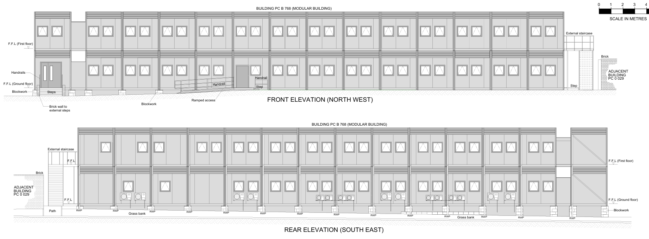

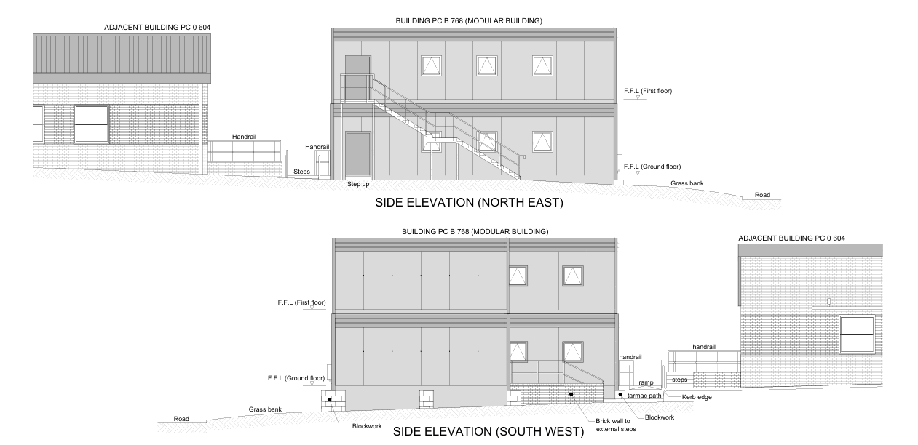

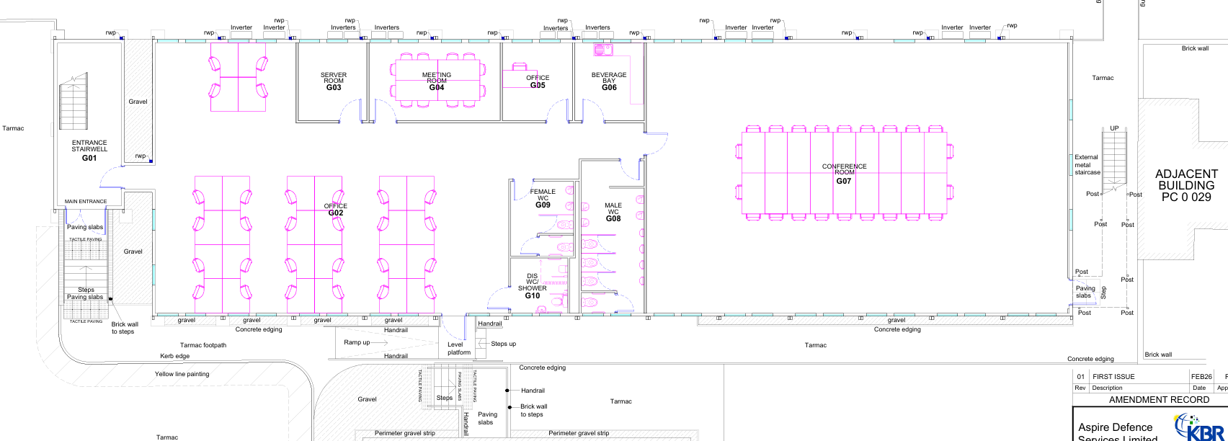

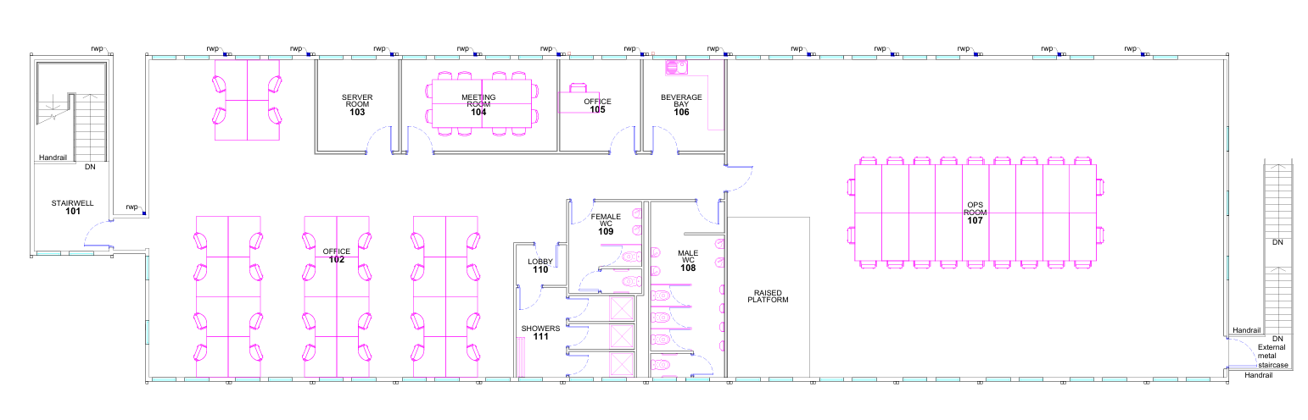

The applicant has confirmed that the need for the further 5 years for the approved temporary building as follows –

Due to the ongoing operational military requirements, there is a need to retain the building in situ pending cessation of its current use.

SITE DESCRIPTION/CONTEXT

The application site relates to an existing temporary office building located within a well-established Army complex at the Bulford Camp.

PLANNING HISTORY

Proposal / Summary
15/05950/FUL - Full planning permission Decision - Approve with Conditions Date: 29/4/2016 – Outline planning permission for new build Intermediate Healthcare facility (WD0640), Pre-School (WD0650), Training building (WI0610), 2 Office Buildings (WI0611 & WI0617), Live Out Changing facility (WI0649), 3 Technical Stores (WI0614, WI0615 and WI0620)
15/12663/FUL - Full planning permission Decision - Approve with Conditions Date: 14/4/2016 – Proposed construction of two storey temporary office building, with associated works
16/09267/DEM - Demolition Details Decision - Prior Approval Not Required Date: 21/10/2016 – Prior notification for the demolition of single storey stores and metal storage shelters
17/05700/REM - Reserved Matters Decision - Approve with Conditions Date: 29/8/2017 – All Reserved Matters for three new build Garages (WI0616, WI0618 and WI0619), together with associated external works, including hardstanding and landscaping
19/04749/DOC - Approval of details reserved by a condition Decision - Approved Date: 3/6/2019 – Discharge of condition 11 of 15/05950/FUL
19/11427/DOC - Approval of details reserved by a condition Decision - Approved Date: 23/1/2020 – Discharge of Condition 9 & 10 of planning application 15/ 05950/FUL
20/04105/DOC - Approval of details reserved by a condition Decision - Approved Date: 14/7/2020 – Discharge of conditions 7, 8, 12 & 16, application reference 15/05950/FUL.
PL/2023/02417 - Non-Material Amendment Decision - Approve with Conditions Date: – Non-Material Amendment to planning application 15/05950/FUL - Car parking (Outline planning permission for new build Intermediate Healthcare facility)
S/2002/1984 - Outline Planning Decision - Approve with Conditions Date: 17/4/2003 – PROPOSED REDEVELOPMENT OF BULFORD BARRACKS
S/2003/1796 - Outline Planning Decision - Approve with Conditions Date: 12/12/2003 – REDEVELOPMENT OF MILITARY BARRACKS IN CONNECTION WITH PROJECT ALLENBY/CONNAUGHT: NEW DOMESTIC ACCOMMODATION TO PROVIDE EACH SOLDIER WITH 'Z' STANDARD ACCOMMODATION (SINGLE EN-SUITE ROOMS) SINGLE STOREY SNCOS' 'PAIRED' MESS ON THE SOUTHERN EDGE OF THE P
S/2003/2134 - Reserved Matters Decision - Approve with Conditions Date: 9/2/2004 – A SOLDIERS VILLAGE COMPRISING FLATS AND TERRACED ACCOMMODATION IN EAST BULFORD AND A SMALLER VILLAGE IN WEST BULFORD TO CREATE Z STANDARD ACCOMMODATION (INDIVIDUAL ROOMS WITH ENSUITE FACILITIES) AND INCORPORATED JUNIOR RANKS PUBS DINING CENTRES AND SPORT
S/2004/1772 - Reserved Matters Decision - Approve with Conditions Date: 27/10/2004 – CONSENT FOR A RESERVED MATTER APPLICATION FO THE TRANCHE 1 REDEVELOPMENT OF THE REDEVELOPMENT OF THE BULFORD MILITARY ESTABLISHMENT OF THE PROJECT ALLENBY/CONNAUGHT. THIS RESERVED MATTER APPLICATION DIFFERS FROM THE PREVIOUS (03/2134) DUE TO VARIATION IN
S/2004/1806 - Removal/variation of conditions Decision - Approve with Conditions Date: 27/10/2004 – VARIATION OF CONDITION 3 OF S/2003/1796 TO REDEVELOP MILITARY BARRACKS IN CONNECTION WITH PROJECT ALLENBY
S/2005/1616 - Full planning permission Decision - Approve with Conditions Date: 30/12/2005 – AMENDMENT TO BUILDING PC0604 OFFICE EXTENSION TO HG3DIV AS PART OF PROJECT ALLENBY/ CONNAUGHT

RELEVANT POLICIES AND GUIDANCE

The National Planning Policy Framework (NPPF)
The Planning Practice Guidance
National Design Guide

Wiltshire Core Strategy adopted by the Council in January 2015.

Core Policy 37 Military establishments
Core Policy 50 Biodiversity
Core Policy 57 Ensuring high quality design and place shaping
Core Policy 61 Transport and new development

Wiltshire Design Guide
Creating Places Design Guide

CONSULTATION RESPONSES

Parish Council: None received

Highways: No objection

REPRESENTATIONS

No comments were received.

ASSESSMENT

Section 38(6) of the Planning and Compulsory Purchase Act 2004 states:

"If regard is to be had to the development plan for the purposes of any determination to be made under the planning Acts, the determination must be made in accordance with the plan unless material considerations indicate otherwise."

In accordance with this statutory requirement, this application has been assessed against the relevant policies of the Development Plan, including the adopted Wiltshire Core Strategy (2015) and, where applicable, any made Neighbourhood Plans.

Impact of development

The application seeks permission for the retention and renewal of a temporary office building within the established Bulford Camp military garrison for a further period of five years. The building was originally granted permission under application ref. 15/12663/FUL for a temporary period of 10 years, with a condition requiring its removal by 16 April 2026. The proposal therefore seeks to extend the operational life of an existing and established element of the site. The building forms part of a wider programme of development associated with the restructuring of the Army estate across the Salisbury Plain Training Area (SPTA), which has necessitated the provision of additional operational facilities within key garrison locations, including Bulford.

By way of background, in March 2013 the Secretary of State for Defence announced the Regular Army Basing Plan, which set out the future disposition of Army units returning from Germany and the transition towards the Army 2020 operating model. This has since been progressed through the Army Basing Programme (ABP), which seeks to optimise the UK defence estate, including a greater concentration of forces within the SPTA. This has resulted in a series of developments across Bulford, Tidworth, Larkhill, Perham Down and Ludgershall to accommodate increased personnel, infrastructure and associated operational requirements. Core Policy 37 of the Wiltshire Core Strategy explicitly acknowledges this programme and supports the provision of operational facilities and infrastructure on MOD land where required to meet defence needs. The policy envisaged the delivery of development through a comprehensive masterplan approach, which was completed in June 2014 and subsequently endorsed by the Council.

In this context, the continued retention of the temporary office building is considered to align with the strategic objectives of Core Policy 37, in that it supports the ongoing operational needs of the military establishment within a designated garrison location. The proposal represents a modest and established component of the wider development framework already anticipated by the ABP and its associated master plan. Furthermore, the building has been in situ for approximately 10 years and remains compatible with the character and function of the wider military site. As such, it is considered to comply with the requirement of Core Policy 37 to ensure that development within military establishments is appropriate in scale, enhances the overall character of the site, and does not result in unacceptable impacts.

The proposal has also been assessed against Core Policy 57 (Ensuring High Quality Design and Place Shaping), which applies to all forms of development. While the building is of a temporary and utilitarian form, this is reflective of its functional role within a secure military environment, where design expectations differ from those in civilian contexts. The structure is of an appropriate scale, siting and appearance relative to its surroundings, and does not detract from the overall character of the garrison. In particular, the proposal is considered to meet the aims of Core Policy 57, in that it sits comfortably within its setting and contributes to a coherent and functional environment.

In amenity and highways terms, the proposal is acceptable when assessed against the requirements of Core Policy 57 and 61. The site is located within a secure and self-contained military establishment, where the nature of activity and access arrangements are established and controlled. The office use is not of a scale or type that would give rise to unacceptable levels of noise, disturbance, overlooking or loss of privacy, and the building is sufficiently separated from sensitive receptors. In addition, the development does not give rise to any material impact on the local highway network, with traffic movements remaining negligible in the context of the wider garrison. Accordingly, the proposal would not result in any unacceptable impacts on amenity, the environment or transport infrastructure.

Taking all matters into account, the proposal is considered to comply with the provisions of Core Policy 37 in supporting necessary military development, while also meeting the requirements of Core Policy 57 and Core Policy 61. The proposal represents a continuation of an established and acceptable use and is therefore considered acceptable for a further temporary period of five years.

Biodiversity Net Gain

Biodiversity Net Gain - From 12 February 2024 Biodiversity Net Gain (BNG) became mandatory under Schedule 7A of the Town and Country Planning Act 1990 (as inserted by Schedule 14 of the Environment Act 2021). Based on the information available the biodiversity gain planning condition is not considered to apply to this application as the proposal is for the retention of an existing temporary building that does not impact a priority habitat and impacts less than 25 square metres (5m by 5m) of on-site habitat.

As such, the development complies with Core Policy 50 of the Wiltshire Core Strategy and the relevant provisions of the NPPF.

CONCLUSION

The proposed retention and renewal of the temporary office building for a further five-year period is considered acceptable. The development supports the ongoing operational needs of Bulford Camp, is appropriate in scale and design within its military context, and would not result in unacceptable impacts on amenity, highway safety or the wider environment

The proposal is therefore considered to comply with the relevant policies of the Wiltshire Core Strategy, the Wiltshire Local Plan, and the National Planning Policy Framework. As such, the application is recommended for approval, subject to the conditions set out below.

RECOMMENDATION: That Planning Permission be GRANTED subject to conditions.

1. The temporary building hereby permitted shall be permanently removed from the site and the land restored to its former condition within 5 years of the date of this planning permission.
REASON: To ensure a satisfactory standard of development in the interests of visual amenities and in recognition of the temporary nature of the permitted building.
2. The development hereby permitted shall be carried out in accordance with the following approved plans, all received 07/05/2026:
Application form
Location plan Drg no 3-PCB768-XX-AR-0591 01
Existing site plan Drg no 3-PCB768-XX-AR-0590 01
Existing Ground Floor Plan Drg no 3-PCB768-00-AR-0588 01
Existing First Floor Plan Drg no 3-PCB768-01-AR-0589 01
Existing Building Elevations Drg no 3-PCB768-XX-AR-0587 01

REASON: For the avoidance of doubt and in the interests of proper planning

