APPLICATION FOR A CERTIFICATE OF LAWFULNESS FOR PROPOSED USE OR DEVELOPMENT

APPLICATION REFERENCE: | PL/2026/02069
APPLICATION TYPE: | Lawful development: Proposed use
SITE ADDRESS: | 4 Manor Farm Lane, Patney, Devizes, SN10 3RB
DEVELOPMENT DESCRIPTION: | Proposed caravan
RECOMMENDATION: | REFUSE

PROPOSAL
This application seeks a Certificate of Lawfulness (CLP) under Section 192 of the Town and Country Planning Act 1990 (as amended) for the siting of a proposed caravan to provide ancillary domestic accommodation within the garden of a dwelling house.

The proposed site plan, as shown below outlines where the proposed caravan unit would be sited, on the position of the existing garage to the side/rear of the dwelling.

Location plan and proposed site plan
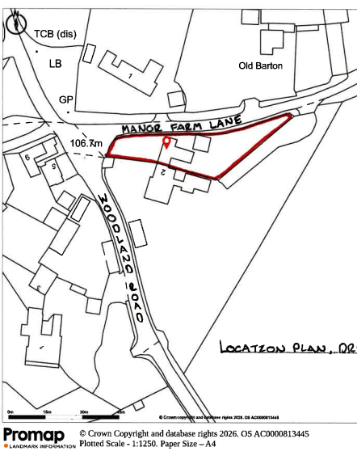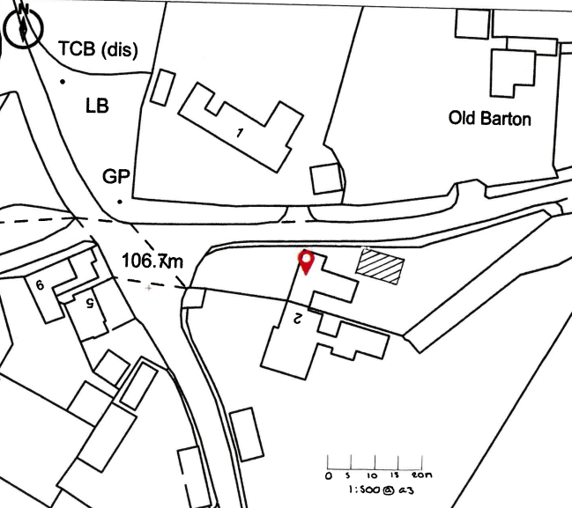

The planning merits of the proposal are not under consideration. A Certificate of Lawfulness must only confirm that a specific, precisely described development would be lawful if carried out. This is a legal test, not a planning merits judgment. Under section 192(1) of the Town and Country Planning Act 1990, a CLP may only be granted where the LPA is satisfied that: “the proposed use or development would be lawful if instituted or begun at the time of the application.”

SITE DESCRIPTION
The application relates to 4 Manor Farm Lane, Patney, a semi-detached dwelling, with associated garage, parking and access to the side (north elevation) of the site, off Manor Farm Lane. The property has a large rear garden (to the east) which is generally level, and is bordered by a predominantly mature hedgerow and some timber fencing. The application site is within the built form of the small village of Patney. There are residential neighbours to the west, north and south, and open countryside to the east.

The application site is subject to the following planning policy constraints:
- North Wessex Downs National Landscape
- Grade II Listed Building 40 metres to the northeast of the site
- Groundwater Flood Risk: Groundwater levels are either at or very near (within 0.025m of) the ground surface
- Risk of Flooding from Surface Water 1 in 100 + Climate Change (40%) along site access
- Salisbury Plain SPA - 6400m Buffer
These constraints are noted for completeness only and do not form part of the assessment, as planning merits and policy considerations are not material to the determination of this application.

THE EVIDENCE SUBMITTED IN SUPPORT OF THE APPLICATION
- Application form
- Covering Letter
- Location plan
- Site plan
- Floor Plan and Elevations
- Planning Statement
- Construction and Mobility Tests
- Case Law
- Supporting Applications
- Agents further emails

RELEVANT LEGISLATION AND POLICY
The statutory framework governing CLP’s is set out in Section 192 of the Town and Country Planning Act 1990 (as amended). This section establishes that a proposed development or use is "lawful" if it would not constitute a breach of planning control. A CLP can be granted if the Local Planning Authority is satisfied, on the balance of probabilities, that the proposed development or use would not require planning permission.

Town and Country Planning Act 1990 (as amended):
- Section 55 (1)
- Sections 191-193

Also, of relevance –
- Caravan Sites & Control of Development Act 1960,
- Caravan Sites Act 1968 (Definition of Caravan) (Amendment) (England) Order 2006)

LEGISLATION / PLANNING PRACTICE GUIDANCE
Section 55 (1) Subject to the following provisions of this section, in this Act, except where the context otherwise requires, “development,” means the carrying out of building, engineering, mining or other operations in, on, over or under land, or the making of any material change in the use of any buildings or other land.

Section 192(1) of the Act outlines that “if any person wishes to ascertain whether—
(a) any proposed use of buildings or other land; or
(b) any operations proposed to be carried out in, on, over or under land, would be lawful, he may make an application for the purpose to the local planning authority specifying the land and describing the use or operations in question.

Section 192(2) of the Act outlines that “if, on an application under this section, the local planning authority are provided with information satisfying them that the use or operations described in the application would be lawful if instituted or begun at the time of the application, they shall issue a certificate to that effect; and in any other case they shall refuse the application.

REPRESENTATIONS

There is no legal obligation to consult third parties, including Town/Parish Councils or neighbouring properties, for this type of application.

RELEVANT SITE HISTORY
The site has the following relevant planning history:

Proposal / Summary
K/20671 - Full planning permission Decision - Approve with Conditions Date: 23/9/1993 – EXTENSION TO DWELLING
K/82/0438 - Full planning permission Decision - Approve with Conditions Date: 29/7/1982 – Alterations and extension
K/81/1129 - Full planning permission Decision - Approve with Conditions Date: 21/1/1982 – Extension to house and erection of garage

ASSESSMENT

The Local Planning Authority needs to consider whether, on the facts of the case and relevant planning law, the specific matter is or would be lawful. Planning merits are not relevant at any stage in this particular type of application or appeal process. Views expressed by third parties on the planning merits of the case, or on whether the applicant has any private rights to carry out the operation, use, or activity in question, are therefore irrelevant when determining the application.

This Lawful Development Certificate for Proposed Use relates to the proposed siting of a caravan (in this instance a timber frame unit) within the curtilage of an existing dwelling to operate as ancillary to the use of the main dwelling.

The proposed caravan unit would be sited within the garden of the host dwelling on the location of an existing double garage. The proposed caravan unit would measure 9.14m in length, 5.675m wide and the under side of the ceiling internally would be 3m as set out in the Proposed Plans and Cross Section submitted in support of the application. The proposal does not include the provision of any separate curtilage, access or parking for the caravan.

In order to facilitate the siting of the caravan unit the existing garage would have to be removed from site. It is noted that the demolition of the existing garage would require prior approval. By virtue of section 55(1A)(a) of the Town and Country Planning Act 1990, the demolition of a building constitutes operational development. In this case, the removal of the existing garage would fall within Part 11, Class B of Schedule 2 to the GPDO and is subject to the requirement for prior approval.

It is considered that the demolition of the garage forms an integral and necessary component of the proposed development. Such demolition constitutes operational development requiring prior approval under the GPDO. In the absence of that approval, the development would not be lawful if carried out at the time of determination. Although certain demolitions may constitute permitted development subject to prior approval, the requirement for prior approval is a condition which must be satisfied before the permitted development right can be exercised. Until such approval is granted, the demolition cannot lawfully be carried out. Section 192 requires the Local Planning Authority to be satisfied that the proposed development, taken as a whole, could be carried out lawfully at the time of determination, and not on the basis of assumed or contingent future approvals. Accordingly, the proposal fails to meet the statutory test under section 192 and the application should be refused.

The applicant was invited to withdraw the application to address this issue but declined to do so. No conclusion is reached on whether the proposed caravan would otherwise meet the statutory definition of a caravan or benefit from permitted development rights, as even if those matters were resolved in the applicant’s favour, the proposal would still fail the statutory test under section 192 due to its dependence on demolition works that are not currently lawful.

Conclusion
A Certificate of Lawfulness can only be granted where the Local Planning Authority is satisfied that the entire sequence of works necessary to implement the proposal is lawful at the time of determination. In this case, the proposed siting of the caravan is inseparable from the prior demolition of the existing garage, which itself requires prior approval that has not been obtained.

In reaching this conclusion, the Local Planning Authority has had regard to established Planning Inspectorate practice in relation to certificates of lawfulness, which consistently confirms that a certificate under section 192 of the Town and Country Planning Act 1990 can only be granted where the decision‑maker is satisfied that the proposed development could be carried out lawfully at the time of determination. Inspectors have repeatedly found that a certificate cannot be issued where the proposal is dependent upon other operational development that is not itself lawful at that point, or where its implementation would rely upon future or assumed consents. The Authority has therefore correctly assessed the proposal as a whole and has not proceeded on the basis of hypothetical or contingent circumstances. Accordingly, the Authority cannot lawfully issue a certificate on the basis of a development scenario that is contingent upon future procedural steps or approvals.

RECOMMENDATION
It is recommended that the Certificate of Lawfulness for Proposed Development be REFUSED for the following reasons:

Reason for Refusal
The application seeks a Certificate of Lawfulness of Proposed Use or Development under section 192 of the Town and Country Planning Act 1990 in respect of the siting of a caravan on the land shown on the submitted plans.
Section 192 requires the Local Planning Authority to be satisfied that the proposed operations would be lawful if carried out at the time of the application. In this case, the proposed siting of the caravan is dependent upon the prior demolition of the existing garage currently occupying the site. The demolition of that building constitutes operational development within the meaning of section 55 of the Act and, in this instance, requires prior approval under Part 11, Class B of Schedule 2 to the Town and Country Planning (General Permitted Development) (England) Order 2015.
At the time of determination, no such prior approval has been granted. As a result, the works necessary to facilitate the proposal are not currently lawful. A certificate of lawfulness cannot be issued on the basis of assumed or prospective future consents, and the Local Planning Authority must consider the lawfulness of the proposal as a whole, rather than in isolation.
Accordingly, the Local Planning Authority is not satisfied that the proposed development would be lawful if carried out at the time of the application, and the statutory test under section 192 of the Town and Country Planning Act 1990 has not been met.

