APPLICATION FOR VARIATION/REMOVAL OF CONDITION
CASE OFFICER REPORT

APPLICATION REFERENCE: | PL/2026/01057
APPLICATION TYPE: | Removal/variation of conditions
SITE ADDRESS: | 5A COXHILL LANE, POTTERNE, DEVIZES, SN10 5PH
DEVELOPMENT DESCRIPTION: | Variation of condition 2 (Approved Plans) relating to application PL/2024/08330
RECOMMENDATION: | Approve with Conditions

SITE DESCRIPTION/CONTEXT

The site lies within the settlement limits of Potterne on a plot of land used for parking cars and to the south of 5a Coxhill Lane. The site is located within a mainly residential area with residential development to the north, east, south and west. No’s 1a and 3 Coxhill Lane are detached bungalows while No’s 5a and 5b are detached 2 storey properties. The adjacent property at 5 Coxhill Lane is a dormer bungalow.

The Potterne Conservation area is located to the north and west of the site (30 metres distant at its closest). Cosy Cottage, 10, Coxhill Lane, a grade II listed building is located directly to the southeast of the site. Listed buildings fronting High Street are located 60 metres to the west. Public footpaths POTT139 and POTT21 are located to the south and west of the site. The site is also located within the Salisbury Plain Special Protection Area (SPA).

The site is not located within flood zones 2 or 3 and is not susceptible to ground water flooding.

However, over 10% of the site is subject to 1:1000 surface water flood risk.

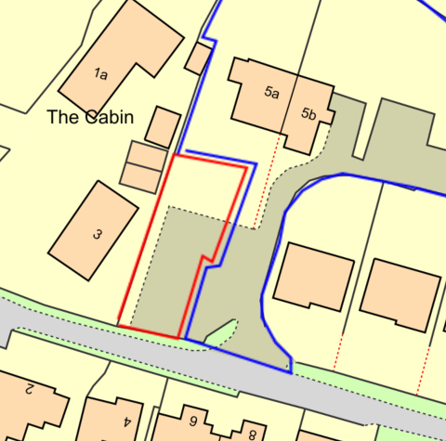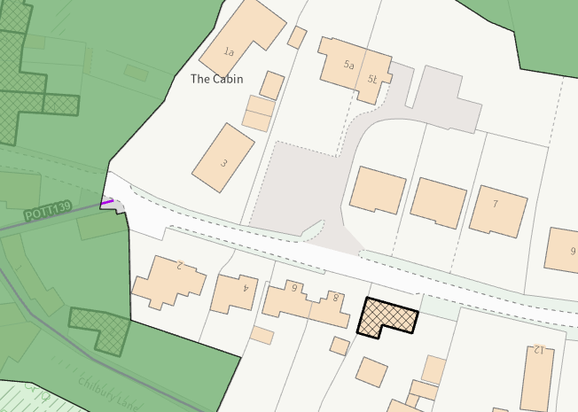

Site Location Plan and Council Image showing the PRoWs and conservation area (green) and listed buildings (black hatching)

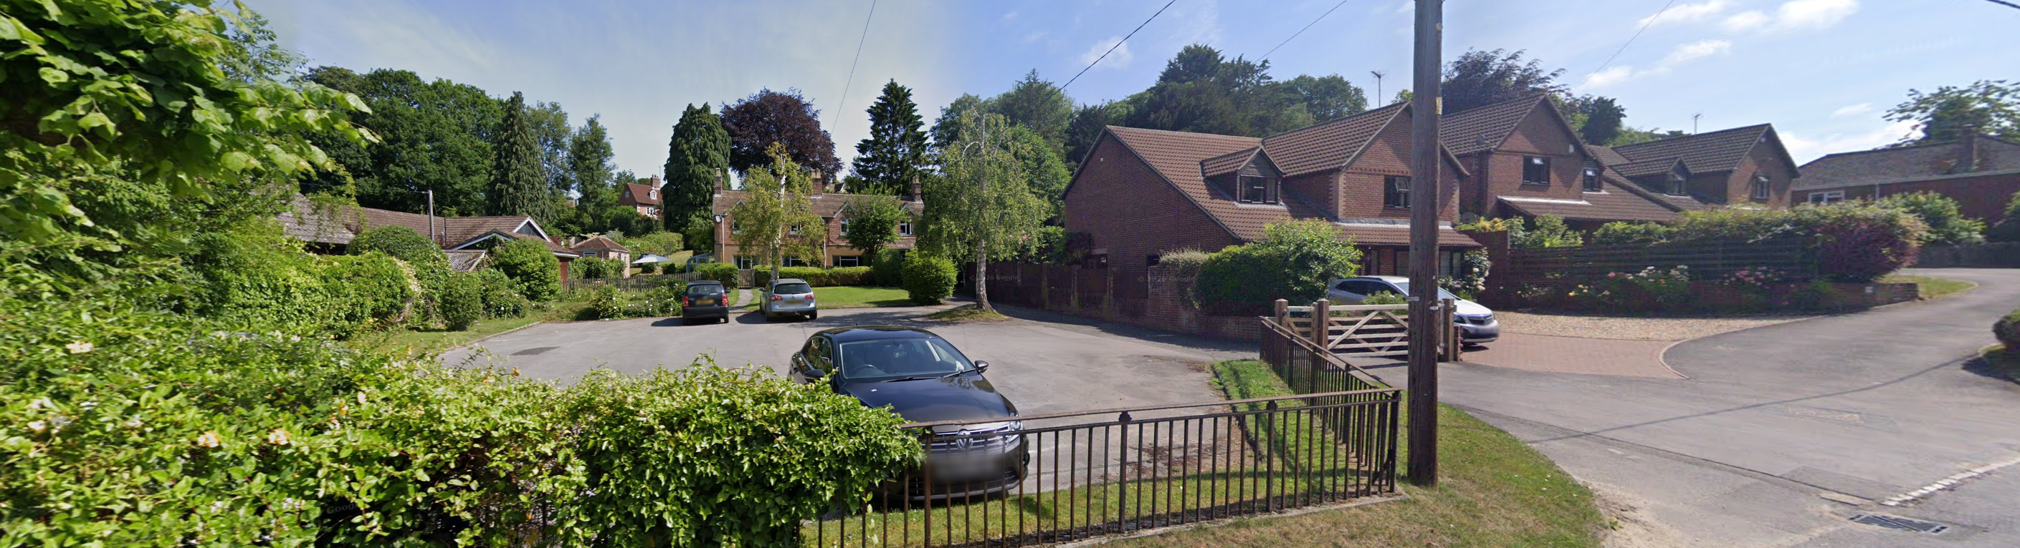

June 2025 Google Street View Image of the site and No 7a to the left

PROPOSAL

This report considers a Section 73 application for the variation condition(s) imposed on planning permission PL/2024/08330. The application relates to the site at 5a Coxhill Lane, Potterne, and seeks to vary condition 2, the approved plan list in relation to the buildings position within the site, ridge height, general design including the fenestration design and car parking layout. The proposal remains a self-build development.

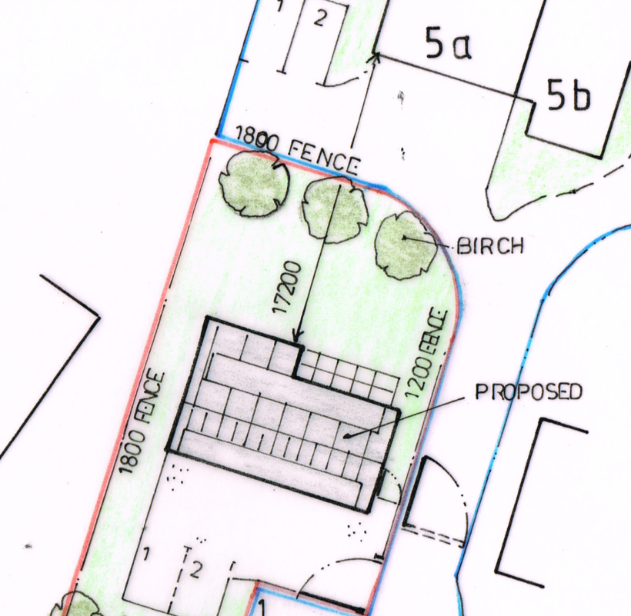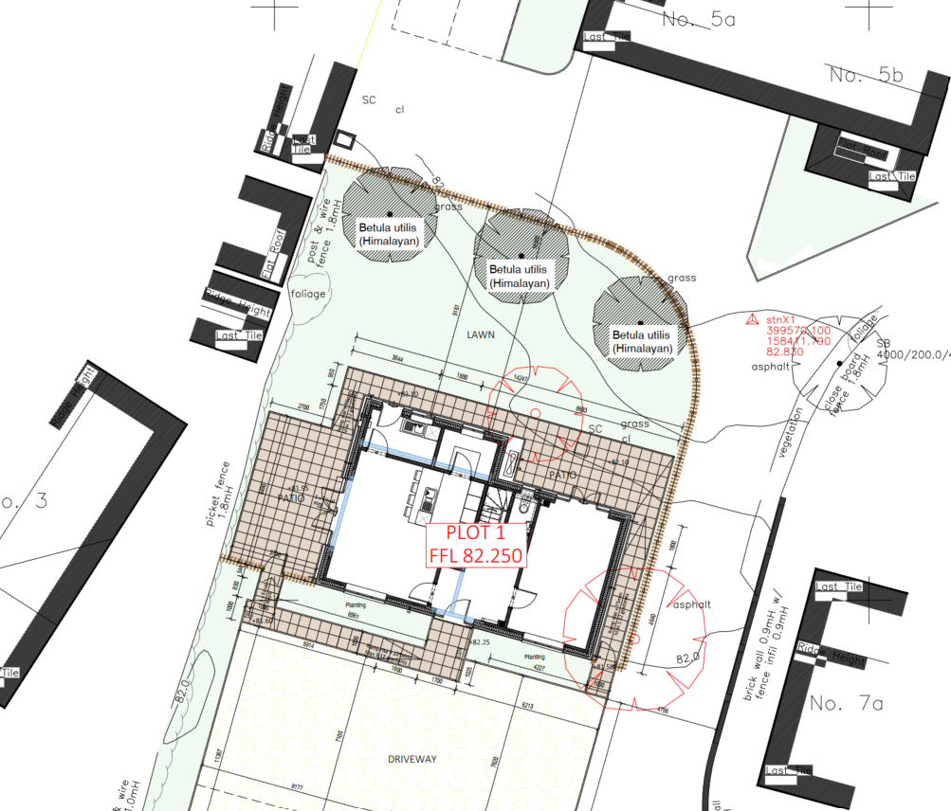

Originally approved Site Plan and Proposed Site Plan

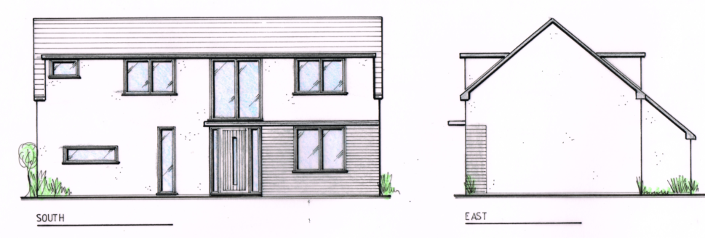

Originally approved Front and East Side Elevation

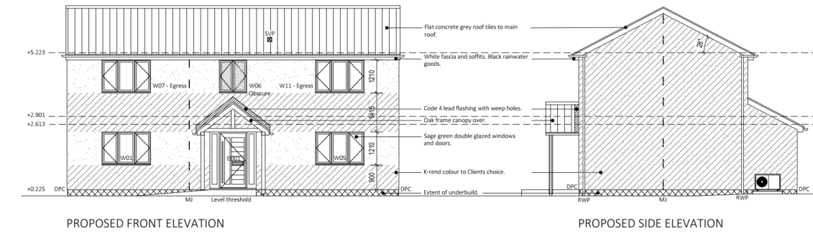

Proposed Front and East Side Elevation

The changes include;

- Move the plot back circa 700mm deeper into the site so that the rear wall would be 16.5m from No 5a rather than 17.2m

- Increase the ridge height from 6.31m high to 6.9m high

- Change the roof design to remove the large front and rear dormers and replace with a single pitched roof. The eaves therefore have increased from 4.8m to 5.15m

- Removal of asymmetric contemporary fenestration design and porch to traditional windows on a balanced front elevation. Introduction of a centrally places front door and porch canopy

-Changes to the soft landscaping (birch trees removed for Betula Utilis (Himalayan) and introduction of planting to the front of the dwelling, reducing driveway size

- Turning the 3 car parking spaces for No 6, 90 degrees so they share the same driveway as the proposed dwelling

- Change the 1m high railing on the front boundary with the main road to 1m high timber picket fence

For the avoidance of doubt, the elevation plans show that the main footprint of the dwelling will remain (c12.1m x 6.15m).

RELEVANT PLANNING HISTORY

PL/2024/08330 Erection of detached 3-bedroom self-build dwelling – Approved subject to conditions and a Unilateral Undertaking legal agreement. It is important to note that the legal agreement relates to PL/202/08330 and any variation of planning permission. Therefore, the legal agreement does not need to be amended to include this application.

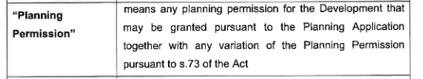

PL/2026/00996 - charge of conditions 5 (hard & soft landscaping) and 9 (surface water drainage) on PL/2024/08330 – Approved – 23 April 2026

RELEVANT LEGISLATION, POLICIES AND GUIDANCE

Town and Country Planning Act. 1990 (as amended)

Section 73 of the Town and Country Planning Act. 1990 (as amended) relates to the determination of applications to develop land without compliance with conditions previously attached. It states that:

(2) On such an application the local planning authority shall consider only the question of the conditions subject to which planning permission should be granted, and—

- if they decide that planning permission should be granted subject to conditions differing from those subject to which the previous permission was granted, or that it should be granted unconditionally, they shall grant planning permission accordingly, and

- if they decide that planning permission should be granted subject to the same conditions as those subject to which the previous permission was granted, they shall refuse the application.

The National Planning Practice Guidance (PPG) states the following:

- Nature of the Application: A Section 73 application is treated as a new planning permission, although it does not alter the original permission itself. The original permission remains intact and can still be implemented unless it has expired or been superseded.
- Limitations:
  - Section 73 cannot be used to change the description of development or the operative part of the permission (e.g. the nature or extent of the approved use).
  - It cannot be used to extend the time limit for implementing the original permission.
  - If the proposed changes go beyond what can reasonably be considered under Section 73, a new planning application under Section 70 would be required.
- Decision-making: The local planning authority must consider the application only in relation to the conditions subject to which the original permission was granted. However, it may impose new or revised conditions if granting a new permission.
- Legal Agreements: Because a Section 73 application results in a new permission, any existing Section 106 agreement may need to be varied or replaced via a deed of variation to ensure obligations continue to apply to the new permission.

National Planning Policy:

- National Planning Policy Framework (NPPF)
- Planning Practice Guidance (PPG)
Development Plan:

The development plan for Wiltshire comprises the Wiltshire Core Strategy (WCS) (adopted January 2015) and any made neighbourhood plans, which remains the principal statutory planning document guiding development across the county. In line with Section 38(6) of the Planning and Compulsory Purchase Act 2004, planning decisions must be made in accordance with the development plan unless material considerations indicate otherwise.

Though the development plan is considered as a whole, those parts deemed to be particularly relevant to this application are listed below:

The adopted Wiltshire Core Strategy (WCS), with particular regard to:

- Core Policy 1 Settlement Strategy;
- Core Policy 2 Delivery Strategy;
- Core Policy 12 Devizes Community Area
- Core Policy 50 Biodiversity and Geodiversity;
- Core Policy 57 Ensuring High Quality Design and Place Shaping;
- Core Policy 58 Ensuring the Conservation of the Historic Environment;
- Core Policy 61 Transport & Development;
- Core Policy 64 Demand Management
- Core Policy 67 Flood Risk;

Neighbourhood Plan: Potterne Neighbourhood Plan 2017

Supplementary Planning Documents:

Wiltshire Local Transport Plan 3 (2011- 2026) and Local Transport Plan 4 2025-2038
Wiltshire Local Transport Plan 2011- 2026: Cycling Strategy
Wiltshire Design Guide 2024 SPD
Wiltshire Strategic Flood Risk Assessments 2019 and 2024

ISSUES

The key considerations in the assessment of this application are as follows:

- Determining whether the proposed amendments fall within the scope of Section 73 of the Town and Country Planning Act 1990 which allows for the variation or removal of conditions attached to an existing planning permission.
- Assessing whether the development, as amended, remains in accordance with the relevant policies and provisions of the development plan, and whether the changes materially alter the nature or impacts of the approved scheme.

CONSULTATION RESPONSES

Potterne Parish Council: No objection to this Application provided there is imposed a condition that the proposed glass doors on the western side of the house cannot be seen from 3 Coxhill Lane because of the fence to be erected between the those two properties.

Wiltshire Council Drainage Officer: No objection

Pluvial risk was considered as part of our assessment of the discharge of Condition 9 (PL/2026/00996). For context here, based on the mapped pluvial flood extents we do not see that the proposed works would result in an increase in risk as the area shown at risk corresponds with existing hard standing.

Wiltshire Council Highways Officer: No objection

REPRESENTATIONS

Below is a summary of the representations received during the consultation period. Only material planning considerations have been taken into account in the assessment of this application. Non-material issues, such as property values or private legal disputes, cannot be considered in the determination process.

No comments received.

ASSESSMENT

Section 38(6) of the Planning and Compulsory Purchase Act 2004 states:

"If regard is to be had to the development plan for the purposes of any determination to be made under the planning Acts, the determination must be made in accordance with the plan unless material considerations indicate otherwise."

In accordance with this statutory requirement, this application has been assessed against the relevant policies of the Development Plan, including the Wiltshire Core Strategy (2015) and, where applicable, any made Neighbourhood Plans. Consideration has also been given to the policies of the National Planning Policy Framework (NPPF) as a material consideration in the assessment.

Principle of the Development – Do the proposed amendments fall within the scope of s73?

The proposed amendments have been reviewed and are considered to fall within the scope of Section 73 of the Town and Country Planning Act 1990. The changes do not result in a fundamentally different development from that originally approved, nor do they seek to alter the description of development or extend the time limit for implementation. As such, the application is valid under Section 73 and can be determined as a variation of condition(s) attached to the original planning permission.

The original application description read “Erection of detached 3 bedroom self-build dwelling” and was a detached two storey dwelling.

Whilst the position of the dwelling is being moved slightly and the height increased; these were not explicitly fixed in the applications description. The proposal remains a detached, two storey, 3-bedroom self build dwelling. The increase in height does not make the building look like a 3 storey or even a two and a half storey dwelling. There would be only 1.4m from the eaves to the underside of the ridge, meaning that a loft conversion (into additional accommodation space,) would be unlikely. Therefore, it is considered that the new dwelling is still firmly consistent with the original description, nor its appearance as a detached two storey dwelling.

Compliance with the Development Plan

Design:
It is considered that the proposal remains in full compliance with the development plan, most notably CP57 and CP58. The revised site location, height, vertical design and fenestration design is now more ‘traditional’ in appearance with simple gables ends and a balanced and symmetrical fenestration centred around a re-positioned front door and porch. This is more in keeping with its neighbouring properties, many of which have large projecting front gable ends and standard window details. Whilst PL/2024/08330 would have been an acceptable development for the plot and the street scene, this proposal would be more in keeping with its surroundings and the removal of the large dormer windows on both front and rear elevations, would be a further benefit.

Heritage Assets:
The setting of the listed building opposite would continue to be preserved, as would the character and appearance of the adjacent conservation area. No harm would be caused to the historic significance of the heritage assets.

Neighbouring Amenity:
Core Policy 57 of the Wiltshire Core Strategy requires a high standard of design in all new developments and that development has regard to the compatibility of adjoining buildings and uses, the impact on the amenities of existing occupants and ensuring that appropriate levels of amenity are achievable within the development.

The impact on neighbouring amenity has been carefully reassessed in light of amendments to the building’s siting and increased height. In the delegated report for application PL/2024/01057, the case officer concluded that, overall, the proposal would not give rise to unacceptable harm. While some limited loss of light was identified to the rear, east-facing garden of No. 3 Coxhill Lane during early morning hours, this impact was considered minor and insufficient to justify refusal. No first-floor side windows were proposed, meaning there would be no overlooking or loss of privacy to Nos. 3 or 5 Coxhill Lane.

The report also noted that the separation distance between the proposed dwelling and No. 5a Coxhill Lane would be 18.2 metres. Although this creates some potential for overlooking, two of the three first-floor windows would serve bathrooms and be conditioned to be obscurely glazed. The remaining bedroom window was not considered to result in significant harm, particularly given the proposed boundary planting and the limited daytime use of such rooms. Similarly, while some overlooking of the proposed garden by neighbouring properties may occur, this is typical of residential settings and would be mitigated by additional planting.

The case officer concluded that the development would not result in demonstrable harm to neighbouring amenity in terms of privacy or light and that sufficient amenity space would be provided for future occupiers, thereby complying with Core Policy 57.

In assessing whether the proposed changes to the proposal would have demonstrable and material effects on neighbours, comparisons between the plans have been made. It is important to note that the footprint of the dwelling is not being made larger.

In reviewing the current application, comparisons have been made with the previously approved scheme. It is important to note that the footprint of the dwelling remains unchanged. Officers have also verified the submitted plans against the Council’s OS mapping. Using fixed reference points, an approximate distance of 26.9 metres between No. 3 and No. 7a is identified. Earlier plans under application PL/2024/08330 appear to have been inaccurately scaled, understating this distance. Consequently, the side garden was shown smaller than it would realistically be, whereas the current plans more accurately reflect the true spacing.

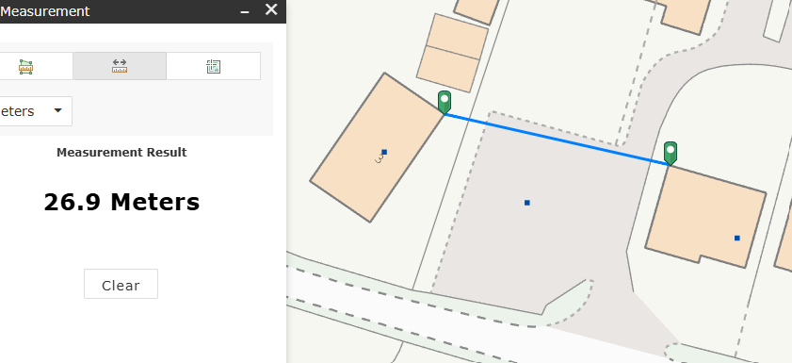

Council Mapping Image of the site

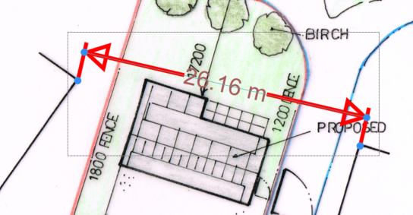

Site Plan for PL/2024/08330

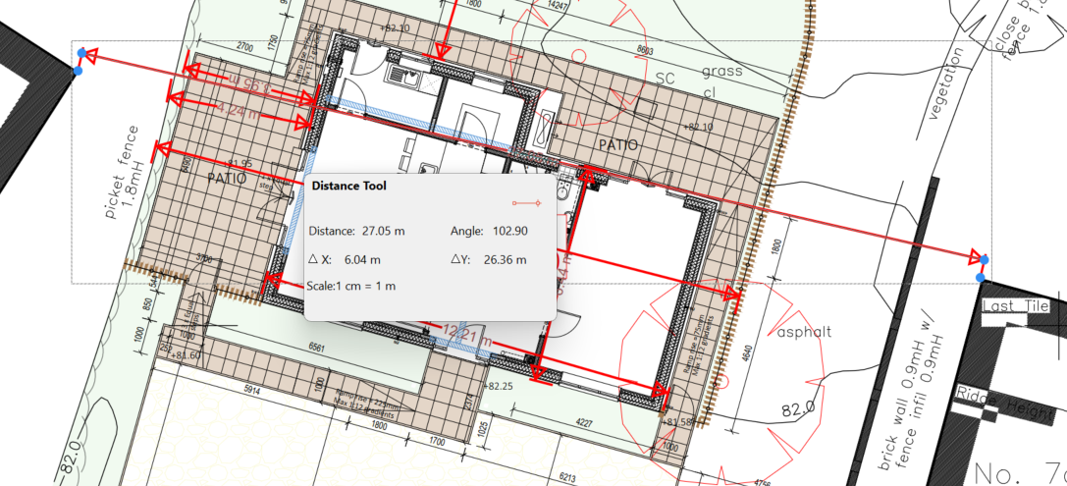

Site Plan for PL/2026/01057

Although the revised proposal involves a slight repositioning and increase in height, any additional impact on No. 3 and Trymnell (No. 1) would be limited. Both properties benefit from boundary outbuildings, meaning any marginal increase in overshadowing would primarily affect these structures rather than main habitable areas or gardens.

Overall, while there may be a slight increase in overshadowing and reduction in daylight compared to the 2024 approval, these changes are minor and do not amount to material harm sufficient to warrant refusal.

Similarly, the relationship with Nos. 5a and 5b Coxhill Lane would not be adversely affected. Whilst the gap would be slightly shorter, and the bedroom window increased slightly in depth it is considered that it would not amount to material harm that would warrant refusal. The bedroom window would have direct line of sight to the side garden rather than No 5a’s windows and in the approved landscaping scheme, three small trees are proposed in the rear garden which should help offer further screening mitigation.

The Parish Council has requested a condition to ensure that glass doors on the western elevation are not visible from No. 3. However, such a condition would not meet the established tests for planning conditions, as private views are not protected in planning terms. Furthermore, a fence may not entirely obscure views of the doors in any event. The key consideration is whether overlooking occurs, and it is considered that, as the doors are at ground floor level and at a similar level to No. 3, no harmful overlooking would arise.

The proposed 1.8m boundary fence, alongside existing or proposed planting, would provide adequate screening between properties. No additional condition is considered necessary to restrict first-floor windows on the side elevation, as permitted development rights already limit such openings to obscure glazing and controlled opening heights. Moreover, the internal layout negates any practical need for additional side windows.

Ecology:

Core Policy 50 of the Wiltshire Core Strategy seeks to protect and enhance biodiversity and geodiversity, including through ensuring that development avoids harm to protected species and habitats.

The National Planning Policy Framework (NPPF), in Paragraphs 193, requires that development minimises impacts on and provides net gains for biodiversity, including ensuring mitigation is secured where harm cannot be avoided.

The Council’s Ecology Officer has not been consulted on this application, but the application site is within the 6.4km zone of influence of the Salisbury Plain SPA and in light of the HRA for the Wiltshire Core Strategy and the HRA for the Wiltshire Housing Site Allocations Plan it is screened into Appropriate Assessment due to the potential impact of recreational pressure on stone curlew in combination with other plans and projects.

A strategic Appropriate Assessment (AA) has been prepared pertaining to development within the 6.4 km zone of influence that could result in a likely significant effect on the SPA as a result of an increase in recreational / visitor pressure. The AA reached a conclusion of no adverse effects on the integrity of the SPA or its qualifying features provided that the council’s mitigation strategy continues to be implemented. Annual stone curlew monitoring and protection measures continue to be secured by the Council.

In January 2026 Natural England (NE) confirmed that the 2025 strategic AA for Salisbury Plain SPA continues to be supported by NE.

BNG:

Based on the information available, the biodiversity gain planning condition is not considered to apply to this application as the application is for Self and Custom Build Development, meaning development which:
• consists of no more than 9 dwellings;
• is carried out on a site which has an area no larger than 0.5 hectares; and
• consists exclusively of dwellings which are self-build or custom housebuilding (as defined in section 1(A1) of the Self-build and Custom Housebuilding Act 2015).

Flood Risk:

The application site is at risk of surface water flooding and therefore in accordance with the NPPF and advice in the PPG a site specific flood risk assessment (FRA) should have been undertaken. However, no FRA has been submitted with either application.

However, it has to be noted that the applicants could implement PL/2204/08330 as it remains an extant permission and Officers are mindful that in discharge of conditions application PL/2026/00996 Drainage Officers took into account both ground and surface water flood risk when agreeing the drainage scheme. The Drainage Officer also noted “for context here, based on the mapped pluvial flood extents we do not see that the proposed works would result in an increase in risk as the area shown at risk corresponds with existing hard standing.”
Therefore, in this instance Officers are satisfied that the site can be adequately drained and that a site specific flood risk assessment is not necessary.

Assessment of Conditions

Condition 1 of PL/2024/08330 is to be amended to reflect the 3 year permission from the 8 October 2025.

Condition 2 (plan list) shall be updated to reflect the changes in this application.

Condition 3 (obscure glazing) shall be amended to reflect the revised first floor layout. The levels shall be increased due to the reduced distance between the proposal and No 5a.

Condition 4 – removing permitted development rights shall remain.

Condition 5 shall be amended to reflect the permission of discharge of condition application PL2026/00996.

Condition 6 (implementation of soft landscaping) removed as it will be incorporated into condition 5.

Condition 7 (Visibility Splays) shall remain

Condition 8 (car parking spaces) shall be amended to reflect the new plans

Condition 9 (surface water) shall be amended to reflect the permission of discharge of condition application PL2026/00996.

Section 106 Agreement

A deed of variation is not required because the existing unilateral undertaking already allows for variation of condition applications to automatically apply to it.

PLANNING BALANCE AND CONCLUSION
In determining this application under Section 73 of the Town and Country Planning Act 1990, the Local Planning Authority has considered whether the proposed amendments fall within the scope of Section 73. The proposed amendments have been assessed against the relevant policies of the Wiltshire Core Strategy, any applicable Neighbourhood Plan, and the National Planning Policy Framework. The assessment has also considered whether the development, as amended, materially alters the nature or impacts of the approved scheme.

In weighing the planning balance, the following factors have been considered:

Benefits

- The proposal delivers a self-build dwelling within settlement limits, contributing to housing supply in a sustainable location.
- The revised design is more traditional in form and appearance, resulting in improved visual compatibility with the surrounding street scene.
- Removal of large dormer features and introduction of a simpler roof form reduces visual clutter and enhances overall design quality.
- The development preserves the setting of nearby heritage assets, including the conservation area and listed buildings.
- The footprint remains unchanged from the approved scheme, ensuring efficient use of the site without intensification.
- Enhanced landscaping and boundary treatments provide improved screening and contribute positively to local character.
- The proposal maintains compliance with key development plan policies, including Core Policies 50, 57 and 58.

Harms

- A slight increase in ridge and eaves height results in a marginal increase in bulk when compared to the previously approved scheme.
- The repositioning of the dwelling deeper into the site leads to a minor reduction in separation distances to neighbouring properties.
- There would be a limited increase in overshadowing and a corresponding small reduction in daylight to neighbouring properties, particularly No. 3 and Trymnell.
- A small degree of additional perceived overlooking may arise, although this is mitigated by window positioning, obscure glazing, and landscaping.

The proposed variation of condition(s) is considered acceptable. The benefits of the proposal, including [insert key benefits], are judged to outweigh any identified harms, which can be appropriately mitigated through planning conditions or other controls. The proposal remains in accordance with the development plan and relevant national guidance, and there are no material considerations that indicate otherwise.

RECOMMENDATION:
That Planning Permission be GRANTED subject conditions

