HOUSEHOLDER PLANNING APPLICATION.
CASE OFFICER REPORT

APPLICATION REFERENCE: | PL/2026/02096
APPLICATION TYPE: | Householder
SITE ADDRESS: | 39 Elmfield, Bradford on Avon, BA15 1RH
DEVELOPMENT DESCRIPTION: | Single-Storey front extension
RECOMMENDATION: | Approve with Conditions.

PROPOSAL
The proposal seeks planning permission for the construction of a single storey front extension.

SITE DESCRIPTION/CONTEXT
The existing two storey dwelling is located within an established residential development within the Market Town of Bradford on Avon and consists of an end of terrace dwelling of three properties. The site is located within the Bath and Bradford on Avon Bat SAC and is not within a Conservation Area.

RELEVANT PLANNING HISTORY
Proposal / Summary
85/00564/FUL Domestic garage/workshop Approved.
2022/00535 Installation of a glass roof conservatory to side. Approved

RELEVANT POLICIES AND GUIDANCE

Wiltshire Core Strategy:

- Core Policy 07 Bradford on Avon Spatial Strategy
- Core Policy 57 Ensuring High Quality Design and Place Shaping
- Core Policy 50: Biodiversity and Geodiversity
- Core Policy 51: Landscape
- Core Policy 58: Ensuring the Conservation of the Historic Environment
- Core Policy 61: Transport and New Development
- Core Policy 64: Demand Management
- Core Policy 67: Flood Risk

Bradford on Avon ‘Made’ Neighbourhood Plan.

Wiltshire Design Guide: Appendix D – Design Guidance for Householder extensions

The National Planning Policy Framework (NPPF)

The Planning Practice Guidance

National Design Guide

Emerging Wiltshire Local Plan:
At Full Council on 19 May, the elected members of Wiltshire Council agreed to withdraw the emerging WLP. It will now be subject to a legal process to finalise its withdrawal - which is likely to happen in July or August (2026). The said Plan has no material weight for the purposes of the application.

CONSULTATION RESPONSES
Bradford on Avon Town Council: No objections.

Bradford on Avon Preservation Trust: No comment.

REPRESENTATIONS
Two emails of support received.

PRINCIPLE OF THE PROPOSAL.
The principle of the proposed scheme is considered to be acceptable for the reasons as discussed below.

ASSESSMENT
Section 38(6) of the Planning and Compulsory Purchase Act 2004 states:

"If regard is to be had to the development plan for the purposes of any determination to be made under the planning Acts, the determination must be made in accordance with the plan unless material considerations indicate otherwise."

In accordance with this statutory requirement, this application has been assessed against the relevant policies of the Development Plan, including the adopted Wiltshire Core Strategy (2015) and the Neighbourhood Plan for Bradford on Avon.

Design and Impact upon the upon the character and context of the area

Core Policy 57 - Ensuring High Quality Design and Place Shaping of the Wiltshire Core Strategy seeks to ensure that all new development is of high design quality, reflecting local context, character, and distinctiveness.

The proposals can be viewed within the plan snippets taken from the submitted plans:

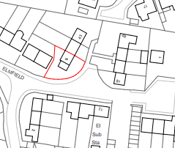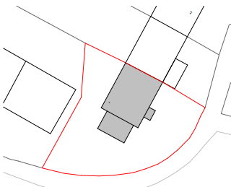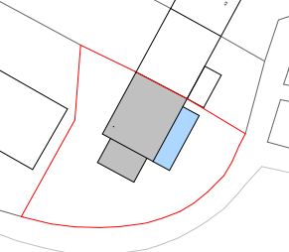
Location Plan Existing & Proposed Site Plans

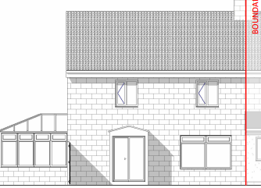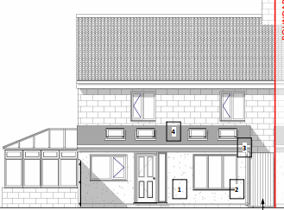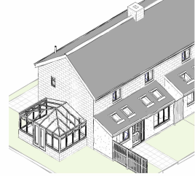
Existing & Proposed Front Elevations Proposed 3D Projection.

The proposal would see the removal of the existing small sized front porch, to be replaced by an enlarged single storey front extension that would serve as a combined porch and study, whilst also slightly extending the living room. The intended measurements are 2m by 6.8m, with the proposal having a rendered finish on its exterior walls and matching rooftiles with the existing host dwelling.

The design would be of a simple ‘lean-to’ construction, with a sloping roof and with four roof lights and two front facing windows. The design would match and sit alongside the neighbouring property at No.41 to the immediate north-east, which also has a very similar front facing extension to that as proposed.

It is therefore appraised that the proposed small sized single storey extension would represent a complimentary addition to the host dwelling, continuing the built form as found within the neighbouring property. The scale and massing of the extension proposal is considered commensurate to the size of the property and plot, thereby preserving the character and appearance of the host dwelling and offering a subservient addition.

In summary, having regard to the above, the proposal complies with the design principles set out in Core Policy 57 of the Wiltshire Core Strategy and Appendix D of the Wiltshire Design Guide.

Amenity
Point vii of Core Policy 57 - Ensuring High Quality Design and Place Shaping of the Wiltshire Core Strategy seeks to ensure that developments do not adversely affect neighbouring properties. The National Planning Policy Framework (NPPF), particularly Paragraph 135(f), stresses that planning decisions should ensure developments provide a high standard of amenity for existing and future users.
The proposed extension would be at ground floor level and would look out onto the site’s front garden. The extension would be sited alongside the existing extension at No.41 and so there would be no overlooking of neighbours. The front garden area of this rank of three dwellings are small, with the rear gardens being larger and so utilised for amenity purposes, any overlooking of this front area is acceptable and is no different to that as already existing.

Due to the location and orientation of the proposal, there would not be any significant overshadowing or loss of light to the most immediate neighbour at No.41.

The proposal therefore accords with Core Policy 57 point vii. in respect of safeguarding residential amenity and Appendix D of the Wiltshire Design Guide.

Ecology Impact CP50 requires no net loss of biodiversity on site. The site is located within the Bath and Bradford on Avon Bat SAC. The proposed development because of its minor nature and urban location is considered unlikely to result in harm to bats or their habitat. There is no mechanism for significant effects from recreational pressure since it does not result in the creation of a new dwelling. Accordingly, the proposal is acceptable in this regard. As such, the development complies with Core Policy 50 of the Wiltshire Core Strategy and the relevant provisions of the NPPF.

Biodiversity Net Gain. This application is exempt from the requirement to deliver Biodiversity Net Gain under Schedule 7A, Section 4(2)(a) of the Town and Country Planning Act 1990, as inserted by the Environment Act 2021, because the proposal is a householder extension.

CONCLUSION
The proposed development is acceptable in terms of its design, scale, and relationship with the surrounding area. It would not result in any unacceptable harm to the character of the locality, or the amenities of neighbouring occupiers.

The proposal is therefore considered to comply with the relevant policies of the Wiltshire Core Strategy, the Wiltshire Local Plan, and the National Planning Policy Framework. As such, the application is recommended for approval, subject to the conditions set out below.

RECOMMENDATION: Planning Permission be GRANTED subject to conditions.

