APPLICATION FOR A NON-MATERIAL AMENDMENT
CASE OFFICER REPORT

APPLICATION REFERENCE: | PL/2026/01965
APPLICATION TYPE: | NON-MATERIAL AMENDMENT
SITE ADDRESS: | Land at The Street, Hullavington
DEVELOPMENT DESCRIPTION: | NMA application relating to application PL/2024/03115 (pursuant to outline permission 20/10972/OUT) to amend the roof tile products to alternative materials.
RECOMMENDATION: | That the non-material amendment be GRANTED

PROPOSAL

The application proposes amendments to reserved matters applications PL/2024/03115 (erection of 71 residential dwellings) pursuant to outline planning application 20/10972/OUT (erection of up to 71 Dwellings) with regards changing roof materials to the dwellings.

As per Materials Layout Plan drg no 0808-108 rev E and External Materials Schedule Rev B, proposed roof materials will consist of –

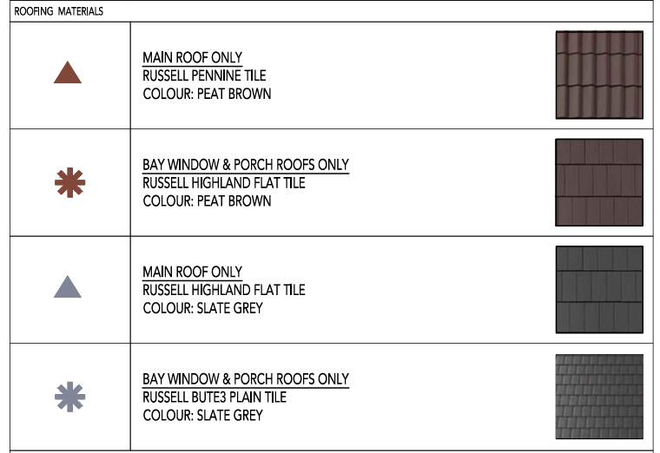

Rather than as previously approved –

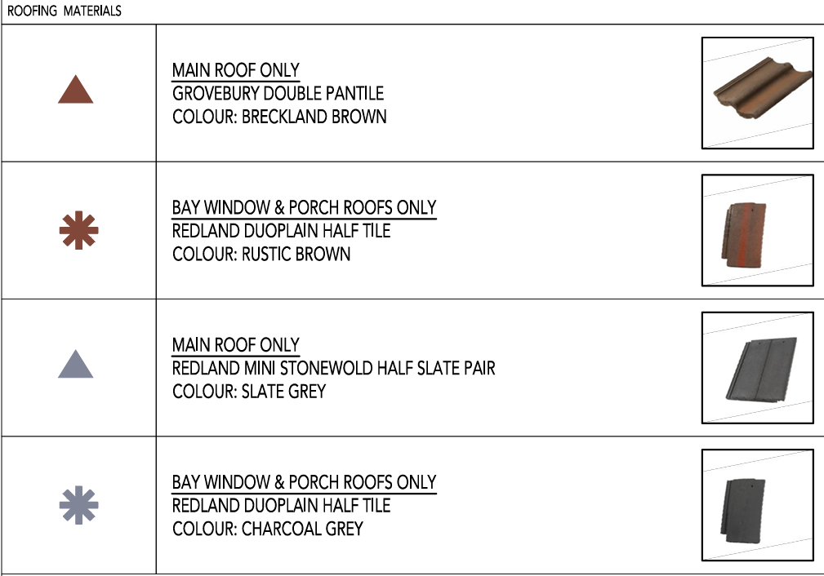

PLANNING HISTORY

PL/2024/03115 – Reserved Matters (appearance, landscaping, layout and scale) for up to 71 residential dwellings (Use Class C3), pursuant to Condition 2 of outline planning permission ref. 20/10972/OUT – Approved

20/10972/OUT – Outline Planning Application for up to 71 Dwellings, Community Car Park, Land Reserved for Future Expansion of Hullavington CofE Primary School, Access, Open Space, Surface Water Attenuation Basin, Landscaping and Associated Works – Approved

RELEVANT LEGISLATION AND GUIDANCE

Town and Country Planning Act 1990 (as amended):
- Section 96A: This section provides the legal basis for non-material amendments to an existing planning permission. It allows Local Planning Authorities (LPAs) to make changes to a planning permission without the need for a new application, provided that the changes are considered to be "non-material."
- The Act does not define "non-material," and it is at the discretion of the LPA to determine whether a proposed amendment qualifies as such, considering the specific context of the development and its impacts.

CONSULTATION

As an application for a non-material amendment is not a full planning application, the provisions under the Town and Country Planning (Development Management Procedure) (England) Order 2015 relating to statutory consultation and publicity do not apply. Consequently, local planning authorities have discretion regarding whether and how to inform interested parties or seek their views.

Given that the changes proposed are by definition non-material, consultation or publicity are typically not required. Additionally, as the proposed amendments are minor in nature, there are generally no significant effects that would necessitate consideration under the Environmental Impact Assessment Regulations 2011. In this instance, it has not been considered necessary to consult.

ASSESSMENT

Non-material amendments are changes that do not significantly alter the scheme's overall impact. They can involve minor adjustments to the design or other aspects of the development but should not fundamentally change its character, scale, or overall effect on the surrounding area.

The proposed alterations to roof materials are considered acceptable and would cause no harm to the development’s overall appearance and character. The changes remain consistent with the development's overall aims and do not materially affect its operation or outcomes, and the scale of the change would be proportionate to the original permission

CONCLUSION

In conclusion, based on the assessment, it is recommended that the non-material amendment application be granted.

Revised plans condition 2 should read –

The reserved matters application hereby approved shall be carried out in accordance with the schedule of documents and plans contained with the developer's Document Schedule received by the Council on 18 December 2024 including:

Location Plan, Drawing No. 0808-101-L
Planning Layout, Drawing No. 0808-102 C
External Work Layout, Drawing No. 0808-104-1 C, 0808-104-2C, and 0808-104-3C
Material Layout, Drawing No. 0808-108-E
Garage Details, Drawing No. 0808-109 Garages -A1P
Refuse Strategy, Drawing No. 0808-112C
PV Panel and Bicycle Storage Layout, Drawing No. 0808-119C ASHP, EVCP, PV Panel and Bike Storage
EV Charging Details, Drawing No. UK - Zaptec Go PEN Product Sheet
External Details, Drawing No. 0808-106 External Detailing A3L
Vehicle Tracking, Layout, Drawing No. 0808-105 C
External Material Schedule - Hullavington External Materials Schedule Rev B
Substation, Drawing No. 0808-114 Substation A3L
Housetype Booklet, Reference No. 0808-HTB-ISSUE 3 Housetype Booklet A3L
Site Levels, Drawing No. 19700-PEL-01 Rev J Preliminary External Levels Sheet 1 of 2
Site Levels, Drawing No. 19700-PEL-02 Rev J Preliminary External Levels Sheet 2 of 2
Highway Details, Drawing No. 19700-PHL-01 Rev I Preliminary Highway Layout
Highway Details, Drawing No. 19700-PHL-02 Rev D Preliminary Road Profiles
Drainage Details, Drawing No. 19700-PDL-01 Rev J Preliminary Drainage Layout
Drainage Details, Drawing No. 19700-PDL-02 Rev H Flood Exceedance Route Plan
Soft Landscape Proposals, Drawing No. GL2229 02L, GL2229 03L, GL2229 04L
Landscape Management Plan, Drawing No. GL2229 Landscape Management Plan - Hullavington - Issue 3
LEMP, Drawing No. 240806_P1365_LEMP_Final02
CEMP, Drawing No. 240806_P1365_Ecology_CEMP_Final02
CMP, Drawing No. CMS- Hullavington (Rev B) (1)
Lighting Strategy, Drawing No. P24799-R-01-v1,
S38 lighting Calculation, Drawing No. P24799-S38-01-P06
Private Lighting Calculation, Drawing No. P24799-PR-01-P03
Lighting Calculation no. MF, Drawing No. P24799-S38-03-P05
Light Spill Statement, Reference No. P24799
PROW Surfacing Plan, Drawing No. 0808-115
Adoption Plan, Drawing No. 0808-107C

REASON: For the avoidance of doubt and in the interests of proper planning.

Revised condition 3 should read –

The materials to be used in the construction of the external surfaces of the development hereby permitted shall match in material, colour and texture those as set out in the approved material layout, Drawing no. 0808-108-E.

REASON: In the interests of visual amenity.

