APPLICATION FOR ADVERTISEMENT CONSENT
CASE OFFICER REPORT

APPLICATION REFERENCE: | PL/2026/01968
APPLICATION TYPE: | Consent to display an advertisement
SITE ADDRESS: | 3, Hackett Place, Hilperton, Trowbridge, BA14 7GW
DEVELOPMENT DESCRIPTION: | Erection of three internally illuminated fascia signs and one non-illuminated graphic panel
RECOMMENDATION: | Approve with Conditions

SITE DESCRIPTION/CONTEXT
The application site is one of a cluster of retail premises, community centre and nursery with associated parking, at the local centre Hackett Place, sited at the edge of the Paxcroft Mead C20 development.

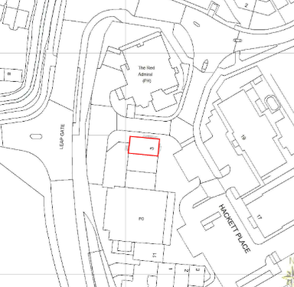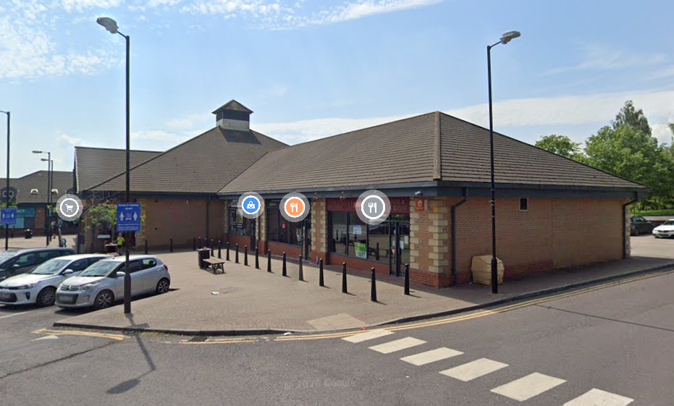
Location Plan and Google Earth Site Photo from Car Park to front

PROPOSAL:

The application seeks advertisement consent for a change of, and additional fascia signs all with white text on a red background between the dates 1st June 2026-2036.

Internal illuminated fascia signs measuring:

1 no. 0.65m x 6.1m on front elevation

1 no. 0.65m x 3m on rear elevation

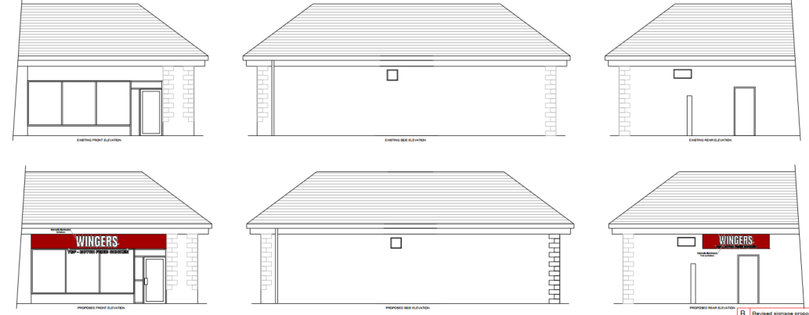
Existing and Proposed Elevations

RELEVANT LEGISLATION, POLICIES AND GUIDANCE

The Town and Country Planning (Control of Advertisements) (England) Regulations 2007

National Planning Policy Framework (NPPF)
- Paragraph 141

Planning Practice Guidance (PPG)
- Advertisements

Wiltshire Core Strategy 2015 (WCS):
- Core Policy 51 Landscape
- Core Policy 57 Ensuring High Quality Design & Space Shaping
- Core Policy 62 Development Impacts on the Transport Network

Trowbridge has a designated Neighbourhood Plan but no made plans as yet.

Supplementary Planning Documents:
Institute of Lighting Professionals: The Brightness of Illuminated Advertisements (2014) PLG 05.

RELEVANT PLANNING HISTORY:
W/00/00533/REM - Reserved Matters Decision - Approve with Conditions Date: 6/11/2000 – Local centre with public house, retail units (A1, A2 and A3), store, community centre and children's day care centre
W/88/01650/OUT - Outline Planning Decision - Approve with Conditions Date: 8/8/1995 – Residential development together with local centre, highway improvements and public open space
W/01/00719/ADV - Consent to display an advertisement Decision - Approved Date: 20/6/2001 – Front illuminated signage to retail unit B - Budgens
W/01/00720/ADV - Consent to display an advertisement Decision - Approve with Conditions Date: 19/10/2001 – Rear sign to retail unit B - Budgens
W/01/00722/ADV - Consent to display an advertisement Decision - Refused Date: 4/4/2002 – Totem pole entrance signage - Budgens
W/01/00724/ADV - Consent to display an advertisement Decision - Approve with Conditions Date: 18/6/2001 – General signage – Local Centre
PL/2025/06972/ADV - Consent to display an advertisement Decision - Approve with Conditions Date: 25/11/2025 – Proposal to install 2x Fascia, 1x projection sign, 1x Vinyl - Tesco

ISSUES
The issues that are relevant to the consideration of an application for consent to display advertisements are the effects of the proposal on ‘amenity’ and ‘public safety’.

CONSULTEE RESPONSES
Trowbridge Town Council: no objection.
Wiltshire Council’s Highways Engineer: no objection.
Trowbridge Civic Society: noted positively that a vacant unit is being brought back into use, but raised concerns that one sign be too large and strident.

RESPRESENTATIONS
No comments received.

ASSESSMENT
Regulation 3 of The Town and Country Planning (Control of Advertisements) (England) Regulations 2007 requires that local planning authorities exercise their powers in relation to the display of advertisements in the interests of amenity and public safety, taking into account the provisions of the development plan, in so far as they are material, and any other relevant factors.

The NPPF (141) is clear that the quality and character of places can suffer when advertisements are poorly sited and designed and should be subject to control only in the interests of amenity and public safety, also considering the cumulative impacts.

Impact on Amenity:
Policy Context
“Amenity” is not exhaustively defined in the Town and Country Planning (Control of Advertisements) (England) Regulations 2007 but is generally understood to include both visual and aural amenity. Factors relevant to amenity include the general characteristics of the locality, such as the presence of features of historic, architectural, cultural, or similar interest.

In broader planning terms, as reflected in the National Planning Policy Framework (NPPF), amenity refers to the quality or character of an area and the elements that contribute to the overall enjoyment and liveability of a place.

CP57 requires a high standard of design in all proposals, including (x) the sensitive design of advertisements and signage.

The proposed fascia signage on the front elevation is of an appropriate scale in the context of the existing signage it would replace. The proposed signage on the rear elevation introduces a new sign where the elevation is currently blank, however it is similar to that previously approved for surrounding units having regard to new illuminated signage recently approved on the rear elevation of Tesco.

The proposed illumination is considered to be acceptable and given the nature of the locality is not considered to pose any undue harm to visual amenity in the local context.

The signs would be permanently fixed and so do not have the potential to create a noise disturbance and as such the proposals are acceptable in terms of aural and visual amenity impact.

It is considered that the proposed advertisement would not cause undue harm to the visual amenity of the area and would therefore comply with the relevant provisions of the Town and Country Planning (Control of Advertisements) Regulations 2007.

Impact on Public Safety:
Policy Context
“Public safety” is not exhaustively defined in the Town and Country Planning (Control of Advertisements) (England) Regulations 2007, but it generally refers to the potential impact of a development or advertisement on the safe use and operation of public spaces, including roads, footpaths, and other areas accessible to the public.

In assessing public safety, the Local Planning Authority (LPA) may consider:
- Whether the proposal would obstruct visibility for road users or pedestrians;
- Whether it could distract, confuse, or mislead drivers, particularly near junctions or crossings;
- Whether it interferes with traffic signs, signals, or street lighting;
- Whether it poses a physical hazard, such as through poor structural integrity or inappropriate siting.

The National Planning Policy Framework (NPPF) also supports the principle that planning decisions should ensure developments create places that are safe, inclusive, and accessible, and that they do not undermine public safety or security.

CP62 advises that proposals should provide appropriate mitigating measures to offset any adverse impacts on the transport network at both the implementation and operational stages.

Due to the location of the site on an established commercial local centre and the signage replacing earlier forms or within the rear service courtyard of the commercial units and with the signs being at a height and depth to not raise any concerns and with static illumination, the proposal is not considered to result in any demonstrable public safety concerns.

There are no objections from the Highways Officer in respect of highway safety.

It is considered that the proposal would not result in an unacceptable impact on public safety, either individually or cumulatively, and would therefore satisfy the relevant provisions of the Town and Country Planning (Control of Advertisements) Regulations 2007.

CONCLUSION:
The proposed advertisement has been assessed in accordance with the relevant provisions of the Town and Country Planning (Control of Advertisements) (England) Regulations 2007.

It is considered that the advertisements, by reason of their design, scale, siting, and method of illumination, would not result in harm to the visual amenity of the area. Furthermore, the proposal is not considered to pose a risk to public safety, either individually or cumulatively with other signage in the vicinity.

Subject to the recommended conditions, the proposal is therefore considered acceptable, and it is recommended that advertisement consent be granted.

RECOMMENDATION:
It is recommended that advertisement consent be GRANTED subject to conditions.

