FULL PLANNING APPLICATION.
CASE OFFICER REPORT

APPLICATION REFERENCE: | PL/2026/01852
APPLICATION TYPE: | Full Planning Application
SITE ADDRESS: | Land South West Of Cemetery Holt Road Bradford On Avon, BA15 1TS.
DEVELOPMENT DESCRIPTION: | The removal of the existing 3no antennas and 1no. cabinet; the installation of 6no. antennas, 1no. 300mm and 1no. 600mm dishes, 18 ERS units and 1no. GPS module mounted on the existing 25m mast; the installation of 1no. cabinet and development works thereto.
RECOMMENDATION: | Approve with Conditions.

Proposal.
The proposal seeks the upgrade of an existing telecom mast with the following equipment: The removal of the existing 3no. antennas and 1no. cabinet; the installation of 6no. antennas, 1no. 300mm and 1no. 600mm dishes, 18 ERS units and 1no. GPS module. The mast will be reused and will not increase in height above its current 25 metre height. The replacement equipment will be used to provide 5G coverage.

A planning committee call in request has been requested of the local ward member Councillor Sam Blackwell, who has confirmed that he will not be calling the application in to the planning committee, thereby leaving the determination process to officers under the council’s delegated powers.

Site Description/Context.
The existing mast is located on land to the south of Holt Road, on the eastern edge of Bradford-on-Avon settlement boundary, by a copse of established trees adjacent to an area of green walkway. The site is positioned within land adjacent to a residential area and some light industrial development around Duffield Lane and AB Dynamics. To the southeast of the mast there is a solar farm utilising four fields.

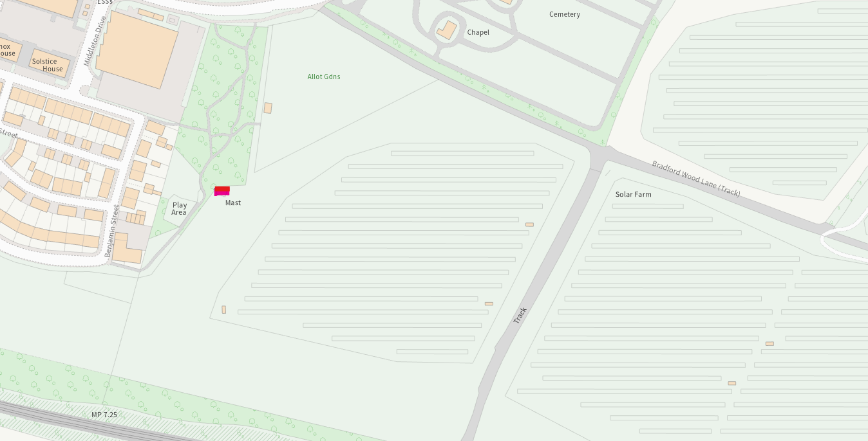

The mast location is highlighted above within the context of the surrounding solar farm.

Relevant Planning History.
Proposal / Summary
W/07/01818/FUL Telecommunications base station. Approved.

Relevant Policies and Guidance

Wiltshire Core Strategy:

- Core Policy 03 Infrastructure Requirements
- Core Policy 07 Bradford on Avon Spatial Strategy.
- Core Policy 57 Ensuring High Quality Design and Place Shaping
- Core Policy 50: Biodiversity and Geodiversity
- Core Policy 51: Landscape
- Core Policy 58: Ensuring the Conservation of the Historic Environment
- Core Policy 61: Transport and New Development
- Core Policy 64: Demand Management
- Core Policy 67: Flood Risk

Bradford on Avon ‘made’ Neighbourhood Plan

Wiltshire Design Guide: Appendix D – Design Guidance for Householder extensions

The National Planning Policy Framework (NPPF)

The Planning Practice Guidance

National Design Guide

Emerging Wiltshire Local Plan:
The examination of the emerging Wiltshire Local Plan has been paused and the weight to be afforded to any part of the emerging plan can be no more than very limited. A decision on how to proceed will be made by the Council in May 2026.

Consultation Responses
Bradford on Avon Town Council: No objections.

Bradford on Avon Preservation Trust: No objections and comment:

‘The site is well screened by existing trees and vegetation, the application is accompanied by an ICNIRP Declaration and as such we have no objection’.

Conservation: No objections and comment:

‘The impact of the proposals on heritage assets will be neutral and the requirements of current conservation legislation, policy or guidance are considered to be met and there is therefore no objection to the approval of the application’.

Highways: No objections.
Ecology: No objections and comment:

‘A test of likely significance has been carried out by the relevant Competent Authority (Wiltshire Council) as required by Regulation 63 of the Conservation of Habitats and Species Regulations 2017 (as amended). This concluded that given the scale and nature of the currently proposed development which (i) involves no overall loss of a roost of a qualifying species, (ii) does not propose removal of any vegetation, and iii) does not propose any additional external lighting, there is no mechanism for adverse impact on the Conservation Objectives of the SAC, and the proposal can be screened out of Appropriate Assessment’.

Environmental Health Public Protection: No objections and request that a condition be applied in regard to the submission of a noise assessment.

Landscape: No objections and comment:

‘The site does not sit in a designated landscape or impact on its setting or that of a heritage asset. The proposals consist of adding additional mobile phone equipment to the top and base of a pre-existing phone mast. The existing phone mast is relatively well screened behind existing tree belts and I consider the impact of the works would have only negligible adverse landscape character and visual impacts on the areas and thus have no landscape objection’.

Representations
One email of support and twenty-three emails of objection were received, raising the following points:

-Email of support, improved telecom service, much needed in BonA, as reception is poor and strongly support the proposed upgrades and improvements for better reception.
-Upgrades will be cluttered and highly visible within the valley, degrade rural character, harmful to green belt and conservation area and surrounding landscape. They are not ‘sympthetic’ to the area.
-Concerns over radio frequency radiation harmful to health. Papers and studies argue that 5G is harmful to health.
-Mast to carry ‘No Entry’ zones.
-Debates and studies carried out as possible carcinogen.
-Properties nearby may be affected, no need for upgrades.
-Proposed upgrades represent a disproportionate intensification.
-Harmful to ecology wildlife and bats.
-Extent of upgrades not clearly identified or represented.
-Object to 5G communications of technology in BoA and everywhere else in Wiltshire on health safety grounds and possible causes of carcinogens.
-Insurers refuse to insure against possible 5G health liabilities.
-Ban to wifi and mobile phones in schools.
-Central government’s ruling that local councils to not take health or environmental concerns into account is wrong. 98% of 5G use is for data collection, surveillance and marketing, not for the public.
-5G orientated devices such as mobile phones, smart meters, white goods harmful to health.
-Affect residential property prices.
-No need for 5G as it is financially motivated.
-Impact on residential amenity by visual dominance and overdevelopment of the site.
-Lack of demonstrated need for 5G.
-Concern of potential driverless vehicles in BonA, relying on 5G.
-Clarification of proposals needed i.e. 3G, 4G or 5G. 5G not safe.
-Danish opinion on 5G is contravention of human rights.
-Quoted caselaw on concerns about radio frequency harm to health.
-Ongoing scientific debate regarding long-term exposure to radio frequency radiation.
-Insufficient information for the council to determine the application.
-Call into planning committee.
-EIA development therefore needs screening opinion
-Neighbour/s not contacted by letter, proper neighbour notification process not carried out.

Environment Impact Assessment.
The council has carried out its own internal appraisal of an Environment Impact Assessment (EIA) regarding the proposed works and its findings were that the proposal did not constitute EIA development under the Town and Country Planning (Environmental Impact Assessment) Regulations 2017. The proposal relates to the upgrade of an existing telecommunications installation and does not comprise development of a scale, nature or location likely to give rise to significant environmental effects. The works are limited in extent and relate to established telecommunications infrastructure on an existing operational site.

Policy Matters.
Whilst the above information serves to address third party concerns in regard to health matters, the application’s documentation explains the operational need for the 5G upgrade, including the requirement to enhance network capacity and maintain reliable connectivity within the area. National policy places significant weight on the importance of high-quality digital communications infrastructure, recognising its social and economic benefits to communities and businesses.

The NPPF is of relevance and makes it clear that from a planning perspective, officers are not able to take such matters into account, paragraph 123 states this to be the case. Reassurance on health needs to be taken from the ICNIRP declaration accreditation. Paragraph 123 states:

‘Local planning authorities must determine applications on planning grounds only. They should not seek to prevent competition between different operators, question the need for an electronic communications system, or set health safeguards different from the International Commission guidelines for public exposure’.

Paragraph 123 is of relevance to the third-party comments received relating to or questioning the need for 5G. Paragraph 119 emphasises this:

‘Advanced, high quality and reliable communications infrastructure is essential for economic growth and social well-being. Planning policies and decisions should support the expansion of electronic communications networks, including next generation mobile technology (such as 5G) and full fibre broadband connections’.

The NPPF positively encourages the re-use of telecom equipment, as is the case here; received third party comments question the need to re-use of the mast. From a planning perspective such re-use effectively prevents the erection of additional masts elsewhere. Paragraph 120 of the Frameworks shows this to be the case:

‘The number of radio and electronic communications masts, and the sites for such installations, should be kept to a minimum consistent with the needs of consumers, the efficient operation of the network and providing reasonable capacity for future expansion. Use of existing masts, buildings and ‘other structures for new electronic communications capability (including wireless) should be encouraged.

Principle of the proposal.
The principle of the proposed scheme is acceptable for the reasons as discussed below. Support is offered in policy CP3 ‘Infrastructure requirements’ and is of particular relevance, as subsection 4.41 specifically highlights the need for ‘telecommunications facilities, including fibre-optic superfast broadband and connectivity services, to serve local communities and the business community’.

Similarly, CP3 further encourages such infrastructure requirements at sub paragraph 4.39 which states:

‘Existing community services and facilities will be protected in line with Core Policy 49 and existing green infrastructure will be protected in line with Core Policy 52. To encourage the most effective use of existing and new infrastructure, co-location and multi-functional use of land and buildings for services and facilities will be supported in accordance with other policies of the Core Strategy. The provision of new or improved infrastructure will be positively supported, particularly where opportunities arise through redevelopment or regeneration in sustainable locations, provided that this has no detrimental impact on the environment and contributes towards mitigation and adaptation to climate change’.

Assessment.
Section 38(6) of the Planning and Compulsory Purchase Act 2004 states:

"If regard is to be had to the development plan for the purposes of any determination to be made under the planning Acts, the determination must be made in accordance with the plan unless material considerations indicate otherwise."

In accordance with this statutory requirement, this application has been assessed against the relevant policies of the Development Plan, including the adopted Wiltshire Core Strategy (2015) and the Neighbourhood Plan for Bradford on Avon.

Design and Impact upon the upon the character and context of the area

Core Policy 57 - Ensuring High Quality Design and Place Shaping of the Wiltshire Core Strategy seeks to ensure that all new development is of high design quality, reflecting local context, character, and distinctiveness.

The proposals are for the proposed upgrade measures to an existing telecom mast located within an established area as identified on the site location plan. The proposals can be viewed within the plan snippets taken from the submitted plans:

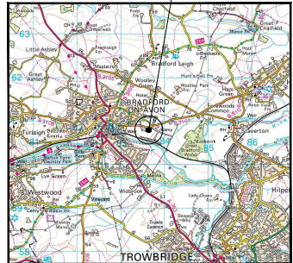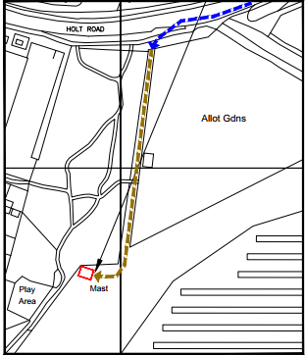
Location Plan Detailed location plan

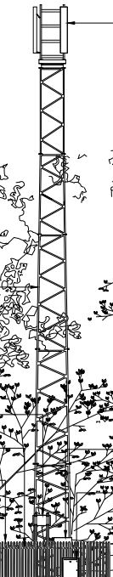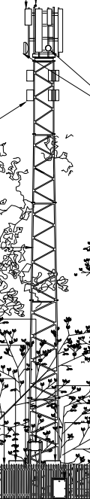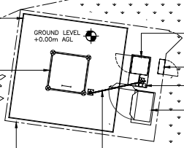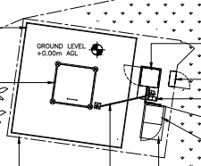
Existing & proposed Telecom Mast Existing & Poposed site plan

It is important to state that the telecom mast will remain at its same 25 metre height and also that the ground floor area of the base station will also remain the same and will not increase in size. The proposed upgrades will comprise of the following: The removal of the existing 3no. antennas and 1no. cabinet. These will be replaced by the installation of 6no. antennas, 1no. 300mm and 1no. 600mm dishes, 18 ERS units and 1no. GPS module will also be mounted on the existing mast; the installation of 1no. cabinet. No other works are proposed. The described ERS units are small and compact in size, and form a part of the overall remote radio equipment, which implement other parts of the telecommunications radio access network. The equipment is mounted close to the antennas in order to improve overall network efficiency, signal performance and coverage reliability.

Impact of the proposal on the character of the surrounding area.
The telecom mast is already in place and its height will not increase, the mast will have the existing equipment removed and upgraded such that the above detailed equipment will be on display. The mast is in a secluded corner location sited behind an established copse of trees and so is not readily visible from the established public areas, this being as denoted on the above plan and as shown in the following two photographs:

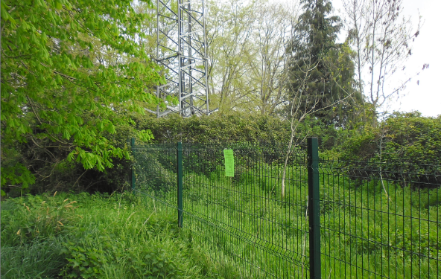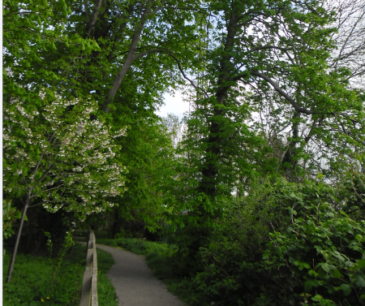
The mast is surrounded by an established solar farm, which consists of four fields of solar panels at ground level, therefore the open character of the immediate area is already arguably eroded or affected, consequently the mast upgrades need to be seen in this context. The mast and its base equipment is surrounded by high level fencing which as the above photograph shows is covered in vegetation and so is not visible or accessible.

Landscape.
It is noted that a neighbour has written in and commented that the top of the mast is visible from her property which is 300 metres away and that the newly installed equipment would be readily visible. Whilst this is understood, any views from this property are interesected by views of roof tops and buildings; notwithstanding this, within planning terms a loss of a view or a change thereto, is not a material planning consideration.

It has also been suggested within neighbour comments that a landscape visual assessment should have been undertaken by the applicant. This is not considered to be necessary because the telecom mast is already in place behind a copse of trees; with the attached replacement equipment, due to their comparative small size not warranting such an assessment.

The Council’s Landscape Officer has been consulted on this application who has not raised any objections and who comments:

‘The site does not sit in a designated landscape or impact on its setting or that of a heritage asset. The proposals consist of adding additional mobile phone equipment to the top and base of a pre-existing phone mast. The existing phone mast is relatively well screened behind existing tree belts and I consider the impact of the works would have only negligible adverse landscape character and visual impacts on the areas and thus have no landscape objection’.

As such, the proposals accord with the principles of CP51, which would not harmfully impact on the surrounding landscape character.

Green Belt. The site is not within a conservation area but is within Green Belt Land. There are no relevant WCS development plan policies relating to the Green Belt, therefore the NPPF provides the policy direction. The recently revised NPPF sets out within paragraph 142 that “The Government attaches great importance to Green Belts. The fundamental aim of Green Belt policy is to prevent urban sprawling developement by keeping land permanently open; the essential characteristics of Green Belts are their openness and their permanence”. Openness is the absence of development and Paragraph 143 of the NPPF sets out five key purposes of the Green Belt with one being to safeguard the open countryside from encroachment. The NPPF explains how to treat proposals within the Green Belt.

In this instance, the telecom mast has been in place for approxiately 18 to 19 years, so it is well establshed at it’s location. Paragraph 153 of the NPPF states inappropriate development is, by definition, harmful to the Green Belt and should not be approved except in very special circumstances. The two key characteristics of the Green Belt are its openness and its permanence.

Telecommunication masts are not expressly mentioned in the Green Belt section of the NPPF, however, the mast is in place and compared against the adjacent solar farm and expanse of solar panels (also in the Green Belt) the panels’ visual impact is far geater; therefore the presence of the mast is appraised as de minimis. Similarly, the volume of the mast’s antenna dishes and other related equipment is also de-minimis. The presence of the mast and the installation of the new equipment does not harmfully impact on Green Belt openness and permanence due to its established location, limited and small footprint.

Amenity & Public Health.
Point vii of Core Policy 57 - Ensuring High Quality Design and Place Shaping of the Wiltshire Core Strategy seeks to ensure that developments do not adversely affect neighbouring properties. The National Planning Policy Framework (NPPF), particularly Paragraph 135(f), stresses that planning decisions should ensure developments provide a high standard of amenity.
The telecom mast is in place and its visual impact in terms of amenity aspects have been discussed above.

The council’s Environmental Public Protection Officer has been consulted who raises no objections but considers that there may be a possible noise nuisance from the replacement floor cabinets. Consequently, the officer has asked for a condition be attached to the final decision notice relating to the submission of an acoustic noise assessment prior to the upgraded mast’s first use. This is entirely reasonable.

A large part of the neighbour consultation responses relates to possible harm to human health by exposure to electromagnetic fields. In a general sense, such concerns are not new and are openly discussed within the World Wide Web, with much of its scientific concerns and theories being submitted as representations for the purposes of this current application.

Such concerns are understood; however, the applicant has provided many and numerous documents within the application relating to such health concerns for people to read and to allay such worries, this information being in addition to the submission of scaled plans and a comprehensive accompanying statement. Therefore, the Council considers it has sufficient information to make a decision on the application.

Paragraph 123 of the NPPF is of direct relevance to such health concerns which states that:

‘Local planning authorities must determine applications on planning grounds only. They should not seek to prevent competition between different operators, question the need for an electronic communications system, or set health safeguards different from the International Commission guidelines for public exposure’.

Therefore, officers are not able to consider such health concerns outside of the mast’s ICNIRP Compliance Declaration, as this has strong relevance being the industry standard, this being as discussed throughout.

5G concerns are countered by a submitted statement from the World Health Organisation:

‘The levels of RF exposure from base stations and wireless networks are so low that the temperature increases are insignificant and do not affect human health" World Health Organisation, Fact Sheet 304, Base stations and wireless technologies, 2006. In addition, the WHO notes that “Based on a recent in-depth review of the scientific literature, the WHO concluded that current evidence does not confirm the existence of any health consequences from exposure to low level electromagnetic fields’.

Notwithstanding such concerns relating to the safety of the replacement equipment, the equipment and proposed works do carry a ICNIRP Compliance Declaration, which is the recognised and official industry standard for safe use.

The accompanying information tells us that the ICNIRP declaration takes into account the cumulative effect of the emissions from the proposed installation and all radio base stations present at, or near, the proposed location.

All operators of radio transmitters are under a legal obligation to operate their transmitters in accordance with the conditions of their licence. Operation of the transmitter in accordance with the conditions of the licence fulfils their legal obligations in respect of interference to other radio systems, other electrical equipment, instrumentation, or air traffic systems. The conditions of the licence are mandated by Ofcom, an agency of national government, who are responsible for the regulation of the civilian radio spectrum.

As discussed below, the Framework is very clear in that local planning authorities must determine applications on the basis of planning considerations only and should not seek to question the health safeguards set by the ICNIRP guidelines, where compliance has been demonstrated, as has been done in this case.

Ecology Impact Third party concern has been received in regard to possible impact of the mast upgrades on ecology and bats. Policy CP50 requires no net loss of biodiversity on site. The site is located within the Bath and Bradford on Avon Bat SAC. The council’s ecologist has been consulted, who has not raised any objections and has commented that a test of likely significance had been carried out by the relevant Competent Authority (Wiltshire Council) as required by Regulation 63 of the Conservation of Habitats and Species Regulations 2017 (as amended).

The test concluded that given the scale and nature of the currently proposed development which (i) involves no overall loss of a roost of a qualifying species, (ii) does not propose removal of any vegetation, and iii) does not propose any additional external lighting, there is no mechanism for adverse impact on the Conservation Objectives of the SAC, and the proposal can be screened out of Appropriate Assessment.

The ecologist has requested that an informative relating to outside lighting be attached to the decision notice.

As such, the development complies with Core Policy 50 of the Wiltshire Core Strategy and the relevant provisions of the NPPF.

Biodiversity Net Gain. This application is exempt from the requirement to deliver Biodiversity Net Gain under Schedule 7A, Section 4(2)(a) of the Town and Country Planning Act 1990, as inserted by the Environment Act 2021, because the proposal is below the de minimis threshold.

Highway Matters.
Core Policy 57 (xiv) of the Wiltshire Core Strategy seeks to ensure that development must meet the requirements of Core Policy 61. This policy requires proposals to be capable of being served by safe access to the highway network. The site is established and access to it is via the established walkway, which would only be utilised during times of instalment or maintenance. The Highways Officer has been consulted who has not raised any objections.

Other Matters.
Comments have been received stating that neighbours did not receive neighbour notification letters for this planning application. Wiltshire Council’s adopted practice in accordance with The Town & Country Planning Development Management Procedure England Order 2015, is to consult adjoining and nearby properties when assessing planning applications, typically those properties directly adjacent to the red line boundary shown on the submitted location plan, based on proximity and potential impact. Site notices can also be used as part of the consultation process especially where the site is in a Conservation Area and/or is a listed building.

In this instance, neighbouring properties were notified by letter in accordance with these requirements, and two site notices were also displayed, the application was also advertised in the local press. Consequently, the Council has more than met its legal obligations in such matters.

All applications are also available to view on the Council’s website should anyone wish to comment. Whilst such comments were received from neighbours about not being neighbour notified, they were aware of the application and were able to comment, with such comments being taken into full consideration by officers.

Comments have also been submitted to the effect that insufficient information had been submitted to suitably inform members of the public (and officers) about telecom matters. This is not the case because in addition to the standard scaled plans, an additional nine information sheets have also been submitted, with many of these sheets having weblinks for people to click on for further information.

Concerns in regard to possible depreciation of property values is not a material planning consideration and so cannot be taken into consideration.

Finally, it is worthwhile to mention that all the formal internal consultation responses have been positive and supportive of the upgrades, together with both the Town Council and The Preservation Trust being in support and not objecting.

Conclusion.
The proposed development is acceptable in terms of its design, scale, and relationship with the surrounding area. It would not result in any unacceptable harm to the character of the locality, the amenities of neighbouring occupiers, or the interests of highway safety, heritage, or ecology.
Overall, it is considered that the proposal accords with the relevant provisions of the NPPF and local planning policy and that there are no material planning considerations which would warrant refusal of the application. As such, the application is recommended for approval, subject to the conditions set out below.

Recommendation: Planning Permission be GRANTED subject to conditions.

