Planning Applications for works to trees protected by a Tree Preservation Order at 2 Great Orchard, Upper Westwood, Bradford-on-Avon, BA15 2DF
Ref PL/2026/02463 and PL/2026/02464

I carried out a site visit with Cllr Nigel White on Wednesday 13th of May 2026 to assess the proposals for both applications. I met with the applicant, supporters, and an objector.

PL/2026/02464 - T1 Oak tree - Re-balance the canopy and reduce height by 2 metres so as to finish up as works ended in 2023. Remove a small but very very low branch about 3 metres from ground level and remove any dead wood within the canopy.
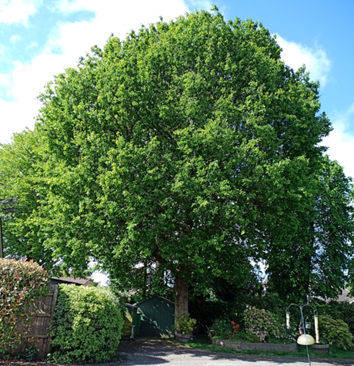

This Oak tree is in good form and appears healthy. There are no obvious defects. It has been agreed that there will be a 2 metre reduction, which will be carried out on the whole crown, resulting in small cuts which will allow the tree to be balanced out. This will only take place on the side overhanging the applicant’s land as the other side is suppressed by the Beech tree and therefore works are not required. Whilst it could be argued that the works are not necessary, the crown is slightly bias on one site so this will allow a more symmetrical tree. This will not result in a 2 metre crown reduction
The branch to be removed is of small diameter and is identified by a red line on the annotated photo below. Obviously no further reductions to this branch will be necessary for some time as it will be reduced back to a previous pruning point.

This application will be approved, with conditions applied to specify the measurement of crown reduction and the removal of the small branch. Statutory informatives relating to ownership and the Wildlife and Countryside Act 1981 will also be included in on the decision notice.

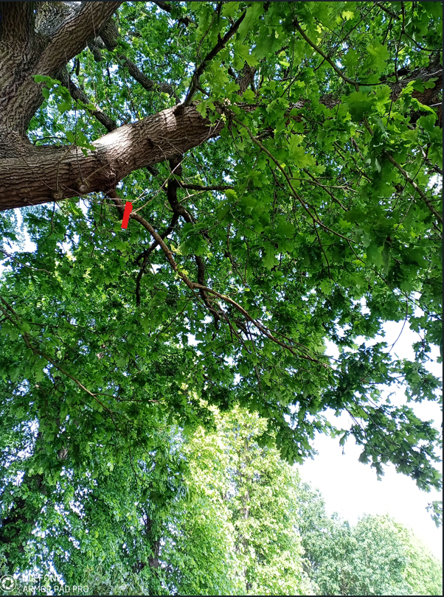

PL/2026/02463 - 3 Lime trees - Re Pollard back to last cut line in February 2023.

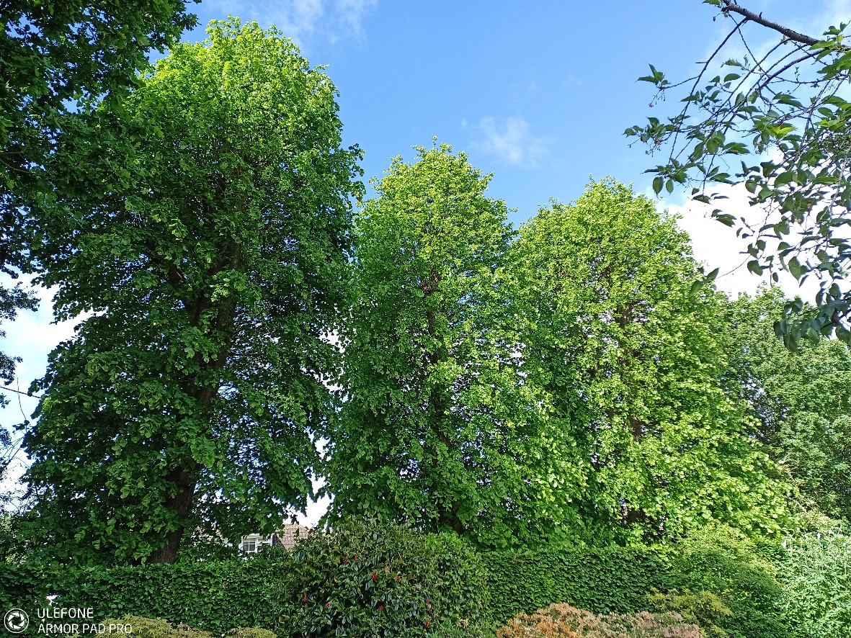

The three lime trees were first pollarded in 2019 and again in 2022. I am aware of the previous applications and the views expressed by the local community at that time. However, my role is to assess the trees based on their current condition.
Accordingly, I will not engage in further discussion regarding matters that occurred prior to this application.

The trees responded well to the pollarding undertaken in 2022 and continue to provide a strong level of visual amenity to the local area. However, pollarding is a cyclical management practice that is ideally implemented as formative pruning on young trees. This ensures cuts remain small and are typically carried out every 4–5 years, resulting in minimal physiological impact.
In contrast, these trees are mature and well established. Undertaking large pruning cuts in such circumstances is likely to have a detrimental effect on their long-term health and their ability to sustain a lapsed pollard regime, as referenced in previous correspondence.

A lapsed pollard in a busy area can become unsafe. This is because branches may fail due to weak connections when they become large and heavy.
Lime trees respond strongly to pruning. If a lapsed pollard is reduced in the future, it will grow back quickly. This new growth can increase the weight in the canopy and put more strain on the branch connections.

I understand this is disappointing. I have spoken with the applicant, and they have agreed to withdraw the current application to repollard the trees. They plan to submit a new application at the end of 2027, with work planned for early 2028.
This means the trees will keep their current appearance for at least another 18 months. They will continue to grow, while still remaining safe for nearby residents.

Please note that when an application to repollard is submitted at the end of 2027, it is likely to be approved. I understand there will be different views about the need for the work and how it will look. However, I hope that allowing a longer time between pollarding will be seen as a reasonable compromise.

At this time, this application will be withdrawn and therefore will not longer be available on our website.

