APPLICATION FOR HOUSEHOLDER PLANNING PERMISSION
DELEGATED REPORT

APPLICATION REFERENCE: | PL/2026/01684
APPLICATION TYPE: | Householder planning permission
SITE ADDRESS: | 1a Church Acre, Bradford On Avon, BA15 1RL
DEVELOPMENT DESCRIPTION: | The removal of an existing conservatory, replacing utilising the same footprint a single storey extension, also proposed is the addition of a small rear dormer window.
RECOMMENDATION: | That Planning Permission be GRANTED

PROPOSAL

The proposal seeks planning permission for a single storey extension on the rear elevation extending over the footprint of an existing conservatory that would be removed, and a dormer window to be inserted on the rear elevation

SITE DESCRIPTION/CONTEXT
This application relates to a detached two storey dwelling, 1a Church Acre, located within an established residential area in Bradford on Avon. The host dwelling benefits from an off-road parking area to the front elevation and an attached garage. The general area comprises of a mixture of housing types and styles of different periods.

The application site sits just outside of the Bradford on Avon Conservation Area and within the Bath and Bradford on Avon Special Area of Conservation for bats.

PLANNING HISTORY
W/04/01625/FUL Conservatory at rear and enclosed porch to front – Approve with conditions
W/06/02340/FUL Change of use from garages to form dependant relative’s area – Approve with conditions

RELEVANT POLICIES AND GUIDANCE
Wiltshire Core Strategy:
Core Policy 2 Delivery Strategy
Core Policy 7 Spatial Strategy for the Bradford on Avon Community Area
Core Policy 50 Biodiversity and Geodiversity
Core Policy 57 Ensuring High Quality Design and Place Shaping
Core Policy 58 Ensuring the Conservation of the Historic Environment

Emerging Policy – Wiltshire Local Plan Review
The examination of the emerging Wiltshire Local Plan has been paused and the weight to be afforded to any part of the emerging plan can be no more than very limited. A decision on how to proceed will be made by the Council in May 2026.
Bradford on Avon Conservation Area Statement
Bradford on Avon Neighbourhood Plan 2013 – 2026 Made October 2017
Wiltshire Design Guide: Appendix D – Design Guidance for Householder extensions
The National Planning Policy Framework (NPPF)
Planning (Listed Buildings and Conservation Areas) Act 1990
The Planning Practice Guidance
National Design Guide

CONSULTATION RESPONSES
Bradford on Avon Town Council: No objection

REPRESENTATIONS
Bradford on Avon Preservation Trust – No objection
One letter of representation was received in support of the proposal.

ASSESSMENT
Section 38(6) of the Planning and Compulsory Purchase Act 2004 states:

"If regard is to be had to the development plan for the purposes of any determination to be made under the planning Acts, the determination must be made in accordance with the plan unless material considerations indicate otherwise."

In accordance with this statutory requirement, this application has been assessed against the relevant policies of the Development Plan, including the adopted Wiltshire Core Strategy (2015) and, where applicable, any made Neighbourhood Plans.

Heritage, Design and Impact upon the character and context of the area
From the point of view of the historic environment the main statutory tests are set out within the Planning (Listed Building and Conservation Areas) Act 1990.

Section 72(1) of the Act requires the Council to pay special attention to the desirability of preserving or enhancing the character or appearance of designated Conservation Areas.
The Council’s Core Strategy Policy CP58 ‘Ensuring the conservation of the historic environment’ requires that designated and non-designated heritage assets and their settings will be conserved, and where appropriate enhanced, in a manner appropriate to their significance and encourages proposals which improve the condition of heritage assets at risk.

The Council’s Core Strategy CP 57: Ensuring high quality design requires a high quality of design in all new developments. The policy requires applicants to “demonstrate how the proposal will make a positive contribution to the character of Wiltshire through (amongst other things) responding to the value of the natural and historic environment and being sympathetic to and conserving historic buildings and landscapes. Development is required to respond positively to the existing in terms of building layouts, built form, height, mass, scale, building line, plot size, elevational design, materials, streetscape and rooflines to effectively integrate the building into its setting.

The NPPF outlines government policy for planning. Chapter 16 of the NPPF 'Conserving and enhancing the historic environment' sets out the Government's high-level policies concerning heritage and sustainable development.

The property lies just outside of the Bradford on Avon Conservation Area which envelopes it to the north and west. As views in and out of the conservation area are important, any proposal has to be assessed mindful of Section 72 of the abovementioned Act as well as CP58 of the Wiltshire Core Strategy and the relevant paragraphs of the NPPF.
Within the vicinity of the host dwelling lie a couple of listed buildings and structures therefore, any works to the host dwelling have to be appraised in relation to any impact upon the immediate setting of these listed buildings.

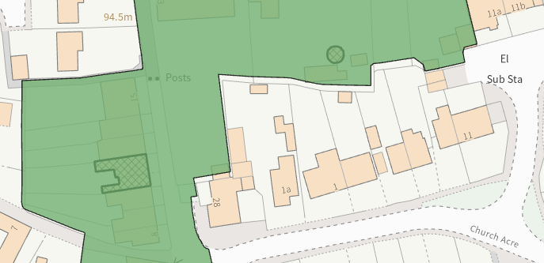
Conservation area (shaded green) and listed buildings (hatched black)

The single storey rear extension would be positioned on the north elevation, extending over and forward of the footprint of the existing conservatory building that would be removed to facilitate the build. The extension would consist of a hipped roof form, sitting at a height of 4m and would have a central glass roof light inserted to illuminate the internal space.

The dormer window would be inserted on the rear elevation, mirroring the height and scale of the existing dormer on the front elevation and would consist of a pitched roof form with a single window.
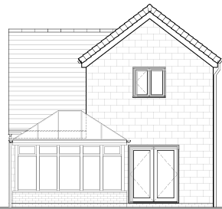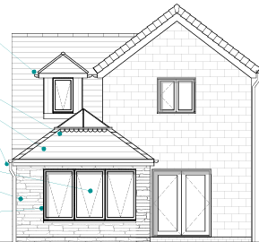
Existing (left) and proposed (right) rear elevation
The applicant seeks to utilise sandstone elevations on the extension alongside larch cladding detailing with black framed fenestration. The dormer window would also consist of larch clad elevations and to the front elevation of the host dwelling part of the ground floor elevation would have some larch cladding.

The cladding would introduce a contemporary appearance to the host dwelling, however officers raise no concerns in regard to the proposal seeming out of character or appearance with the area, with many buildings within Bradford on Avon celebrating contemporary design. The use of the natural sustainable material is supported and given the limited works proposed, that would be set within the built envelope of the application site, it is considered that there would be nominal harm to the conservation area.

Officers raise no objections as the proposal, by virtue of its scale, would preserve the character and appearance of the conservation area and would not result in harm to the significance of any heritage assets.

The development is therefore considered to comply with Core Policy 58 of the Wiltshire Core Strategy and Sections 66 and 72 of the Planning (Listed Buildings and Conservation Areas) Act 1990, as well as the relevant provisions of the NPPF.

Amenity
Point vii of Core Policy 57 - Ensuring High Quality Design and Place Shaping of the Wiltshire Core Strategy seeks to ensure that developments do not adversely affect neighbouring properties.

The National Planning Policy Framework (NPPF), particularly Paragraph 135(f), stresses that planning decisions should ensure developments provide a high standard of amenity for existing and future users.

The proposed development has been assessed in terms of its potential impact on the residential amenity of neighbouring properties, with particular regard to loss of light, overshadowing, loss of privacy, and overbearing effects.

The windows on the extension would overlook the applicant’s private residential rear curtilage and given the single storey nature of the proposal no overlooking concerns are concerned.

The insertion of the dormer window on the rear elevation of the host dwelling could introduce some overlooking to the properties to the rear. However, the window would be positioned at a height similar to the existing fenestration arrangement on the rear of the host dwelling and given the separation distance between the rear elevation of the host dwelling and the properties to the north no overlooking concerns are raised.

The single storey rear extension would be replacing existing built form on the rear of the host dwelling, of a similar height scale and massing to existing therefore raise no concerns in regard to any adverse overbearing or overshadowing impacts

The proposal therefore accords with Core Policy 57 point vii in respect of safeguarding residential amenity and Appendix D of the Wiltshire Design Guide.

Ecology Impact
Core Policy 50 of the Wiltshire Core Strategy seeks to protect and enhance biodiversity and geodiversity, including through ensuring that development avoids harm to protected species and habitats.

The National Planning Policy Framework (NPPF), in Paragraphs 193, requires that development minimises impacts on and provides net gains for biodiversity, including ensuring mitigation is secured where harm cannot be avoided.

The application site sits within the Bath and Bradford on Avon Special Area of Conservation for bats, therefore due consideration has to be given to the potential disturbance of any bats because of the proposed development.

However, the proposed development comprises an extension to existing residential development consisting of limited built form close to the existing dwelling which does not involve works to the roof. Given the established high density urban residential nature of the location, it is considered highly unlikely that any bats would be affected and significant effects relating to the disturbance to bats can be ruled out.

As a precautionary measure an informative would be added to any decision that in event any evidence of bat activity is detected that the applicant should follow the advice of a professional ecologist or contact Natural England.

As such, the development complies with Core Policy 50 of the Wiltshire Core Strategy and the relevant provisions of the NPPF.

Biodiversity Net Gain
Householder planning applications are exempt from the requirement to deliver Biodiversity Net Gain under Schedule 7A, Section 4(2)(a) of the Town and Country Planning Act 1990, as inserted by the Environment Act 2021.

CONCLUSION
The proposed development is considered to be acceptable in terms of its design, scale, and relationship with the surrounding area. It would not result in any unacceptable harm to the character of the locality, the amenities of neighbouring occupiers, or the interests of heritage, or ecology.

The proposal is therefore considered to comply with the relevant policies of the Wiltshire Core Strategy, the Wiltshire Local Plan, and the National Planning Policy Framework. As such, the application is recommended for approval, subject to the conditions set out below.

RECOMMENDATION: That Planning Permission be GRANTED subject to conditions.

Conditions

1.The development hereby permitted shall be begun before the expiration of three years from the date of this permission.
REASON: To comply with the provisions of Section 91 of the Town and Country Planning Act 1990 as amended by the Planning and Compulsory Purchase Act 2004.

2. The development hereby permitted shall be carried out in accordance with the following approved plans and documents:
Location Plan - Received 12/03/2026
Existing Floor Plan DWG No 5085-001-EP - Received 12/03/2026
Existing Site Plan DWG No 5085-105-EBP - Received 12/03/2026
Existing Elevations DWG No 5085-002-EE - Received 19/03/2026

Existing Site Plan DWG No 5085-105-EBP - Received 12/03/2026

Proposed Floor Plan DWG No 5085-101-PP Rev A - Received 23/03/2026

Proposed Elevations DWG No 5085-102-PE - Received 12/03/2026

Proposed Site Plan DWG No 5085-106-PBP - Received 12/03/2026

REASON: For the avoidance of doubt and in the interests of proper planning.

Informative
If bats or evidence of bats are found during the works, the applicant is advised to stop work and follow advice from an independent ecologist or to contact Natural England’s Bat Line through the internet.

