APPLICATION FOR HOUSEHOLDER PLANNING PERMISSION
DELEGATED REPORT

APPLICATION REFERENCE: | PL/2026/02151
APPLICATION TYPE: | Householder planning permission
SITE ADDRESS: | Kingsdown Farm, Longbridge Deverill, Warminster, BA12 7DY
DEVELOPMENT DESCRIPTION: | Replace existing underground domestic septic tank with an upgraded underground domestic package treatment plant within the curtilage of the dwelling.
RECOMMENDATION: | That Planning Permission be GRANTED

PROPOSAL

The proposal seeks planning permission for the Replace existing underground domestic septic tank with an upgraded underground domestic package treatment plant within the curtilage of the dwelling at Kingsdown Farm, Longbridge Deverill, Warminster, BA12 7DY.

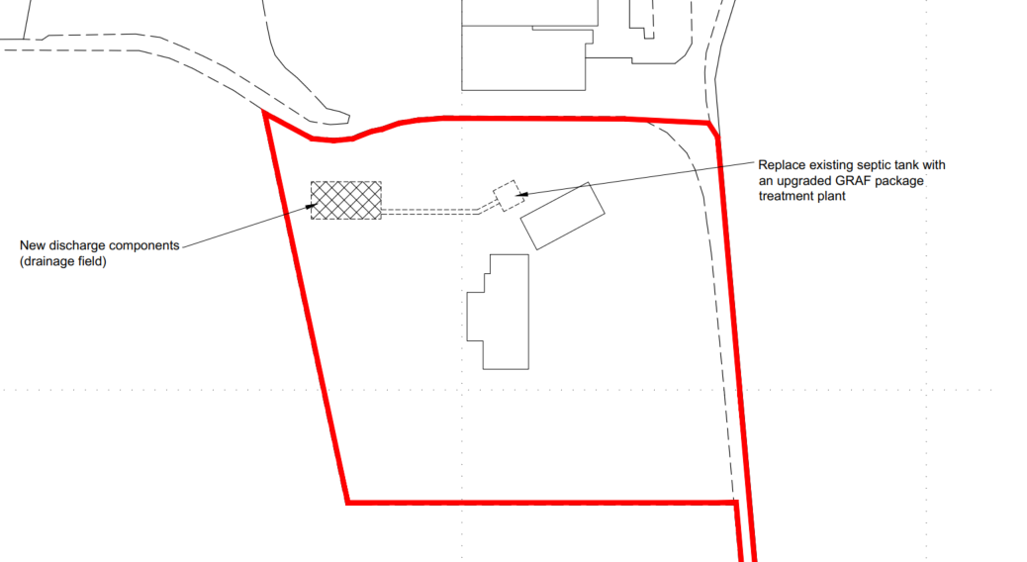

Proposed Site Plan

The applicants have not supplied detailed information of the proposed “7PE One2Clean Tank” but have confirmed that it is a biological treatment system that does not require chemical dosing.

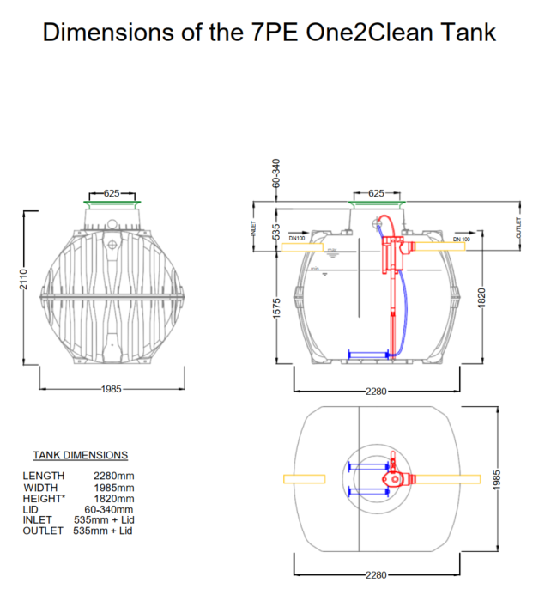

Proposed Replacement Septic Tank Details

SITE DESCRIPTION/CONTEXT

Kingsdown Farm extends to approximately 10.3 hectares and is located 2.5km from Longbridge Deverill and 2.6km from Sutton Veny. The agricultural landholding is extensively farmed, concentrating primarily on cattle grazing together with some arable farming. The site is very rural.

Kingsdown Farm has been subject to many recent applications for agricultural buildings within the farm complex and other applications relating to land-repofling. This application relates to the farmhouse located to the south of the farm complex.

The site is not subject to any ground or surface water flood risk. The site is not within a conservation area and there are no nearby listed buildings.

The application site is subject to the following planning policy constraints:

- Cranborne Chase National Landscape
- Salisbury Plain Special Protection Area 6.4km buffer
- Hampshire Avon Catchment Area

RELEVANT PLANNING HISTORY

Proposal / Summary
14/11851/OUT - Outline Planning Decision - Approve with Conditions Date: 9/4/2015 – Erection of an agricultural workers dwelling (Outline application with all matters reserved)
16/03111/REM - Reserved Matters Decision - Approve with Conditions Date: 1/6/2016 – Application for approval of all reserved matters comprising access, appearance, landscaping, layout and scale for the erection of an agricultural workers dwelling. (following Outline approval 14/11851/OUT)
W/05/01858/FUL - Full planning permission Decision - Approve with Conditions Date: 26/1/2006 – Farmhouse and garage

The applications relating to the land re-profiling and agricultural buildings have not been include in the above list.

RELEVANT POLICIES AND GUIDANCE

National Context:

The National Planning Policy Framework (NPPF)

The Planning Practice Guidance

Local Context:

Wiltshire Core Strategy:

- Core Policy 50: Biodiversity and Geodiversity
- Core Policy 51: Landscape
- Core Policy 57 Ensuring High Quality Design and Place Shaping

Sutton Veny does not have a Neighbourhood Plan or Area Designation

Wiltshire Design Guide: Appendix D – Design Guidance for Householder extensions

CONSULTATION RESPONSES

Sutton Veny Parish Council: No objection

Environment Agency: No comment to make

Ecology Officer: Verbal comments only

As the proposal does not relate to, nor would it result in, an increase in residential dwellings, there is no requirement for a Habitats Regulations Assessment (HRA) or a consultation with the Council’s Ecologist.

REPRESENTATIONS

The application was advertised by site notice erected at the access to the farm from the main road.

No comments were received.

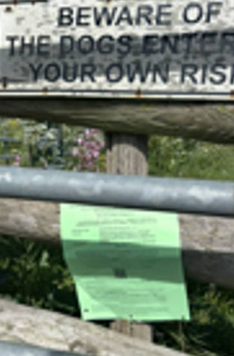

ASSESSMENT

Section 38(6) of the Planning and Compulsory Purchase Act 2004 states:

"If regard is to be had to the development plan for the purposes of any determination to be made under the planning Acts, the determination must be made in accordance with the plan unless material considerations indicate otherwise."

In accordance with this statutory requirement, this application has been assessed against the relevant policies of the Development Plan, including the adopted Wiltshire Core Strategy (2015) and, where applicable, any made Neighbourhood Plans.

Design and Impact upon the character and context of the area

Core Policy 57 - Ensuring High Quality Design and Place Shaping of the Wiltshire Core Strategy seeks to ensure that all new development is of high design quality, reflecting local context, character, and distinctiveness.

The development is to replace an underground sewerage system. Although the development works would involve excavation, the completed works would essentially be hidden and would therefore result in no identified harm to the appearance of the site or its locality.

Having regard to the above, the proposal complies with the design principles set out in Core Policy 57 of the Wiltshire Core Strategy and Appendix D of the Wiltshire Design Guide.

Amenity

Point vii of Core Policy 57 - Ensuring High Quality Design and Place Shaping of the Wiltshire Core Strategy seeks to ensure that developments do not adversely affect neighbouring properties.

The National Planning Policy Framework (NPPF), particularly Paragraph 135, stresses that planning decisions should ensure developments provide a high standard of amenity for existing and future users.

No amenity concerns are identified, as the proposed upgrade would be contained within the property curtilage and would not result in any visual or overbearing impact. The system is appropriately sited, designed, and oriented to avoid any unacceptable effects on neighbouring residential amenity, including outlook, privacy, and access to natural light.

The proposal therefore accords with Core Policy 57 point vii in respect of safeguarding residential amenity and Appendix D of the Wiltshire Design Guide.

Ecology Impact

Core Policy 50 of the WCS requires development to avoid and minimise disturbance to sensitive habitats and species.

The proposed development involves a like-for-like replacement of residential equipment within existing curtilage, an area already subject to development. It is therefore unlikely to impact sensitive habitats or species. Furthermore, the updated drainage system retains the existing discharge method while improving nutrient filtration, resulting in a neutral to positive environmental outcome. The proposal is considered to comply with Core Policy 50 and is acceptable in this regard.

As confirmed by the Council’s Ecology Officer the proposal does not relate to, nor would it result in, an increase in residential dwellings and therefore there is no requirement for a Habitats Regulations Assessment (HRA).

Additionally, the application site is within the 6.4km zone of influence of the Salisbury Plain SPA and in light of the HRA for the Wiltshire Core Strategy and the HRA for the Wiltshire Housing Site Allocations Plan it is screened into Appropriate Assessment due to the potential impact of recreational pressure on stone curlew in combination with other plans and projects.

A strategic Appropriate Assessment (AA) has been prepared pertaining to development within the 6.4 km zone of influence that could result in a likely significant effect on the SPA as a result of an increase in recreational / visitor pressure. The AA reached a conclusion of no adverse effects on the integrity of the SPA or its qualifying features provided that the council’s mitigation strategy continues to be implemented. Annual stone curlew monitoring and protection measures continue to be secured by the Council.

In January 2026 Natural England (NE) confirmed that the 2025 strategic AA for Salisbury Plain SPA continues to be supported by NE.

The proposal involves the replacement of an existing domestic drainage system within the curtilage of an existing dwelling and would not result in any increase in residential units, population, or recreational pressure. As such, the development would not give rise to a Likely Significant Effect, either alone or in combination with other plans or projects, on the Salisbury Plain Special Protection Area.

In accordance with the Habitats Regulations, no Appropriate Assessment is therefore required.

National Landscape

Core Policy 51 of the Wiltshire Core Strategy requires all development to protect, conserve, and where possible enhance the character and quality of Wiltshire’s landscapes, giving particular weight to designated areas such as National Landscapes.

The National Planning Policy Framework (NPPF), in Paragraph 176, states that “great weight” should be given to conserving and enhancing landscape and scenic beauty in National Landscapes (formerly Areas of Outstanding Natural Beauty). Development within or affecting the setting of a National Landscape must demonstrate that it will not result in unacceptable harm to the special qualities of that area.

Given the minimal scale, underground siting, and functional nature of the proposed septic tank, the development would not harm the special qualities or scenic character of the and Chase National Landscape.

The development therefore complies with Core Policy 51 of the Wiltshire Core Strategy and Paragraph 176 of the NPPF in conserving and enhancing the National Landscape.

Drainage and Flood Risk

Core Policy 67 of the Wiltshire Core Strategy sets out the approach to managing flood risk, while paragraph 172 of the NPPF requires a sequential, risk-based strategy for locating development. The site lies within Flood Zone 1, indicating the lowest risk of fluvial flooding, and is also at low risk of surface and groundwater flooding. The proposed replacement of sewerage equipment is a like-for-like installation and is not expected to alter existing drainage characteristics. Accordingly, no flood risk concerns are identified.

Matters relating to detailed specification, installation, and operation of the package treatment plant are subject to separate regulatory controls, including the Environmental Permitting regime and Building Regulations, and do not weigh against the acceptability of the proposal in planning terms.

Biodiversity Net Gain

Householder planning applications are exempt from the requirement to deliver Biodiversity Net Gain under Schedule 7A, Section 4(2)(a) of the Town and Country Planning Act 1990, as inserted by the Environment Act 2021.

CONCLUSION

In the planning balance, the proposal represents a minor, functional form of development that results in no material harm to landscape character, residential amenity, ecology, or flood risk. Given its contained, underground nature and compliance with the development plan, there are no material considerations that indicate permission should be withheld.

The proposal is considered to comply with the relevant policies of the Wiltshire Core Strategy and the National Planning Policy Framework. As such, the application is recommended for approval, subject to the conditions.

RECOMMENDATION: That Planning Permission be GRANTED subject to conditions.

