APPLICATION FOR HOUSEHOLDER PLANNING PERMISSION
DELEGATED REPORT

APPLICATION REFERENCE: | PL/2026/01967
APPLICATION TYPE: | Householder planning permission
SITE ADDRESS: | Springways Cottage, 56 Duck Street, Sutton Veny, Warminster, BA12 7AL
DEVELOPMENT DESCRIPTION: | Demolition of existing porch and change of existing door to window. Construction of veranda roof including raising boundary wall and forming door opening
RECOMMENDATION: | That Planning Permission be GRANTED

PROPOSAL

The proposal seeks planning permission for Demolition of existing porch and change existing door to window. Construction of veranda roof including raising boundary wall and forming door opening at Springways Cottage, 56 Duck Street, Sutton Veny.

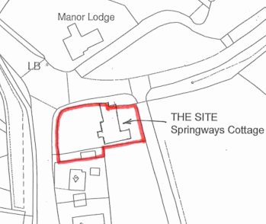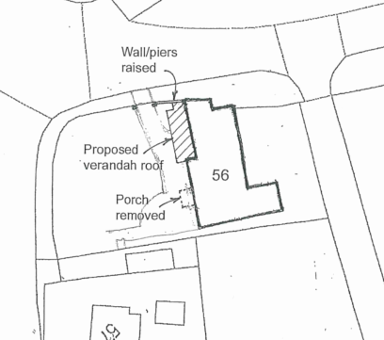

Site Location Plan and Block Plan

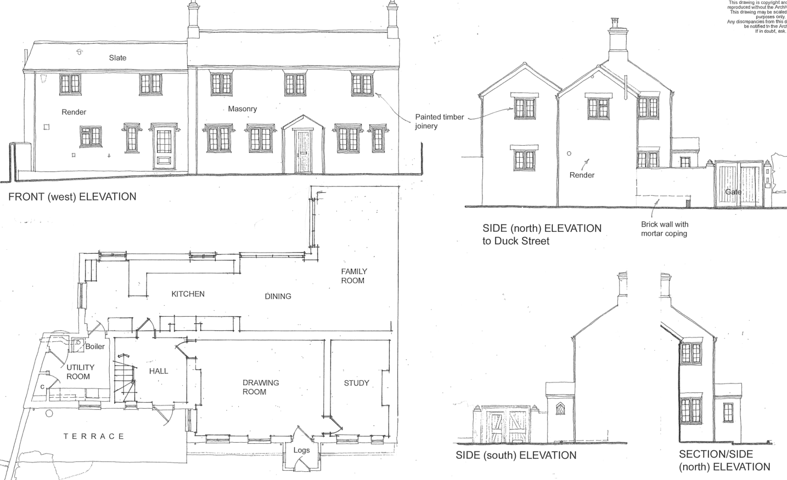

Existing Elevations and Floor Plan

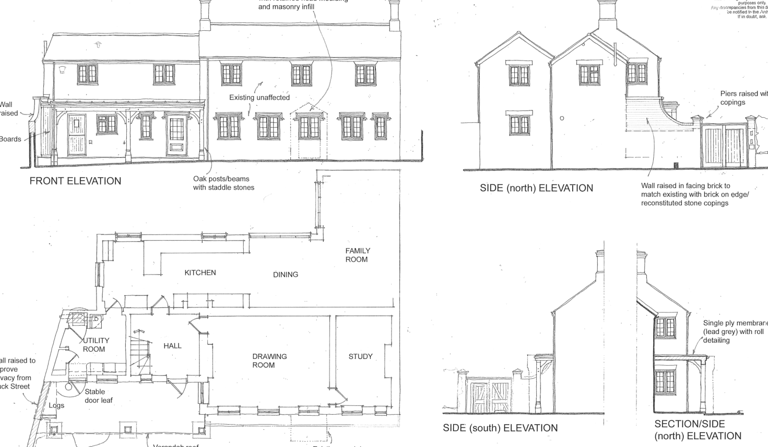

Proposed Elevations and Floor Plan

SITE DESCRIPTION/CONTEXT

Springways Cottage is a detached two storey cottage located within the Sutton Veny Conservation Area (although there are no nearby listed buildings). It is located on a junction between the High Street and Duck Street and resultantly, its front (western) elevation is widely visible from the street scene.

The application site is subject to the following planning policy constraints:

- Salisbury Plain Special Protection Area 6.4km buffer zone
- Cranborne Chase and West Wiltshire Downs National Landscape
- Ground water flood risk – within 0.025m of the ground surface

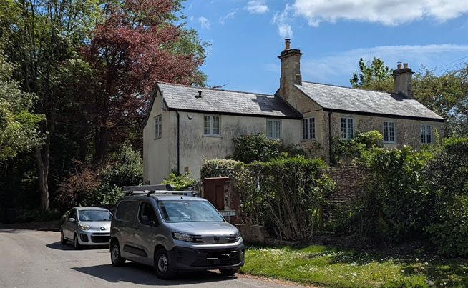

View from High Street/Duck Street junction

PLANNING HISTORY

W/10/01567/FUL - Proposed two storey extension to provide additional accommodation – Approved with conditions

RELEVANT POLICIES AND GUIDANCE

National Context:

The NPPF outlines government policy for planning. Chapter 16 of the NPPF 'Conserving and enhancing the historic environment' sets out the Government's high-level policies concerning heritage and sustainable development.

The Planning Practice Guidance

From the point of view of the historic environment the main statutory tests are set out within the Planning (Listed Building and Conservation Areas) Act 1990.

Section 72 of the Planning (Listed Buildings and Conservation Areas) Act 1990 states that in the exercise of any functions, with respect to any buildings or other land in a conservation area, under or by virtue of any of the provisions mentioned in this Section, special attention shall be paid to the desirability of preserving or enhancing the character or appearance of that area.

Local Context:

Wiltshire Core Strategy:

- Core Policy 50: Biodiversity and Geodiversity
- Core Policy 51: Landscape
- Core Policy 57: Ensuring High Quality Design and Place Shaping
- Core Policy 58: Ensuring the Conservation of the Historic Environment
- Core Policy 67: Flood Risk

The Council’s Core Strategy Policy CP58 ‘Ensuring the conservation of the historic environment’ requires that designated and non-designated heritage assets and their settings will be conserved, and where appropriate enhanced, in a manner appropriate to their significance and encourages proposals which improve the condition of heritage assets at risk.

The Council’s Core Strategy CP 57: Ensuring high quality design requires a high quality of design in all new developments. The policy requires applicants to “demonstrate how the proposal will make a positive contribution to the character of Wiltshire through (amongst other things) responding to the value of the natural and historic environment and being sympathetic to and conserving historic buildings and landscapes. Development is required to respond positively to the existing in terms of building layouts, built form, height, mass, scale, building line, plot size, elevational design, materials, streetscape and rooflines to effectively integrate the building into its setting.”

Sutton Veny does not have a Neighbourhood Plan or Area designation

Wiltshire Design Guide: Appendix D – Design Guidance for Householder extensions

Sutton Veny Conservation Area Statement 1975

Wiltshire Local Transport Plan.

CONSULTATION RESPONSES

Sutton Veny Parish Council: No objection

Wiltshire Council Highways Officer – No objection

REPRESENTATIONS

The application was advertised by means of site notice and 4 neighbour notification letters. One letter of support was received
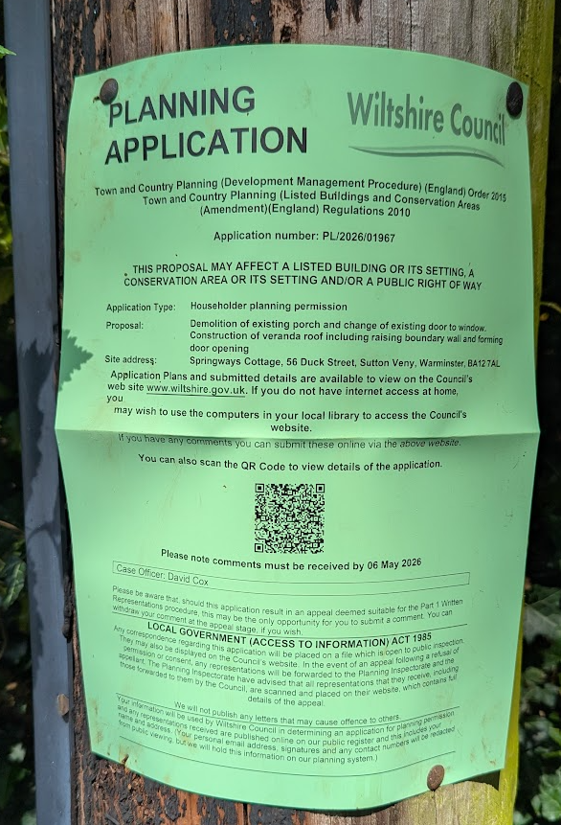

Site notice erected on telegraph pole opposite the site

ASSESSMENT

Section 38(6) of the Planning and Compulsory Purchase Act 2004 states:

"If regard is to be had to the development plan for the purposes of any determination to be made under the planning Acts, the determination must be made in accordance with the plan unless material considerations indicate otherwise."

In accordance with this statutory requirement, this application has been assessed against the relevant policies of the Development Plan, including the adopted Wiltshire Core Strategy (2015) and, where applicable, any made Neighbourhood Plans.

Design and Impact upon the character and context of the area

Core Policy 57 - Ensuring High Quality Design and Place Shaping of the Wiltshire Core Strategy seeks to ensure that all new development is of high design quality, reflecting local context, character, and distinctiveness.

The proposal is to increase the height of the existing boundary wall so that it can provide some screening of the proposed veranda. The wall would be built with matching materials under a stone cap and would not dominate against or detract from the host building (the cottage) nor adversely affect the existing gate.

Whilst the veranda would still be visible from the High Street, the veranda would be a simple and appropriate addition to the host building which would have the benefit of improving the accommodation offer at Springways Cottage.

Having regard to the above, the proposal complies with the design principles set out in Core Policy 57 of the Wiltshire Core Strategy and Appendix D of the Wiltshire Design Guide.

Amenity

Point vii of Core Policy 57 - Ensuring High Quality Design and Place Shaping of the Wiltshire Core Strategy seeks to ensure that developments do not adversely affect neighbouring properties.

The National Planning Policy Framework (NPPF), particularly Paragraph 135(f), stresses that planning decisions should ensure developments provide a high standard of amenity for existing and future users.

The proposed development has been assessed in terms of its potential impact on the residential amenity of neighbouring properties, with particular regard to loss of light, overshadowing, loss of privacy, and overbearing effects.

The increased wall and veranda would be sufficiently far away from any neighbour and would not cause any harm to neighbouring amenity.

The proposal therefore accords with Core Policy 57 point vii in respect of safeguarding residential amenity and Appendix D of the Wiltshire Design Guide.

Heritage Impact

The Sutton Veny conservation area statements sets out:

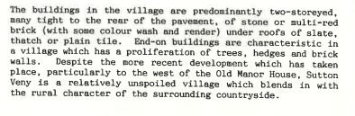
The proposal would add a small increase in wall but in a Conservation Area characterised by a proliferation of brick walls.

It is considered that the proposal, by virtue of its limited scale, appropriate design, and use of materials, would preserve the character and appearance of the conservation area. Additionally, it would not result in harm to the significance of any heritage assets.

In accordance with Section 72 of the Planning (Listed Buildings and Conservation Areas) Act 1990, special attention has been paid to the desirability of preserving the character and appearance of the Sutton Veny Conservation Area. The proposal, by virtue of its limited scale, siting and use of appropriate materials, would preserve that character and appearance and would not result in harm to the significance of any designated or non‑designated heritage asset.

Ecology Impact

Core Policy 50 of the Wiltshire Core Strategy seeks to protect and enhance biodiversity and geodiversity, including through ensuring that development avoids harm to protected species and habitats.

The National Planning Policy Framework (NPPF), in Paragraphs 193, requires that development minimises impacts on and provides net gains for biodiversity, including ensuring mitigation is secured where harm cannot be avoided.

The Council’s Ecology Officer has not been consulted on this application, but the application site is within the 6.4km zone of influence of the Salisbury Plain SPA and in light of the HRA for the Wiltshire Core Strategy and the HRA for the Wiltshire Housing Site Allocations Plan it is screened into Appropriate Assessment due to the potential impact of recreational pressure on stone curlew in combination with other plans and projects.

A strategic Appropriate Assessment (AA) has been prepared pertaining to development within the 6.4 km zone of influence that could result in a likely significant effect on the SPA as a result of an increase in recreational / visitor pressure. The AA reached a conclusion of no adverse effects on the integrity of the SPA or its qualifying features provided that the council’s mitigation strategy continues to be implemented. Annual stone curlew monitoring and protection measures continue to be secured by the Council.

In January 2026 Natural England (NE) confirmed that the 2025 strategic AA for Salisbury Plain SPA continues to be supported by NE.

Given the nature of the proposal as a minor householder development which would not result in additional residential units or population increase, it would not materially increase recreational pressure on the Salisbury Plain SPA. The proposal therefore falls within the scope of the Council’s strategic mitigation approach.

As such, the development complies with Core Policy 50 of the Wiltshire Core Strategy and the relevant provisions of the NPPF.

National Landscape

Core Policy 51 of the Wiltshire Core Strategy requires all development to protect, conserve, and where possible enhance the character and quality of Wiltshire’s landscapes, giving particular weight to designated areas such as National Landscapes.

The National Planning Policy Framework (NPPF), in Paragraph 176, states that “great weight” should be given to conserving and enhancing landscape and scenic beauty in National Landscapes (formerly Areas of Outstanding Natural Beauty). Development within or affecting the setting of a National Landscape must demonstrate that it will not result in unacceptable harm to the special qualities of that area.

The proposal only involves a small veranda extension and the increase in height of an existing wall. There would be no wider impact on the landscape setting within the National Landscape.

The proposal, by virtue of its scale, siting, and design, would not harm the special qualities or scenic character of the Cranborne Chase and West Wiltshire Downs National Landscape.

The development therefore complies with Core Policy 51 of the Wiltshire Core Strategy and Paragraph 176 of the NPPF in conserving and enhancing the National Landscape.

Drainage and Flood Risk

The application site is within flood zone 1 but is within the highest risk category of ground water flooding and in accordance with the Council’s 2019 and 2024 Strategic flood risk assessments (SFRA) the site cannot be considered to be at a low risk of flooding.

The National Planning Policy Framework and associated Planning Practice Guidance set out that householder development is not subject to the sequential or exception tests, but that site‑specific flood risk should be considered where other sources of flooding are present.

This application is for an increase in wall height and a veranda which only requires footings for three support columns. It is not considered that these works should require a flood risk assessment which would detail mitigation measures of floor levels, flood resilient materials and electrical sockets being 400mm above floor level etc. It would not be an ‘inside room’ and planning permission would not be needed to lay the ground under the veranda with a patio. Therefore, for these reasons Officers are satisfied that the application does not require a flood risk assessment and that the proposal would not increase the risk of ground water flooding in the area.

The proposal therefore complies with Core Policy 67 of the Wiltshire Core Strategy and the policy in the NPPF, ensuring that flood risk is not increased.

Biodiversity Net Gain

Householder planning applications are exempt from the requirement to deliver Biodiversity Net Gain under Schedule 7A, Section 4(2)(a) of the Town and Country Planning Act 1990, as inserted by the Environment Act 2021.

Highways Impact

The National Planning Policy Framework (NPPF), particularly Paragraph 115 and 116, requires that development proposals do not have an unacceptable impact on highway safety and that safe and suitable access to the site can be achieved for all users.

The Highway Authority has raised no objection to the proposal. The development would not alter the existing access arrangements or materially intensify the use of the site, and no adverse impact on highway safety would arise.

The proposal is therefore considered to comply with the NPPF, and the Wiltshire Local Transport Plan.

CONCLUSION

The proposed development is considered to be acceptable in terms of its design, scale, and relationship with the surrounding area. It would not result in any unacceptable harm to the character of the locality, the amenities of neighbouring occupiers, or the interests of highway safety, heritage, flooding or ecology.

The proposal is therefore considered to comply with the relevant policies of the Wiltshire Core Strategy, and the National Planning Policy Framework. As such, the application is recommended for approval, subject to conditions.

RECOMMENDATION: That Planning Permission be GRANTED subject to conditions.

