APPLICATION FOR HOUSEHOLDER PLANNING PERMISSION
DELEGATED REPORT

APPLICATION REFERENCE: | PL/2026/00330
APPLICATION TYPE: | Householder planning permission
SITE ADDRESS: | 24 Huntingdon Rise, Bradford on Avon, BA15 1RJ
DEVELOPMENT DESCRIPTION: | First floor extension above existing garage/utility/hall, new porch and internal alterations
RECOMMENDATION: | That Planning Permission be GRANTED

SITE CONTEXT: The application relates to 24 Huntingdon Rise (the ‘site’), which is a residential plot situated off a modern suburban cul-de-sac situated in the northern area of Bradford on Avon (designated a Market Town in the Wiltshire Core Strategy).

The surrounding area comprises a modern residential estate characterised predominantly by detached bungalows and two-storey houses arranged in a regular pattern. Most properties sit behind modest front gardens, contributing to a spacious and consistent streetscape. Immediately around the site, the northern boundary adjoins the public highway (an unmarked two-way road with pavements), with two-storey residential properties located to the east, south and west.

The application site contains a modern detached dwelling with an integrated garage and associated amenity space. The house comprises a two-storey pitched-roof dwelling, with a single-storey flat-roofed side element accommodating the hall, part of the kitchen and the garage. Its external materials include blockwork walling, concrete roof tiles and uPVC double-glazed windows.

The site is not subject to, nor within notable proximity of any planning policy designations and/or constraints that are pertinent to the consideration of this proposal.

PROPOSAL: The proposal comprises a first-floor side extension above the existing garage, utility and hall to provide an additional en-suite bedroom, together with a new porch formed by infilling the gap between the house and garage and an open porch.

Following officer's advice, revised plans have been submitted which reduce the width of the extension by approximately 1m and incorporate a hipped roof design to prevent an overbearing impact on the neighbouring property.

The revised first-floor extension comprises a hipped-roof element containing the bedroom, with a small flat-roof aspect accommodating the en-suite, with an open porch aspect to the north. The garage on the ground floor would have a hipped roof and would have a greater western projection of 1m to the west compared to the first floor aspect, which would be set back.

The proposed materials palette includes blockwork walling, concrete roof tiles and uPVC windows to match the existing dwelling, plus EPDM roofing for the flat-roofed elements, a new timber front door and some ground-floor doors and windows would be replaced with aluminium-framed glazing. The proposed development is shown below:

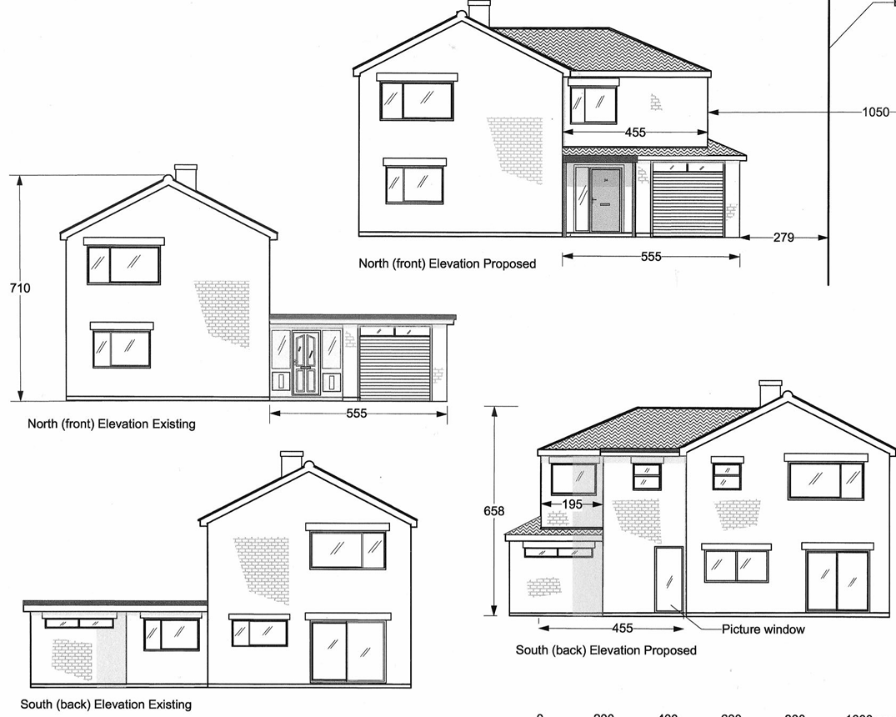

Figure 1: Existing and proposed front and rear elevations (left and right, respectively).

PLANNING HISTORY: No relevant records.

RELEVANT LEGISLATION, POLICIES AND GUIDANCE

Planning Legislation:
- Town and Country Planning Act 1990
- Planning and Compulsory Purchase Act 2004

Development Plan:
- Wiltshire Core Strategy (WCS, adopted January 2015):
  - Core Policy 41: Sustainable construction and low-carbon energy
  - Core Policy 57: Ensuring high quality design and place shaping
  - Core Policy 64: Demand management

- The Bradford on Avon Neighbourhood Plan 2013-2026 (BoANP, made October 2017):
  - Policy BE1 (relates to local distinctiveness and sense of place)
  - Policy BE2 (relates to land use efficiency and character of the area)

Material Considerations (Policy): National Planning Policy Framework (NPPF) December 2024 and associated Planning Practice Guidance

Wiltshire Local Plan: The examination of the emerging Wiltshire Local Plan has been paused, and the weight to be afforded to any part of the emerging plan can be no more than very limited. A decision on how to proceed will be made by the Council in May 2026.

Material Considerations (Guidance):
- National Design Guide (January 2021)
- Wiltshire Design Guide (March 2024)
- Wiltshire Local Transport Plan 2011-2026: Car Parking Strategy

CONSULTATION RESPONSES

Bradford on Avon Town Council: No objection.

Bradford on Avon Preservation Trust: No comment.

Wiltshire Council Highways: No objection.

REPRESENTATIONS: Two representations have been submitted from a neighbouring property, within which concerns have been raised over the first floor south-facing windows, which are considered to generate an unacceptable level of overlooking towards their property. The submitted representations include suggested mitigation, including having the first floor south-facing windows obscurely glazed and/or relocated to other elevations.

The concerns raised by neighbouring occupiers in respect of overlooking and loss of privacy are material planning considerations and are assessed in detail below under neighbouring amenity.

ASSESSMENT: Section 38(6) of the Planning and Compulsory Purchase Act 2004 states that planning decisions must be made in accordance with the development plan unless material considerations indicate otherwise. In accordance with this requirement, this application has been assessed against the relevant policies of the development plan and the material considerations listed above.

Having regard to the planning context and nature of the proposal, the following key matters are considered pertinent to the assessment of the proposal and are addressed in turn:

- Design
- Neighbouring amenity
- Transport

Design: WCS Core Policy 57 requires that all development be of high design quality, create a strong sense of place and complement its context, including through enhancing local distinctiveness and responding positively to local characteristics.

Appendix D of the Wiltshire Design Guide states that extensions should be subservient to and respect the scale, form, appearance and character of the host dwelling and should harmonise with its context.

BoANP Policy BE1 states that development should reinforce local distinctiveness, help create a sense of place and respond positively to its immediate and wider context, including in respect of materials palette.

Policy BE2 states that development should make efficient use of land and respect the character of the area.

The proposed extension would be clearly subordinate to the main pitched roof range in terms of its siting, footprint, height and overall massing. It would be set slightly back from the principal façade, represent a modest increase in floorspace of circa 23%, and incorporate a subservient hipped roof with a ridge positioned around 0.5 metres below that of the main dwelling. The proposal would complement the character and appearance of the host property and nearby dwellings, with detailing and materials that are consistent with the existing dwelling. The open porch, together with the revised doors and fenestration, would also add visual interest and represent an upgrade to the overall appearance of the property.

Having regard to the above, the proposal is of an appropriate quality and respects the local character in accordance with the design principles of WCS Core Policy 57, BoANP Policies BE1 and BE2 and the Design Guide.

Neighbouring Amenity: Core Policy 57(vii) requires that development be compatible with the adjoining uses and protect the residential amenity of existing and future users of the site and its surroundings, including in respect of natural lighting, privacy, outlook and pollution sources.

The Design Guide states that minimum garden areas for all houses should be equivalent to the footprint of the house and at least 10m long for two-storey dwellings. A back-to-back separation distance of minimum 20m should be provided. The guide also refers to the BRE Site layout planning for daylight and sunlight as an appropriate source for assessing proposals. Appendix D of the guide states that extensions should not be unduly overbearing or obtrusive to neighbouring properties.

The application site has a side‑by‑side relationship with No. 22 to the west, which occupies a corner plot. While most habitable rooms are served by windows on the north‑ and west‑facing elevations, one bedroom is served solely by an east‑facing side window directly opposite the proposed extension. Given the absence of alternative sources of natural light and outlook, this window carries particular weight in the assessment.

The Wiltshire Design Guide does not specify separation standards for back‑to‑side relationships or blank side elevations, and applying the 20‑metre back‑to‑back separation would be disproportionate in this context. However, similar best‑practice guidance typically supports minimum back‑to‑blank side wall separations of between 10-15m (with a 10m separation generally only being supported in more urban authorities). The original proposal, which introduced a blank gable of up to 6.6 metres in height at approximately 9.5 metres from the bedroom window, was therefore considered unacceptable.

The revised plans increase the separation distance to approximately 10.5 metres and introduce a hipped roof form, resulting in the bulk of the roof form sloping away from the neighbouring, reducing the height and perceived massing of the extension. Officers consider the revised relationship to be acceptable in this specific context. Furthermore, with the neighbouring window being located to the west of the proposed extension, any potential reduction in light would be limited to the early morning hours during the summer months, with due regard to the direction of the suns trajectory over the course of a year, and it is important to mention that the existing build form would itself already generate a degree of overshadowing, which is not uncommon in residential area.

The proposed development would not therefore have an adverse impact on the overall amenity of neighbouring properties, due to its location and design.

With regard to the proposed first‑floor south‑facing windows, these would be located approximately 10m from the southern site boundary. As the Design Guide supports garden lengths of 10m, windows at this distance are generally acceptable. Subject to a condition requiring obscure glazing to the bathroom window, the proposal would not result in an unacceptable loss of privacy. No other neighbouring properties would be adversely affected.

Having regard to the above and as the proposal maintains sufficient amenity space for the host dwelling, it therefore achieves an acceptable standard of residential amenity in accordance with WCS Core Policy 57(vii) and the Design Guide.

Highways: Core Policy 64 requires that development proposals comply with parking standards set out in the Local Transport Plan (which requires that 4-bedroom dwellings or larger are provided with 3 parking spaces at a minimum).

The proposal provides three parking spaces, in accordance with the Council’s parking standards. Furthermore, the Council’s highways engineer does not object to the proposal. The proposal is therefore considered to comply with Core Policy 64 of the Wiltshire Core Strategy and the Wiltshire Local Transport Plan Car Parking Strategy.

CONCLUSION: In the planning balance, the proposal would deliver a modest improvement to the living conditions of the occupants through additional accommodation, with no identified harm to the character and appearance of the area or to neighbouring residential amenity. Any minor impacts arising from the increase in built form have been appropriately mitigated through amendments to the design. When assessed against the development plan as a whole, the proposal represents sustainable development.

RECOMMENDATION: That Planning Permission be GRANTED subject to the following conditions:

- The development hereby permitted shall be begun before the expiration of three years from the date of this permission.

REASON: To comply with the provisions of Section 91 of the Town and Country Planning Act 1990 as amended by the Planning and Compulsory Purchase Act 2004.

- The development hereby permitted shall be carried out in accordance with the following approved plans and documents:

- Location Plan, ref: PP-14631160v1, as received on 19 January 2026
- Proposed Roof and Boundary Plans, ref: 04/04 rev 2 [also serves as proposed site plan], as received on 23 April 2026
- Proposed Floor Plans, ref: 01/04 rev 2, as received on 22 April 2026
- Proposed North and South Elevations, ref: 02/04 rev 2, as received on 22 April 2026
- Proposed East and West Elevations, ref: 03/04 rev 2, as received on 22 April 2026

REASON: For the avoidance of doubt and in the interests of proper planning.

- The materials to be used in the construction of the external surfaces of the development hereby permitted shall match those of the existing dwelling in respect of type, colour, texture and finish, unless otherwise agreed in writing by the Local Planning Authority.

REASON: In the interests of visual amenity and the character and appearance of the area.

- Before the development hereby permitted is first occupied, the south-facing first-floor en-suite bathroom window shown on the approved plans shall be glazed with obscure (privacy) glass to an obscurity level of no less than level 3 and the window shall be permanently maintained with obscure glazing in perpetuity.

REASON: In the interests of residential amenity and privacy.

