HOUSEHOLDER PLANNING APPLICATION.
CASE OFFICER REPORT

APPLICATION REFERENCE: | PL/2026/00702
APPLICATION TYPE: | Householder Planning Application
SITE ADDRESS: | 396 The Ham, Holt, Trowbridge, BA14 6PX.
DEVELOPMENT DESCRIPTION: | Two storey rear extension.
RECOMMENDATION: | Approve with Conditions.

PROPOSAL
The proposal seeks the construction of a two-storey extension over a single storey garage located to and attached to the rear of the host dwelling.

SITE DESCRIPTION/CONTEXT
The site is a detached two storey dwelling within the Large Village of Holt within an established residential area, it is located close to the centre of the village by the Ham. The locality is an established residential area which is in the Holt Conservation Area and the proposed extension would be located to the rear of the dwelling. The site is located within the Bath & Bradford on Avon Bat SAC.

RELEVANT PLANNING HISTORY
Proposal / Summary
98/00706 Ful Two storey extension. Approved.
98/01401 Ful Demolition of existing garage & erection of attached garage & utility room. Approved.

RELEVANT POLICIES AND GUIDANCE

Wiltshire Core Strategy:

- Core Policy 57 Ensuring High Quality Design and Place Shaping
- Core Policy 50: Biodiversity and Geodiversity
- Core Policy 51: Landscape
- Core Policy 58: Ensuring the Conservation of the Historic Environment
- Core Policy 61: Transport and New Development
- Core Policy 64: Demand Management
- Core Policy 67: Flood Risk

Conservation Area

Holt made Neighbourhood Plan

Wiltshire Design Guide: Appendix D – Design Guidance for Householder extensions

The National Planning Policy Framework (NPPF)

The Planning Practice Guidance

National Design Guide

Emerging Wiltshire Local Plan:
The examination of the emerging Wiltshire Local Plan has been paused and the weight to be afforded to any part of the emerging plan can be no more than very limited. A decision on how to proceed will be made by the Council in May 2026.

CONSULTATION RESPONSES
Holt Parish Council: No objections and ask that the materials are appropriate and match those as existing.

Highways: No objections subject to condition.

REPRESENTATIONS
Two emails of neighbour support received, raising the following points:
-Extent of proposed extension relating to possible impacts on 397a.
-Satisfied with the proposed parking spaces to the rear rather than to the front of the site.

PRINCIPLE OF THE PROPOSAL.
The principle of the proposed scheme is considered to be acceptable for the reasons as discussed below.

ASSESSMENT
Section 38(6) of the Planning and Compulsory Purchase Act 2004 states:

"If regard is to be had to the development plan for the purposes of any determination to be made under the planning Acts, the determination must be made in accordance with the plan unless material considerations indicate otherwise."

In accordance with this statutory requirement, this application has been assessed against the relevant policies of the Development Plan, including the adopted Wiltshire Core Strategy (2015) and the made Neighbourhood Plan for Holt.

Design and Impact upon the upon the character and context of the area

Core Policy 57 - Ensuring High Quality Design and Place Shaping of the Wiltshire Core Strategy seeks to ensure that all new development is of high design quality, reflecting local context, character, and distinctiveness.

The proposals can be viewed within the plan snippets taken from the submitted plans:

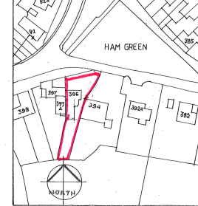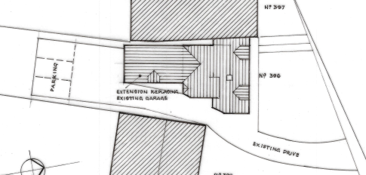
Location Plan Proposed Site Plan

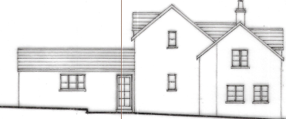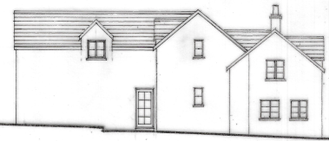
Existing & Proposed East Side Elevations.

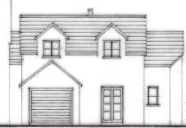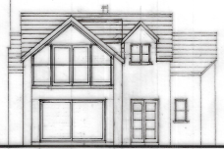
Existing & Proposed South Rear Elevations.

The proposal would see the scheme utilise the existing garage, as located to the rear of the site and which would be slightly extended in both width and length and extended to first floor level, to create a bedroom and en-suite. A new lounge would be created at ground floor level, which would enter onto the rear garden of the site. Materials would match those as existing, in that natural stone would be used for the walls and clay roof tiles would be utilised, which is wholly appropriate. Existing rooms within the building would be reconfigured.

As shown in the plan snippets, at first floor level, the rear of the extension would have a Juliet balcony offering views of the site’s rear garden area and then onto open fields beyond. A small sized dormer window would be created on the east side elevation, that would serve the newly created bedroom.

Three off road car parking spaces would be created and utilised to the rear of the site, with the hard stone surface already being laid from a previous such use.

It is appraised that the proposed two storey extension would represent a complimentary addition to the host dwelling, continuing the built form and roof profile of the original building. The scale and massing of the extension proposal is considered commensurate to the size of the property and plot, thereby preserving the character and appearance of the host dwelling.

Therefore, in summary, having regard to the above, the proposal complies with the design principles set out in Core Policy 57 of the Wiltshire Core Strategy and Appendix D of the Wiltshire Design Guide.

Amenity
Point vii of Core Policy 57 - Ensuring High Quality Design and Place Shaping of the Wiltshire Core Strategy seeks to ensure that developments do not adversely affect neighbouring properties. The National Planning Policy Framework (NPPF), particularly Paragraph 135(f), stresses that planning decisions should ensure developments provide a high standard of amenity for existing and future users.
The proposed extension would be two storey and would look out onto and face its rear garden and car parking area, therefore there would not be any overlooking of neighbours from the rear southern aspect. The proposed dormer window on the side east elevation would face and look onto a high-level blank end gable wall of the immediate neighbour at No.394.

This neighbouring property does have a window at ground floor level within its side elevation, serving as a second light source to the existing room. As shown within the above plan snippets, the garage building already has existing fenestration within its side elevation facing onto this neighbour; however, these windows would be blocked up and removed during the course of this current application.

It is further noted that there is also a high level small bathroom window facing onto a blank stone wall belonging to No.397A, which would be retained and not altered.

Due to the location and orientation of the proposal, there would not be any significant overshadowing or loss of light to the most immediate neighbour at No.397A.

The proposal therefore accords with Core Policy 57 point vii. in respect of safeguarding residential amenity and Appendix D of the Wiltshire Design Guide.

Highway Matters.
Core Policy 57 (xiv) of the Wiltshire Core Strategy seeks to ensure that development must meet the requirements of Core Policy 61. This policy requires proposals to be capable of being served by safe access to the highway network. Core Policy 64 seeks to ensure compliance with parking standards set out in the Local Transport Plan.

The National Planning Policy Framework (NPPF), particularly Paragraph 115 and 116, requires that development proposals do not have an unacceptable impact on highway safety and that safe and suitable access to the site can be achieved for all users.

The proposed development would continue to use the established site access and so which there would not be any adverse impact on highway safety.

During the initial consultation process, two sets of car parking plans were inadvertently submitted, causing the Parish Council to comment. Through dialogue with the applicant and agent, the car parking scheme whereby three vehicles parked to the rear of the site was chosen. The Parish Council were accordingly informed and relevant plans reflect this.

The proposal is therefore considered to comply with Core Policies 57 (xiv), 61 and 64 of the Wiltshire Core Strategy, the NPPF, and the Wiltshire Local Transport Plan.

Conservation Area. The NPPF, Section 72 of the Planning (Listed Building and Conservation Area) Act 1990 and Core Policy 58 of the Council’s adopted Core Strategy highlights the fact that the Local Planning Authority has a duty to pay special attention to the preservation and enhancement of the character and appearance of the Conservation Area.

The site is located within the Holt Conservation Area and therefore careful consideration has been given to CP 58 of the Core Strategy, the NPPF and Section 72 of the Planning (Listed Building and Conservation Area) Act 1990. Due to the use of matching materials, and not being readily visible from the public realm, the character and setting of the surrounding Conservation Area would not be harmfully impacted on. Therefore, for such reasons it is appraised that the proposed works would cause no harm to the character of the surrounding Conservation Area.

Ecology Impact CP50 requires no net loss of biodiversity on site. The site is located within the Bath and Bradford on Avon Bat SAC. The proposed development because of its minor nature and high-density urban location is considered unlikely to result in harm to bats or their habitat. There is no mechanism for significant effects from recreational pressure since it does not result in the creation of a new dwelling. Accordingly, the proposal is acceptable in this regard. As such, the development complies with Core Policy 50 of the Wiltshire Core Strategy and the relevant provisions of the NPPF.

Biodiversity Net Gain. This application is exempt from the requirement to deliver Biodiversity Net Gain under Schedule 7A, Section 4(2)(a) of the Town and Country Planning Act 1990, as inserted by the Environment Act 2021, because the proposal is a householder extension.

CONCLUSION
The proposed development is acceptable in terms of its design, scale, and relationship with the surrounding area. It would not result in any unacceptable harm to the character of the locality, the amenities of neighbouring occupiers, or the interests of highway safety, heritage, or ecology.

The proposal is therefore considered to comply with the relevant policies of the Wiltshire Core Strategy, the Wiltshire Local Plan, and the National Planning Policy Framework. As such, the application is recommended for approval, subject to the conditions set out below.

RECOMMENDATION: Planning Permission be GRANTED subject to conditions.

