APPLICATION FOR HOUSEHOLDER PLANNING PERMISSION
DELEGATED REPORT

APPLICATION REFERENCE: | PL/2026/01814
APPLICATION TYPE: | Householder Planning Permission
SITE ADDRESS: | 16 Lower Marsh Road, Warminster, BA12 9PB
DEVELOPMENT DESCRIPTION: | Conversion of garage to create annexe for dependent family member
RECOMMENDATION: | That Planning Permission be GRANTED

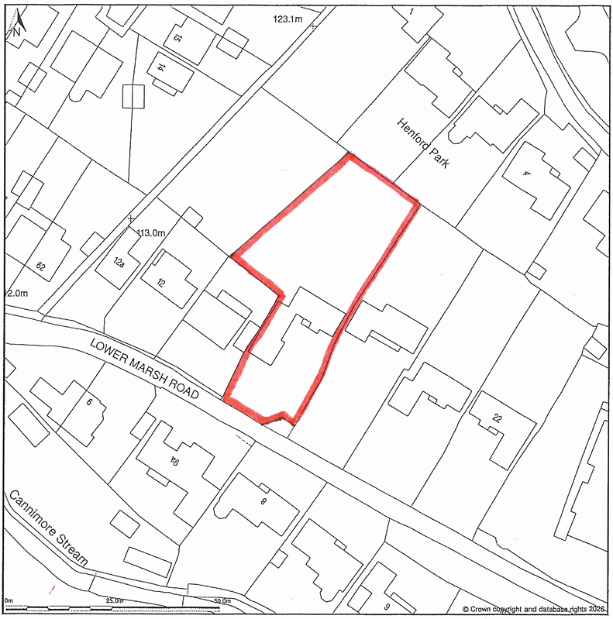

PROPOSAL

The application seeks permission to convert an existing detached garage into a self-contained annexe for use by a dependent family member. External alterations include the replacement of the existing roller shutter door with cladding and uPVC windows, the insertion of a new access door on the side elevation facing the main dwelling, and the relocation of a gas meter to the front elevation. Additional works comprise the installation of a screen fence boundary treatment and a raised decking area on the southern side. Internally, the scheme provides a kitchen, shower room, and sitting/living area, with associated reconfiguration to create a store and cloakroom. An existing bedroom already exists on the ground floor, adjacent to the garage that is to be converted as part of this application, and this shall be retained as part of the proposal.

SITE DESCRIPTION / CONTEXT

The site comprises a two-storey detached dwelling constructed of red brick with a dark tiled roof, situated on the edge of the Warminster settlement boundary within a semi-rural transitional setting. The character of the area shifts noticeably along Lower Marsh Road, where built form becomes more dispersed, with larger plots, established hedgerows, and increasingly open countryside views. While the site lies within Flood Zone 1, there are localised constraints including mapped surface water risk along the adjacent roadway and a high susceptibility to groundwater flooding, albeit the application building itself is unaffected and positioned on land that rises away from the highway. The site is also within the Salisbury Plain SPA buffer and the Hampshire Avon catchment, though no direct impacts arise from the proposal. Three TPO trees are present in the rear garden, but are not affected by the development.

PLANNING HISTORY

Reference No. | Proposal / Summary | Decision
W/89/02005/FUL | Double garage adjoining existing garage | Approved

RELEVANT LEGILSATION, POLICIES AND GUIDANCE

Wiltshire Core Strategy:

Core Policy 1 Settlement Strategy;
Core Policy 2 Delivery Strategy;
Core Policy 31 Spatial Strategy: Warminster Community Area;
Core Policy 50 Biodiversity and Geodiversity;
Core Policy 51 Landscape;
Core Policy 57 Ensuring High-Quality Design and Place Shaping;
Core Policy 60 Sustainable Transport;
Core Policy 61 Transport and Development;
Core Policy 64 Demand Management;
Core Policy 67 Flood Risk;
Core Policy 69 Protection of the River Avon SAC

The National Planning Policy Framework (NPPF) and the Planning Practice Guidance (PPG)

Wiltshire Design Guide - Appendix D – Design Guidance for Householder extensions

The Wiltshire Local Transport Plan 2011 – 2026: Car Parking Strategy (March 2015).

The Wiltshire Local Transport Plan 4 (LTP4) (March 2025)

The 'made' Warminster Neighbourhood Plan, November 2016

Emerging Policy – Wiltshire Local Plan Review: The examination of the emerging Wiltshire Local Plan has been paused and the weight to be afforded to any part of the emerging plan can be no more than very limited. A decision on how to proceed will be made by the Council in May 2026.

CONSULTATION RESPONSES

Warminster Town Council – No Objection (subject to condition)

Local Highway Authority (Wiltshire Council) – No Objection (subject to condition)

Both the Town Council and Highway Authority responses are addressed through the imposition of a condition restricting occupation of the annexe to purposes ancillary to the host dwelling.

REPRESENTATIONS: No comments received.

ASSESSMENT: Section 38(6) of the Planning and Compulsory Purchase Act 2004 states:

"If regard is to be had to the development plan for the purposes of any determination to be made under the planning Acts, the determination must be made in accordance with the plan unless material considerations indicate otherwise."

In accordance with this statutory requirement, this application has been assessed against the relevant policies of the Development Plan, including the adopted Wiltshire Core Strategy (2015) and, where applicable, any made Neighbourhood Plans.

Householder extensions are generally acceptable in principle, as they typically fall within the established residential curtilage of an existing property and do not result in new residential development in the open countryside. In this case, the proposal also lies within the defined limits of development for Warminster, where there is a presumption in favour of sustainable development in accordance with CP2 of the adopted WCS, further reinforcing its acceptability in principle.

To be an annexe, there must be a direct and dependent relationship between the occupants of the main dwelling (in this instance No.16) and an annexe. The submitted plans illustrate the creation of a one-bed annexe on the ground floor of an existing dwelling, which would benefit from access to a shared driveway, with on-site car parking provision and shared amenity space, with no subdivision of the existing plot associated with No.16.

A condition is necessary to ensure that the converted garage remains ancillary to the host dwelling, as the proposal has been assessed on this basis.

Design and Impact the upon the character and context of the area: Core Policy 57 Ensuring High Quality Design and Place Shaping of the Wiltshire Core Strategy requires all new development to achieve a high standard of design that responds positively to its local context. Proposals must reinforce and enhance local character and distinctiveness, relate appropriately to the surrounding landscape, and demonstrate a thoughtful response to existing townscape features. This includes careful consideration of elements such as building height, scale, massing, building line, materials, and overall appearance, ensuring new development integrates harmoniously with its setting.

The proposal represents a very limited form of development, involving only minor external alterations with no meaningful increase in built footprint, scale or massing, aside from the addition of a modest decking area to the southern elevation. The primary visual change relates to the replacement of the garage door with cladding and windows; however, this is designed to closely reflect the existing detailing of the building, with the cladding replicating the horizontal boarding already present beneath existing windows, and the overall appearance not dissimilar to the current horizontal emphasis of the roller shutter. The proposed windows would be matching, ensuring a coherent and sympathetic finish. The decking is constructed from materials appropriate to the local context and is largely screened by existing boundary treatments, whilst additional elements such as the side access door and relocated gas meter are discreet and inconsequential in visual terms. Overall, the scheme would preserve the character and appearance of the host building and surrounding area.

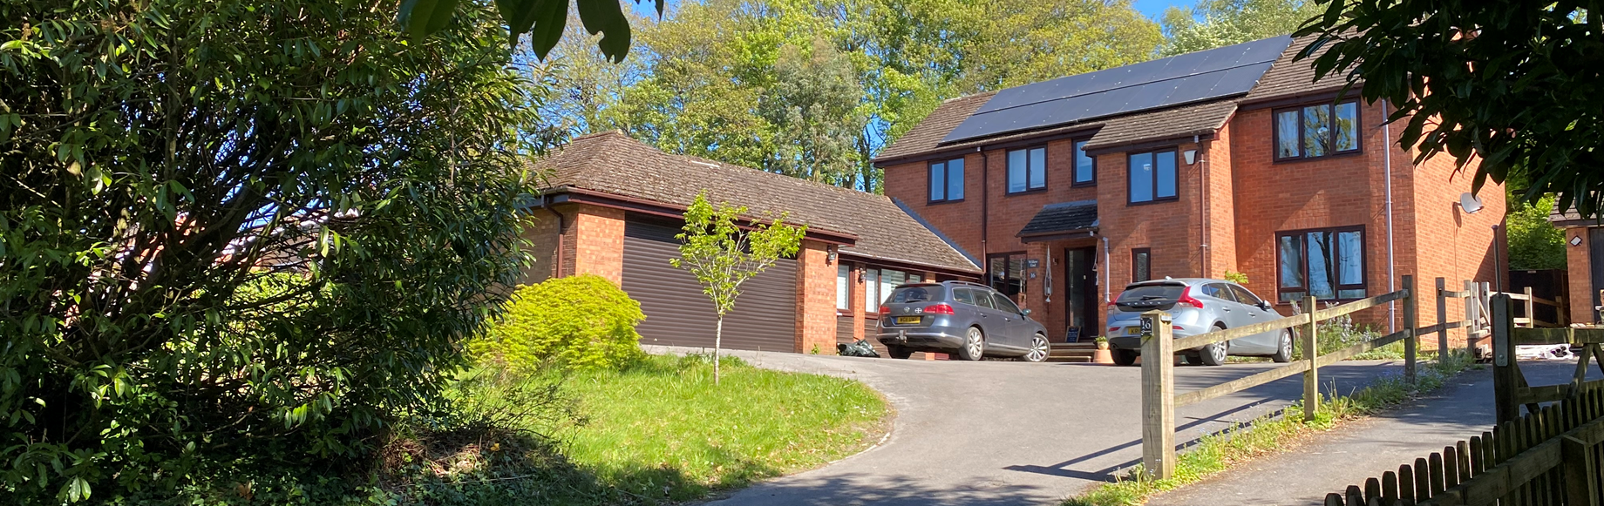
Site Visit (Existing Dwelling and Garage)
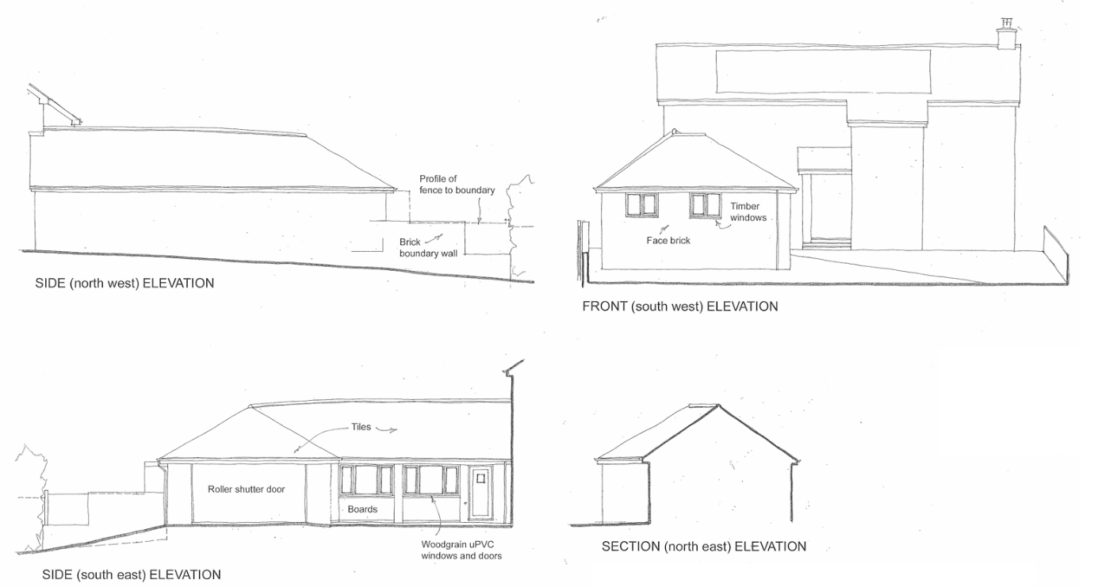
Existing Plans
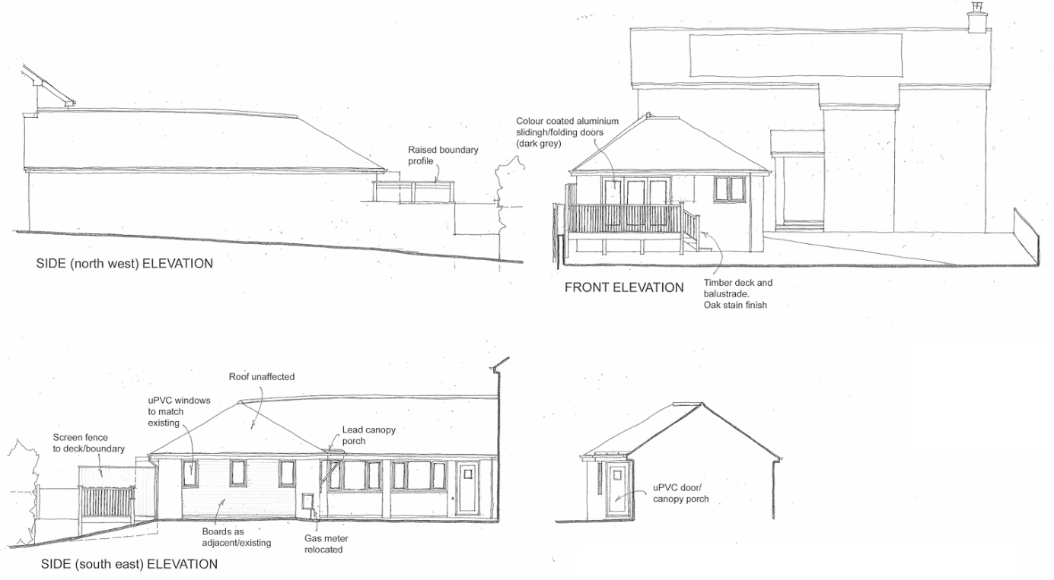
Proposed Plans

Having regard to the above, the proposal complies with the design principles set out in Core Policy 57 of the Wiltshire Core Strategy and Appendix D of the Wiltshire Design Guide.

Amenity: Point vii of Core Policy 57 Ensuring High Quality Design and Place Shaping of the Wiltshire Core Strategy seeks to ensure that developments do not adversely affect neighbouring properties.

The National Planning Policy Framework (NPPF), particularly Paragraph 135, stresses that planning decisions should ensure developments provide a high standard of amenity for existing and future users.

The proposal would not give rise to any unacceptable impacts on neighbouring residential amenity. The only new openings are located within the former garage door which faces the site’s front parking area, at ground floor level and away from any sensitive receptors, such that no overlooking or loss of privacy would occur. The internal use of the space is not materially different from that which could reasonably occur within the existing garage and adjoining accommodation, and the inclusion of a living area is not considered to result in any additional harm.

The proposed raised decking area represents the most notable change in amenity terms; however, this is appropriately mitigated through the provision of new boundary screening, which would prevent overlooking and maintain privacy. This is considered suitable in the context of the site, which is already well enclosed by established boundary vegetation, ensuring no material impact in terms of overshadowing or visual intrusion. The proposed screening is indicated at approximately 2 metres in height, which may fall within the scope of permitted development (notwithstanding that this is not determinative), and given the orientation of surrounding dwellings and the site’s relationship with the sun path, any potential loss of light would be minimal and limited in extent.

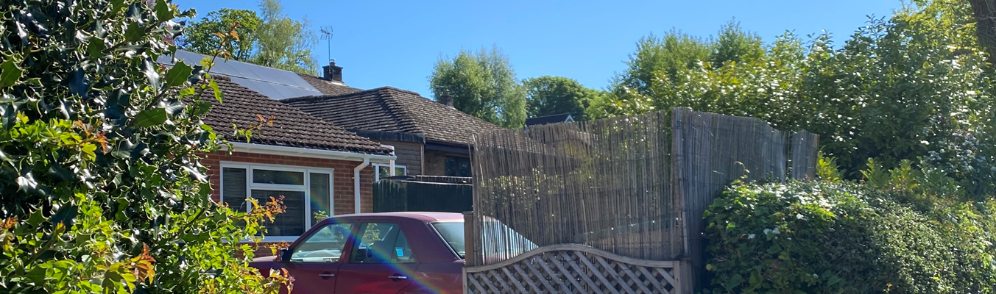
Site Visit (From Neighbouring Boundary)

The proposal is appropriately sited, designed, and oriented to ensure that it would not result in unacceptable impact upon/to the amenities or living conditions of neighbouring residential occupiers, particularly in terms of outlook, privacy, or access to natural light.

The proposal therefore accords with Core Policy 57 point vii in respect of safeguarding residential amenity and Appendix D of the Wiltshire Design Guide.

Other Issues: The proposal accords with Core Policies 60, 61 and 64 of the Wiltshire Core Strategy, as well as national guidance within the NPPF, in that it would not result in any unacceptable impacts on highway safety or the local road network. The Highway Authority has raised no objection, noting that access arrangements and on-site parking provision would remain unchanged and continue to meet adopted standards. Whilst the garage would be lost, sufficient off-street parking is retained, and as the annexe is to be occupied ancillary to the main dwelling, with no net increase in bedrooms, given the existing bedroom already serving the accommodation, no additional parking demand is generated. The proposal is therefore considered acceptable in highways terms.

The proposal complies with Core Policy 50 of the Wiltshire Core Strategy, as it would not result in harm to ecological interests or protected species. The development involves no significant extension to the built footprint, with only a modest raised decking area which is predominantly elevated above ground level, thereby minimising interaction with any potential habitats. Whilst the site lies within the Salisbury Plain SPA buffer and the Hampshire Avon catchment, given the nature and scale of the works, no adverse effects would arise, and there would be no net increase in the number of bedrooms.

The proposal would not result in a change to the number of dwellings on site, and as recommended, the annexe accommodation would be restricted in terms of its use to being ancillary to the main dwelling at No.16. Therefore, no nutrient neutrality mitigation is necessary for this application.

The TPO trees within the rear garden remain unaffected. As a householder development, the proposal is exempt from the statutory requirement to deliver Biodiversity Net Gain, and overall the scheme is considered to have a neutral ecological impact.

The proposal is considered acceptable in relation to Core Policy 67 of the Wiltshire Core Strategy and the NPPF. Although the site is subject to some identified constraints, including areas of surface water flood risk along the southern boundary and a general susceptibility to groundwater flooding, the development would not increase the building footprint or introduce additional impermeable surfaces. As such, there would be no increased risk of surface water runoff or flood risk elsewhere. The works are limited in scale and largely involve the re-use of an existing structure, and therefore do not necessitate significant drainage interventions. Furthermore, as a householder development below 250m², the proposal is exempt from the sequential and exception tests, and is considered acceptable from a drainage and flood risk perspective.

CONCLUSION: The proposal is considered to be acceptable and in accordance with the relevant policies and guidance outlined above.

RECOMMENDATION: That Planning Permission be GRANTED subject to the following conditions:

1.
The development hereby permitted shall be begun before the expiration of three years from the date of this permission.
REASON: To comply with the provisions of Section 91 of the Town and Country Planning Act 1990 as amended by the Planning and Compulsory Purchase Act 2004.

2.
The development hereby permitted shall be carried out in accordance with the following approved plans and documents:

Proposed Elevations 225029/04
Site Block Plan and Proposed Part Ground Floor Plan 225029/03
Site Location Plan and Existing Part Ground Plan 225029/01

REASON: For the avoidance of doubt and in the interests of proper planning.

3.
The development hereby permitted shall not be occupied at any time other than for purposes ancillary to the residential use of the main dwelling, known as (16 Lower Marsh Road) and it shall remain within the same planning unit as the main dwelling.

REASON: The proposed accommodation has been considered as ancillary to the host dwelling and within the same planning unit. This condition is required as the impacts of the development have not been assessed on the basis of use as a separate self-contained dwelling, particularly in respect of amenity, access, and planning policy considerations.

4.
Prior to the first occupation of the annexe hereby permitted, the privacy screen shown on the approved plans (drawing no. 225029/04) shall be fully installed in accordance with the approved details and shall thereafter be retained and maintained over the lifetime of the development.

REASON: In the interests of safeguarding the privacy and residential amenity of neighbouring occupiers.

