

Listed materials information.

Proposed Opposite-Handed Car Barn at:

Midge Hall
Coped Hall
Royal Wootton Basett
SN4 8ER

On behalf of:
Julian Hayward
Prepared by:
Equestrian Blueprint
enquiries@equestrianblueprint.co.uk
https://equestrianblueprint.co.uk/
May 2026

Garden boundary wall.

Existing historic boundary wall constructed in traditional handmade red/orange clay brickwork laid in lime mortar, incorporating varied tonal colouring and weathered historic fabric characteristic of vernacular estate walling. Bricks are circa 60mmx100mmx215mm.

Bricks for proposed wall to stop-up the existing access in the garden wall, and the plinth for the proposed garage. This is a sample that are being cleaned up for reuse

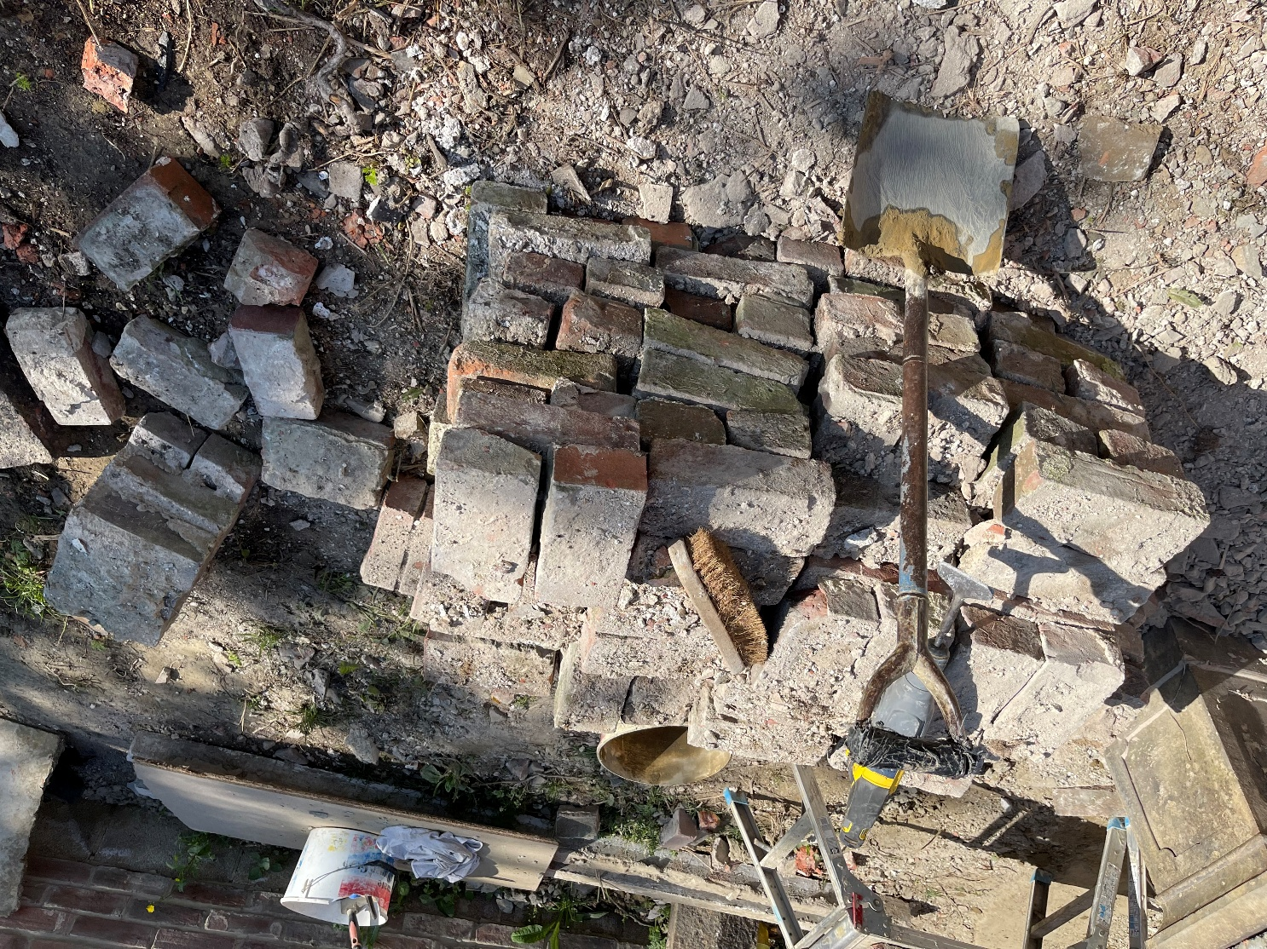

Clay tiles to be used on the new garage.

Reclaimed clay plain roof tiles with traditional weathered finish and varied natural colouring

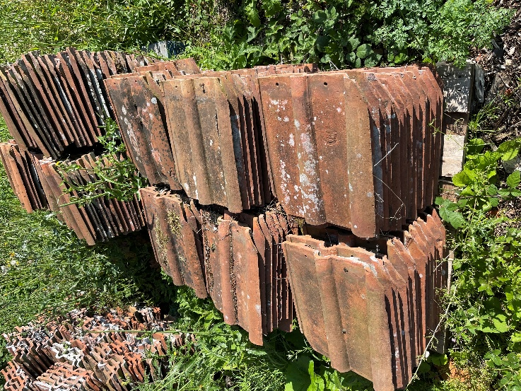

Double Field Gate

The gate will be pressure treated and have a mid-brown finish.

