APPLICATION FOR ADVERTISEMENT CONSENT
CASE OFFICER REPORT

APPLICATION REFERENCE: | PL/2026/01436
APPLICATION TYPE: | Consent to display an advertisement
SITE ADDRESS: | Southview Farm, Widbrook, Bradford On Avon, BA15 1UH
DEVELOPMENT DESCRIPTION: | New signage to identify property at start of driveway
RECOMMENDATION: | That advertisement consent be GRANTED

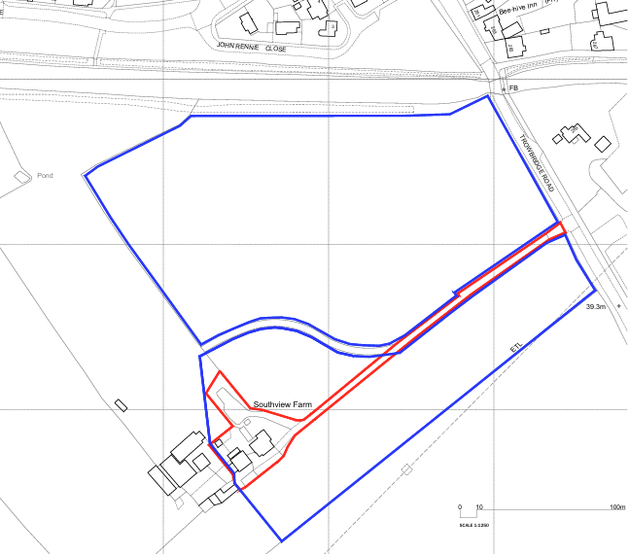

SITE DESCRIPTION/CONTEXT

The application site relates to the frontage of an agricultural access onto the A363 Trowbridge Road, a principal route between Trowbridge and Bradford on Avon characterised by relatively high traffic speeds and a wide carriageway. The surrounding area is distinctly rural in character, comprising open countryside with established hedgerows and sporadic commercial uses, including the Boathouse public house to the east and the Kennet and Avon Canal and associated boatyard beyond. The site lies outside any defined settlement boundary within a designated Green Gap between Trowbridge and Bradford on Avon, and within a Special Area of Advertisement Control. Notable constraints include proximity (approximately 85m) to the Grade II listed Widbrook Bridge, location on a Class A road (50mph), and environmental considerations such as bat roost buffers and areas susceptible to low-level groundwater flooding.

PROPOSAL:

The application seeks advertisement consent for the erection of a single, non-illuminated freestanding sign measuring approximately 3 metres in height and 0.5 metres in width. The sign would be constructed from mild steel mounted on a white acrylic backing panel, with a treated finish to create a weathered appearance. The design incorporates laser-cut lettering (approximately 125mm in height) through the steel face to reveal the acrylic panel behind, resulting in a simple and contemporary form of signage.

RELEVANT LEGISLATION, POLICIES AND GUIDANCE

The Town and Country Planning (Control of Advertisements) (England) Regulations 2007

National Planning Policy Framework (NPPF)
Paragraph 141

Planning Practice Guidance (PPG)
Advertisements

Wiltshire Core Strategy 2015 (WCS):
Core Policy 7 Spatial Strategy: Bradford on Avon Community Area;
Core Policy 51 Landscape
Core Policy 57 Ensuring High Quality Design & Space Shaping
Core Policy 58 Ensuring the Conservation of the Historic Environment
Core Policy 62 Development Impacts on the Transport Network

Neighbourhood Plan:

Bradford on Avon Neighbourhood Plan 2013 - 2026

Supplementary Planning Documents:

Institute of Lighting Professionals: The Brightness of Illuminated Advertisements (2014) PLG 05.

RELEVANT PLANNING HISTORY:

No relevant planning history has been identified for the site subject of this application.

ISSUES

The issues that are relevant to the consideration of an application for consent to display advertisements are the effects of the proposal on ‘amenity’ and ‘public safety’.

CONSULTEE RESPONSES

The following consultees were invited to comment on this application:

Bradford on Avon Town Council – No Objection

Local Highway Authority (Wiltshire Council) – No Objection

REPRESENTATIONS

A single representation was received from the Bradford on Avon Preservation Trust in which they stated No Objection to the proposal.

ASSESSMENT

Regulation 3 of The Town and Country Planning (Control of Advertisements) (England) Regulations 2007 requires that local planning authorities exercise their powers in relation to the display of advertisements in the interests of amenity and public safety, taking into account the provisions of the development plan, in so far as they are material, and any other relevant factors.

The NPPF (141) is clear that the quality and character of places can suffer when advertisements are poorly sited and designed and should be subject to control only in the interests of amenity and public safety, also considering the cumulative impacts.

Impact on Amenity:

Policy Context

“Amenity” is not exhaustively defined in the Town and Country Planning (Control of Advertisements) (England) Regulations 2007, but is generally understood to include both visual and aural amenity. Factors relevant to amenity include the general characteristics of the locality, such as the presence of features of historic, architectural, cultural, or similar interest.

In broader planning terms, as reflected in the National Planning Policy Framework (NPPF), amenity refers to the quality or character of an area and the elements that contribute to the overall enjoyment and liveability of a place.

CP57 requires a high standard of design in all proposals, including (x) the sensitive design of advertisements and signage.

Assessment

The proposed signage is of a simple and well-considered design, comprising a muted and natural material palette with a weathered steel finish that would assimilate appropriately into its rural surroundings. Its slim, vertical form and modest scale ensure that it would not appear unduly prominent or visually intrusive within the open countryside context. The sign also reflects the established character of signage in the locality, notably the presence of a comparable sign at the nearby Boathouse access, thereby reinforcing a sense of local distinctiveness.

With regard to heritage impacts, the proposal would have limited intervisibility with the Grade II listed Widbrook Bridge, with views largely restricted by intervening hedgerows and roadside vegetation. The primary public views of the bridge are experienced from the adjacent canal towpath, where the proposed sign would not form a prominent or harmful feature. Furthermore, the advertisement is non‑illuminated, removing any potential concerns relating to light pollution or visual intrusion during hours of darkness. In reaching this conclusion, the Local Planning Authority has had special regard to the desirability of preserving the setting of the listed building in accordance with Section 66(1) of the Planning (Listed Buildings and Conservation Areas) Act 1990.

The site lies within a Special Area of Advertisement Control where stricter control applies; however, given the modest scale, subdued materials and limited visual prominence of the proposal, it is considered to preserve the character and appearance of the area.

Overall, the advertisement is considered to represent a high-quality, contextually appropriate design that would preserve the character and appearance of the surrounding area and the setting of nearby heritage assets.

It is considered that the proposed advertisement would not cause harm to the visual amenity of the area, including the setting of any heritage assets, and would therefore comply with the relevant provisions of the Town and Country Planning (Control of Advertisements) Regulations 2007.

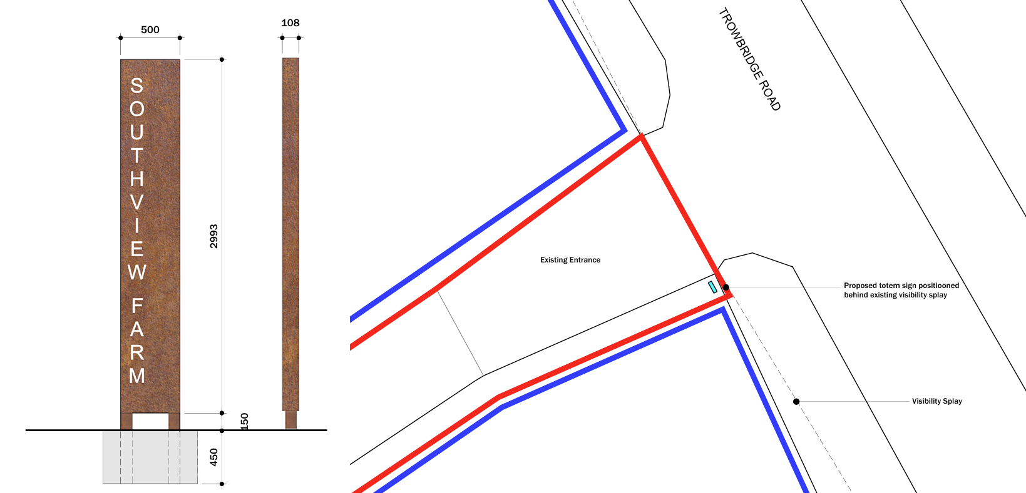

Proposed Sign Elevations and Proposed Block Plan
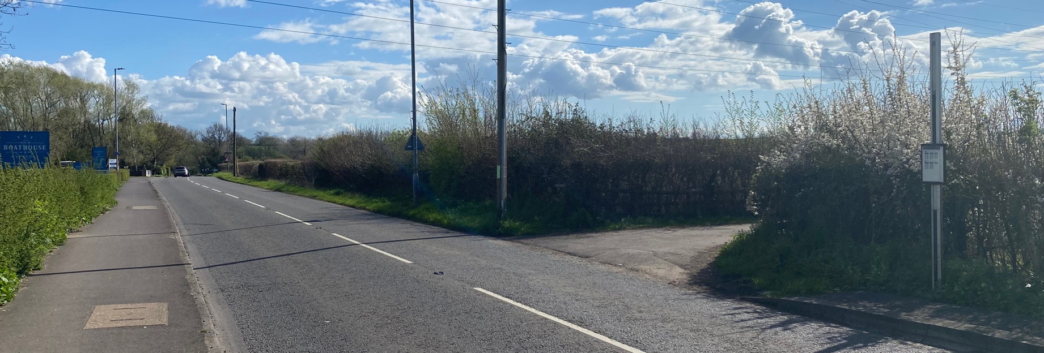
Site Visit (Facing South)

Impact on Public Safety:

Policy Context

“Public safety” is not exhaustively defined in the Town and Country Planning (Control of Advertisements) (England) Regulations 2007, but it generally refers to the potential impact of a development or advertisement on the safe use and operation of public spaces, including roads, footpaths, and other areas accessible to the public.

In assessing public safety, the Local Planning Authority (LPA) may consider:
- Whether the proposal would obstruct visibility for road users or pedestrians;
- Whether it could distract, confuse, or mislead drivers, particularly near junctions or crossings;
- Whether it interferes with traffic signs, signals, or street lighting;
- Whether it poses a physical hazard, such as through poor structural integrity or inappropriate siting.

The National Planning Policy Framework (NPPF) also supports the principle that planning decisions should ensure developments create places that are safe, inclusive, and accessible, and that they do not undermine public safety or security.

CP62 advises that proposals should provide appropriate mitigating measures to offset any adverse impacts on the transport network at both the implementation and operational stages.

Assessment

The proposed sign is located adjacent to the A363, a classified main road; however, it is positioned within the site boundary at the entrance to the access and would not encroach onto the highway or interfere with its operation. There are no nearby traffic signals, pedestrian crossings, or complex junction arrangements that could be affected by the development, and the siting of the sign would not obscure or compete with any existing highway signage. The advertisement is modest in scale, with a narrow, vertical form that would only marginally extend above the adjacent hedgerow when viewed from the south, thereby limiting its prominence in the roadside environment.

Importantly, the sign is non-illuminated and static, with no digital display or moving elements, ensuring that it would not give rise to distraction or confusion for road users. Its subdued colour palette and material finish would further reduce visual prominence and distraction, particularly when viewed at speed along this section of highway. No objections have been raised by the Highway Authority, and it is not considered that the proposal, either in isolation or in combination with existing signage in the vicinity, would give rise to harmful levels of visual clutter or distraction. Overall, the proposal is considered to maintain appropriate levels of visibility and clarity for drivers and would not prejudice highway safety.

It is considered that the proposal would not result in an unacceptable impact on public safety, either individually or cumulatively, and would therefore satisfy the relevant provisions of the Town and Country Planning (Control of Advertisements) Regulations 2007.

CONCLUSION:

The proposed advertisement has been assessed in accordance with the relevant provisions of the Town and Country Planning (Control of Advertisements) (England) Regulations 2007.

It is considered that the advertisement, by reason of its design, scale, siting, and method of illumination, would not result in harm to the visual amenity of the area, including the setting of any nearby heritage assets. Furthermore, the proposal is not considered to pose a risk to public safety, either individually or cumulatively with other signage in the vicinity.

Subject to the recommended conditions, the proposal is therefore considered acceptable and it is recommended that advertisement consent be granted.

RECOMMENDATION:
It is recommended that advertisement consent be GRANTED subject to condition(s).

1.
No advertisement is to be displayed without the permission of the owner of the site or any other person with an interest in the site entitled to grant permission.

No advertisement shall be sited or displayed so as to—

(a) endanger persons using any highway, railway, waterway, dock, harbour or aerodrome (civil or military);
(b) obscure, or hinder the ready interpretation of, any traffic sign, railway signal or aid to navigation by water or air; or
(c) hinder the operation of any device used for the purpose of security or surveillance or for measuring the speed of any vehicle.

Any advertisement displayed, and any site used for the display of advertisements, shall be maintained in a condition that does not impair the visual amenity of the site.
Any structure or hoarding erected or used principally for the purpose of displaying advertisements shall be maintained in a condition that does not endanger the public.
Where an advertisement is required under these Regulations to be removed, the site shall be left in a condition that does not endanger the public or impair visual amenity.

REASON: To comply with Regulation 14 (7) of the Town and Country Planning (Control of Advertisements) (England) Regulations 2007.

2.
This consent shall expire at the end of the period of [5] years from the date of this Notice.

REASON: To comply with Regulations 14 (7) and (8) of the Town and Country Planning (Control of Advertisements) (England) Regulations 2007.

3.
The development hereby permitted shall be carried out in accordance with the following approved plans and documents:

Location Plan A0.01
Proposed Sign Details A0.03
Proposed Block Plan A0.02

REASON: For the avoidance of doubt and in the interests of proper planning.

