APPLICATION FOR PRIOR NOTIFICATION - AGRICULTURAL
CASE OFFICER REPORT

APPLICATION REFERENCE: | PL/2026/02538
APPLICATION TYPE: | Prior notification: Building
SITE ADDRESS: | Auckland Farm, Codford St Mary, BA12 0LY
DEVELOPMENT DESCRIPTION: | An extension to an existing building to be used as a farm workshop.
RECOMMENDATION: | Planning Permission Required

SITE DESCRIPTION/CONTEXT

The application form states that Auckland Farm extends to approximately 40 hectares and the site location plan (blue line) includes land to both the north and south of the application site on the eastern side of Chitterne Road. This land is characterised as open countryside.

The full extent of the holding is not shown on the submitted site location plan. There is a small complex of agricultural buildings located around 260 metres to the north of the prior approval site; however, this area is not included or shown as part of the blue line application boundary. Notwithstanding this, previous planning applications indicate that this northern complex forms a part of Auckland Farm.

The dwelling immediately to the north of the prior approval site is an agricultural worker dwelling approved in applications 18/03181/OUT and 18/05384/FUL.

However, applications 16/07266/FUL and 18/05384/FUL also demonstrate that the properties of Auckland Cottage and Bramley Cottage are not shown to be part of the agricultural unit of Auckland Farm. These buildings are within 220m of the prior approval site.

The site is not within but is c195m to the north of the Cranborne Chase and West Wiltshire Downs National Landscape. The site is also within the 6.4km buffer of the Salisbury Special Protection Area. The site is not within a conservation area and there are no listed buildings surrounding. The site is also not subject to any ground or surface water flood risk.

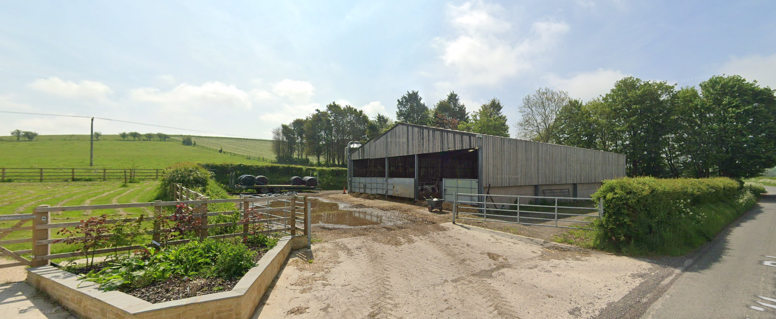

Google Street View Image May 2023 (housing cows)

PROPOSAL

The proposal seeks to add an extension to the existing building, on its rear (eastern) elevation. The proposal would “provide secure workshop facilities for this farm which it doesn't have at present. The majority of the buildings on this farm are not able to be securely locked and this proposal will enable to have facilities to be able to repair and maintain their own machinery, which will help to maintain their financial stability.”

The extension would be built with concrete panels on the lower walls with high level cladding above (merlin grey). The roof would be anthracite grey fibre cement.

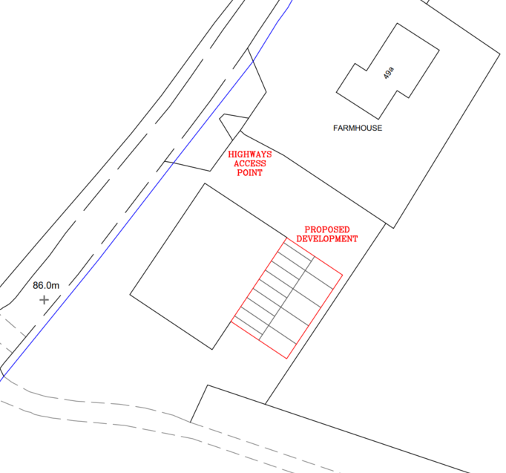

Proposed Block Plan

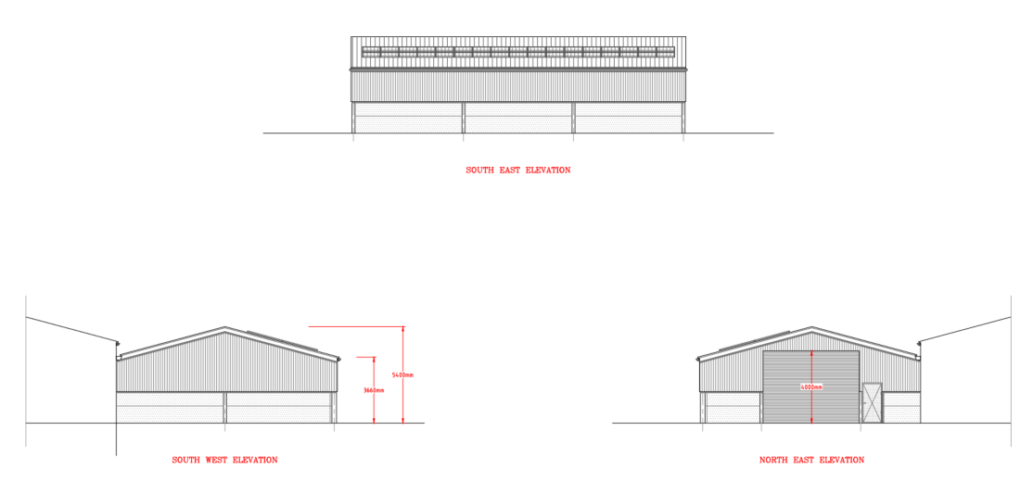

Proposed Elevations

RELEVANT PLANNING HISTORY

Proposal / Summary
16/07266/FUL - Full planning permission Decision - Approve with Conditions Date: 13/9/2016 – Proposed barn
18/03181/OUT - Outline Planning Decision - Approve with Conditions Date: 5/7/2018 – Demolition of existing breeze block building and erection of agricultural workers dwelling (Outline application relating to access)
18/05384/FUL - Full planning permission Decision - Approve with Conditions Date: 13/12/2018 – Proposed detached farm workers dwelling with integral garage and vehicular access
W/78/00839/HIS - Historic apps 1974 to 1983 Decision - Refused Date: 29/9/1978 – Erection of stock housing steel framed building
W/78/01159/HIS - Historic apps 1974 to 1983 Decision - Approve with Conditions Date: 9/11/1978 – Cattle housing

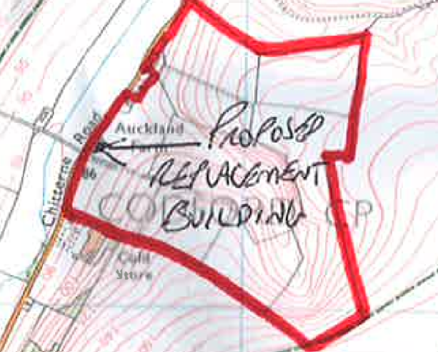

Red outline for application 16/07266/FUL

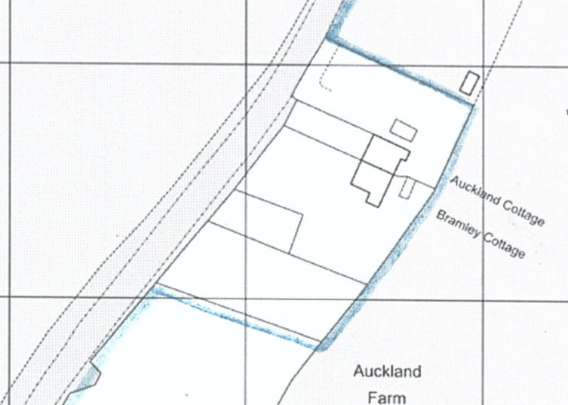

Blue outline of 18/05384/FUL

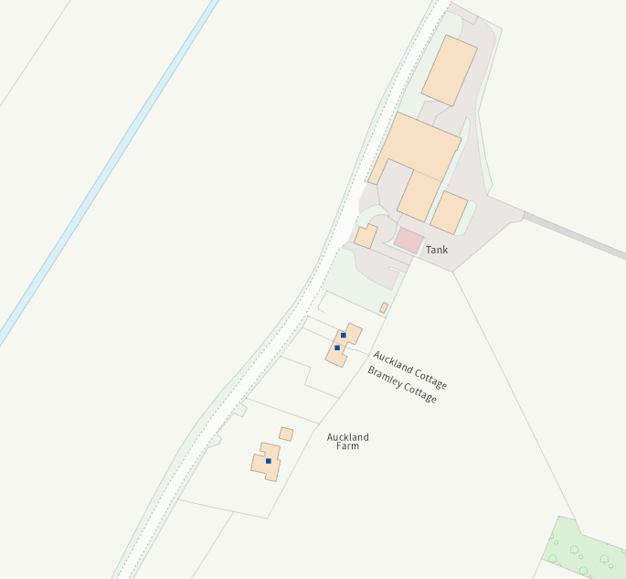

Two dwellings (Auckland Cottage and Bramley Cottage) understood to be outside of the red outline of application 16/07266/FUL and blue outline of 18/05384/FUL

RELEVANT LEGISLATION, POLICY AND GUIDANCE

This application is assessed under Article 3 of the Town and Country Planning (General Permitted Development) (England) Order 2015 (as amended), which grants planning permission for certain types of development described in Schedule 2 of the Order. The grant of permission is subject to the limitations, conditions, and provisions set out within the relevant Classes of permitted development.

Under Schedule 2, Part 6, Class A of the Town and Country Planning (General Permitted Development) (England) Order 2015 (as amended), certain types of agricultural development may be permitted, including:

- The erection, extension, or alteration of a building;

Where such development is proposed, the developer is required to apply to the local planning authority for a determination as to whether prior approval is needed. This prior approval process is limited in scope and relates only to the following matters:

- The siting, design, and external appearance of the building;
- The siting and means of construction of the private way;
- The siting of the excavation or deposit;
- The siting and appearance of the tank.

ASSESSMENT

Does the Proposal Qualify as Permitted Development? No.

The application site lies approximately 220 metres from Auckland Cottage and Bramley Cottage, which are dwellings not forming part of the agricultural unit. These dwellings therefore constitute ‘protected buildings’ as defined under Part 6 of Schedule 2 to the GPDO.

The existing building is currently and lawfully used for the accommodation of livestock, as evidenced by its historic planning use and recent on‑site imagery, and the proposed extension would remain physically and functionally part of that building.

Whilst the proposal is proposed to be for secure workshop facilities, it would consist of any works to a building used for the accommodation of livestock (Schedule 2, Part 6, Class A, condition A.1 (i)) which is within 400m of the curtilage of a protected building. Therefore, the proposal fails Condition A.1 (i) and is not permitted development.

The intended workshop use of the extension does not alter the legal classification of the host building for the purposes of Class A.1(i), which applies to any works to a livestock building irrespective of the specific use of the extension.

Having completed the detailed assessment checklist at Appendix 1 of this report, the Local Planning Authority determines that the proposal does not constitute permitted development under Schedule 2, Part 6, Class A of the GPDO and that full planning permission is therefore required.

CONCLUSION

The proposal comprises an extension to an existing building currently in use for the accommodation of livestock. Under Class A.1(i) of Part 6 of the GPDO, permitted development rights do not apply to works to a building used for the accommodation of livestock where the development is within 400m of the curtilage of a protected building.

Notwithstanding that the proposed extension is intended to provide workshop space, it remains physically and functionally an extension to an existing livestock building. The limitation applies to “works to” such a building and is not limited to development that would itself house livestock.

As the building lies approximately 220m from neighbouring non‑agricultural dwellings, the proposal fails to comply with Class A.1(i) and does not benefit from permitted development rights.

RECOMMENDATION:
That prior approval be REFUSED – Full planning permission required.

A
APPENDIX 1 – PERMITTED DEVELOPMENT CHECKLIST
 | Permitted Development | Yes / No
A | Does the proposal involve the carrying out, on agricultural land forming part of an agricultural unit of 5 hectares or more, of either:  (a) works for the erection, extension, or alteration of a building; or  (b) any excavation or engineering operations,  which are reasonably necessary for the purposes of agriculture within that unit? | Yes
Criteria (A.1) – Development not permitted by Class A:
(a) | Is the development proposed to be carried out on a separate parcel of land forming part of the agricultural unit that is less than 1 hectare in area? | No – despite there being a hedge separating it from the next field, it is all part of the same blue outline and therefore is not a separate parcel of land within the agricultural unit
(b) | Would the development consist of the erection or extension of any agricultural building on an established agricultural unit where development under Class Q or Class S of Part 3 (changes of use) has been carried out within the last 10 years? | No
(c) | Would the development consist of, or include, the erection, extension, or alteration of a dwelling? | No
(d) | Would it involve the provision of a building, structure or works not designed for agricultural purposes? | No
(e)(i) | Would the ground area covered by any works or structures (excluding fences) for accommodating livestock or plant/machinery arising from engineering operations exceed 1,000 square metres? | No
(e)(ii) | Would the ground area of any building erected, extended, or altered under Class A exceed 1,500 square metres? | No
(f) | Is any part of the proposed building, structure, or works within 3 kilometres of the perimeter of an aerodrome and would exceed 3 metres in height? | No
(g) | Is any part of the proposed building, structure, or works not within 3 kilometres of an aerodrome and would exceed 12 metres in height? | No
(h) | Would any part of the development be within 25 metres of a metalled part of a trunk road or classified road? | No – it is approximately 26m from the highway
(i) | Would the development consist of, or include, the erection or construction of, or works to, a building, structure, or excavation used or intended for the accommodation of livestock or storage of slurry/sewage sludge, and be within 400 metres of the curtilage of a protected building? | Yes – the existing building is used for cow accommodation. Therefore these are works to that existing building to which is only 220m from protected buildings.
(j) | Would the development involve excavations or engineering operations on or over article 2(4) land that are connected with fish farming? | No
(k)(i) | Would any building for storing fuel for or waste from a biomass boiler or anaerobic digestion system be used for storing waste not produced by that system or fuel not produced on land within the unit and be within 400 metres of the curtilage of a protected building? | No
(k)(ii) | Would any building for storing fuel for or waste from a biomass boiler or anaerobic digestion system and be within 400 metres of the curtilage of a protected building? | No
(l) | Would the erection or extension of a building be carried out on land or a building that is, or is within the curtilage of, a scheduled monument? | No

