Hard and Soft Landscaping & Surface Water Drainage
PL/2024/05367 – Conversion & extension of existing garage and water tower to form 1 no. residential dwelling with associated parking, turning, landscaping and private amenity space.
This statement is to accompany the discharge of conditions application for the above job at:
Foxhill House (The Watertower), Clench Common, Marlborough, Wiltshire, SN8 4DR.
Condition 3:
Prior to the first occupation of the development or the substantial completion of the development (whichever is sooner) a hard and soft landscaping scheme shall be submitted to and approved in writing by the Local Planning Authority, the details of which should include:
- Location and current canopy spread of all existing trees and hedgerows on the land and identifying those and the extent to be retained.
- A detailed planting specification showing all plant species, supply and planting sizes and planting densities for any new or replacement planting.
- Means of enclosure (including existing fencing and walls to be retained.
Condition 5:
The accommodation hereby permitted shall not be first occupied until a scheme of surface water drainage (for the buildings and areas of hardstanding) has been submitted and approved in writing by the local planning authority. The development shall then be carried out in accordance with the approved details for the lifetime of the development.
REASON: In the interest of controlling flood risk.
Condition 3:
Details of the hard and soft landscaping were provided in the main planning application so it is difficult to know what to add here. This planning application essentially converted 2 existing buildings whilst filling in the gap between them with a new build. We tried to minimise the visual changes for the neighbourhood so retained all that we could. The existing landscaping has been completely maintained as a result except for a few minor changes:
- A dead holly tree has been removed.
- The shed has been removed and that area is now laid to lawn.
- 2 patio areas have been added near to the external doors.
- A concrete driveway 4.5m from the carriageway has been added, as per planning condition 8.
The rest is all retained from before the build:
- The hedges are the existing hedges and being maintained.
- The fencing is the existing fence and being maintained.
- The main gate has been retained.
- The whole area was gravelled and that is being maintained except the stipulated 4.5m from the road which will be concrete.

The diagram below shows the existing and new landscaping:
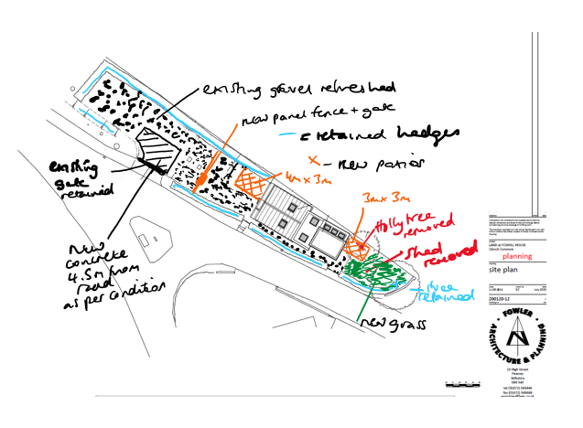
There were no flowerbeds or shrubs on the site prior to the renovation. This will be maintained except with the addition or 3 large pots:
Pot 1: by the front door will contain Acer Palmatum dissectum.
https://www.crocus.co.uk/plants/_/acer-palmatum-dissectum/classid.2000037215/sku.PL00006799/?wickedsource=google&wickedid=Cj0KCQjwk_bPBhDXARIsACiq8R2pqWmmW6E5m8c9OdGvGE2u3YyyT_3CpGu-ibmZ-DNDjC-oFf_It3kaAuFBEALw_wcB&w_adid=&w_campaignid=21879439388&utm_source=google&utm_medium=cpc&utm_campaign=21879439388&gad_source=1&gad_campaignid=21879487628&gbraid=0AAAAADohxrxp75Q2VOIRphycHYSPf6XF8&gclid=Cj0KCQjwk_bPBhDXARIsACiq8R2pqWmmW6E5m8c9OdGvGE2u3YyyT_3CpGu-ibmZ-DNDjC-oFf_It3kaAuFBEALw_wcB
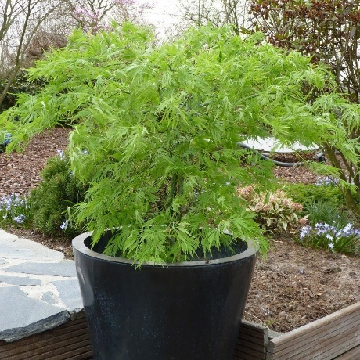
With Hostas underneath:
https://www.crocus.co.uk/plants/_/hosta-patriot/classid.2000010758/sku.RH30000254/?wickedsource=google&wickedid=Cj0KCQjwk_bPBhDXARIsACiq8R3jQt-l_yeYZ3mWSED_kHY2HYdLjwsC4R3yf4wzsYgww_bTBOfy4qUaAuGCEALw_wcB&w_adid=&w_campaignid=21111890123&utm_source=google&utm_medium=cpc&utm_campaign=21111890123&gad_source=1&gad_campaignid=21105156876&gbraid=0AAAAADohxrw99ndEOWqTjrjN7tcJ2hLHK&gclid=Cj0KCQjwk_bPBhDXARIsACiq8R3jQt-l_yeYZ3mWSED_kHY2HYdLjwsC4R3yf4wzsYgww_bTBOfy4qUaAuGCEALw_wcB
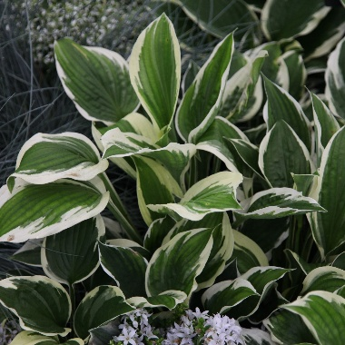

Pots 2 and 3: by the north side windows will both contain the same plants: Acer Palmatum Taylors
https://www.crocus.co.uk/plants/_/acer-palmatum-wilsons-pink-dwarf/classid.2000027220/sku.PL30004108/?wickedsource=google&wickedid=Cj0KCQjwk_bPBhDXARIsACiq8R0m_VhSsi3PsU6KKzd7eaAy8tMbT9nNSml5k9u1inq0CMMxMtXxHVwaAh67EALw_wcB&w_adid=&w_campaignid=15800828825&utm_source=google&utm_medium=cpc&utm_campaign=15800828825&gad_source=1&gad_campaignid=15793456071&gbraid=0AAAAADohxrw-ZyFyliCODAXg_-yXVFWo2&gclid=Cj0KCQjwk_bPBhDXARIsACiq8R0m_VhSsi3PsU6KKzd7eaAy8tMbT9nNSml5k9u1inq0CMMxMtXxHVwaAh67EALw_wcB

See location of plots on diagram below:
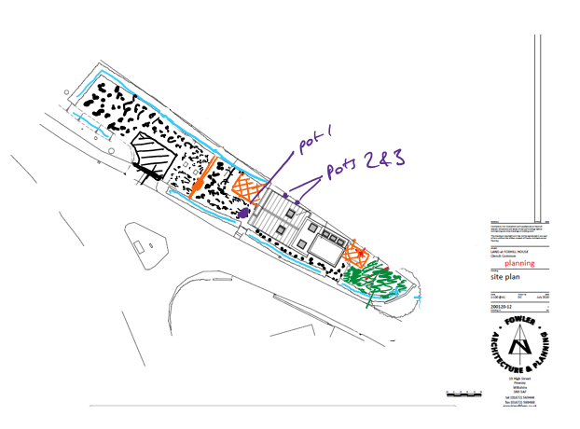
Our neighbour at Levetts Farm has planted a Laurel Hedge and a Beech hedge that is on his land and runs the length between us. The Watertower plot is nicely contained.

Condition 5:
Again, the buildings were existing so utilise the existing drainage with a hopper coming down from the flat roof of the existing tower and drainpipes on the existing garage. Additional hoppers and drainpipes were added on the new build part as per the diagram below.
The water drains to a new, larger soakaway (checked and approved by Wiltshire Building Control) under the area laid to lawn on the tower side, as per the diagram below.
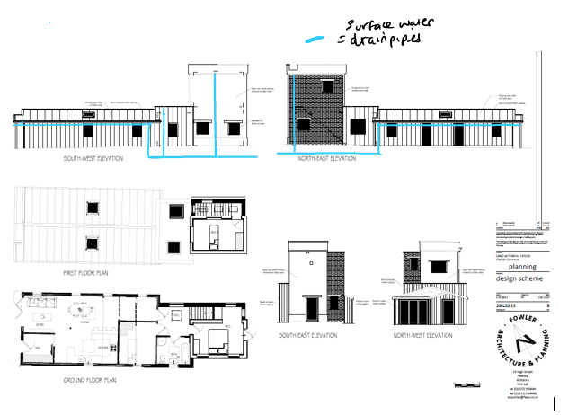
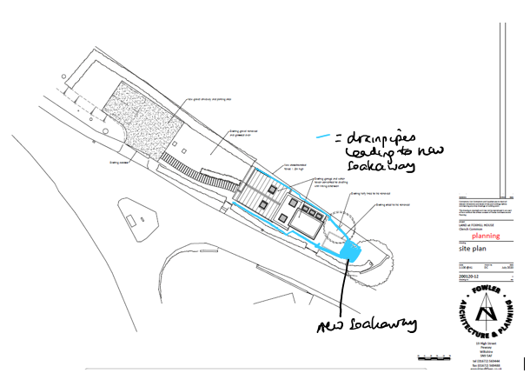
The patios are 12m2 and 9m2 respectively and have a gradient so that the surface water runs onto the gravel and the lawn respectively. These drain well and there is no pooling.
The rest of the area is gravelled as it was previously. This is permeable and allows water to drain away.

There has never been an issue with the surface water drainage on this site and there are minimal changes to the existing effective drainage scheme.
Wiltshire Building Control advised and signed it off.

