APPLICATION FOR HOUSEHOLDER PLANNING PERMISSION DELEGATED REPORT

APPLICATION REFERENCE: | PL/2025/09997
APPLICATION TYPE: | Householder planning permission
SITE ADDRESS: | 179 Devizes Road, Hilperton, Trowbridge, BA14 7QS
DEVELOPMENT DESCRIPTION: | Single and two storey extensions to include kitchen, sitting, wc, utility and pool (with changing room and plant lean too), en-suite bedroom, detached single garage with internal alterations
RECOMMENDATION: | That Planning Permission be GRANTED

PROPOSAL
The proposal seeks planning permission for a part two storey extension to the rear and side elevation, alongside a single storey rear extension. The proposal also seeks permission for the erection of a detached single storey garage to the front elevation.
The proposal was initially called into committee by Cllr Ernie Clark, citing concerns in regard to the scale of the development, in relation to its design, bulk, height and general appearance, the visual impact on the surrounding area and the proposal’s relationship to adjoining properties. Concerns were also raised in regard to potential noise disturbance from the proposed plant room that would be erected on the rear elevation of the host dwelling.
Following officer negotiations, and revised plans received (09.04.2026) removing the plant room from the exterior wall to an internal room within the ground floor layout, the call in was rescinded.

SITE DESCRIPTION/CONTEXT

The subject property is a detached two storey property, set back within a large plot on the Devizes Road at the beginning of its approach into Hilperton village. The area is characterised by an area of detached dwellings set centrally within their generous plots, set back from the public highway to the south. The properties within the vicinity comprise of a mixture of housing types.

The application site sits within the Bath and Bradford on Avon Special Area of Conservation for bats and within the grey hatched zone of the Trowbridge and Westbury Bat Mitigation Strategy (TWBMS)

PLANNING HISTORY
N/a

RELEVANT POLICIES AND GUIDANCE

Wiltshire Core Strategy:
Core Policy 1 Settlement Strategy
Core Policy 2 Delivery Strategy
Core Policy 29 – Spatial Strategy for the Trowbridge Community Area
Core Policy 50 – Biodiversity and Geodiversity
Core Policy 57 - Ensuring High Quality Design and Place Shaping
Core Policy 60 – Sustainable Transport
Core Policy 61 – Transport and Development
Core Policy 64 – Demand Management
Wiltshire Local Transport Plan 2011 – 2026 (March 2015)

Hilperton Neighbourhood Development Plan 2017-2026 Made November 2018

Wiltshire Design Guide: Appendix D – Design Guidance for Householder extensions

The National Planning Policy Framework (NPPF)

The Planning Practice Guidance

National Design Guide

CONSULTATION RESPONSES

Hilperton Parish Council: No comment

Wiltshire Council Highways: No objection

REPRESENTATIONS
One letter of objection was received from a neighbouring occupier who objected to the proposed siting garage building within the front driveway area, citing concerns that it would be out of character with the character and appearance of the area. The points raised will be appraised within the officer report below.

ASSESSMENT
Section 38(6) of the Planning and Compulsory Purchase Act 2004 states:

"If regard is to be had to the development plan for the purposes of any determination to be made under the planning Acts, the determination must be made in accordance with the plan unless material considerations indicate otherwise."

In accordance with this statutory requirement, this application has been assessed against the relevant policies of the Development Plan, including the adopted Wiltshire Core Strategy (2015) and, where applicable, any made Neighbourhood Plans.

Design and Impact upon the character and context of the area
Core Policy 57 - Ensuring High Quality Design and Place Shaping of the Wiltshire Core Strategy seeks to ensure that all new development is of high design quality, reflecting local context, character, and distinctiveness.

The scheme seeks to extend the existing two storey form on the rear elevation, further to the southwest to introduce a two-storey form on the side elevation, set back from the principal elevation, with a single storey extension to the rear elevation extending over an L-shaped plan.

The two-storey roof form would employ a matching ridge height to existing with an end hipped roof to match existing. To the rear the single storey extension would employ a flat roof form, with patio doors inserted on the northwest rear elevation of the extension and the northeast side elevation, overlooking the rear garden.

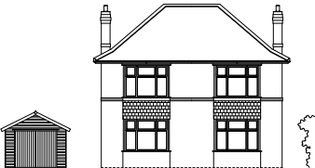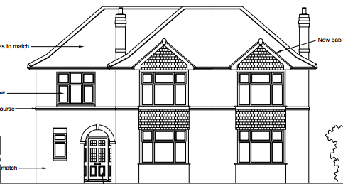

Existing (left) and proposed (right) front elevation of the host dwelling

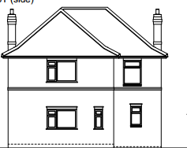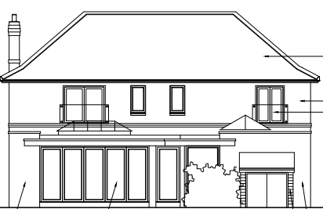
Existing (left) and proposed (right) rear elevation of the host dwelling

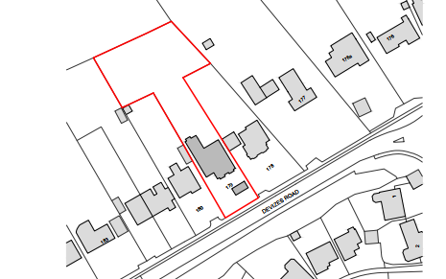
Plan illustrating the generous front and rear curtilages of the properties lining Devizes Road

Whilst it is acknowledged that the proposal would introduce a generous footprint to the application site, the host dwelling occupies an extended private curtilage, and the proposed plan would not be deemed disproportionate within the footprint of the generous application site.

The detached properties lining this side of Devizes Road benefit from large private residential rear curtilages, with many properties extending over large footprints that sit comfortably within the application site, as illustrated in the map insert and Google image insert below.

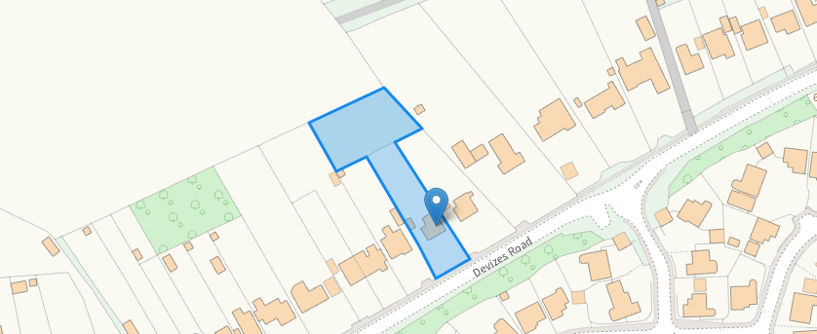

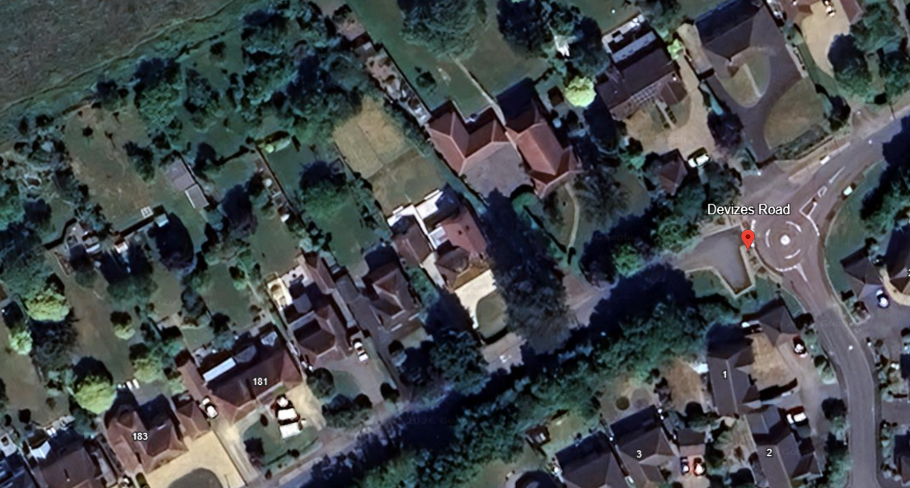

Officers have also observed that the properties within the vicinity have similar footprints, with the properties immediately to the northeast at No.177 and No.178 extending over larger footprints than proposed within this scheme. Therefore, the proposal is not considered to be at odds with the prevailing character and appearance of the immediate area.
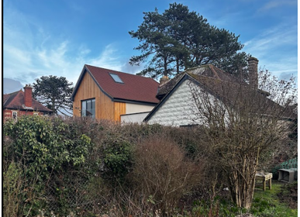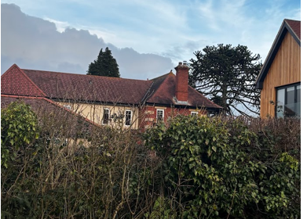
Large dwellings at No.177 Devizes Road and No.178 Devizes Road
To the front elevation the applicant seeks to erect a single storey garage with a hipped roof and garage door on the front southwest elevation accessed off the existing driveway. The garage would be positioned behind the existing mature landscaping to the front elevation of the host dwelling. The garage would be modest in size extending over a footprint of 22m2, with a maximum height of 4.10m.

An interested party has raised concerns that the siting of the garage would be out of character with the immediate area with many of the existing properties lining Devizes Road having garages set further into their application sites, and this is duly noted.

However, given the moderate size of the proposal, set within the southeast corner of the front driveway area, screened from view by the existing mature soft landscaping, officers are of the opinion that the proposal presents as an acceptable addition within the street scene, with a similar layout (of a double garage) within the front curtilage of the property at No.176 Devizes Road.

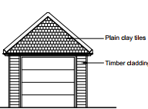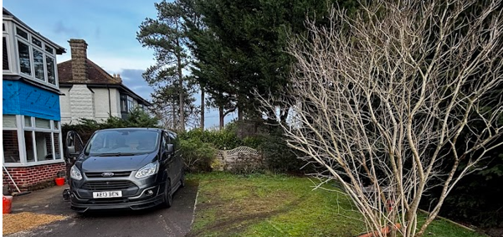

Front elevation of the proposed garage with location of the garage annotated

The use of matching materials (brick elevations on the two-storey extension and render on the rear extension) under concrete roof tiles with matching fenestration would ensure the proposal would integrate into the surrounding setting and existing street scene.

It is considered that the extensions would by virtue of their height, scale and design constitute complementary additions to the host dwelling that would appear commensurate to the size of the property and plot. Having regard to the above, the proposal complies with the design principles set out in Core Policy 57 of the Wiltshire Core Strategy and Appendix D of the Wiltshire Design Guide.

Amenity
Point vii of Core Policy 57 - Ensuring High Quality Design and Place Shaping of the Wiltshire Core Strategy seeks to ensure that developments do not adversely affect neighbouring properties.

The National Planning Policy Framework (NPPF), particularly Paragraph 135(f), stresses that planning decisions should ensure developments provide a high standard of amenity for existing and future users.

The proposed development has been assessed in terms of its potential impact on the residential amenity of neighbouring properties, with particular regard to loss of light, overshadowing, loss of privacy, and overbearing effects.

The proposal would introduce additional built form on the southwest elevation of the host dwelling, closer to the property at No. 180 Devizes Road, with the erection of a two storey extension extending over the footprint of the existing single storey garage, with a single storey extension that would project from the rear elevation of the host dwelling adjacent to the common shared boundary with No.180.

Whilst it is acknowledged that the two-storey extension would bring additional first floor form closer to the adjacent neighbour the proposal would still maintain a separation distance to the side elevation of No.180 of 4m which is considered acceptable in planning term. With many of the properties lining this side of Devizes Road separated by similar distances, therefore officers raise no objections in terms of overbearing impacts.

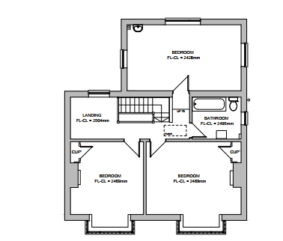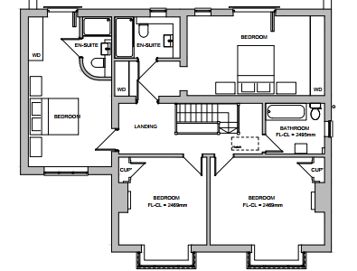
Existing (left) and proposed (right) first floor plan of the host dwelling

It is also acknowledged that the extension would be erected on the southwest elevation of the host dwelling. With the sun rising in the east, and setting in the west, officers are of the opinion that any overshadowing experienced by the adjacent neighbour, over and above that already experienced by the existing built form of the host dwelling, would be limited.
The property at No.180 would experience some overshadowing within the early morning hours however as the day passes into mid-morning the direction of the sun’s shadow moves further north-west then northwards and the effect on No. 180 would decrease with every minute/hour. Officers are satisfied that the effect of the development on the neighbouring property at No.180 would be nominal and acceptable.
There is a window at first floor level on the side elevation of No.180. This has obscure glass and it is assumed that this is a bathroom window, consistent with the layout of the similar host dwelling, and not a habitable room. The effect of the proposal on outlook from the first-floor window would therefore be limited. The proposal would not result in an unduly overbearing outlook from the side of No 180. The southwest common shared boundary is enclosed by fencing of around 2.1m in height which prevents overlooking between gardens and ground floor level windows between adjacent dwellings.

The single storey rear extension raises no adverse neighbouring amenity concerns given it would be limited to a height of 3.3m, would extend over the footprint of the existing garage building and sit adjacent to the existing built form to the rear of the property at No.180 Devizes Road.

Concerns have been raised over potential noise disturbance from the pool pump which would be positioned to the northwest elevation of the single storey elevation. Revised plans were received, removing the proposed plant room from the rear elevation, and replacing it within an enclosed room within the ground floor layout of the main dwelling. The pump would be fully enclosed within the utility room (a centralised room without an external facing wall or window) and given the separation distance between the room and the common shared boundary with the neighbour (4.15m) officers are of the opinion that the proposal would not introduce unacceptable noise levels.

The proposal therefore accords with Core Policy 57 point vii in respect of safeguarding residential amenity and Appendix D of the Wiltshire Design Guide.

Highways Impact
Core Policy 57 (xiv) of the Wiltshire Core Strategy seeks to ensure that development must meet the requirements of Core Policy 61. This policy requires proposals to be capable of being served by safe access to the highway network. Core Policy 64 seeks to ensure compliance with parking standards set out in the Local Transport Plan.

The National Planning Policy Framework (NPPF), particularly Paragraph 115 and 116, requires that development proposals do not have an unacceptable impact on highway safety and that safe and suitable access to the site can be achieved for all users.

Impact on parking provision – Core Policy 64 (Demand Management) seeks to manage the demand for vehicle parking and confirms that residential parking standards are to be based on minimum parking standards.
The proposed development would increase the number of bedrooms within the first-floor plan from three to four. In order to comply with the Wiltshire Local Transport Plan 2011 – 2026: Car Parking Strategy (March 2015) three on-site car parking spaces would be required for a 4+ bed dwelling (standard min. size 2.4m x 4.8m).
The proposed scheme would remove the existing garage from the rear elevation of the host dwelling and seeks to provide a single storey garage within the existing front driveway area, therefore 3 off road parking spaces would need to be provided within the existing driveway area.

In order to count as a parking space a garage should have internal dimensions of 3m x 6m, and the proposed garage would meet the criteria set by the Transport Plan for the parking of one vehicle and it is considered that sufficient off-street parking for two cars would be provided to the front elevation of the host dwelling, as illustrated by the plan insert below
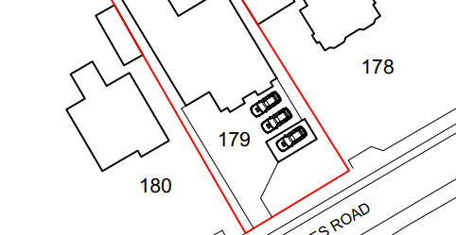
The Local Authority highways officer was consulted on the proposed scheme and offered no objections. The proposal retains the existing access and would not give rise to significant harm in terms of highway safety.
The proposal is therefore considered to comply with Core Policies 57 (xiv), 61 and 64 of the Wiltshire Core Strategy, the NPPF, and the Wiltshire Local Transport Plan.

Ecology Impact
Core Policy 50 of the Wiltshire Core Strategy seeks to protect and enhance biodiversity and geodiversity, including through ensuring that development avoids harm to protected species and habitats.

The National Planning Policy Framework (NPPF), in Paragraphs 193, requires that development minimises impacts on and provides net gains for biodiversity, including ensuring mitigation is secured where harm cannot be avoided.

The application site is located within one of the ‘consultation zones’ for the Bath and Bradford-on-Avon Bat Special Area of Conservation (SAC), as well as the grey, hatched zone of the Trowbridge and Westbury Bat Mitigation Strategy (TWBMS). As this application involves removal of a dilapidated barn, and disturbance to an existing roof, due consideration has to be given to the potential disturbance of any bats because of the proposed development.

The application site is located within one of the ‘consultation zones’ for the Bath and Bradford-on-Avon Bat Special Area of Conservation (SAC) and within the grey, hatched zone of the Trowbridge and Westbury Bat Mitigation Strategy (TWBMS). Therefore, due consideration has to be given to the potential disturbance of any bats because of the proposed new residential development.

The proposed development comprises an extension to existing residential development consisting of limited built form close to the existing dwelling. Given the established high density urban residential nature of the location, it is considered highly unlikely that any bats would be affected and significant effects relating to the disturbance to bats can be ruled out.

As a precautionary measure an informative would be added to any decision that in event any evidence of bat activity is detected that the applicant should follow the advice of a professional ecologist or contact Natural England.

As such, the development complies with Core Policy 50 of the Wiltshire Core Strategy and the relevant provisions of the NPPF.

Biodiversity Net Gain
Householder planning applications are exempt from the requirement to deliver Biodiversity Net Gain under Schedule 7A, Section 4(2)(a) of the Town and Country Planning Act 1990, as inserted by the Environment Act 2021.

CONCLUSION
The proposed development is considered to be acceptable in terms of its design, scale, and relationship with the surrounding area. It would not result in any unacceptable harm to the character of the locality, the amenities of neighbouring occupiers, or the interests of highway safety, or ecology.

The proposal is therefore considered to comply with the relevant policies of the Wiltshire Core Strategy, the Wiltshire Local Plan, and the National Planning Policy Framework. As such, the application is recommended for approval, subject to the conditions set out below.

RECOMMENDATION: That Planning Permission be GRANTED subject to conditions.

Conditions

- The development hereby permitted shall be begun before the expiration of three years from the date of this permission.
REASON: To comply with the provisions of Section 91 of the Town and Country Planning Act 1990 as amended by the Planning and Compulsory Purchase Act 2004.

- The development hereby permitted shall be carried out in accordance with the following approved plans and documents:
Existing Elevations & Floor Plans DWG No 1353-S02 - Received 23.12.2025
Existing Location & Site Plan DWG No 1353-S01 - Received 23.12.2025
Proposed Location & Block Plan DWG No 1353-P01 A - Received 09.04.2026
Proposed House & Garage Elevations DWG No 1353-P02 A - Received 09.04.2026
Proposed Floor and Roof Plans DWG No 1353-P03 A

REASON: For the avoidance of doubt and in the interests of proper planning.

Informative
If bats or evidence of bats are found during the works, the applicant is advised to stop work and follow advice from an independent ecologist or to contact Natural England’s Bat Line through the internet.

