PL/2026/01909
Site: 30 Kent End Ashton Keynes SN6 6PU
Proposal: Proposed Erection of Self Build Dwelling.
Conservation Officer: Alex Marsh
_____________________________________________________________________
Recommendations:

X | Comment
 | Support in principle subject to amendments to the scheme (as set out below)
 | Support subject to conditions (as set out below)
X | Object (for reasons set out below)
 | No objections

Scope of comments: the following comments relate to the built historic environment.

Policy: From the point of view of the historic environment the main statutory tests are set out within the Planning (Listed Building and Conservation Areas) Act 1990. Sections 16 (LBC) and 66 (PP) require that special regard be given to the desirability of preserving listed buildings, their settings or any features of special architectural or historic interest which they possess.

Section 72(1) of the Planning (Listed Building and Conservation Areas) Act 1990 also requires the Council to pay special attention to the desirability of preserving or enhancing the character or appearance of designated Conservation Areas.

The NPPF outlines government policy, including its policy in respect of the historic environment. Section 16 of the NPPF 'Conserving and enhancing the historic environment' sets out the Government's high-level policies concerning heritage and sustainable development.

Paragraphs 213 - 215 of the NPPF 2024 require a balanced approach with any harm which would be caused being weighed against the potential public benefits which might be achieved.

Paragraph 210 requires local planning authorities should take account of the desirability of sustaining and enhancing the significance of heritage assets and of new development making a positive contribution to local character and distinctiveness.

Paragraph 219 Local Planning Authorities should look for opportunities for new development ….within Conservation Areas …..to enhance or better reveal their significance.

The Council’s Core Strategy Policy CP58 ‘Ensuring the conservation of the historic environment’ requires that “designated heritage assets and their settings will be conserved, and where appropriate enhanced, in a manner appropriate to their significance.”

The Council’s Core Strategy CP 57: Ensuring high quality design requires a high quality of design in all new developments. Proposals are required to “demonstrate how the proposal will make a positive contribution to the character of Wiltshire through (amongst other things) “enhancing local distinctiveness by responding to the value of the natural and historic environment, relating positively to its landscape setting and the existing pattern of development” and “responding positively to the existing townscape and landscape features in terms of building layouts, built form, height, mass, scale, building line, plot size, elevational design, materials, streetscape and rooflines to effectively integrate the building into its setting.”

Heritage Assets:
Ashton Keynes Conservation Area

Site and assets considered:
The site on Kent End is located at the east edge of the village. The 1998 Conservation Area Appraisal identifies that this area of Kent End was added to the Conservation Area as it sat in the defined grid of lanes that form the village and that the variety of architecture including the pre war council houses of the east side of Kent End contributed to the unity of character through diversity that is embedded in the village grid.

The site is located within a garden of No. 30 Kent End. There are two phases or style of pre war Council housing with the division on the footpath that links Kent End to the Thames Path. To the east that runs between No’s 20 – 29 that are consistent for their semi-detached cottage style of architecture, concrete recon stone rusticated blockwork and plain tile roof. The roofs have prominent gable dormers and shared central stack and the cottage style of No’s 30 – 33 which are similarly modest pairs of semis with brick plinth, rendered walls and brown plain tile to hipped roofs and consistent eaves with shared chimney stack. Windows to all the properties are 20th century split casements with top hung opening lights and more horizontal emphasis and a small hood on bracket porch.

There is a distinctive layout to the pre war council houses as either side of the footpath they are set at a progressive angle to Kent End lane to provide definition toward the pubic footpath. The appraisal also notes the local character of large open verges onto the Kent End and the properties are set well back and surrounded by open gardens that separate the pairs of semis.

Proposal:
The application proposal is for the Erection of Self Build Dwelling to the garden of the No. 30 and sharing the existing access.

Relevant planning history:
ENQ/2025/00591 Proposed Erection of Self Build Dwelling

Issues: The impact of a new dwelling its siting, scale, masing, design and materials on the character and appearance of the Ashton Keynes Conservation Area.

Significance of assets and contribution of setting: The NPPF defines significance as the “value of a heritage asset to this and future generations because of its heritage interest.

The interest may be architectural, or historic as set out in the Town and Country Planning (Listed Building and Conservation Areas) Act 1990 S 1.

Significance derives not only from a heritage asset’s physical presence, but also from its setting.” Historic England assesses significance in a similar manner, referring to evidential, historic, aesthetic and communal values of a place.

In this case the significance of the Conservation Area is evident in the Conservation Area Appraisal. The local distinctive character and appearance of this part of Kend End pre war council housing is well defined and described for its form, layout, materials and architectural expression/detailing which have significant aesthetic and architectural interest that make a positive contribution to the Ashton Keynes Conservation Area .

Assessment:

The site’s is formed from a substantial section of rear garden curtilage of No. 30 Kent End and shares the driveway access.

The orientation of the proposed dwelling is slightly angled to respect the existing splay of pairs of semi-detached dwellings either side of the public footpath that separates the two phases of pre-war council houses on Kent End east side. Its siting is also dictated by a mains foul sewer that has an alignment with the footpath under the access drive to No. 30 this requires a no build wayleave 3m either side.

The proposed new dwelling has been amended and reduced in scale, massing and plan form however maintains the same siting and orientation tight to the north boundary of the amended narrower rear garden of No. 30 and set roughly in line with the back wall of the existing dwelling.

The elevational materials are defined as squared stoen cladding to the ground floor and painted render with a plain tile roof.

The sketch design with the application does not provide the principle view of the new dwelling siting/layout in the context that it will be viewed from Kent End and the footpath. It needs to be introduced in this context of the image below.

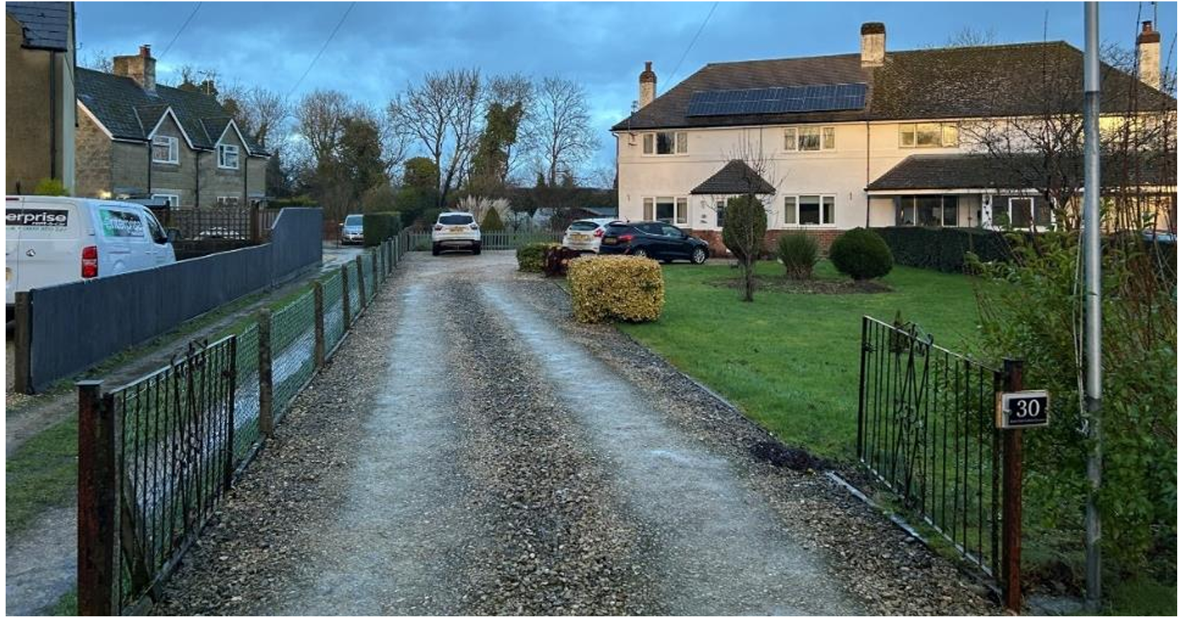

Its siting orientation and massing and scale would still appear out of character with the open gardens that separate the existing semi-detached properties. It would block the through views from Kent End and would appear visually cramped and tight to the new north boundary edge of the rear garden of No. 30 and is still to tight to the rear of the property creating an overbearing blank wall to this host property.

The modest cottage style of the pre-war semi-detached dwellings which have a specific character, scale and design and use of materials recognised in the Conservation Area Appraisal. They have specific design attributes that assist in reducing massing and scale such as the gable dormers and hipped roofs and use a simple palate of 20th century materials.

The architectural design, materials, orientation, siting, scale and massing of the dwelling would make it stand out against the surrounding modest cottage style of the pre-war semi-detached houses and would obscure current significant open views from Kent End along the footpath to the tree line Thames path that are defined by the splay of the pre-war semi-detached dwellings. In addition, the existing characterful open views across gardens from the neighbouring dwellings and their gardens would be significantly impeded.

The proposals need significant amending. The siting needs to be pushed back deeper into the plot with a more linear footprint rather than square and the orientation carefully splayed to reflect the cottages opposite.

The design alternatives are either a quality contemporary building or a better reflection of the small-scale cottage dwellings on the opposite side of the footpath the site to provide balance and better reveal the character ana appearance of the Conservation Area

As proposed the new dwellings siting, orientation, scale, massing, footprint, plan form and architectural design are incongruous and harmful in this location of specific architectural cottage style pre-war council houses in large open gardens that make a recognised positive contribution to the character and appearance of the Conservation Area.

There is a potential for a new dwelling on the site but it needs a much-improved design response to the site and site local distinctive architecture.

Summary: The NPPF confirms that when considering the impact of a proposed development on the significance of a designated heritage asset, great weight should be given to the asset’s conservation (and the more important the asset, the greater the weight should be). It makes clear that any harm to a designated heritage asset requires clear and convincing justification.

The proposals need significant amending. The siting needs to be pushed back deeper into the plot with a more linear footprint rather than square and the orientation carefully splayed to reflect the cottages opposite.

The design alternatives are either a quality contemporary building or a better reflection of the small-scale cottage dwellings on the opposite side of the footpath the site to provide balance and better reveal the character ana appearance of the Conservation Area

As proposed the new dwellings siting, orientation, scale, massing, footprint, plan form and architectural design are incongruous and harmful in this location of specific architectural cottage style pre-war council houses in large open gardens that make a recognised positive contribution to the character and appearance of the Conservation Area.

There is a potential for a new dwelling on the site but it needs a much-improved design response to the site and site local distinctive architecture.

I consider a new dwelling in this location should not be pursued, would not be supported and is contrary to National and Local Policies NPPF 210, 213 – 215 and 219 policies and Core Strategy Policy CP58 ‘Ensuring the conservation of the historic environment’ requires that “designated heritage assets and their settings will be conserved, and where appropriate enhanced, in a manner appropriate to their significance.” And Policy CP 57: Ensuring high quality design requires a high quality of design in all new developments. Proposals are required to “demonstrate how the proposal will make a positive contribution to the character of Wiltshire through (amongst other things) “enhancing local distinctiveness by responding to the value of the natural and historic environment, relating positively to its landscape setting and the existing pattern of development” and “responding positively to the existing townscape and landscape features in terms of building layouts, built form, height, mass, scale, building line, plot size, elevational design, materials, streetscape and rooflines to effectively integrate the building into its setting.”

