APPLICATION FOR HOUSEHOLDER PLANNING PERMISSION
DELEGATED REPORT

APPLICATION REFERENCE: | PL/2026/01532
APPLICATION TYPE: | Householder planning permission
SITE ADDRESS: | Hillview, Chapel Lane, Box, Corsham, SN13 8NU
DEVELOPMENT DESCRIPTION: | Raised platform to rear, privacy screen and guarding
RECOMMENDATION: | That Planning Permission be GRANTED

SITE DESCRIPTION/CONTEXT

The subject property is a semi-detached, early C20, two-storey dwelling built of recon stone under a concrete tiled roof, with rendered sections to the understorey below dpc level.

The site is within the historic core of the village of Great Somerford which is reflected by its inclusion in the Box Conservation Area. There are surrounding listed buildings, but all visually distanced.

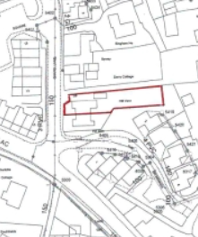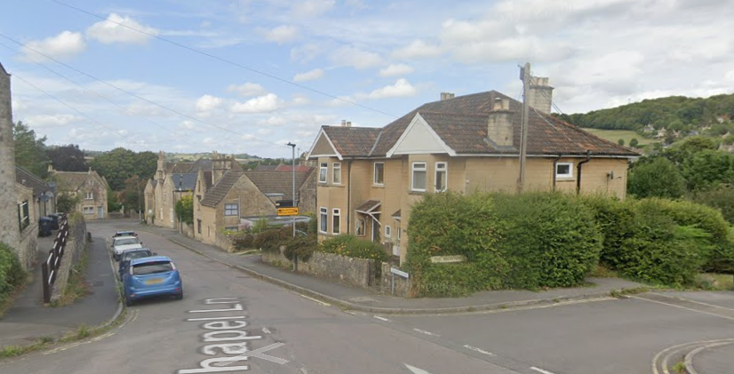

Site Location and Google Earth Site Photo

The application site is within the North Wiltshire Green Belt and Cotswolds National Landscape (formerly AONB). The site is also within buffer zones of various bat roosts but is not within any statutory protected areas.

As the site photo above shows, Chapel Lane and the property’s rear garden slope downwards to the river valley.

PROPOSAL
The proposal seeks planning permission for a raised platform to the rear of the dwelling, to replace an existing lower ground floor level conservatory, with privacy screening to the south side (to side boundary with attached neighbour) and guarding (to the east (rear) and north (side beside driveway).

Proposed materials include rendered elevations to match existing, a wooden privacy screen and glass guarding. All as per plans and elevations below:

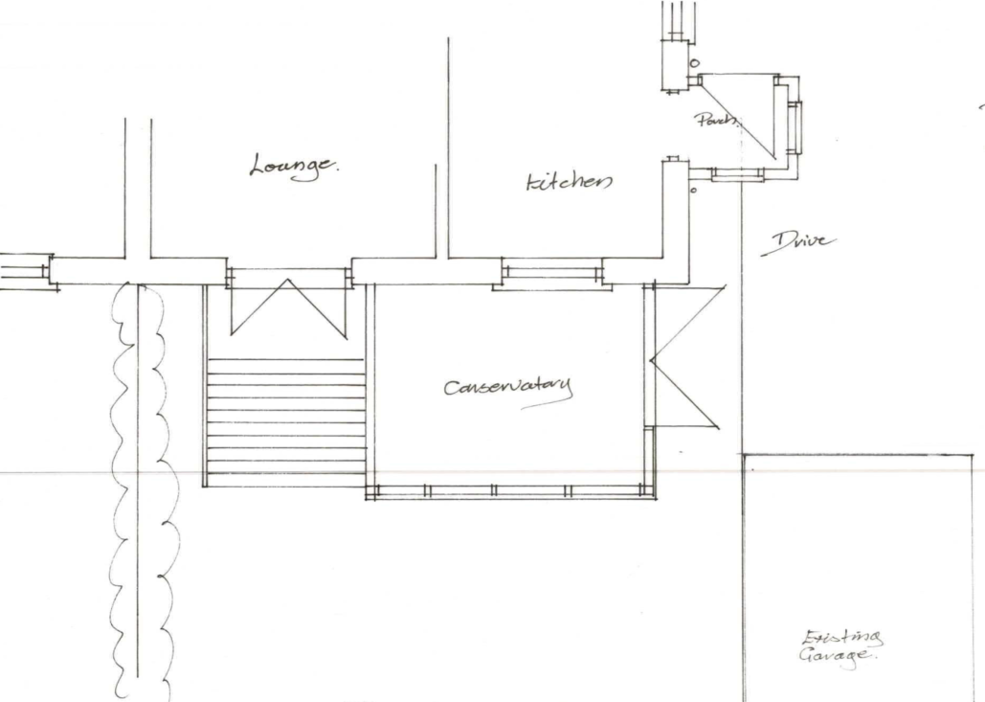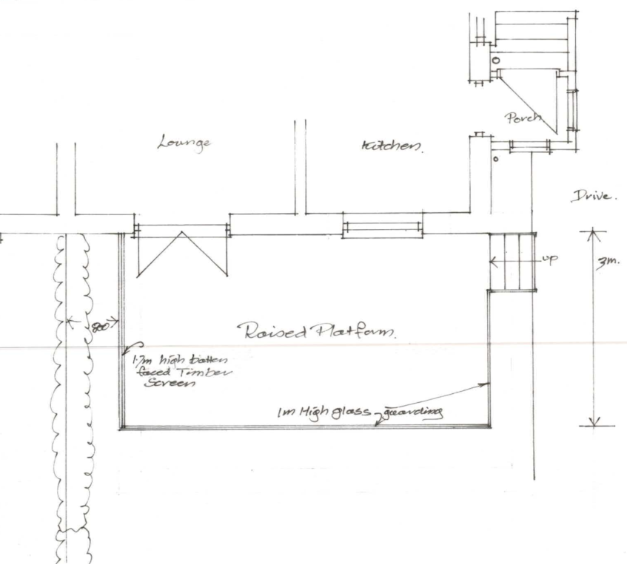
Existing and Proposed Ground Floor Plan

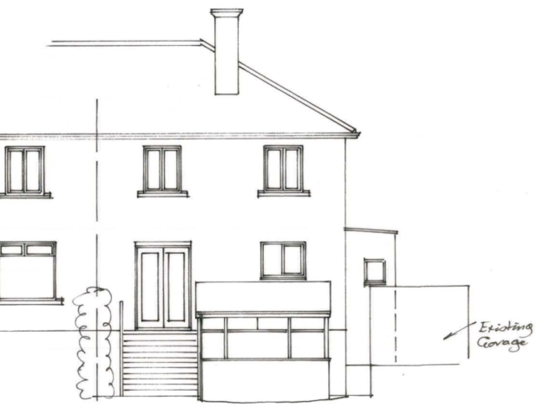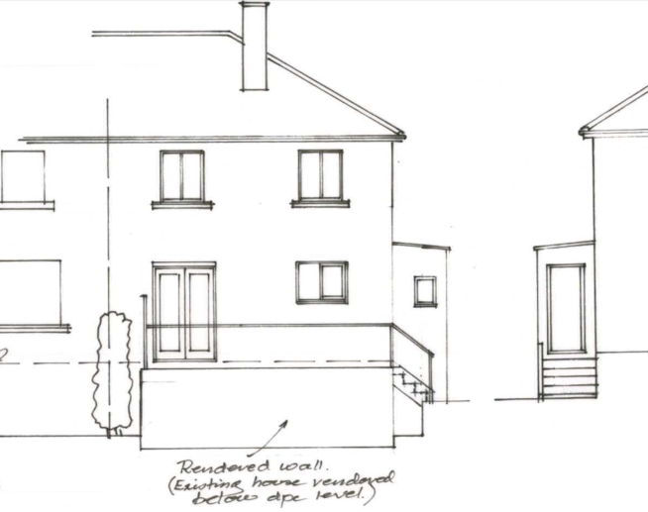
Existing and Proposed Rear (East) Elevation

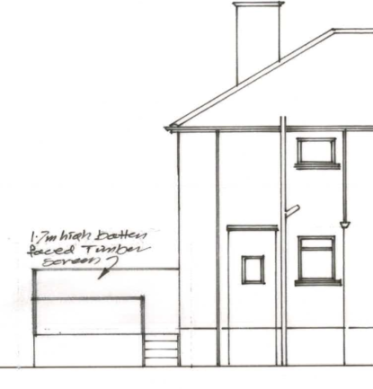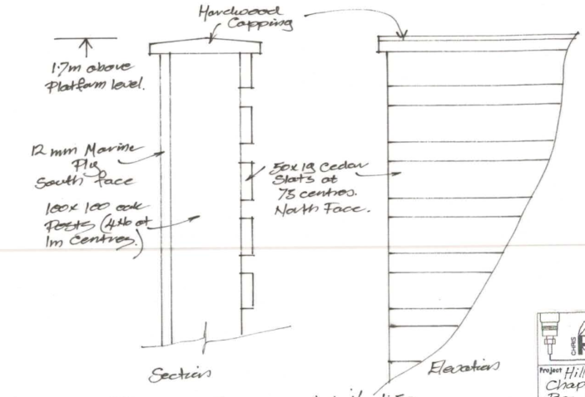
Detailing of Privacy Screen and Guarding

PLANNING HISTORY

None. Preapplication advice sought prior to this application.

RELEVANT POLICIES AND GUIDANCE
The National Planning Policy Framework (NPPF)
The Planning Practice Guidance
National Design Guide
Wiltshire Design Guide: Appendix D – Design Guidance for Householder extensions

Wiltshire Core Strategy:
- Core Policy 51: Landscape
- Core Policy 57 Ensuring High Quality Design and Place Shaping
- Core Policy 58: Ensuring the Conservation of the Historic Environment

Box has a Neighbourhood Plan area, but no made plans as yet.
Box Conservation Area Appraisal
Cotswolds National Landscape Management Plan, 2018-2023

CONSULTATION RESPONSES
Box Parish Council: No objection.

REPRESENTATIONS
3 third party comments of support.

ASSESSMENT
Section 38(6) of the Planning and Compulsory Purchase Act 2004 states:

"If regard is to be had to the development plan for the purposes of any determination to be made under the planning Acts, the determination must be made in accordance with the plan unless material considerations indicate otherwise."

In accordance with this statutory requirement, this application has been assessed against the relevant policies of the Development Plan, including the adopted Wiltshire Core Strategy (2015) and, where applicable, any made Neighbourhood Plans.

Principle of Development and Impact on the Openness of the Green Belt and Impact on Special Landscape Character:
The primary considerations are the impact of the proposals on the landscape;
- if it would be inappropriate development in the Green Belt,
- the impact on the openness and purposes of the Green Belt, and
- the effect on the landscape and scenic beauty of the Cotswold National Landscape.
The NPPF, paragraph 153, is clear in asserting that inappropriate development is ‘harmful to the Green Belt and should not be approved except in very special circumstances’.

Paragraph 142 states that “the fundamental aim of Green Belt Policy is to prevent urban sprawl by keeping land permanently open; the essential characteristics of Green Belts are their openness and their permanence.”

CP51 of the WCS, states that ‘development should protect, conserve and where possible enhance landscape character and must not have a harmful impact upon landscape character …’ including the ‘special qualities of National Landscapes, where great weight will be afforded to conserving and enhancing landscapes and scenic beauty.’
The National Planning Policy Framework (NPPF), in Paragraph 189, states that “great weight” should be given to conserving and enhancing landscape and scenic beauty in National Landscapes (formerly Areas of Outstanding Natural Beauty). Development within or affecting the setting of a National Landscape must demonstrate that it will not result in unacceptable harm to the special qualities of that area.
In considering applications where new development is proposed to an existing building within the Green Belt, the following two criteria must be met:
1. Would the proposed development comprise a disproportionate addition to the original building as it was when erected, or since 1st July 1948? and/or,
2. Would there be any material harmful impact on the openness of the Green Belt?

The NPPF does not, elaborate on the definition of ‘disproportionate’ addition nor does it quantify what would represent a disproportionate addition. In light of the above and in accordance with well-established planning practices, each case must be assessed on its own individual merits.

The proposal does not seek urban sprawl or further encroach on the countryside but is an external alteration to an existing residential dwelling.

There is no proposed increase of internal ground floor plan, only a raised external platform to negotiate the steep topography and maximise external amenity area, replacing an existing lower ground floor Conservatory.

This is clearly not a disproportionate addition but a considered reworking of existing built floor plan, to improve access and privacy of outdoor amenity space over tricky topography.

The proposal site is a C20 semi-detached dwelling, one of a few modern dwellings scattered amongst the historic village, and as such the proposal is considered acceptable due to its minor scale and invisibility to the wider landscape within this built cluster.

The proposal, by virtue of its scale, siting, and design, would not harm the special qualities or scenic character of the Cotswolds National Landscape.

The development therefore complies with Core Policy 51 of the Wiltshire Core Strategy and Paragraph 189 of the NPPF in conserving and enhancing the National Landscape.

Design and Impact on the Character and Appearance of the Area
Core Policy 57 of the WCS requires high-quality design that:
- Enhances local character.
- Responds to the natural, historic, and built environment.
- Retains important features (e.g., trees, hedges).
- Supports sustainable construction and compatibility with surrounding uses.
- Creates safe, legible, and accessible spaces.

Section 12 of the NPPF emphasises design that is:
- Visually attractive.
- Functionally effective.
- Contributes to the quality of the built environment.

The Wiltshire Design Guide encourages sensitivity to local character, materials, and architectural styles and supports modern living standards while maintaining aesthetic and functional quality.

Proposed materials for the raised platform would include rendered elevations to match existing, a wooden privacy screen and glass guarding. These materials are considered appropriate for the external scheme and would help harmonise with the host dwelling and wider residential character.
The proposal, by virtue of its scale, design, and use of materials, is considered to preserve the character and appearance of the area. The development is therefore considered to comply with Core Policy 57 of the Wiltshire Core Strategy, as well as the relevant provisions of the NPPF.

Amenity
Point vii of Core Policy 57 - Ensuring High Quality Design and Place Shaping of the Wiltshire Core Strategy seeks to ensure that developments do not adversely affect neighbouring properties.

The National Planning Policy Framework (NPPF), particularly Paragraph 135(f), stresses that planning decisions should ensure developments provide a high standard of amenity for existing and future users.

The proposed development has been assessed in terms of its potential impact on the residential amenity of neighbouring properties, with particular regard to loss of light, overshadowing, loss of privacy, and overbearing effects.

The external scheme seeks to remove a Conservatory and replace with a raised platform. There are therefore no concerns regarding overshadowing or overbearing.

Impact to privacy is managed by proposed privacy screening to the south side (to side boundary with attached neighbour) and guarding (to the east (rear) and north (side beside driveway).

The proposal therefore accords with Core Policy 57 point vii in respect of safeguarding residential amenity and Appendix D of the Wiltshire Design Guide.

Heritage Impact
From the point of view of the historic environment the main statutory tests are set out within the Planning (Listed Building and Conservation Areas) Act 1990.

Section 72(1) of the Act requires the Council to pay special attention to the desirability of preserving or enhancing the character or appearance of designated Conservation Areas.

The Council’s Core Strategy Policy CP58 ‘Ensuring the conservation of the historic environment’ requires that designated and non-designated heritage assets and their settings will be conserved, and where appropriate enhanced, in a manner appropriate to their significance and encourages proposals which improve the condition of heritage assets at risk.

The Council’s Core Strategy CP 57: Ensuring high quality design requires a high quality of design in all new developments. The policy requires applicants to “demonstrate how the proposal will make a positive contribution to the character of Wiltshire through (amongst other things) responding to the value of the natural and historic environment and being sympathetic to and conserving historic buildings and landscapes. Development is required to respond positively to the existing in terms of building layouts, built form, height, mass, scale, building line, plot size, elevational design, materials, streetscape and rooflines to effectively integrate the building into its setting.

The NPPF outlines government policy for planning. Chapter 16 of the NPPF 'Conserving and enhancing the historic environment' sets out the Government's high-level policies concerning heritage and sustainable development.

The proposed works would be restricted to the rear of the dwelling, and so not visible to the streetscape and therefore would not impact the character and appearance of the Conservation Area but by design and scale, harmonise against the modern host dwelling.

The proposal, by virtue of its scale, design, and use of materials, would not result in harm to the significance of the Conservation Area. The development is therefore considered to comply with Core Policy 58 of the Wiltshire Core Strategy and Sections 72 of the Planning (Listed Buildings and Conservation Areas) Act 1990, as well as the relevant provisions of the NPPF.

Biodiversity Net Gain
Householder planning applications are exempt from the requirement to deliver Biodiversity Net Gain under Schedule 7A, Section 4(2)(a) of the Town and Country Planning Act 1990, as inserted by the Environment Act 2021.

CONCLUSION
The proposed development is considered to be acceptable in terms of its design, scale, and relationship with the surrounding area. It would not result in any unacceptable harm to the character of the locality, the amenities of neighbouring occupiers, nor the interests of heritage, or ecology.

The proposal is therefore considered to comply with the relevant policies of the Wiltshire Core Strategy, the Wiltshire Local Plan, and the National Planning Policy Framework. As such, the application is recommended for approval, subject to the conditions set out below.

RECOMMENDATION: That Planning Permission be GRANTED subject to conditions.

