APPLICATION FOR FULL PLANNING PERMISSION
DELEGATED REPORT

APPLICATION REFERENCE: | PL/2026/00390
APPLICATION TYPE: | Full planning permission
SITE ADDRESS: | 16 Budbury Place, Bradford on Avon, BA15 1QF
DEVELOPMENT DESCRIPTION: | Re-application for change of use from class C3, 4-bedroom house to class C4, 5-bedroom house of multiple occupancy
RECOMMENDATION: | That Planning Permission be GRANTED

PROPOSAL

The proposal seeks full planning permission for change of use from a class C3, 4-bedroom house to a class C4, five bedroomed house of multiple occupancy. A duplicate application was consented in 2020 (PL/2020/09524) and has not been implemented and has therefore lapsed. This submission seeks to renew the lapsed consent with a new application.

The application does not propose any internal or external changes to the fabric of the Grade II listed building.

SITE DESCRIPTION/CONTEXT
The application relates to a three storey Grade II listed end terrace property. The property is part of the Grade II listed Budbury House and sits within the Bradford on Avon Conservation Area.
The application site comprises of a driveway along the southwest boundary, a rear garden with a patio and a detached double garage and single garage at the rear (northwest of the site).
The application site lies within the Bath and Bradford on Avon Special Area of Conservation for bats. To the south and southeast of the site lies a terraced row of Grade II properties, No.1-25 Tory.

PLANNING HISTORY

Proposal / Summary
W/10/00962/LBC - Listed building consent Decision - Approve with Conditions Date: 19/5/2010 – Internal alterations for the removal of block wall and construction of stud partition
W/80/01528/LBC - Listed building consent Decision - Approved Date: 3/2/1981 – Remove defective natural slates and reroof with blue asbestos cement slates
W/79/00889/FUL - Full planning permission Decision - Approved Date: 22/7/1980 – Conversion to three dwellings
W/82/00590/LBC - Listed building consent Decision - Approve with Conditions Date: 20/7/1982 – Insertion of five matching windows and door on northwest elevation - rebuild southwest elevation wall in reconstructed stone reinstating six windows
20/09524/FUL - Full planning permission Decision - Approve with Conditions Date: 2/3/2021 – Change of use from a 4-bed house to a 5-bed house for multiple occupancy.

RELEVANT POLICIES AND GUIDANCE
Wiltshire Core Strategy:
Core Policy 2 Delivery Strategy
Core Policy 7 – Spatial Strategy for the Bradford on Avon Community Area
Core Policy 50 – Biodiversity and Geodiversity
Core Policy 57 - Ensuring High Quality Design and Place Shaping
Core Policy 58 - Ensuring the Conservation of the Historic Environment
Core Policy 60 – Sustainable Transport
Core Policy 61 – Transport and Development
Core Policy 64 – Demand Management

Bradford on Avon Conservation Area Statement
Bradford on Avon Neighbourhood Plan 2013 – 2026 Made October 2017

Wiltshire Design Guide: Appendix D – Design Guidance for Householder extensions

The National Planning Policy Framework (NPPF)

The Planning Practice Guidance

National Design Guide

CONSULTATION RESPONSES

Bradford on Avon Town Council: Object
Wiltshire Council Highways: No objection
Wiltshire Council Ecology: No objection
Wiltshire Council Conservation: No objection subject to no internal changes to the building

REPRESENTATIONS
15 objection letters were received, from 9 objectors.
Bradford on Avon Preservation Trust: Object
Their comments are summarised as following:
- The area is residential and the HMO would adversely impact on this
- The red-line boundary of the site is incorrect
- The incorrect boundary would be a violation of the property deeds
- No demonstrated need for a HMO in this location
- Increased number of residents would create additional noise from traffic and vehicles
- Limited information on the type of occupants proposed
- Limited parking space in the area
- Third parties are concerned that there would be no method of resolving any matters, issues or disputes with potential residents of the proposed HMO.
- Concerns over the provision of adequate living provision for the occupants – space standards
- Concern that the proposal would negatively impact on the appearance of the listed building and the conservation area and surrounding listed buildings
- The proposed HMO would result in the more frequent use of the privately-owned single-track road – single track road is difficult to manoeuvre
- HMO could lead to the building being occupied by 10 people
- Potential occupancy of 10 people would mean 4 parking spaces would not be sufficient
- Concerns over asbestos being present within the roofing materials.
- Concerns over potential toxic substances being present within the building fabric due to its historic use
- Increased no. of people would lead to increase no. of cars
- Increase noise from increase no. of cars
- Detrimental impact on the quality of life for occupants of No.14 Budbury Place
- Inadequate parking provision would result in users of the HMO to park elsewhere, leading to street-parking
- Lead to congestion of streets and car parking in the surrounding area.
- The proposal would lead to an adverse impact on neighbouring properties due to the impact on the access road
- Adverse impact on pedestrians using the public right of way
- The dwellings have consent for residential purposes only, not for a business requiring a change of use to an HMO.
- Lack of information regarding the purpose of the proposed use as an HMO, e.g. residential care home, hotel, guest house, safe accommodation for vulnerable adults/supported living, immigration and asylum supported, homeless shelter, probationary service, social housing and student accommodation – this would influence the potential instances of anti-social behaviour.
- Unknown occupants would lead to neighbour safety concerns
- Third parties are concerned about the information provided to the Council regarding the submitted plans, Land Registry and boundary dispute.
- Third parties are concerned that as there is a pre-existing unresolved boundary dispute, the application should not be determined – the submitted plans have no legal jurisdiction and cannot override the land registry
- Third-party concern on the structure of the building and fire safety of the proposed HMO
- Concerns over how the waste will be dealt with
- Increase in traffic on the access road which would lead to emergency services access
- Increased noise pollution and noise nuisance from use of doors, doorbell, ventilation fan, boiler, staircase, which would become more intrusive over time due to the no. of potential occupants for the HMO – this would result in the disruption of neighbour’s well-being and mental health
- Concerns over fire safety regulations with an increase in residents
- Concerns over disturbance to bats
- Previous changes to the building have also contributed to noise nuisance
- An excessive no. of cars would drive past No.12 Budbury Place, resulting in danger for pedestrians to cross the road
- The proposal would exacerbate the existing poor condition of the access road.

ASSESSMENT
Section 38(6) of the Planning and Compulsory Purchase Act 2004 states:

"If regard is to be had to the development plan for the purposes of any determination to be made under the planning Acts, the determination must be made in accordance with the plan unless material considerations indicate otherwise."

In accordance with this statutory requirement, this application has been assessed against the relevant policies of the Development Plan, including the adopted Wiltshire Core Strategy (2015) and, where applicable, any made Neighbourhood Plans.

Principle of Development
Core Policy 1 titled Settlement Strategy of the Wiltshire Core Strategy (WCS) identifies settlements where sustainable development will take place. Bradford on Avon is identified by the WCS as a Market Town, which is defined as a settlement that has the ability to support sustainable patterns of living through their current levels of facilities, services and employment opportunities. Market towns have the potential for significant development that would increase jobs and homes and promote levels of self-containment and viable sustainable communities.
Core Policy 2 of the WCS titled Delivery Strategy states that within the limits of development, there is a presumption in favour of sustainable development.
Core Policy 7 of the WCS titled Bradford on Avon Community Area Spatial Strategy states that development within this community area should be in accordance with the Settlement Strategy set out in Core Policy 1.
The site as existing is classed as a C3 ‘Dwellinghouse’. A C4 ‘House in Multiple Occupation’ (HMO) is defined as small, shared houses occupied by between three and six unrelated individuals, as their only or main residence, who share basic amenities, such as a kitchen or bathroom. The General Permitted Development Order permits the change of use of a C3 ‘Dwellinghouse’ Use to a C4 ‘HMO’ Use. In the event of any refusal this would be a potential fall-back option for the application.
This resubmission (of the previously approved identical proposal) would constitute a large/sui generis HMO (more than 6 people) as the proposal would have the potential to accommodate up to 9 occupants – therefore this proposal would not meet the provisions of PD rights and requires planning permission. Officers have noted concerns regarding the number of potential occupants for the development. Such as the previously consented identical scheme this application will be assessed as a sui-generis HMO. Mindful that the proposal would result in 5 bedrooms, with a potential to accommodate 9 people and the application for a sui-generis HMO, a condition limiting the number of occupants would fail to satisfy the 6 tests for a planning condition to be applied.
The principle of the proposed development would be considered acceptable as the site is within the defined limits of development for Bradford on Avon, where there is an assumption of sustainable development. The proposal would thereby meet WCS Core Policies 1, 2 and 7.
The application does not propose any physical alterations to the external appearance of the dwelling and the property would be a sufficient scale to accommodate the proposed development in terms of bedrooms and garden area. The proposals are located within an accessible location giving good access to services, facilities and public transport – which would likely suit the needs of future occupiers. Mindful of policies CP1, CP2 and CP7 - the site would be suitable for the proposed use in principle.
As such, the principle of development is considered acceptable, subject to the detailed assessment of design, amenity, and other material considerations set out below.

Heritage, Design and Impact upon the character and context of the area
From the point of view of the historic environment the main statutory tests are set out within the Planning (Listed Building and Conservation Areas) Act 1990.

Section 66 requires that special regard be given to the desirability of preserving listed buildings, their settings or any features of special architectural or historic interest which they possess.

Section 72(1) of the Act requires the Council to pay special attention to the desirability of preserving or enhancing the character or appearance of designated Conservation Areas.
The Council’s Core Strategy Policy CP58 ‘Ensuring the conservation of the historic environment’ requires that designated and non-designated heritage assets and their settings will be conserved, and where appropriate enhanced, in a manner appropriate to their significance and encourages proposals which improve the condition of heritage assets at risk.

The Council’s Core Strategy CP 57: Ensuring high quality design requires a high quality of design in all new developments. The policy requires applicants to “demonstrate how the proposal will make a positive contribution to the character of Wiltshire through (amongst other things) responding to the value of the natural and historic environment and being sympathetic to and conserving historic buildings and landscapes. Development is required to respond positively to the existing in terms of building layouts, built form, height, mass, scale, building line, plot size, elevational design, materials, streetscape and rooflines to effectively integrate the building into its setting.

The NPPF outlines government policy for planning. Chapter 16 of the NPPF 'Conserving and enhancing the historic environment' sets out the Government's high-level policies concerning heritage and sustainable development.

The host building is a Grade II listed end terraced property. The listed row of buildings known as Budbury Place are known to have been built in the early 19th Century. The terraced row forms an important position within the Bradford on Avon Conservation Area overlooking the town. To the south and southeast of the site lies a terraced row of Grade II properties, No.1-25 Tory, with a number of listed buildings sat further beyond the application site towards the historic core of the town.

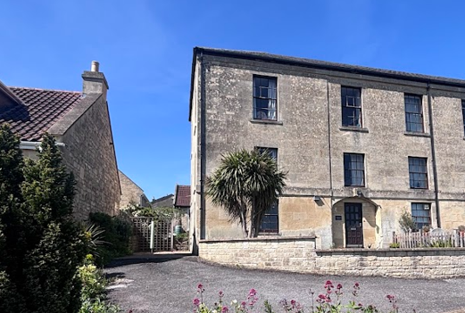

Front elevation of 16 Budbury Place

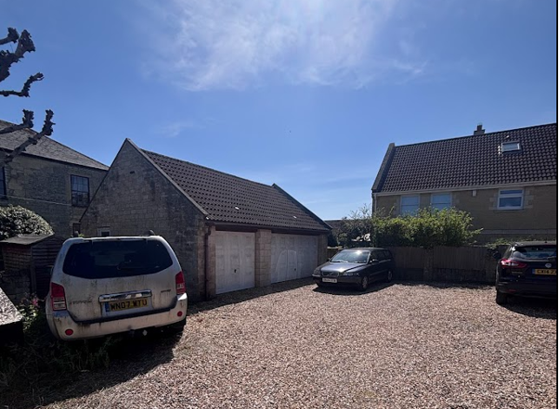

Rear elevation with off road parking area and garages

The listed buildings are annotated within the map insert below by the black hatching and the conservation area by the green shading.

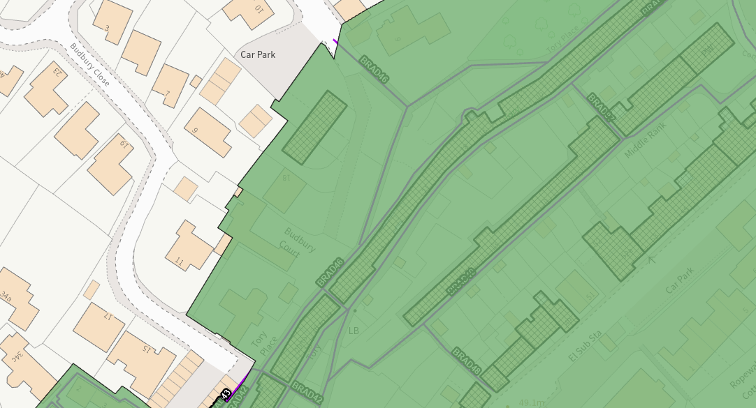

The proposal relates to full planning permission for change of use from a residential dwelling to a class C4, 5-bedroom house of multiple occupancy. No external alterations are proposed to the historic dwelling and internally no changes will be made aside from the use of an existing living room area as a bedroom.

The Local Authority Conservation Officer was consulted on the proposal and offered the following feedback

“Site and assets considered: The site is a Grade II listed building located in Bradford On Avon Conservation Area.

Proposal: The proposal seeks pre-application advice for change of use from class C3, 4 bedroom house to class C4, 5bedroom house of multiple occupancy.

Relevant planning history: 20/09524/FUL - Change of use from a 4 bed house to a 5 bed house for multiple occupancy (approved); W/79/00889/FUL - Conversion to three dwellings (approved).

Issues: impact on the listed building, impact on the setting of neighbouring listed buildings, impact on the conservation area.

Information considered/provided: Paragraph 207 requires that applicants describe the significance of any heritage assets affected, including any contribution made by their setting. The current statement incorporates some analysis of character but a future application will need to be accompanied by an assessment which should be allowed to inform the proposals.

Paragraph 207 requires that applicants describe the significance of any heritage assets affected, including any contribution made by their setting. This should include sufficient information to provide a clear understanding of the significance of the heritage asset and its setting and the potential impact of any proposals on that significance. In this case, whilst the applications are accompanied by a “Design, Access and Heritage Statement” the document provides limited information about the building and fails to provide any objective assessment of the fabric affected, its date or significance or of the impact of the proposals and, as a result, it fails to meet the requirements of the NPPF.

Paragraph 207 requires that applicants describe the significance of any heritage assets affected, including any contribution made by their setting. This should include sufficient information to provide a clear understanding of the significance of the heritage asset and its setting and the potential impact of any proposals on that significance. In this case, the applications are accompanied by a “Design and Heritage Statement” which provides sufficient information to understand the impact of the proposals and is proportionate to their scope. The requirements of the NPPF are therefore met in this respect.

However, paragraph 208 also provides for the local planning authority to make its own assessment of impact and the following heritage recommendations are offered on this basis.

Significance of assets and contribution of setting (as appropriate): The NPPF defines significance as the “value of a heritage asset to this and future generations because of its heritage interest. The interest may be archaeological, architectural, artistic or historic. Significance derives not only from a heritage asset’s physical presence, but also from its setting.” Historic England assesses significance in a similar manner, referring to evidential, historic, aesthetic and communal values of a place.

In this case the significance of the building lies largely with its historic fabric and architecture - its form, layout and architectural expression/detailing and use of high-quality design materials which have significant aesthetic and architectural interest and which contribute to the character of the conservation area. etc

The rear of the building has, however, been compromised by extension and alteration during the modern period and is of lesser interest.

The interior retains a good set of historic joinery

The circulation pattern remains largely unaltered

Assessment: The subject building is a Grade II listed building, and it is within the Bradford on Avon Conservation Area.

The Design & Access Statement that accompanies this application states that there are no external alterations proposed to the property. However, it does not mention whether it is proposed to make any interior changes to the listed building. From assessing the existing and proposed floor plans submitted, it does not appear that any interior alterations are proposed. As such could this please be clarified?

Providing that no alterations to the fabric of the building are proposed, the character and appearance of the property would remain as a residential property and the application would not result in harm to the conservation area or significance of the listed building.

As such providing that the proposal is not making any exterior or interior changes to the building this would be acceptable and complementary to the heritage assets.

Summary & conclusion: The NPPF confirms that when considering the impact of a proposed development on the significance of a designated heritage asset, great weight should be given to the asset’s conservation (and the more important the asset, the greater the weight should be). It makes clear that any harm to a designated heritage asset requires clear and convincing justification.

Clarification is required as to whether and internal changes are proposed to the listed building. If no changes are proposed, the impact of the proposal on heritage assets will be neutral and the requirements of current conservation legislation, policy or guidance will be met and there will be no objection to the application”

The applicant has confirmed that no internal changes are proposed to the listed building, therefore, officers raise no objections as the proposal, by virtue of its scale, would preserve the character and appearance of the conservation area and the setting of the listed building, and would not result in harm to the significance of any heritage assets.

Having regard to the above, the proposal complies with the design principles set out in Core Policy 57 of the Wiltshire Core Strategy and Appendix D of the Wiltshire Design Guide. The development is therefore considered to comply with Core Policy 58 of the Wiltshire Core Strategy and Sections 66 and 72 of the Planning (Listed Buildings and Conservation Areas) Act 1990, as well as the relevant provisions of the NPPF.

Amenity
Point vii of Core Policy 57 - Ensuring High Quality Design and Place Shaping of the Wiltshire Core Strategy seeks to ensure that developments do not adversely affect neighbouring properties.

The National Planning Policy Framework (NPPF), particularly Paragraph 135(f), stresses that planning decisions should ensure developments provide a high standard of amenity for existing and future users.

The proposed development has been assessed in terms of its potential impact on the residential amenity of neighbouring properties, with particular regard to loss of light, overshadowing, loss of privacy, and overbearing effects.

The scheme would not introduce any additional built form or external alterations, the only modification would be to utilise a first floor living room as a bedroom.

Therefore, officers raise no concerns in regard to any overlooking, overbearing overshadowing or loss of light to neighbouring properties.

Whilst interested parties have raised concerns in regard to an increased number of inhabitants leading to any increase in potential noise disturbance, the use of the building would continue to remain residential, within a residential area. Officers have also noted that the proposed use of the spaces within the building and outside the building would be largely the same as the existing circumstances.

Mindful of these observations, the noise disturbance would not be to a level that would be harmful to the residential amenity of the adjoining occupiers and would not be to a level that would warrant a refusal of the application.

Officers are also mindful that any objections raised in relation to potential adverse noise impacts and light pollution from outside entertaining are dealt with under separate legislation through the Public Protection team at Wiltshire Council. In regard to any security risks from existing or visiting occupants, this also would be dealt with under separate legislation, by the local police force.
The proposal therefore accords with Core Policy 57 point vii in respect of safeguarding residential amenity and Appendix D of the Wiltshire Design Guide.

Highways Impact
Core Policy 57 (xiv) of the Wiltshire Core Strategy seeks to ensure that development must meet the requirements of Core Policy 61. This policy requires proposals to be capable of being served by safe access to the highway network. Core Policy 64 seeks to ensure compliance with parking standards set out in the Local Transport Plan.

The National Planning Policy Framework (NPPF), particularly Paragraph 115 and 116, requires that development proposals do not have an unacceptable impact on highway safety and that safe and suitable access to the site can be achieved for all users.

Impact on parking provision – Core Policy 64 (Demand Management) seeks to manage the demand for vehicle parking and confirms that residential parking standards are to be based on minimum parking standards.
In order to comply with the Wiltshire Local Transport Plan 2011 – 2026: Car Parking Strategy (March 2015) three on-site car parking spaces would be required for a 4+ bed dwelling (standard min. size 2.4m x 4.8m).
The property currently benefits from four bedrooms, and the proposal seeks to change the first floor living room to a bedroom, therefore this property would become a five bedroomed house. The Local Transport Plan criteria require three off road parking spaces to be provided for a four bedroom or five-bedroom dwelling, therefore the off-road parking criteria remains as existing.
The applicant has demonstrated that sufficient off-road parking would be provided to the front and side elevation of the host dwelling, as illustrated in the site plan below. Officers are also cognisant that the property benefits from a large off road parking area to the rear alongside a single and double garage, therefore no concerns are raised in regard to adequate off-road parking being provided.
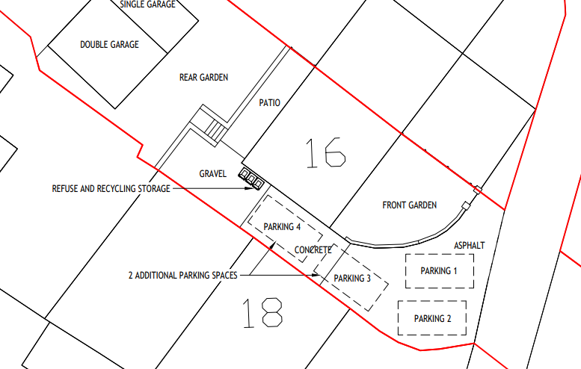
The Local Authority highways officer was consulted on the scheme and offered the following comments

‘I refer to the above planning application for re-application for change of use from class C3, 4 bedroom house to class C4, 5 bedroom house of multiple occupancy.
Since my colleague did not object to the previous application (20/09524) and this application has the same number of bedrooms with the same parking provision proposed, I maintain no highway objection’

In regard to neighbouring occupiers concerns in regard to the existing access route being compromised by an increase in vehicles movement to and from the site, officers acknowledge that the access lane is narrow, however, this access is existing, and no changes are proposed. As previously noted within the appraisal of the lapsed scheme, it is also acknowledged that the access lane has some existing damage, however, the cause of this damage is unknown as several other properties use the access lane.
The proposal would lead to some level of intensification of the use of the access lane – however, mindful that the proposal would continue to be residential in nature and the parking provided by the detached garages, the vehicular movements resulting from the proposal would not be to a substantially harmful level that would warrant a refusal of the application.
It is appreciated that the surrounding public streets and car park are potentially used for parking by residents of neighbouring properties, including residents of Tory and Middle Rank. However, the site is nonetheless adjacent to a public car park for use by all residents and there are opportunities for on-street parking spaces available in the surrounding area. The unrestricted parking opportunities within the area could make up for any deficit should the occupants or visitors have any need to accommodate additional vehicles.
Officers are cognisant that the proposal would meet the Council’s Car Parking Strategy criteria for the minimum number of parking spaces and given its central location within Bradford on Avon and its proximity to public transport any on-street parking associated with the development would not result in severe harm to highway safety that would warrant a refusal of the application.
Third party concerns with regards to the maintenance of the access lane, are noted however it is a private access lane and any concerns regarding the maintenance of the private access lane and the cost of the maintenance would not be a material planning consideration as it would be a civil matter and would be addressed outside of the planning system.
Third-party concerns regarding blocked access for neighbouring properties parking spaces have been noted. The application has demonstrated that there would be adequate provision of parking spaces within the site. Parking and boundary disputes between neighbour properties would be a civil matter and would not be addressed within the planning system.
Officers are of the opinion that the proposed development would not result in any adverse impact on highway safety. Adequate parking and turning provision is provided in accordance with Wiltshire’s adopted parking standards, and access arrangements are acceptable.

The proposal is therefore considered to comply with Core Policies 57 (xiv), 61 and 64 of the Wiltshire Core Strategy, the NPPF, and the Wiltshire Local Transport Plan.

Ecology Impact
Core Policy 50 of the Wiltshire Core Strategy seeks to protect and enhance biodiversity and geodiversity, including through ensuring that development avoids harm to protected species and habitats.

The National Planning Policy Framework (NPPF), in Paragraphs 193, requires that development minimises impacts on and provides net gains for biodiversity, including ensuring mitigation is secured where harm cannot be avoided.

The Local Authority Ecology team were consulted on the proposal and offered the following comments

“Bath and Bradford-on-Avon Bats Special Area for Conservation (SAC)
The site lies within multiple core roost buffers for Greater Horseshoe and Lesser Horseshoe bats associated with the Bath and Bradford-on-Avon Bats SAC, and there are several known roosts within the vicinity. There are records of a small Lesser Horseshoe hibernation roost as well as a Greater Horseshoe roost within 30m of the site, and another Greater Horseshoe roost 75m southwest. The proposal may therefore have the potential to result in significant adverse impact on the special features of that site. Appropriate Assessment (AA) under Section 63 of the Habitats Regulations must be carried out by the relevant Competent Authority (the LPA) to determine the potential significant effects and the suitability of any measures proposed to avoid or mitigate those effects.

A test of likely significance (screening assessment) has been carried out by Wiltshire Council as required under Regulation 63 of the Conservation of Habitats and Species Regulations 2017 (as amended) (also known as the Habitat Regulations). The proposals do not include any building alterations and would not result in a significant increase in human disturbance in this already urban area (with a total increase of 1 bedroom). No foraging/commuting habitat is to be removed, and no lighting is proposed. As such, the application is screened out of Appropriate Assessment with respect to the Bath and Bradford-on-Avon Bat SAC. The HRA has concluded that the application is not likely to have significant impacts on the SAC and Appropriate Assessment is not required.

Protected species
An increase in artificial lighting can deter bats and result in the severance of key areas. No lighting is proposed, and the surrounding roads are subject to light spill from existing streetlights and security lights. Nonetheless, considering the presence (and conservation significance) of Annex II bat roosts nearby, it is recommended that a lighting condition is applied to ensure that, in the event new lighting is required, it must be designed to be wildlife-sensitive and plans must be first submitted to the LPA for approval .Given the lack of physical works proposed, the risk posed to other protected species is thought to be minimal.”

The council’s ecologist has requested a condition requiring details of external lighting however no such condition was imposed on application PL/2020/09524, the site is located within the largely built up area of the town, and there is no control over external lighting within the curtilage of the existing property as such it would not be considered reasonable to impose such a condition.

As such, the development complies with Core Policy 50 of the Wiltshire Core Strategy and the relevant provisions of the NPPF.

Biodiversity Net Gain
As of April 2024, unless exempted, applications need to demonstrate no net loss and a minimum of 10% net gain in biodiversity (BNG) on the site, in line with the requirements of the NPPF, PPG, WCS policy CP50 (Biodiversity and Geodiversity) and the Environment Act. In this case, the application was submitted with a de minimis exemption.
However, the small-scale nature of this proposal means that the scheme falls within De minimis Exemption (less than 25sqm of habitat or 5m of linear habitat) and therefore BNG is not required.

Other Matters
The other matters raised by neighbouring occupiers were largely covered within the appraisal of the previous (near identical) planning submission and are reproduced below.
Red-line boundary/boundary dispute – Officers have acknowledged the third-party concerns regarding the accuracy of the red-line boundary and acknowledge that there is an ongoing boundary dispute. Revised plans were received due to the inconsistency between the original location and block plan with the land registry.
The case officer has compared the plans with a land registry plan provided by the agent, at the same time mindful of the third-party representations. Officers are satisfied that the red line boundary drawn on submitted plans adequately reflect the red line shown in the land registry plan, for the purposes of planning.
It should be noted that the determination of this application does not represent a determination of any boundary dispute. The determination of the boundary dispute would be subject to other processes outside of the planning regime and would not be a material planning consideration.
Impact on public right of way – The application does not propose to change the access to the site. The proposal would also be well-contained within the curtilage of the site. As such, the proposal would have a similar impact on the public right of way as the existing circumstances.
Fire Safety – Building Regulations would address fire safety matters, and it may be necessary for the applicant to complete some residual modifications. Should residual modifications to the building be required, these may need a separate Listed Building Consent application – this would be a separate application from this current application. As such, fire safety would not be a material planning consideration and would be addressed outside this planning application.
Deeds – Concerns regarding the breach of the property deeds have been noted. However, this would not be a material planning consideration and would be a civil matter.
Request for publication of correspondence – Relevant representations and correspondence in relation to the application have been published. Requests for further correspondence in relation to the application would be dealt with appropriately.
Site notice - There were concerns raised that no site notice was initially displayed for the application. In this particular instance, a site notice was subsequently displayed for the application, (despite the absence of the listed building consent application) due to its status as a listed building and its location within the Conservation Area. The consultation period was also extended.
Previous Permissions – comments made in relation to how the previous approval should not set a precedent, are acknowledged. Third parties should be assured that the appraisal of this scheme has been made entirely independent of any previous consent and has been assessed on its own merits. Fresh consultation responses have been received from statutory consultees and neighbouring occupiers and assessed by an officer who has not previously dealt with the site.
CONCLUSION
The proposed development is considered to be acceptable in terms of its design, scale, and relationship with the surrounding area. It would not result in any unacceptable harm to the character of the locality, the amenities of neighbouring occupiers, or the interests of highway safety, heritage, or ecology.

The proposal is therefore considered to comply with the relevant policies of the Wiltshire Core Strategy, the Wiltshire Local Plan, and the National Planning Policy Framework. As such, the application is recommended for approval, subject to the conditions set out below.

RECOMMENDATION: That Planning Permission be GRANTED subject to conditions.

Conditions

- The development hereby permitted shall be begun before the expiration of three years from the date of this permission.

REASON: To comply with the provisions of Section 91 of the Town and Country Planning Act 1990 as amended by the Planning and Compulsory Purchase Act 2004.

- The development hereby permitted shall be carried out in accordance with the following approved plans and documents:

Location Plan DWG No 00454-001-A3LH
Received 26.01.2026
Existing Block Plan DWG No 00454-002-A3LH
Proposed Block Plan DWG No 00454-003-A3LH
Existing Ground Floor Plan DWG No 00454-004-A3LH
Existing First Floor Plan DWG No 00454-005-A3LH
Existing Second Floor Plan DWG No 00454-006-A3LH
Proposed Ground Floor Plan DWG No 00454-007-A3LH
Proposed First Floor Plan DWG No 00454-008-A3LH
Proposed Second Floor Plan DWG No 00454-009-A3LH
Existing Elevations DWG No 00454-010-A3LH
Proposed Elevations DWG No 00454-011-A3LH
Received 21.01.2026

REASON: For the avoidance of doubt and in the interests of proper planning.

Informative
Sui Generis Use Class
The Town and Country Planning (Use Classes) Order 1987 (as amended) identifies Use Class C4 as a house in multiple occupation and defines this as the Use of a dwellinghouse by not more than six residents as a “house in multiple occupation”. The development hereby approved for a 5-bed house in multiple occupation does not meet this definition and is considered to be a sui generis use for the purpose of any future planning applications for change of use.

For the avoidance of doubt, this planning permission is for a change of use only and excludes any operational development which may require separate planning permission.

