
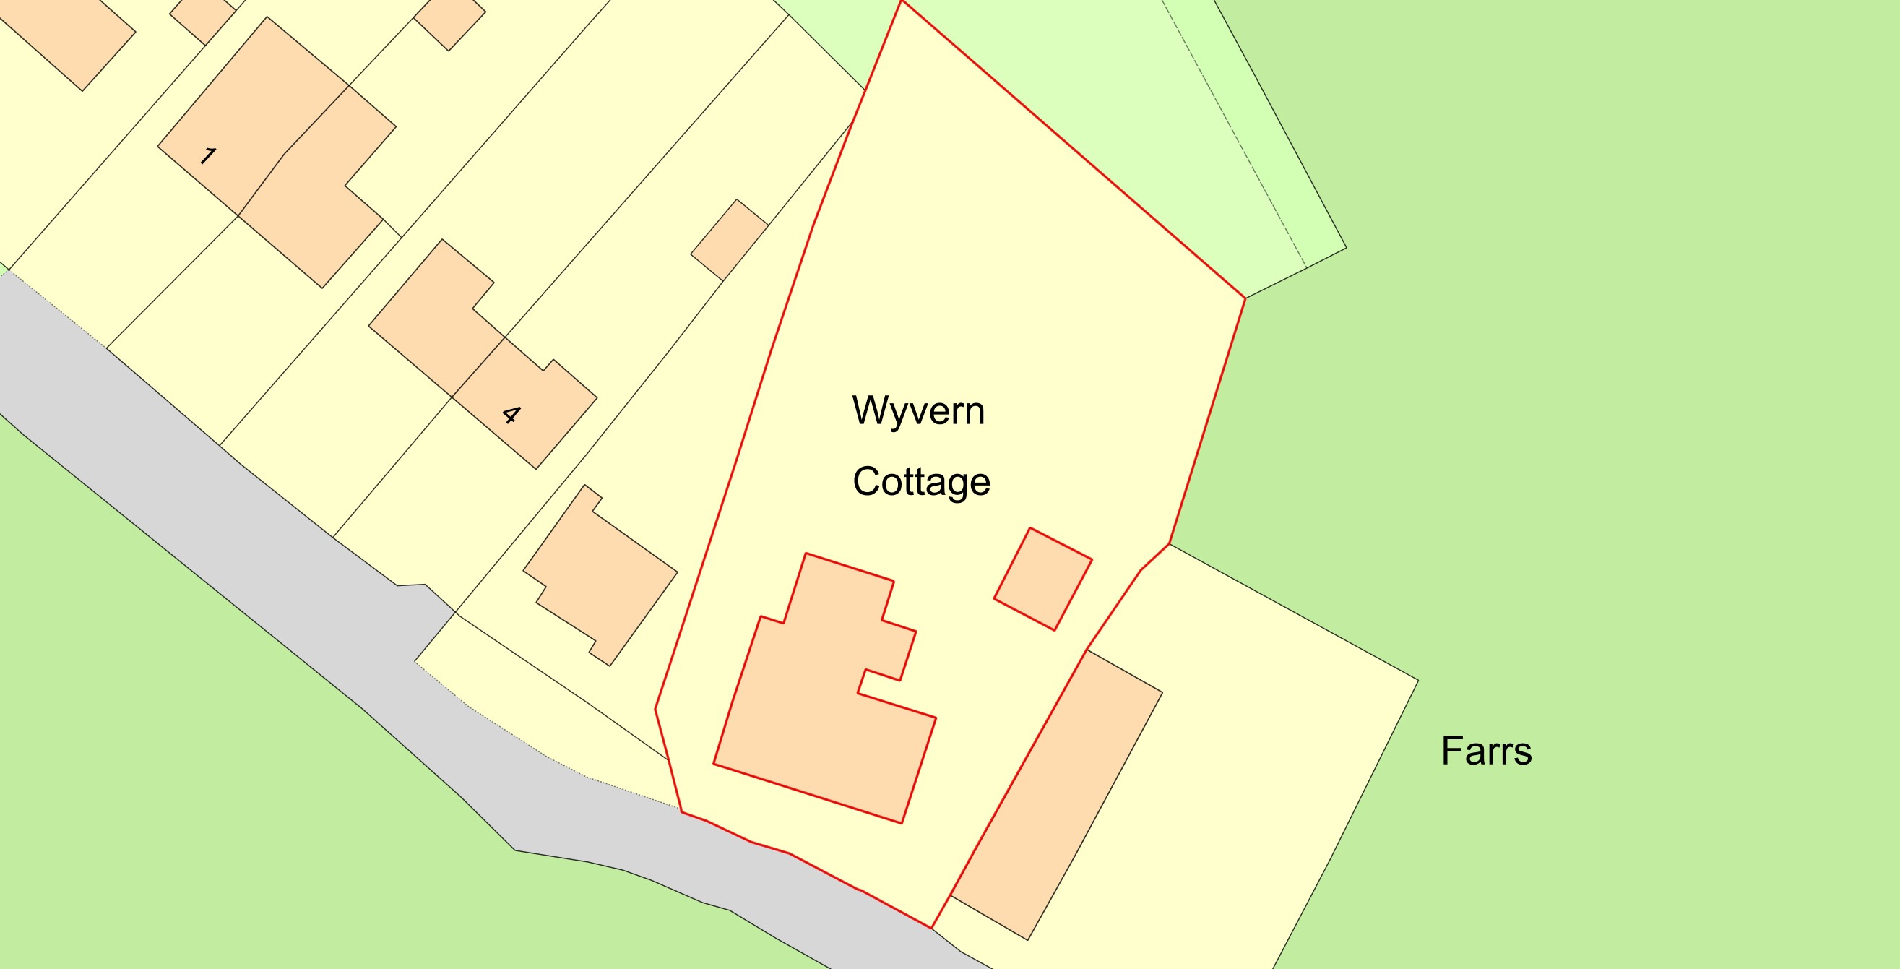



Garage rebuild at Wyvern Cottage, Chapel Lane, Zeals
Plan Produced for:
Mr Rod Lauder
Date Produced:
01
Apr
2026
Plan Reference Number:
TQRQM26091202019250
Scale:
1:500
@ A
4
© Crown copyright and database rights 2025 OS 100042766

