6, The Ham, Westbury BA13 4HF – Reference: PP-14780668.

Planning permission application for the erection of a Summer House style wooden garden shed.

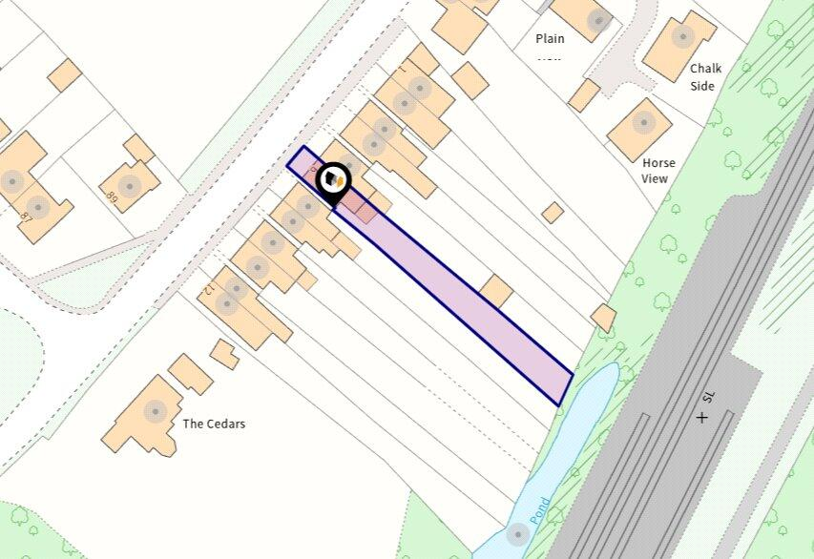

Proposed shed position in rear garden -
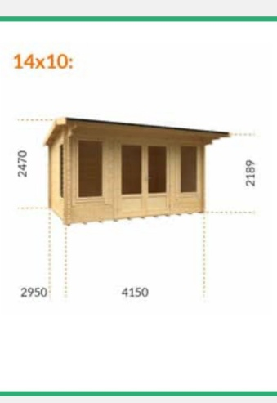
Proposed shed design -

Proposed shed position in rear garden:

Proposed shed position in rear garden -

