FULL PLANNING APPLICATION.
CASE OFFICER REPORT

APPLICATION REFERENCE: | PL/2026/00786
APPLICATION TYPE: | Full Planning Application
SITE ADDRESS: | Little Cuckoos, Lyes Green, Corsley, BA12 7QF.
DEVELOPMENT DESCRIPTION: | Temporary Permission to Retain Existing Building for Pre- School Use and Ancillary Office Building. (Renewal of Permission 21/01064/FUL)
RECOMMENDATION: | Approve with Conditions.

PROPOSAL
The application is for the proposed renewal of a previously granted temporary planning permission for the retention of an existing mobile classroom building and small ancillary wooden office building at the Little Cuckoos Pre-School playgroup.

SITE DESCRIPTION/CONTEXT
The pre-school building is located within the Large Village of Corsley, within a rural location and adjacent to a large sized tarmacked car parking area. A large detached residential building known as The Old School is located nearby.

RELEVANT PLANNING HISTORY
21/01064/FUL Renewal of temporary permission W/13/00918/FUL (for the retention of a building for playgroup) as well as retrospective temporary permission for an ancillary wooden office and shed - for a 5 year period. Permission.
99/01337/FUL Erection of prefabricated single storey building Permission 18.10.1999
02/00340/FUL Single storey pre-school building (renewal) Permission 10.05.2002
07/01819/FUL Single storey pre-school building (renewal) Permission 20.07.2007
08/01247/FUL Retention of building for playgroup (renewal) Permission 01.07.2008
13/00918/FUL Renewal of temporary permission W/08/01247/FUL (Retention of building for
playgroup – Limited period permission). Permission 02.08.2013.

RELEVANT POLICIES AND GUIDANCE
Wiltshire Core Strategy:

- Core Policy 49 Protection of rural services and community facilities
- Core Policy 57 Ensuring High Quality Design and Place Shaping
- Core Policy 50: Biodiversity and Geodiversity
- Core Policy 51: Landscape
- Core Policy 58: Ensuring the Conservation of the Historic Environment
- Core Policy 61: Transport and New Development
- Core Policy 64: Demand Management

WWDP 2004 Retained Policy C3 – Special Landscape Area.

Wiltshire Design Guide: Appendix D – Design Guidance for Householder extensions

The National Planning Policy Framework (NPPF)

The Planning Practice Guidance

National Design Guide

Emerging Wiltshire Local Plan:
The examination of the emerging Wiltshire Local Plan has been paused and the weight to be afforded to any part of the emerging plan can be no more than very limited. A decision on how to proceed will be made by the Council in May 2026.

CONSULTATION RESPONSES
Corsley Parish Council: No response received.

Highways: No objections.

REPRESENTATIONS
No comments were received.

PRINCIPLE OF THE PROPOSAL.
The principle of the proposed scheme is considered to be acceptable for the reasons as discussed below.

ASSESSMENT
Section 38(6) of the Planning and Compulsory Purchase Act 2004 states:

"If regard is to be had to the development plan for the purposes of any determination to be made under the planning Acts, the determination must be made in accordance with the plan unless material considerations indicate otherwise."

In accordance with this statutory requirement, this application has been assessed against the relevant policies of the Development Plan, including the adopted Wiltshire Core Strategy (2015).

Design and Impact upon the upon the character and context of the area

Core Policy 57 - Ensuring High Quality Design and Place Shaping of the Wiltshire Core Strategy seeks to ensure that all new development is of high design quality, reflecting local context, character, and distinctiveness. The proposals can be viewed within the plan snippets taken from the submitted plans:

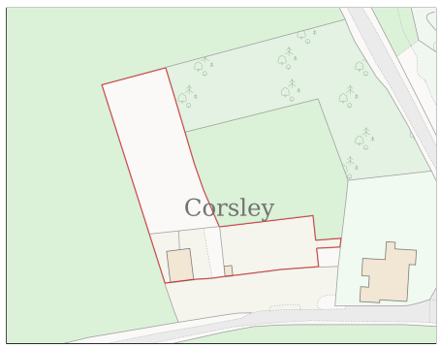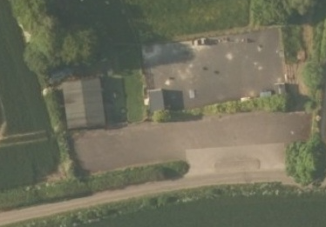
Location Plan Aerial Photograph
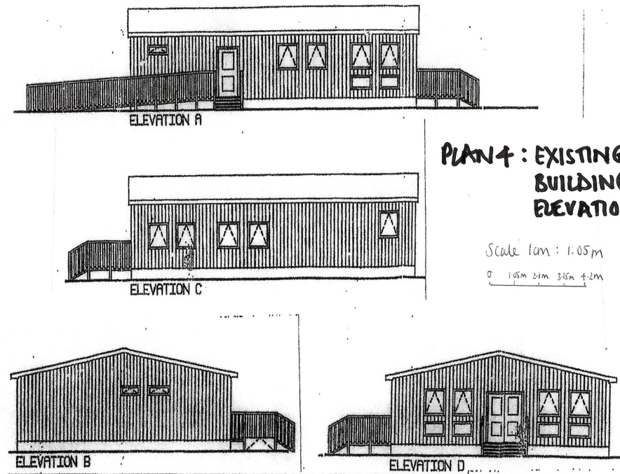
Existing Elevations.

The timber clad classroom building is already in place and in terms of design, is of a standard rectangular design being single storey and low in height. It occupies its own area, being close to the large car park, within the context of the established green hedgerow boundary treatment which serves to separate the entire area from the highway.

The use of natural timber as the material for the construction of the building is also a favourable consideration when reviewing the retention of the building.

The building is established and does not look out of keeping with its surroundings.

Therefore, in summary, having regard to the above, the proposal complies with the design principles set out in Core Policy 57 of the Wiltshire Core Strategy and Appendix D of the Wiltshire Design Guide.

Amenity
Point vii of Core Policy 57 - Ensuring High Quality Design and Place Shaping of the Wiltshire Core Strategy seeks to ensure that developments do not adversely affect neighbouring properties. The National Planning Policy Framework (NPPF), particularly Paragraph 135(f), stresses that planning decisions should ensure developments provide a high standard of amenity for existing and future users.
In terms of amenity, the pre-school is the sole building at this established location and is separated from the residential building to the east, known as The Old School by an approximate distance of 64 metres, which due to its low level single storey design and overall separation distance, is appraised as not harmfully impacting on the amenities of this residential building. Likewise, it is noticed that no neighbour responses have been received.

The adjacent location and established siting of the ancillary timber office is also considered to be acceptable with it facing in on the pre-school, thereby further respecting the amenities of The Old School to its east.

The proposal therefore accords with Core Policy 57 point vii. in respect of safeguarding residential amenity and Appendix D of the Wiltshire Design Guide.

Highway Matters.
Core Policy 57 (xiv) of the Wiltshire Core Strategy seeks to ensure that development must meet the requirements of Core Policy 61. This policy requires proposals to be capable of being served by safe access to the highway network. Core Policy 64 seeks to ensure compliance with parking standards set out in the Local Transport Plan.

The National Planning Policy Framework (NPPF), particularly Paragraph 115 and 116, requires that development proposals do not have an unacceptable impact on highway safety and that safe and suitable access to the site can be achieved for all users.

The proposed development would continue to use the established site access which would not be altered and would not have any adverse impact on highway safety. Adequate parking and turning provision are provided within the adjacent large sized car park. The council’s highways officer has been consulted who has not raised any objections.

The proposal is therefore considered to comply with Core Policies 57 (xiv), 61 and 64 of the Wiltshire Core Strategy, the NPPF, and the Wiltshire Local Transport Plan.

Ecology Impact CP50 requires no net loss of biodiversity on site. The site is located within the Salisbury Plain 6400 metre buffer zone. The proposed retention of the use would not involve any works and so is considered unlikely to result in harm ecology wildlife. Accordingly, the proposal is acceptable in this regard and the development complies with Core Policy 50 of the Wiltshire Core Strategy and the relevant provisions of the NPPF.

Biodiversity Net Gain. This application is exempt from the requirement to deliver Biodiversity Net Gain under Schedule 7A, Section 4(2)(a) of the Town and Country Planning Act 1990, as inserted by the Environment Act 2021, because of its de minimis exemption.

Special Landscape Area: The site is located within a Special Landscape Area (SLA), whereby the
impact of development on the open nature and character of this land designation is a prime
consideration. In this instance however, there are a number of existing and established buildings,
within the immediate locality, with the pre-school building being small in size and whose continued retention is appraised as not harmfully impacting on the surrounding open character of the SLA.

Other matters. The continued retention and use of the pre-school building is acceptable, as it is a much-used thriving service for the local community and whilst understanding the principle of granting temporary consents for this type of building, it has been requested that the time span be increased from five to ten years. This is considered to be acceptable and in accordance with the aims of CP49 of protecting rural services and community facilities, as the pre-school offers a valuable service to the local rural community and a longer time span would assist the businesses’ longevity, whilst not creating harm in planning terms.

CONCLUSION
The continued use of the pre-school building is acceptable in terms of its design, scale, and relationship with the surrounding area. It would not result in any unacceptable harm to the character of the locality, the amenities of neighbouring occupiers, or the interests of highway safety and is recommended for permission subject to conditions.

RECOMMENDATION: Planning Permission be GRANTED subject to conditions.

