APPLICATION FOR FULL-PLANNING PERMISSION
CASE OFFICER REPORT

APPLICATION REFERENCE: | PL/2026/01756
APPLICATION TYPE: | Full planning permission
SITE ADDRESS: | 8, Station Road, Westbury, BA13 3JH
DEVELOPMENT DESCRIPTION: | Extension of existing terrace property to provide additional plant equipment to support the adjacent care home upgrade works.
RECOMMENDATION: | Approve with Conditions

SITE DESCRIPTION/CONTEXT

Westbury Court Care Home is a three storey building in use as a care home. The site is located within the settlement limits of Westbury and in close proximity to the town centre and within a mainly residential area.

The wider site (blue land) is also located directly adjacent the Westbury Conservation Area. There is parking to the rear of the building with access off Station Road.

The application site lies within the 6.4km zone of influence of the Salisbury Plain Special Protection Area (SPA) and within the Bath & Bradford on Avon Special Area of Conservation (SAC) and grey hatched zone of the Trowbridge and Westbury Bat Mitigation Strategy (TWBMS).

Fig. 1: Location Plan

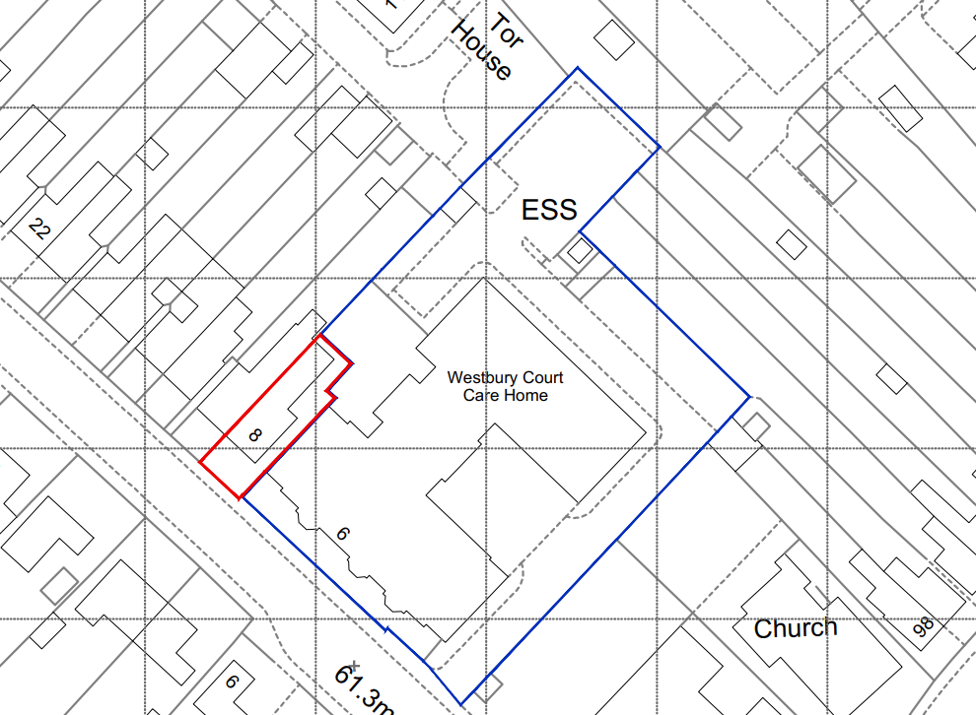

PROPOSAL

The existing end of terrace forms part of the ownership of the care home. The proposal is for the extension of the existing terrace property to provide additional plant equipment to support the adjacent care home upgrade works.

The applicant’s Design and Access Statement explains as follows:

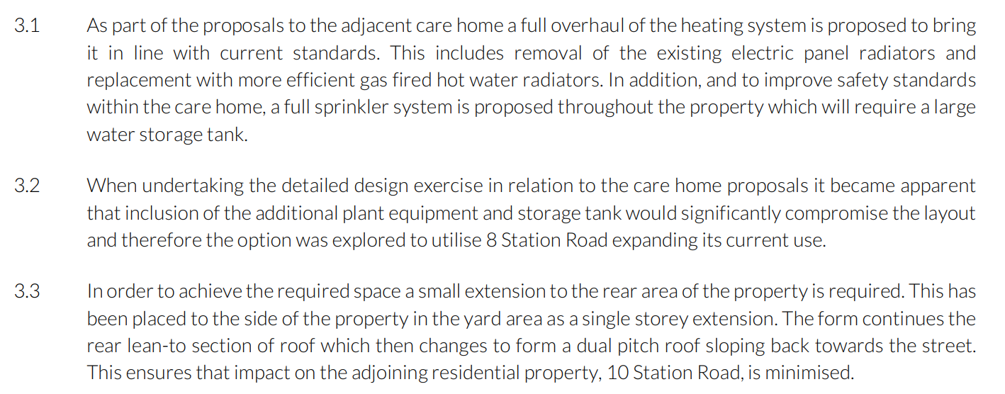

Fig. 2: Existing ground floor plan (top), Proposed ground floor plan (bottom)

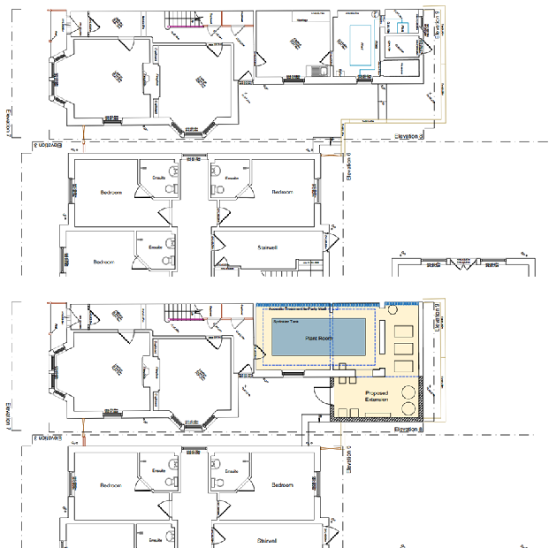

PLANNING HISTORY

Proposal / Summary
PL/2025/03653 - Full planning permission Decision - Approve with Conditions Date: 30/6/2025 – Extension and re-modelling existing care home facility to include 11 additional bedrooms, increased day space, 10 additional parking spaces, and improved external amenity space.
PL/2026/00258 - Approval of details reserved by a condition Decision - Approve Date: 13/3/2026 – Discharge of conditions 4 (Surface Water Drainage Design) of PL/2025/03653.
PL/2026/01756 - Full planning permission – Extension of existing terrace property to provide additional plant equipment to support the adjacent care home upgrade works.
W/09/01080/FUL - Full planning permission Decision - Refused Date: 6/7/2009 – OKReplacement of existing nursing home, bungalow, garage and petrol filling station with a sixty bed healthcare facility
W/09/02634/DEM - Demolition Details Decision - Approved Date: 6/10/2009 – Site to be cleared other than petrol tanks
W/09/02943/FUL - Full planning permission Decision - Approve with Conditions Date: 16/12/2009 – Replacement of existing nursing home, bungalow, garage and petrol filling station with a 60 bed healthcare facility, together with change of use no.8 to C2 D1 use
W/74/00194/HIS - Historic apps 1974 to 1983 Decision - Approved Date: 25/4/1974 – Conversion into two flats

RELEVANT LEGISLATION, POLICIES AND GUIDANCE

National Planning Policy:
- National Planning Policy Framework (NPPF)
- Planning Practice Guidance (PPG)
- National Design Guide
Development Plan:
The development plan for Wiltshire comprises the Wiltshire Core Strategy (WCS) (adopted January 2015) and any made neighbourhood plans, which remains the principal statutory planning document guiding development across the county. In line with Section 38(6) of the Planning and Compulsory Purchase Act 2004, planning decisions must be made in accordance with the development plan unless material considerations indicate otherwise.

Though the development plan is considered as a whole, those parts deemed to be particularly relevant to this application are listed below:

The adopted Wiltshire Core Strategy (WCS), with particular regard to:

- Core Policy 1 Settlement Strategy;
- Core Policy 2 Delivery Strategy;
- Core Policy 3 Infrastructure Requirements;
- Core Policy 32 Westbury Spatial Strategy
- Core Policy 35 Existing Employment Land
- Core Policy 41 Sustainable Construction and Low-Carbon Energy;
- Core Policy 45 Meeting Wiltshire’s Housing Needs;
- Core Policy 46 Meeting the Needs of Wiltshire’s Vulnerable and Older People;
- Core Policy 50 Biodiversity and Geodiversity;
- Core Policy 57 Ensuring High Quality Design and Place Shaping;
- Core Policy 58 Ensuring the Conservation of the Historic Environment;
- Core Policy 60 Sustainable Transport;
- Core Policy 61 Transport & Development;
- Core Policy 62 Development Impacts on the Transport Network;
- Core Policy 63 Transport Strategies
- Core Policy 64 Demand Management
- Core Policy 67 Flood Risk;
- Core Policy 68 Water Resources;

Draft Wiltshire Local Plan Policies [delete/insert above as appropriate]

- Policy 1: Settlement Strategy
- Policy 2: Delivery Strategy
- Policy 3: Reserve sites and broad locations for growth
- Policy 4: Addressing climate change
- Policy 5: Securing infrastructure provision from new development
- Policies 52 – 63:Trowbridge Area Strategy
- Policies 64 – 75: Economic, tourism, retail and transport
- Policies 76 – 84: Social, housing, community, public open space and wellbeing
- Policies 85 – 101: Sustainability, ecology, water and landscape, heritage, air quality

The examination of the emerging Wiltshire Local Plan has been paused and the weight to be afforded to any part of the emerging plan can be no more than very limited. A decision on how to proceed will be made by the Council in May 2026.

Neighbourhood Plan:

WESTBURY NEIGHBOURHOOD PLAN 2023 – 2036 (Made March 2024)

Supplementary Planning Documents and other Guidance:
- Wiltshire Design Guide (adopted April 2024)
- Wiltshire Local Transport Plan 2011-2026, adopted 2015 - including the Car Parking Strategy and Cycling Strategy, adopted 2015
- Wiltshire Council’s Waste Core Strategy, adopted July 2009
- Wiltshire Council’s Waste Storage and Collection: Guidance for Developers Supplementary Planning Document, January 2017

ISSUES

The main issues that need to be addressed in this case include:

- Whether the development is acceptable in principle (CP 1 and 2)
- Whether the scheme constitutes high quality design (CP 57)
- Whether the scheme would have an acceptable impact upon the reasonable living conditions of the adjoining occupants (CP 57)

CONSULTATION RESPONSES

WC Conservation: No comment – outside of conservation consultation remit.

WC Public Protection: No objection subject to conditions.

Town Council: “No Objection subject to conditions. Westbury Town Council would like a condition to be implemented to ensure that noise mitigation is satisfactory to protect surrounding residential property.”

REPRESENTATIONS
In accordance with the requirements of the Town and Country Planning (Development Management Procedure) (England) Order 2015 (as amended), the application was publicised by way of neighbour notification letters sent to adjoining and nearby properties;

These methods were used to inform interested parties and provide a period of 21 days for comments to be submitted.

No responses were received.

ASSESSMENT
Section 38(6) of the Planning and Compulsory Purchase Act 2004 states:

"If regard is to be had to the development plan for the purposes of any determination to be made under the planning Acts, the determination must be made in accordance with the plan unless material considerations indicate otherwise."

In accordance with this statutory requirement, this application has been assessed against the relevant policies of the Development Plan, including the Wiltshire Core Strategy (2015) and, where applicable, any made Neighbourhood Plans. Consideration has also been given to the policies of the National Planning Policy Framework (NPPF) as a material consideration in the assessment.

Principle of Development
Policy Context
Core Policy 1: Settlement Strategy of the WCS establishes a hierarchy of settlements to guide where development should be focused. The policy prioritises growth in:
- Market Towns – support local services and employment; suitable for sustainable development.

Core Policy 2: Delivery Strategy of the WCS sets out how development will be distributed and delivered across Wiltshire. The policy emphasises:
- Sustainable patterns of growth, reducing the need to travel and supporting local services.

Together, CP1 and CP2 ensure that new development is strategically located, sustainable, and supports the character and function of Wiltshire’s communities.

Assessment

This application would support the adjacent care home in its operation by providing space for the relevant building services that are required to successfully operate modern facilities within the care home. The space would be used to house the necessary large water tank for the sprinkler system, and equipment to support the modern central heating system.

Conclusion

The extension would be a small addition to the end of terrace property, but would have an important impact in allowing the successful and efficient running of the care home.

Design and Impact on the Character and Appearance of the Area
Policy Context
Core Policy 57 of the WCS requires high-quality design that:
- Enhances local character.
- Responds to the natural, historic, and built environment.
- Retains important features (e.g., trees, hedges).
- Supports sustainable construction and compatibility with surrounding uses.
- Creates safe, legible, and accessible spaces.

Section 12 of the NPPF emphasises design that is:
- Visually attractive.
- Functionally effective.
- Contributes to the quality of the built environment.

The Wiltshire Design Guide encourages sensitivity to local character, materials, and architectural styles and supports modern living standards while maintaining aesthetic and functional quality.

Assessment

This is an end of terrace traditional dwelling. The proposed extension would be a single storey pitched roof structure at the rear of the dwelling that would not be readily seen from the road.

The extension would be a sensible addition to the house, in matching materials, and of a scale that is common amongst such dwellings.

Fig. 3: Existing side elevation (Top), Proposed side elevation (Bottom)
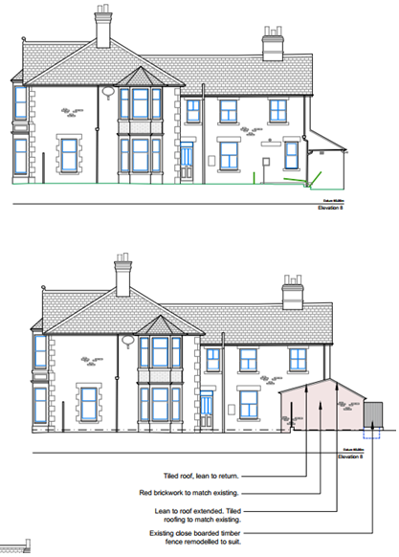

The extension would not have any demonstrable impact on the character of the area due to its size, siting and complementary appearance.

Conclusion

The proposal would be a complementary addition to the dwelling, and would allow the proper functioning of the care home. Consequently, the design and its impact on the character of the area are considered to be entirely acceptable.

Amenity
Policy Context
Core Policy 57 (Point vii) of the Wiltshire Core Strategy requires development to respect the amenity of existing occupants and ensure appropriate amenity levels for future residents.

The National Planning Policy Framework (NPPF), particularly Paragraph 135, reinforces the need for development to provide a high standard of amenity for both existing and future users.

These policies guide the assessment of amenity impacts, which will be considered in detail under the below headings.

Overlooking / loss of privacy / Loss of light / overshadowing / Overbearing Impact / Overall sense of enclosure

As the extension is single storey and complementary in appearance there would be no impact on the above issues.

Noise

The extension is designed to house building services, which can be noisy. Therefore, the impact of the extension and the additional services on the amenity of the attached neighbour in particular merit due consideration.

The applicant produced a Environmental Noise Assessment to deal with this issue. The neighbour did not engage with the process and therefore the consultant worked from a “worst case” scenario. The Council’s Public Protection team have commented as follows:

“I have reviewed the Noise Impact Assessment submitted in support of the proposed installation of a new plant room at Westbury Court Care Home (WCCC).
“In general, I am in agreement with the conclusions of the Acoustic Report prepared by Stantec UK Limited. Subject to the implementation of the recommended mitigation measures relating to airborne noise and vibration control, the amenity of occupants of the neighbouring residential property can be adequately protected. I suggest the following condition:
“All mitigation measures detailed within the acoustic report shall be implemented in full prior to the first use of the plant room and shall thereafter be permanently retained. All vibration prevention measures to the plant equipment should be installed following the recommendations of Table 4.56 of Noise and Vibration Control for Building Service Systems (CIBSE Guide 4B). The development must achieve NR15 and LAeq 23 dB when measured in the structurally adjoining property.
“The approved details shall be implemented prior to occupation and shall thereafter be permanently retained.
“Reason: Core policy 57, Ensuring high design and place shaping such that appropriate levels of amenity are achievable.”

The applicant has taken the potential noise impact to the neighbour very seriously, and has designed a scheme that will ensure that no harm to the amenity of the neighbouring would result from the proposal.

Consequently, subject to the mitigation measures being secured by condition, the impact would not result in harm to the neighbouring dwelling.

Other Issues

The dwelling is sited away from the Conservation Area and therefore there would be no impact on heritage assets.

This is, at its core, an extension to a dwelling. Therefore, there is no additional pressure on ecology interests, including the Trowbridge and Westbury Bat Mitigation Strategy.

PLANNING BALANCE AND CONCLUSION
At the heart of the NPPF there is a presumption in favour of sustainable development requiring local planning authorities to approve development proposals that accord with an up-to-date development plan without delay.

The principle of development is considered acceptable when assessed against the settlement strategy of the Wiltshire Core Strategy and the emerging Local Plan.

The proposal is broadly compliant with relevant local and national planning policies in respect of design, scale, materials and residential amenity (including noise) subject to the recommended conditions.

The development would deliver clear benefits, including allowing the care home to run efficiently and effectively, which weigh positively in the overall planning balance.

Accordingly, the proposal is considered acceptable in planning terms and in accordance with the Wiltshire Core Strategy, the National Planning Policy Framework, and all other relevant material considerations.

RECOMMENDATION:
That Planning Permission be GRANTED, subject to conditions:

1
The development hereby permitted shall be begun before the expiration of three years from the date of this permission.

REASON: To comply with the provisions of Section 91 of the Town and Country Planning Act 1990 as amended by the Planning and Compulsory Purchase Act 2004.

2
The development hereby permitted shall be carried out in accordance with the following approved plans:

Application Forms, Environmental Noise Assessment (Ref. 333701962-STN-ZZ-XX-RP-Y-0001), Drawing Nos. 2411 001, 010, 011, 012, 014, 015, 050, 100, 101, 200 received on 16th March 2026

REASON: For the avoidance of doubt and in the interests of proper planning.

3
All mitigation measures detailed within the acoustic report shall be implemented in full prior to the first use of the plant room and shall thereafter be retained for the life of the development and use.

All vibration prevention measures to the plant equipment shall be installed following the recommendations of Table 4.56 of Noise and Vibration Control for Building Service Systems (CIBSE Guide 4B). The development must achieve NR15 and LAeq 23 dB when measured in the structurally adjoining property.
REASON: Core policy 57, Ensuring high design and place shaping such that appropriate levels of amenity are achievable.

