APPLICATION FOR FULL-PLANNING PERMISSION
CASE OFFICER REPORT

APPLICATION REFERENCE: | PL/2026/01675
APPLICATION TYPE: | Full planning permission
SITE ADDRESS: | Canal Forge, Lower Wharf, Devizes, SN10 1JN
DEVELOPMENT DESCRIPTION: | Proposed change of use from former Canal Forge to office and training centre
RECOMMENDATION: | Approve with Conditions

SITE DESCRIPTION/CONTEXT
The building subject to this application is a forge that has until recently been utilised for that purpose, including educational visits. With the retirement of the blacksmith the site is now vacant.

The building is a small single storey brick structure of 63m2 with a slate roof that runs parallel close to the south bank of the Kennet and Avon Canal. The site lies within the Devizes Conservation Area and is served by a vehicular access off Northgate Street that also serves a number of properties, the rear of the Assizes court and the Devizes Canoe Club.

PROPOSAL
The application proposes change of use of the forge to office and training centre for the Wiltshire Historic Buildings Trust.

External works will be restricted to repairs and refurbishment of the existing structure and fenestration. Internally the space will be re-organised to fit the proposed use.

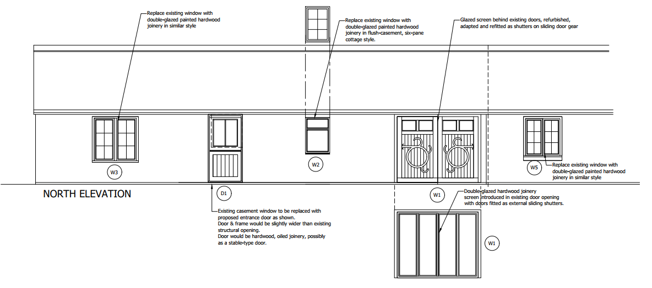
A glazed screen will be situated behind the refurbished doors which will be adapted and refitted as shutters on sliding door gear.

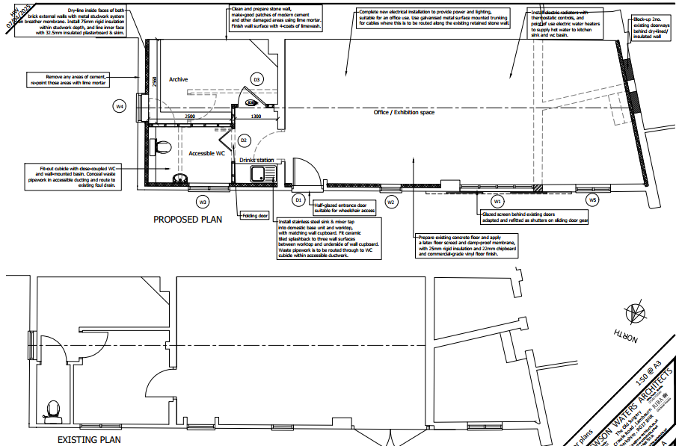

PLANNING HISTORY

No relevant planning history

RELEVANT LEGISLATION, POLICIES AND GUIDANCE

Statutory Legislation:

National Planning Policy:
- National Planning Policy Framework (NPPF)
- Planning Practice Guidance (PPG)
- National Design Guide
Development Plan:
The development plan for Wiltshire comprises the Wiltshire Core Strategy (WCS) (adopted January 2015) and any made neighbourhood plans, which remains the principal statutory planning document guiding development across the county. In line with Section 38(6) of the Planning and Compulsory Purchase Act 2004, planning decisions must be made in accordance with the development plan unless material considerations indicate otherwise.

Though the development plan is considered as a whole, those parts deemed to be particularly relevant to this application are listed below:

The adopted Wiltshire Core Strategy (WCS), with particular regard to:

- Core Policy 1 Settlement Strategy;
- Core Policy 2 Delivery Strategy;
- Core Policy 3 Infrastructure Requirements;
- Core Policy 12 Spatial Strategy Devizes Community Area
- Core Policy 35 Existing Employment Land
- Core Policy 41 Sustainable Construction and Low-Carbon Energy;
- Core Policy 50 Biodiversity and Geodiversity;
- Core Policy 51 Landscape
- Core Policy 52 Green Infrastructure
- Core Policy 55 Air Quality;
- Core Policy 56 Contaminated Land;
- Core Policy 57 Ensuring High Quality Design and Place Shaping;
- Core Policy 58 Ensuring the Conservation of the Historic Environment;
- Core Policy 60 Sustainable Transport;
- Core Policy 61 Transport & Development;
- Core Policy 64 Demand Management
- Core Policy 67 Flood Risk;

Draft Wiltshire Local Plan Policies
The examination of the emerging Wiltshire Local Plan has been paused and the weight to be afforded to any part of the emerging plan can be no more than very limited.

Neighbourhood Plan:
Devizes Area Neighbourhood Plan 2015

Supplementary Planning Documents and other Guidance:
- Wiltshire Local Transport Plan 2011-2026, adopted 2015 - including the Car Parking Strategy and Cycling Strategy, adopted 2015
- A Green & Blue Infrastructure Strategy for Wiltshire: Wiltshire’s Natural Environment Plan 2022-2030
- Wiltshire Local Cycling and Walking Infrastructure Plan (LCWIP)
- Active travel infrastructure design standards 2022
- Active travel parking standards and design guide 2022
- Air Quality SPD (July 2023)
- Devizes Wharf Area Redevelopment & Feasibility Study 2022 Update

ISSUES

The main issues that need to be addressed in this case include:

- Whether the development is acceptable in principle (CP 1 and 2)
- Whether the scheme would have an acceptable impact upon the reasonable living conditions of the adjoining occupants (CP 57)
- Whether the scheme would preserve or enhance the historic environment (CP 58)
- Whether the scheme would have an acceptable landscape impact (CP 51)
- Whether the proposal would have a negative effect upon highway safety, including if there is sufficient parking for the proposed development (CP 61 and 64)
- Whether the site can be adequately drained without increasing flood risk elsewhere (CP 67)
- Whether there would be any harmful impacts upon protected species or priority habitats (CP 50)
- Whether there will be any land contamination / air quality issues (CP 55)

CONSULTATION RESPONSES

WC Highways: No objection subject to conditions regarding parking

WC Conservation: Support subject to conditions regarding external joinery and timber details, landscaping.

Canal and River Trust: No comment

Parish/Town Council: Support

REPRESENTATIONS
In accordance with the requirements of the Town and Country Planning (Development Management Procedure) (England) Order 2015 (as amended), the application was publicised by way of:

- Neighbour notification letters sent to adjoining and nearby properties;
- A site notice displayed near the site;
- An advertisement placed in the local press

These methods were used to inform interested parties and provide a period of 21 days for comments to be submitted.

Below is a summary of the representations received during the consultation period. Only material planning considerations have been taken into account in the assessment of this application. Non-material issues, such as property values or private legal disputes, cannot be considered in the determination process.

A total of 1 representation was received from the public with the Trust for Devizes expressing their support for the scheme:

- Appropriate new use of unlisted building which contributes top the historic character of the Conservation Area
- Furthers the statutory objective to conserve and enhance the Conservation Area.

ASSESSMENT
Section 38(6) of the Planning and Compulsory Purchase Act 2004 states:

"If regard is to be had to the development plan for the purposes of any determination to be made under the planning Acts, the determination must be made in accordance with the plan unless material considerations indicate otherwise."

In accordance with this statutory requirement, this application has been assessed against the relevant policies of the Development Plan, including the Wiltshire Core Strategy (2015) and, where applicable, any made Neighbourhood Plans. Consideration has also been given to the policies of the National Planning Policy Framework (NPPF) as a material consideration in the assessment.

Principle of Development
Policy Context
Core Policy 1: Settlement Strategy of the WCS establishes a hierarchy of settlements to guide where development should be focused. The policy prioritises growth in:
- Principal Settlements (e.g., Salisbury, Chippenham, Trowbridge) – main focus for strategic growth.
- Market Towns – support local services and employment; suitable for sustainable development.

Core Policy 2: Delivery Strategy of the WCS sets out how development will be distributed and delivered across Wiltshire. The policy emphasises:
- Sustainable patterns of growth, reducing the need to travel and supporting local services.
- Development should be plan-led, aligning with the settlement strategy and supported by infrastructure.
- Windfall development (not allocated in plans) must still comply with the principles of sustainable development.

Together, CP1 and CP2 ensure that new development is strategically located, sustainable, and supports the character and function of Wiltshire’s communities.

Core Policy 12 Spatial Strategy Devizes Community Area elaborates on the settlement strategy with regard to the Devizes area.

Core Policy 35 Existing Employment Sites is concerned with the retention or conversion of existing premises or land in B1, B2 or B8 use within Principal Settlements, Market Towns, Local Service Centres and Principal Employment Areas.

Assessment
The proposal is for change of use from forge to office and training area. A forge sits within B2 use class. Office with ancillary training would fall under use class E.

There are a number of criteria within Cp35 under which loss of B2 use would be supported:

i. The proposed development will generate the same number, or more permanent jobs than could be expected from the existing, or any potential employment use.

The former use as a forge appears to have employed one person, the blacksmith. The proposed use will employ one full time and one part time employee, to a full time equivalent of 1.5 employees. Therefore the proposed development will meet the criterion.

ii. Where the proposal concerns loss of employment land of more than 0.25 ha in the Principal Settlements, Market Towns or Local Service Centres it is replaced with employment land of similar size elsewhere at that settlement.

The site is smaller than 0.25ha and therefore this criterion is not relevant.

iii. It can be shown that the loss of a small proportion of employment floorspace would facilitate the redevelopment and continuation of employment uses on a greater part of the site, providing the same number or more permanent jobs than on the original whole site.

This criterion is not relevant to this proposal.

iv. The site is not appropriate for the continuation of its present or any employment use due to a significant detriment to the environment or amenity of the area.

This criterion is not relevant as the proposal is appropriate for the employment use proposed.

v. There is valid evidence that the site has no long term and strategic requirement to remain in employment use; the ability of the site to meet modern business needs must be considered, as well as its strategic value and contribution to the local and wider economy both currently and in the long term. It must be shown that the site is no longer viable for its present or any other employment use and that, in addition, it has remained unsold or un-let for a substantial period of time (at least 6 months), following genuine and sustained attempts to sell or let it on
reasonable terms for employment use, taking into account prevailing market conditions.

This criterion is not relevant as the proposal is for an employment use .

vi. The change of use is to facilitate the relocation of an existing business from buildings that are no longer fi t for purpose to more suitable premises elsewhere within a reasonable distance to facilitate the retention of employment.

The previous business has ceased trading due to the owner operator retiring.

The only criterion that is relevant to this proposal is i. As the proposal will provide at least equal if not more employment onsite than the previous use and due to the small nature of the site with insufficient parking or appropriate access for any larger business, it is considered that in this instance the proposed use is an appropriate use in the Market Town of Devizes which is designated as a suitable area for the provision of services and employment.

Conclusion
The principle of development is considered acceptable.

Design and Impact on the Character and Appearance of the Area
Policy Context
Core Policy 57 of the WCS requires high-quality design that:
- Enhances local character.
- Responds to the natural, historic, and built environment.
- Retains important features (e.g., trees, hedges).
- Supports sustainable construction and compatibility with surrounding uses.
- Creates safe, legible, and accessible spaces.

Section 12 of the NPPF emphasises design that is:
- Visually attractive.
- Functionally effective.
- Contributes to the quality of the built environment.

The Wiltshire Design Guide encourages sensitivity to local character, materials, and architectural styles and supports modern living standards while maintaining aesthetic and functional quality.

Building for a Healthy Life Framework promotes healthy, inclusive, and sustainable places. The document encourages:

- Walkability.
- Access to green space.
- Active design principles for well-being.

Assessment
The only external changes to the existing building will be repair and refurbishment of the building’s windows and doors. These repairs will be undertaken in materials that are sympathetic to or match the existing materials. These repairs are limited to the doors and windows, details for which will be required by condition.

Conclusion
As the proposed repairs and refurbishment will be undertaken in a sympathetic manner and are related to the doors and window details which can be controlled by condition, there are considered to be no design or visual impacts of the development.

Impact on Heritage Assets
Policy Context
From the point of view of the historic environment the main statutory tests are set out within the Planning (Listed Building and Conservation Areas) Act 1990.

Section 72(1) of the Act requires the Council to pay special attention to the desirability of preserving or enhancing the character or appearance of designated Conservation Areas.
The NPPF outlines government policy for planning. Chapter 16 of the NPPF 'Conserving and enhancing the historic environment' sets out the Government's high-level policies concerning heritage and sustainable development. In particular:

Paragraph 208 requires LPAs should “avoid or minimise any conflict” between the heritage asset’s conservation (which includes achieving its optimum viable use) and any aspect of a proposal.

Paragraphs 213-215(214-216) require a balanced approach with any harm which would be caused being weighed against the potential public benefits which might be achieved.

The Planning Practice Guidance provides guidance on interpreting the NPPF.
The Council’s Core Strategy Policy CP58 ‘Ensuring the conservation of the historic environment’ requires that designated and non-designated heritage assets and their settings will be conserved, and where appropriate enhanced, in a manner appropriate to their significance and encourages proposals which improve the condition of heritage assets at risk.

The Council’s Core Strategy CP 57: Ensuring high quality design requires a high quality of design in all new developments. The policy requires applicants to “demonstrate how the proposal will make a positive contribution to the character of Wiltshire through (amongst other things) responding to the value of the natural and historic environment and being sympathetic to and conserving historic buildings and landscapes. Development is required to respond positively to the existing in terms of building layouts, built form, height, mass, scale, building line, plot size, elevational design, materials, streetscape and rooflines to effectively integrate the building into its setting.

Assessment
The proposal has been assessed by the Council’s Conservation Officer. The building is considered a non-designated heritage asset associated with the canal and wharf area and is a late C19th early C20th single storey commercial building with red brick elevations and a rear wall composed of an older, stone built wall that abuts the former Wadworth Brewery site. The site is located within the Devizes Conservation Area.

The Conservation Officer comments:
The building would be repaired and refurbished without changing the character or facing materials of the existing building. Replacement windows would be sympathetic to the existing and would generally be painted casements. The door and glazed screen arrangement would provide a welcoming and appropriate entrance to the building and would encourage visitors.
This application proposal is a carefully-conceived and sensitive scheme which would respect the building (NDHA) and its setting within the conservation area.

Conditions are requested regarding external joinery, external timber and hard and soft landscaping.

Conclusion
It is considered that there will be no harm to the setting of the NDHA or the conservation area as a result of this proposal. Indeed, there will be considerable heritage benefits by virtue of the proposed investment in repair and upgrading/structural repair which will help to secure the future/stability of the building via facilitating the optimum viable use in accordance with paragraph 84b of the NPPF. The proposal will also accord with Section 72(1) of the Planning (Listed Building and Conservation Areas) Act 1990 through preserving and enhancing the character and appearance of the Devizes Conservation Area.

Amenity
Policy Context
Core Policy 57 (Point vii) of the Wiltshire Core Strategy requires development to respect the amenity of existing occupants and ensure appropriate amenity levels for future residents.

The National Planning Policy Framework (NPPF), particularly Paragraph 135, reinforces the need for development to provide a high standard of amenity for both existing and future users.

These policies guide the assessment of amenity impacts, which will be considered in detail under the below headings.

Conclusion
As a change from a manufacturing to an office-based use, with no increase in floorspace it is considered that there will be no more noise from the proposed use than the former use. The proposed use as the office for the Wiltshire Building Trust charity and learning centre is expected to generate only moderate footfall.

The agent has suggested that opening hours will likely be 9-5 during the week with the odd weekend/Bank Holiday slot to link up with any town festivities. There will be no evening opening. A condition will be attached to secure appropriate opening times. As these proposed opening times lie within the normally acceptable parameters and due to the small scale and nature of the proposal it is considered that there will not be any undue impact on neighbouring amenity from the proposal.

Highways Impacts and Parking
Policy Context
Transport implications are a key factor in assessing planning applications, especially for larger developments. Proposals must demonstrate:
- Safe and suitable access for all users, including pedestrians, cyclists, and those with mobility impairments.
- No severe residual impacts on the surrounding highway network.
- Promotion of sustainable travel, reducing reliance on private vehicles.
- Adequate parking and cycle provision, in line with adopted standards.
- Protection and enhancement of public rights of way and active travel routes.

Relevant policies include Core Policies 60–64 of the Wiltshire Core Strategy, supported by the Wiltshire Local Transport Plan, Car Parking Strategy, and Cycling Strategy. The Local Cycling and Walking Infrastructure Plan (LCWIP) and LTN 1/20 (DfT) provide further design guidance for active travel infrastructure.

Assessment
There is one disabled parking space associated with the site. This will be retained. There will be no other vehicular parking at the site for either staff or visitors. The Council’s Highways officer has requested a condition requiring production of a brochure directing visitors to utilise the nearby public parking. However, due to the plentiful public car parking in close proximity to the site and the nature of the former use and associated vehicle movements it is considered that the lack of parking at the site for staff or visitors is not an issue and does not require the suggested condition in order for the proposal to be acceptable.

Conclusion
It is considered that the proposal will not incur negative impact on highway safety.

Ecology and Biodiversity
Policy Context
The ecological impact of development is a key planning consideration, especially for larger schemes. Proposals must assess and address potential effects on:

- Protected species
- Priority habitats
- Ecological networks
- Green and blue infrastructure

Core Policy 50 of the Wiltshire Core Strategy requires development to:

- Avoid harm to ecological assets.
- Deliver measurable Biodiversity Net Gain (BNG), in line with the Environment Act 2021.
- Support habitat restoration and connectivity.
- Integrate biodiversity into site design.

The Green & Blue Infrastructure Strategy (2022–2030) promotes nature recovery, ecosystem services, and habitat connectivity through development.

Unless exempt, National policy requires a minimum of 10% Biodiversity Net Gain (BNG) for major developments, demonstrated via:

- Biodiversity Metric calculations
- Ecological assessments (e.g. PEAs, Phase 1 surveys, protected species surveys)

Assessment
The proposal is for a change of use with minor internal layout change and refurbishment of tired external materials. There is no increase in footprint and the development is therefore considered to qualify for the de minimis exemption from the need to provide 10% BNG.

Conclusion
The proposal is considered to not impact on ecology and biodiversity.

Flood Risk and Drainage
Policy Context
Core Policy 67 of the Wiltshire Core Strategy and NPPF paragraphs 170–182 require:
- Avoidance of increased flood risk.
- Use of appropriate mitigation measures.
- Application of the sequential and exception tests for developments in Flood Zones 2 or 3.

Assessment & Conclusion
As a change of use with no increase in footprint of the building it is considered that there is no potential to increase flooding either to the property or to neighbouring properties.

Environmental Considerations (Noise, Air Quality, Contaminated Land, etc.)
Policy Context
Core Policies 55 and 56 of the Wiltshire Core Strategy require:
- Development proposals to avoid unacceptable environmental impacts.
- To provide appropriate mitigation where risks are identified.

The NPPF and Planning Practice Guidance (PPG) reinforce this by stating that proposals should:

- Prevent development that contributes to or is exposed to unacceptable pollution.
- Ensure developer responsibility for safe development on contaminated land.

Wiltshire Council’s Air Quality SPD (2023) provides detailed guidance, especially near Air Quality Management Areas (AQMAs) and encourages mitigation such as:
- EV charging infrastructure
- Green buffers
- Sustainable transport options

Assessment
Whilst the former use as a forge may result in some potential for contamination, the building has clearly been used for educational purposes during that use and the current condition of the internal area of the former forge which appears to retain none of the former manufacturing equipment or detritus suggests that the presence of any contamination is unlikely however a precautionary condition can be attached to any approval to ensure no harm is raised.

Conclusion
A precautionary condition will be attached to cover the eventuality that any contamination is discovered.

PLANNING BALANCE AND CONCLUSION
At the heart of the NPPF there is a presumption in favour of sustainable development requiring local planning authorities to approve development proposals that accord with an up-to-date development plan without delay; and where there are no relevant development plan policies, or the policies which are most important for determining the application are out-of-date, permission should be granted unless (taken from paragraph 11d of the NPPF):

- The application of policies in the NPPF that protect areas or assets of particular importance provides a clear reason for refusing development proposed; or
- any adverse impacts of doing so would significantly and demonstrably outweigh the benefits, when assessed against the policies in the NPPF taken as a whole;

The principle of development is considered acceptable when assessed against the settlement strategy of the Wiltshire Core Strategy and the emerging Local Plan.

The proposal is broadly compliant with relevant local and national planning policies in respect of business and education use, residential amenity, heritage, highway safety, flood risk and drainage, ecology and biodiversity, and environmental impacts, subject to the recommended conditions and any necessary mitigation measures

The development would deliver clear benefits, including education and employment, which weigh positively in the overall planning balance.

No material considerations have been identified that would significantly and demonstrably outweigh these benefits or indicate that permission should be refused, having regard to the assessment above and the representations received.

Accordingly, the proposal is considered acceptable in planning terms and in accordance with the Wiltshire Core Strategy, the National Planning Policy Framework, and all other relevant material considerations.

RECOMMENDATION:
That Planning Permission be GRANTED, subject to conditions

