



Client
Bluemay Ltd
Project Number
250274
Document Number
0007
Date
08.12.2025

Bluemay Warehouse
Melksham
Design + Access Statement

Glentworth Court, Lime Kiln Close, Bristol BS34 8SR
+44 (0)117 931 2062 • kendallkingscott.co.uk
Glentworth Court, Lime Kiln Close, Bristol BS34 8SR
+44 (0)117 931 2062 • kendallkingscott.co.uk
Document Control Record

Version | Date | Prepared by | Checked by
P01 | 08.12.2025 | Geraint James | Giuseppe Amesbury
P02 | 09.12.2025 | Geraint James | Giuseppe Amesbury
P03 | 30.04.2026 | Geraint James | Giuseppe Amesbury

Contents

1.0 Use 4
1.1 Use 4
2.0 Context 4
2.1 Context 4
3.0 Access 4
3.1 Access 4
4.0 Amount 5
4.1 Amount 5
5.0 Layout 5
5.1 Site Layout 5
5.2 Massing 5
6.0 Scale 6
6.1 Scale 6
7.0 Landscaping 6
7.1 Landscaping 6
8.0 Appearance 6
8.1 Appearance 6
9.0 Sustainability 6
9.1 Renewable Energy 6
10.0 Appendices 7
10.1 Planning Permission No. K/032033 [12.12.1995] 7

- Use
  - Use
The Applicant, Bluemay Ltd. are a UK-based manufacturer specialising in high-quality engineering components, particularly in plastic injection moulding – “engineering components in plastic, comprising: injection moulded parts to customer drawing(s); injection moulded and/or machined parts to the Company's drawing(s), including threaded fasteners and associated items; factored items to specification”.

Bluemay Ltd. are seeking to renew their existing Production Facility at their Wiltshire headquarters:

Bidmead Park
Sells Green
Melksham
SN12 6RS

Google Maps
Virtual Tour

With regards to operational noise break-out; the proposed New Unit is not significantly closer to any noise sensitive receptors, and the use of the New Unit is exactly the same as the 2No. Existing building units - the level of noise pollution will therefore be very similar to what it is currently, and the New Unit may therefore not be considered a significant new noise source on the site. The overall scale of operations is also not increasing, therefore production output, deliveries, staff numbers, operational hours, parking, access routes etc. are all the same as existing.

As a second-generation, family-owned local business with over 50 years of history, Bluemay Ltd. is an established local employer. The company is committed to staying in the area and is actively looking to invest locally, rather than relocating.

- Context
  - Context

Bluemay Ltd.’s Melksham site is located approximately 3.5 miles east of the Bowerhill Industrial Estate located on the southern edge of the town; Plant Hire and Construction Units/Businesses are located directly adjacent, south of the site.

Bluemay Ltd.’s current manufacturing facilities, along with neighbouring businesses, are situated in a well-established industrial area.

The surrounding area includes residential developments, educational institutions, and community facilities, forming a mixed-use setting.

The site is positioned within an area that includes established transport infrastructure, and a range of land uses relevant to industrial and commercial operations.
- Access
  - Access
It is proposed that access to, and into, the site will remain un-changed; the New Unit being accessed from the existing Yard [adjacent the existing Storage + Office Unit] and via the new ‘Link’.
- Amount
  - Amount
Bluemay Ltd. currently house their Production operations in 2No. existing building units to the north-eastern corner of their site [see drawing 250274-1000 Site Location Plan]. These buildings were inherited with the site upon its purchase in 1992; are not suitable for modern manufacturing needs and are too small. The presence of asbestos, their age [approx. mid-20th-century origin], and the nature of their construction also make alterations required for ongoing use unviable.

Current development aspirations are significantly more modest than that of the Planning Permission No. K/032033 12.12.1995, for a combined Production + Office Building, under which the Existing Unit was constructed.

It is proposed that Bluemay Ltd.’s on-site Production operations are re-located into a New Unit, with 930m² floorspace, adjacent their existing mid-1990’s Storage + Office Unit; connected via a ‘Link’ for [segregated] forklift and personnel circulation between the two Units.

It is proposed that the 2No. existing building units to the eastern corner of the site are re-utilised for storage.

The number of staff, number of deliveries to and from, and Production capacity for the site, is proposed to remain unchanged by the proposed development.

- Layout
  - Site Layout
The determining of the location for the New Unit on the site is based on the following considerations:

- adjacent the existing Storage + Office Unit
- facilitates the use of a pre-prepared ‘knock-out aperture’ within the existing Storage + Office Unit’s existing east-facing façade [for the ‘Link’ to connect to] - see also previous Planning Permission No. K/032033
- utilises site topography re-modelling works [flattening] of land east of the existing Storage + Office Unit

  - Massing
The New Unit requires an internal clear height of 5m throughout [below building structure haunches and building services] to accommodate Production equipment and operations. This means that the overall height of the proposed New Unit is less than the existing Storage + Office Unit; the massing of the two buildings therefore ‘steps-down’, from the centre of the site, towards perimeter of the site and the site’s main entrance.

The current development aspirations are notably more modest in terms of massing and building height also; when compared to the previously approved Planning Permission No. K/032033 dated 12 December 1995 (see Appendices for associated Approved drawings).

- Scale
  - Scale
It is proposed that structural span and footprint of the New Unit is akin to that of the existing Storage + Office Unit to (i) properly accommodate Production operations and (ii) maximise flexibility for potential future internal Storage and Production Operations layouts between the two Units.

- Landscaping
  - Landscaping
Proposals include significant areas of enhanced soft-landscaping and habitat areas.

No new or additional vehicle-parking facilities or refuse + recycling storage areas are proposed.

- Appearance
  - Appearance
External envelope materials of the New Unit broadly match that of the existing Storage + Office Unit.

- Sustainability
  - Renewable Energy
Bluemay Ltd. aspire to maximise the potential for on-site renewable energy generation through photovoltaic roof panels and are actively exploring complementary options for on-site energy storage

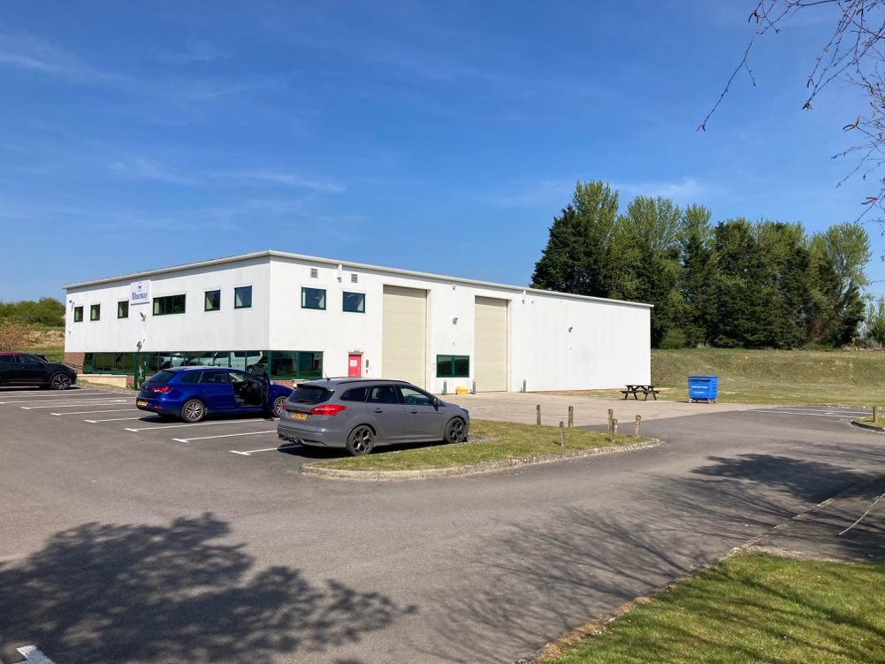

- Appendices
  - Planning Permission No. K/032033 [12.12.1995]
Approved Drawings

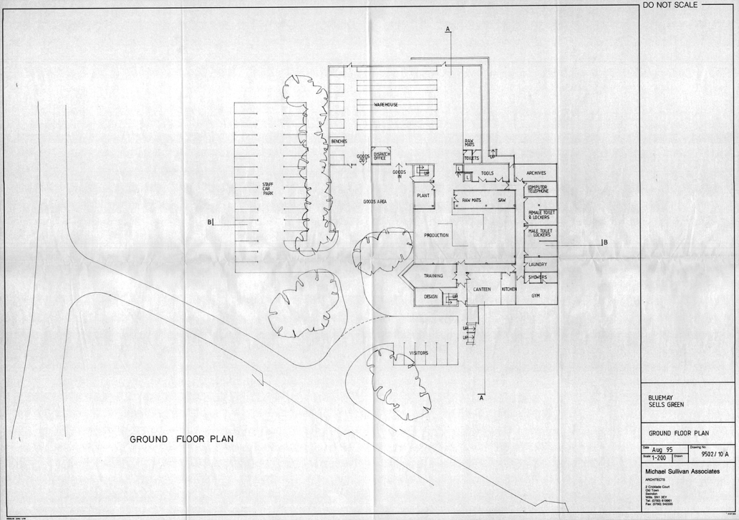

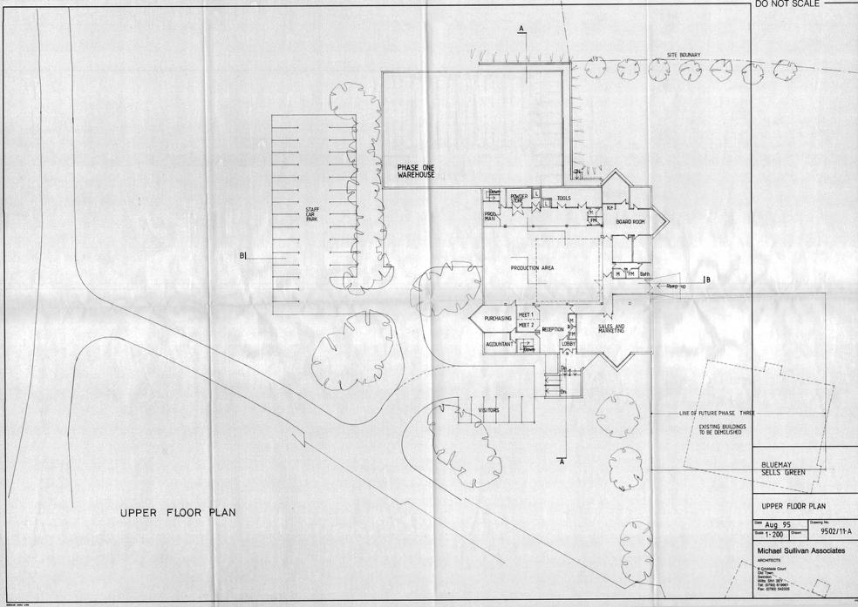

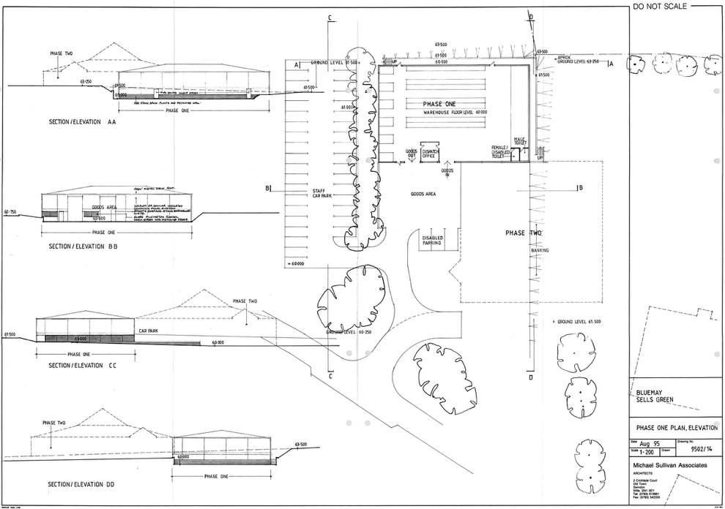

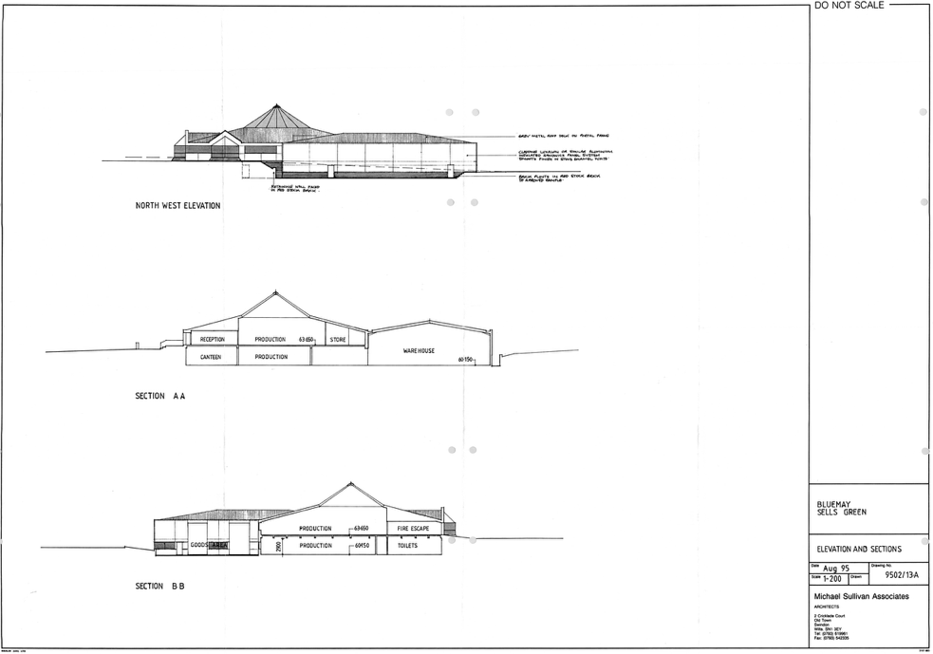



kendallkingscott.co.uk

kendallkingscott.co.uk

