PL/2026/01303
Site: Wick Farm, Wick Lane, Lacock, Chippenham, SN15 2LU
Proposals: Full application (retrospective) for the partial rebuilding and conversion of agricultural buildings into 3 no dwellings.
Conservation Officer: Alex Marsh
_____________________________________________________________________
Recommendations:

X | Comment
 | Support in principle subject to amendments to the scheme (as set out below)
 | Support subject to conditions (as set out below)
X | Object (for reasons set out below)
 | No objections

Scope of comments: the following comments relate to the built historic environment.

Policy: From the point of view of the historic environment the main statutory tests are set out within the Planning (Listed Building and Conservation Areas) Act 1990. Sections 16 (LBC) and 66 (PP) require that special regard be given to the desirability of preserving listed buildings, their settings or any features of special architectural or historic interest which they possess.

The NPPF outlines government policy, including its policy in respect of the historic environment. Section 16 of the NPPF 'Conserving and enhancing the historic environment' sets out the Government's high-level policies concerning heritage and sustainable development.

210. In determining applications, local planning authorities should take account of: a) the desirability of sustaining and enhancing the significance of heritage assets and putting them to viable uses consistent with their conservation; b) the positive contribution that conservation of heritage assets can make to sustainable communities including their economic vitality; and c) the desirability of new development making a positive contribution to local character and distinctiveness

213-15 of the NPPF require a balanced approach with any harm which would be caused being weighed against the potential public benefits which might be achieved.

216. The effect of an application on the significance of a non-designated heritage asset should be taken into account in determining the application. In weighing applications that directly or indirectly affect non-designated heritage assets, a balanced judgement will be required having regard to the scale of any harm or loss and the significance of the heritage asset

The Council’s Core Strategy CP 57: Ensuring high quality design requires a high quality of design in all new developments. Proposals are required to “demonstrate how the proposal will make a positive contribution to the character of Wiltshire through (amongst other things) “enhancing local distinctiveness by responding to the value of the natural and historic

The Council’s Core Strategy Policy CP58 ‘Ensuring the conservation of the historic environment’ requires that “designated heritage assets and their settings will be conserved, and where appropriate enhanced, in a manner appropriate to their significance.”

Historic England Guidance on Adapting Traditional Farm Buildings

Heritage Assets:
Wick Farmhouse grade II
Barn at Wick Farm grade II*
Stable and Barn Range SW of Wick Farmhouse grade II

Site and assets considered:

Wick Farm is an isolated farmstead located about 1.3 km west of Lacock and the A350. It is a Manor with roots in the 13th century.

It contains a two storey Farmhouse a 19th century rebuild of a 16th century or earlier farmhouse. It is rubble stone with stone slate roofs and includes a 16th century partially corbelled stack. The front is a three-window range 19th century with raised quoins band and eaves band. The windows have a plain raised surrounds and central door with hood on brackets.

The front of the farmhouse overlooks two listed barns one of which is a threshing barn of 15th century built-in rubble stone and tile roof. There are buttresses either side of the central projecting cart entries and there are heavy corner stones.

The roof is particularly good Tudor roof structure with a five-bay interior with two purlin roof and two tiers of curved wind braces. Three raised cruck trusses with arch braced cambered collars and against the walls two tie beam and collar trusses.

The other barn is 18th century rubble stone under continuous stone slate roof with 6 bay tie beam and collar truss roof double purlin with straight wind braces.

The application building is an attached pair of formerly ruinous single storey farm buildings at the entrance to the farmstead. Barns A and B. They have been reconstructed of rubble stone with Roman tile roof.

The other barn, Barn C in the application, is a smaller single storey barn that was intact in 2023 with rubble stone walls and tile roof.

Based on google street view in 2023 the lower smaller end barn (Barn B) was substantially intact with the roof and two side walls. The south gable end was open as was the north gable end where it connected to the larger footprint and wider single storey building.

In 2023 Barn A consisted of a standing north gable end wall. The eaves of the gable end where in line with lower building which would appear that the roof would have run through at similar eaves and ridge height.

Curtilage Listing

The applicants comments at paragraphs 28 identifies the Calderdale Test 29 considers the barns are physically separate from the listed farmhouse the grade II* barn and the grade II stable and barn range that they did not from part of the functional domestic or operational farmstead of the listed assets and conclude 30 of the Design and Access Statement ‘it is our opinion that the buildings subject to this application should not be considered as curtilage listed.

All these Barns A, B and C are evident on the 1840 tithe map and 1880 1st Ed OS mapping. They are in a loose arrangement with the other farmyard buildings including the two listed barns about 25 - 30 m away and the farmhouse 45 m to north east.

These barns form part of the same farm building group as the two listed barns and Farmhouse farmstead and pass the Calderdale Test for curtilage including functional, physical and ownership connections to the listed farmhouse and barns. They were recognised as curtilage listed in 2003 as part of the previous applications for conversions to workshops.

These barns A, B and C are considered curtilage listed buildings.

Proposal: Full application (retrospective) for the partial rebuilding and conversion of agricultural buildings into 3 no dwellings.

Relevant planning history:
N/03/02910/COU – Cof U to three workshop units
N/03/03086/LBC Internal and External alterations and extension to agricultural buildings to convert to three workshops

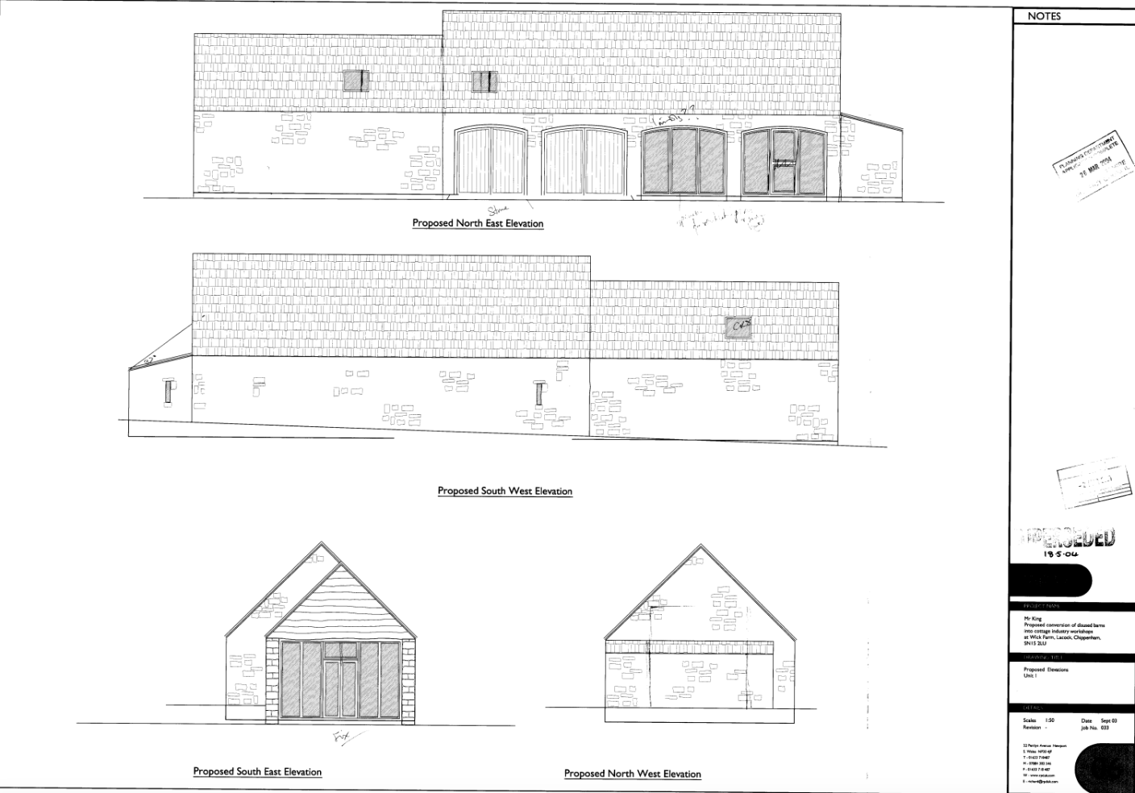
Approved plans for previous listed building consent N/03/03086/LBC evidence of single storey existing buildings and matching eaves heights and lower ridge to larger barn.

Issues: The impact of alterations on the curtilage listed building and setting of a listed buildings.

Significance of assets and contribution of setting: The NPPF defines significance as the “value of a heritage asset to this and future generations because of its heritage interest.

The interest may be architectural, or historic as set out in the Town and Country Planning (Listed Building and Conservation Areas) Act 1990 S 1.

Significance derives not only from a heritage asset’s physical presence, but also from its setting.” Historic England assesses significance in a similar manner, referring to evidential, historic, aesthetic and communal values of a place.

In this case the significance of the farmhouse and farm buildings is evident in their vernacular architecture its form, layout, materials, and architectural expression/detailing which have significant aesthetic and architectural interest and the farmhouse and threshing barn have added historical interest especially in the barns quality of craftmanship in the walling and roof structure.

Assessment:
This is a retrospective application for the partial rebuilding and conversion of agricultural buildings into 3 no. dwellings.

The attached pair of barns (Barns A and B) have been rebuilt into two, storey and half dwellings.

The larger barn which had a gable end and back (west) wall standing prior to works has been totally rebuilt and substantially raised. It is evident that the gable end wall was taken down and rebuilt and now includes very different new rubble stonework cladding, arrow slot recess and quoins.

The former gable end wall had a much lower eaves and ridge height than is portrayed in the application survey drawing. These drawings are inaccurate and a new set of survey drawings are required. It has about 17 courses of stone work to eaves height based on google street view.

The previous listed building consent shows the proposals repair and rebuilding to the as existing ridge and eaves heights as single storey not two storey buildings.

Its reconstruction is total with modern construction in cavity wall with block work and stone clad. The interior has been plaster boarded and skimmed and painted by the time of my visit.

Barn A curtilage listed barn has been demolished and rebuilt and raised in height. The rebuild has created a ground floor three room plan with staircase centrally to first floor in roof.

The ground floor has 4 x bays if new metal two light casement windows to the new east elevation and to the rear (west) elevation aluminium French door, entrance door and single light casement.

The first floor has three bedrooms each with ensuite bathrooms and 4 rooflights to the east roof slope and 5 rooflights to the east roof slope.

Barn B has two room and W.C on ground floor and two bedrooms and shower room to first floor. The small footprint for a 2 storey 2 bed is not large enough for National Space Standards. The ground floor as measured is 7.6 m x 3.7 m – 28.12 sq m not 30.4 sq m as indicated on the drawings and the first floor 26 sq m should be calculated on floor area with head height over 1.5m the combined floor area is well below the requirement for two bed of 70 sq m and below the single bed space standard of 58 sq m

The elevations have a two light casement to the east elevation and 2 x pair of French doors either side of an entrance door and 3 x rooflights to each roof slope.

Barn C This appears to have been in tact prior to the works and has been less invasive with minor internal plan form alterations. The building appears to have previously been adapted and used for a farm office following the 2003 consent.

There are several issues with the application.
- The demolition of curtilage listed buildings without listed building consent
- The inaccurate survey drawings /existing drawings
- The lack of conformity with space standards for Barn B
- The raising of the eaves and roof of both barns and extensive rebuilding of walls to modern cavity construction with stone cladding.
- The design with substantial new window openings to former blank elevations which are overlarge and horizontal in emphasis.
- Substantial use of rooflights to both roof elevations.
- Formation of fenced domestic curtilages out of character with farmyard.
The works of conversion at the time of my site visit were substantially completed with decorative works ongoing on site.

The application has in their statement suggested the barns are not curtilage listed – and at paragraph 57 suggest the works ‘The proposal involves sensitive conversion of the existing stone buildings and rebuilding within the footprint of the former structures. The scheme respects the scale, form and materials of the existing buildings, preserves the historic character of the farmstead and retaining the rural setting of the surrounding countryside. The design also carefully balances residential amenity with the conservation of heritage assets

It also comments at paragraph 32 the conversion ‘maintain the traditional stone construction and two storey height in a matter largely consistent with the consented scheme’

I consider that the evidence in the former application and application of Calderdale Test is sufficient to show that the barns should be considered curtilage listed and the applicant has not accurately depicted the existing survey plans, and the implemented barns do not accord with the evidence of the existing (prior to works) barns A and B in scale, massing, height roof eaves and ridge, architectural appearance and form, openings, solid stone walling and use of materials.

With respect Barns A and B. The demolition of the existing buildings without consent is a significant harm. The inaccurate survey plans is an attempt to cover up the extent of works and demolition.

The resulting substantially new build barns A and B have not adhered to good practice in respect of Historic England guidance on Adapting Farm buildings with respect to plan form subdivision new openings, raising the roof and introduction of rooflights.

The conversion of the Barn C involves minor internal works and subdivision to the previous office building and is in line with good practice for conversions. The internal space standard over two floors is 60 sq m so it also adheres to National Space Standards. The conversion of Barn C to a single dwelling could subject to details and removal of the fenced domestic curtilage could be supported under National and Local Heritage policies.

I cannot support the retrospective proposal for Barns A and B as the harm includes substantial/total demolition to the barns as curtilage listed buildings, rebuilding to larger scale, massing, height and roof form (creation of raised building to accommodate a second floor), subdivision of plan form, openings and materials detail use.

These elements have combined in a resulting poor quality new build /conversion that is also harmful to the setting of the listed barns and farmhouse.

The rebuilding of Barns A and B is contrary to NPPF 213 and 215 seeks justification for harm or loss of significance of a designated heritage asset from its destruction or from development within it setting should require clear and convincing justification through public benefits. The two new dwellings created are not considered to be sufficient justification as public benefits or the optimum viable use for the barns to compensate for the harm caused.

The retrospective proposal is also contrary to Council’s Core Strategy Policy CP58 ‘Ensuring the conservation of the historic environment’ requires that “designated heritage assets and their settings will be conserved, and where appropriate enhanced, in a manner appropriate to their significance.”

I understand the works are already subject to and Enforcement case. We would need following refusal of this application to consider the appropriate enforcement approach and actions to remove the harm to Barns A and B and the setting of the listed buildings.

Summary: The NPPF confirms that when considering the impact of a proposed development on the significance of a designated heritage asset, great weight should be given to the asset’s conservation (and the more important the asset, the greater the weight should be). It makes clear that any harm to a designated heritage asset requires clear and convincing justification.

I cannot support the retrospective proposal for Barns A and B as the harm includes substantial/total demolition to the barns as curtilage listed buildings, rebuilding to larger scale, massing, height and roof form (creation of raised building to accommodate a second floor), subdivision of plan form, openings and materials detail use.

These elements have combined in a resulting poor quality new build /conversion that is also harmful to the setting of the listed barns and farmhouse.

The rebuilding of Barns A and B is contrary to NPPF 213 and 215 seeks justification for harm or loss of significance of a designated heritage asset from its destruction or from development within it setting should require clear and convincing justification through public benefits. The two new dwellings created are not considered to be sufficient justification as public benefits or the optimum viable use for the barns to compensate for the harm caused.

The retrospective proposal is also contrary to Council’s Core Strategy Policy CP58 ‘Ensuring the conservation of the historic environment’ requires that “designated heritage assets and their settings will be conserved, and where appropriate enhanced, in a manner appropriate to their significance.”

I understand the works are already subject to and Enforcement case. We would need following refusal of this application to consider the appropriate enforcement approach and actions to remove the harm to Barns A and B and the setting of the listed buildings.

The conversion of the Barn C involves minor internal works and subdivision to the previous office building and is in line with good practice for adaption of historic farm buildings conversions. The conversion of Barn C to a single dwelling could subject to details and removal of the fenced domestic curtilage be supported under National and Local Heritage policies.

