APPLICATION FOR HOUSEHOLDER PLANNING PERMISSION
DELEGATED REPORT

APPLICATION REFERENCE: | PL/2026/00929
APPLICATION TYPE: | Householder Planning Permission
SITE ADDRESS: | 41 Hilperton Road, Trowbridge, BA14 7JQ
DEVELOPMENT DESCRIPTION: | Part retrospective retention & extension of privacy boarded fencing. Erection of 2m high close boarded boundary - fencing to replace worn post & wire fence.
RECOMMENDATION: | That Planning Permission be GRANTED

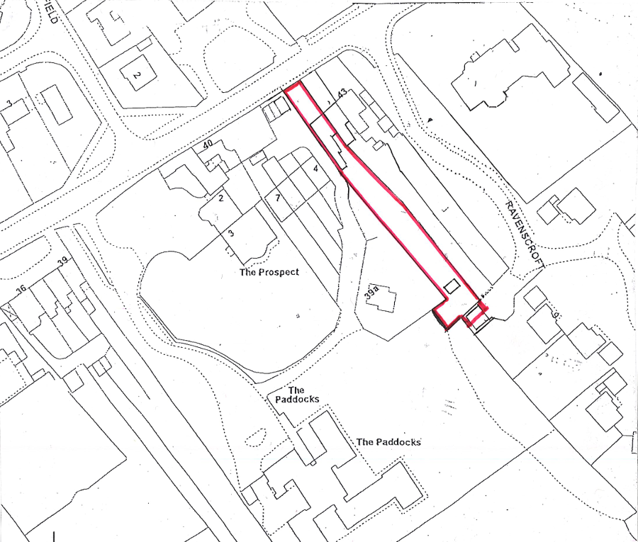

PROPOSAL: This proposal seeks part-retrospective planning permission for the erection of close‑boarded timber fencing along the north‑eastern garden boundary in order to better enclose the rear garden of No.41. Immediately adjacent to the host dwelling, a section of privacy screening is proposed above the existing brick boundary wall, reaching a maximum height of approximately 2.3 metres. Beyond this point, the remainder of the boundary treatment would consist of a 2-metre-high fence extending along the full length of the garden. The fencing would comprise horizontal timber boards with supporting posts set at regular intervals of approximately 3 metres.

SITE DESCRIPTION / CONTEXT: The application site comprises a two‑storey residential dwelling forming part of a short terrace set back from Hilperton Road. The terrace, which includes Nos. 41–43, is Grade II listed (List Entry No. 1364204) and lies within the Trowbridge, Hilperton Road Conservation Area. The buildings are characterised by their Bath stone ashlar elevations, traditional detailing and consistent architectural rhythm, which collectively make a positive contribution to the historic street scene. The site lies within Flood Zone 1 and an area identified as ‘grey’ under the Trowbridge and Westbury Bat Mitigation Strategy.

PLANNING HISTORY

Reference No. | Proposal / Summary | Decision
W/04/01809/FUL | Single storey extension - internal alterations and demolition of existing garden store | Approved
W/04/01813/LBC | Internal adaptations, demolition of garden store, adaptation of existing single storey structure and new build of utility room | Approved
W/84/00554/FUL | Block of two garages | Approved
PL/2023/11025 | Flat roofed infill extension between existing extension | Approved
PL/2024/00488 | Flat roofed infill extension between existing extension | Approved
PL/2024/05443 | Construction of iron gates to the front of the property with 3 foot iron railings, set 4.5m from road. 2ft iron railings on top of stoned wall. Erection of 4 foot picket fence along the boundary between 41 and 42, planted with 6 foot cherry laurels. | Approved
PL/2024/05535 | Retrospective application for the construction of 3 metre x 4 metre summer house at bottom of back garden. | Approved

RELEVANT LEGILSATION, POLICIES AND GUIDANCE

Wiltshire Core Strategy:

Core Policy 1 Settlement Strategy;
Core Policy 2 Delivery Strategy;
Core Policy 29 Spatial Strategy: Trowbridge Community Area;
Core Policy 50 Biodiversity and Geodiversity;
Core Policy 51 Landscape;
Core Policy 57 Ensuring High-Quality Design and Place Shaping;
Core Policy 58 Ensuring Conservation of the Historic Environment;
Core Policy 60 Sustainable Transport;
Core Policy 61 Transport and Development;
Core Policy 64 Demand Management;
Core Policy 67 Flood Risk;

The National Planning Policy Framework (NPPF) and the Planning Practice Guidance (PPG)

Wiltshire Design Guide - Appendix D – Design Guidance for Householder extensions

The Wiltshire Local Transport Plan 2011 – 2026: Car Parking Strategy (March 2015).

The Wiltshire Local Transport Plan 4 (LTP4) (March 2025)

Trowbridge and Westbury Bat Mitigation Strategy (July 2025)

Emerging Policy – Wiltshire Local Plan Review: The examination of the emerging Wiltshire Local Plan has been paused and the weight to be afforded to any part of the emerging plan can be no more than very limited. A decision on how to proceed will be made by the Council in May 2026.

CONSULTATION RESPONSES

Trowbridge Town Council – No Objection

Conservation Officer (Wiltshire Council) – No Objection
The fencing is noted to have a modern, hard‑edged appearance that does not positively enhance the setting of the listed building or conservation area. However, as it is located within a rear garden, screened from public views and comparable to other nearby boundary treatments, its overall impact on the significance of the heritage assets is considered largely neutral.

REPRESENTATIONS

Two objections were received from one neighbour raising concerns that the application description is inaccurate and incomplete, particularly in that it fails to refer to the alleged prior removal of an original sash window and bath stone fabric from the Grade II listed building and its replacement with French doors, which it is argued undermines earlier heritage assessments and calls into question the validity and advertisement of the current application. Further concerns relate to the accuracy of the submitted plans, including the position of the boundary, the true height of the fence when measured from natural ground level, its impact on neighbouring light and amenity, potential harm to the setting of the listed buildings and conservation area, and allegations of procedural flaws and unauthorised boundary works, with a request that the scheme be refused unless supported by accurate plans and a formal boundary survey.

ASSESSMENT

Section 38(6) of the Planning and Compulsory Purchase Act 2004 states:

"If regard is to be had to the development plan for the purposes of any determination to be made under the planning Acts, the determination must be made in accordance with the plan unless material considerations indicate otherwise."

In accordance with this statutory requirement, this application has been assessed against the relevant policies of the Development Plan, including the adopted Wiltshire Core Strategy (2015) and, where applicable, any made Neighbourhood Plans.

Householder extensions are generally acceptable in principle, as they typically fall within the established residential curtilage of a property and do not result in new residential development in the open countryside. In this case, the proposal also lies within the defined limits of development set out in the Core Strategy, further reinforcing its acceptability in principle.

Design and Impact upon the upon the character and context of the area

The proposal relates to the erection and retention of close‑boarded timber fencing within the rear garden of a Grade II listed dwelling, located within the Hilperton Road Conservation Area. Core Policy 57 of the Wiltshire Core Strategy requires development to achieve a high standard of design that responds positively to local context, while Core Policy 58 and Sections 66 and 72 of the Planning (Listed Buildings and Conservation Areas) Act 1990 place a statutory duty on the Local Planning Authority to preserve or enhance the significance of heritage assets and the character and appearance of conservation areas.

The Council’s Conservation Officer has noted that the close‑boarded fencing has a modern suburban appearance and is not reflective of the historic character or materials of the listed building itself. However, it is also acknowledged that the fencing is located within the rear garden, is effectively screened from public viewpoints, and is not visible within any key views of the listed terrace or the wider conservation area. As such, the contribution of this boundary treatment to the setting of the listed building is limited, and any visual impact is largely contained within the private realm.

Timber boundary fencing of a similar height and form is a common and established feature within rear gardens in the surrounding area, and the scale and siting of the proposal would be in keeping with other local examples. Importantly, the fencing does not alter or obscure the principal elevations of the listed building, nor does it detract from the architectural rhythm, materials, or historic qualities that define the terrace's significance within the street scene. It is recognised that, were such fencing proposed in a more prominent or publicly visible location, such as along the principal frontage, it could result in harm to the character and appearance of the listed building and the conservation area; however, that is not the case here.

Taking the above into account, and having regard to the Conservation Officer’s conclusion of no objection, the proposal is considered to result in no harm to the significance of the listed building or the character and appearance of the conservation area. The development is therefore considered acceptable in design and heritage terms and compliant with Core Policies 57 and 58 of the Wiltshire Core Strategy, the statutory duties set out in Sections 66 and 72 of the 1990 Act, and the aims of Section 16 of the NPPF.

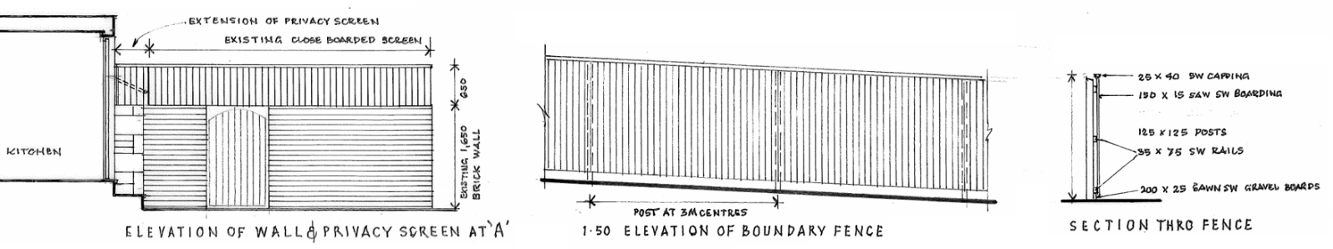
Proposed Fencing

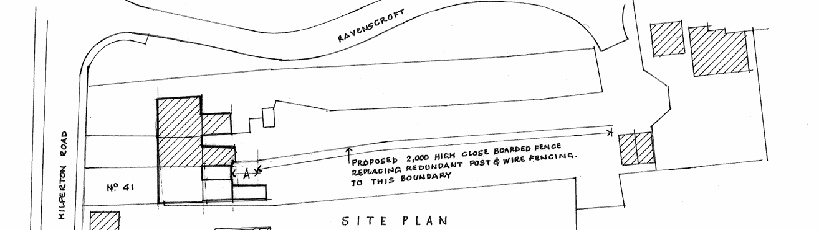
Proposed Site Plan

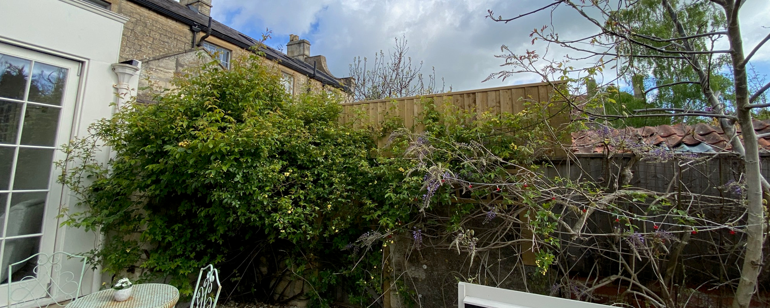
Privacy Fencing (Site Visit)

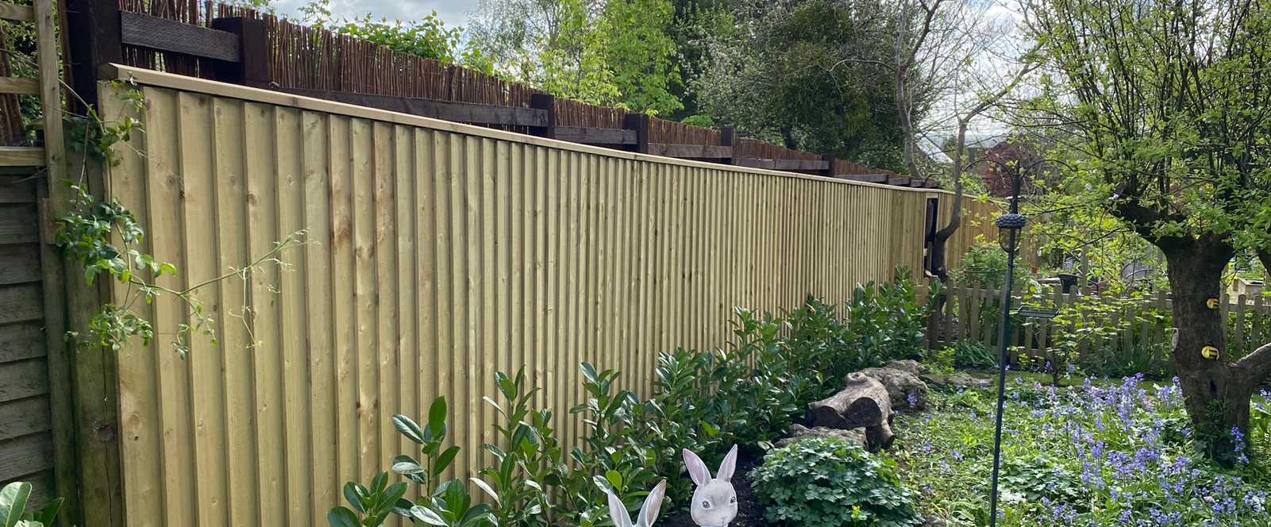
Boundary Fence (Site Visit)

In landscape terms, the fencing represents a small-scale domestic boundary treatment typical of rear garden environments and does not affect wider landscape character or visual amenity, in accordance with CP51.

Having regard to the above, the proposal complies with the design principles set out in Core Policy 57 of the Wiltshire Core Strategy and Appendix D of the Wiltshire Design Guide.

Amenity

Point vii of Core Policy 57 Ensuring High Quality Design and Place Shaping of the Wiltshire Core Strategy seeks to ensure that developments do not adversely affect neighbouring properties.

The National Planning Policy Framework (NPPF), particularly Paragraph 135, stresses that planning decisions should ensure developments provide a high standard of amenity for existing and future users.

With regard to neighbouring amenity, concerns have been raised in relation to potential overbearing and overshadowing impacts. As the fencing runs along the shared boundary, its presence would not result in effects beyond those typically associated with a domestic garden boundary treatment of this nature and scale, and no unacceptable overbearing or loss of light would arise as a result. The section of privacy screening adjoining the dwelling increases the height of the boundary by approximately 0.65m above the existing wall; however, this area is already softened by established planting of a comparable height, and the screening primarily abuts the roof of the neighbouring rear extension rather than any external amenity space or principal habitable room. Furthermore, the site slopes on a northwest–southeast axis and benefits from a generally generous southern aspect, such that any additional overshadowing would be minimal and limited largely to the neighbouring extension roof. On this basis, the proposal is not considered to result in an unacceptable impact on neighbouring residential amenity.

The proposal is appropriately sited, designed, and oriented to ensure that it would not result in unacceptable impact upon/to the amenities or living conditions of neighbouring residential occupiers, particularly in terms of outlook, privacy, or access to natural light.

The proposal therefore accords with Core Policy 57 point vii in respect of safeguarding residential amenity and Appendix D of the Wiltshire Design Guide.

Other Issues

Core Policy 50 of the Wiltshire Core Strategy seeks to avoid harm to protected species and habitats. The site lies within the Trowbridge Bat Mitigation Zone (grey area); however, the proposal relates solely to a domestic boundary fence and would not result in habitat loss, ground disturbance, or changes to lighting conditions. As a householder application, the proposal is also exempt from mandatory Biodiversity Net Gain requirements, and it is therefore concluded that the development would have no ecological impact.

The site is located within Flood Zone 1 and is identified as having very low to no flood risk. The proposal consists only of boundary fencing, which has a negligible footprint and would not affect surface water runoff, drainage patterns, or flood risk on or off site. Householder development of this nature is exempt from the sequential and exception tests, and the proposal is considered acceptable in flood risk and drainage terms.

The proposed fencing is confined entirely within the rear garden and does not affect any existing access or egress arrangements. The site is bounded by neighbouring residential gardens and does not abut, nor is it visible from, the public highway. As such, the development would have no interaction with the highway network and raises no highways safety concerns.

An objection has been raised alleging that the proposed fencing encroaches beyond the applicant’s land. In response, an overlay of the submitted site plan and location plan has been undertaken and is included with this report, which indicates that the red-line boundary aligns with the boundary shown on the detailed site plan and that the fencing is proposed along the applicant’s boundary, within their ownership. The applicant has not completed Certificate B, and on the basis of the submitted plans there is no clear evidence that third-party land is included within the application site. Notwithstanding this, matters relating to land ownership or boundary disputes are civil issues and are not material considerations in the determination of this planning application.

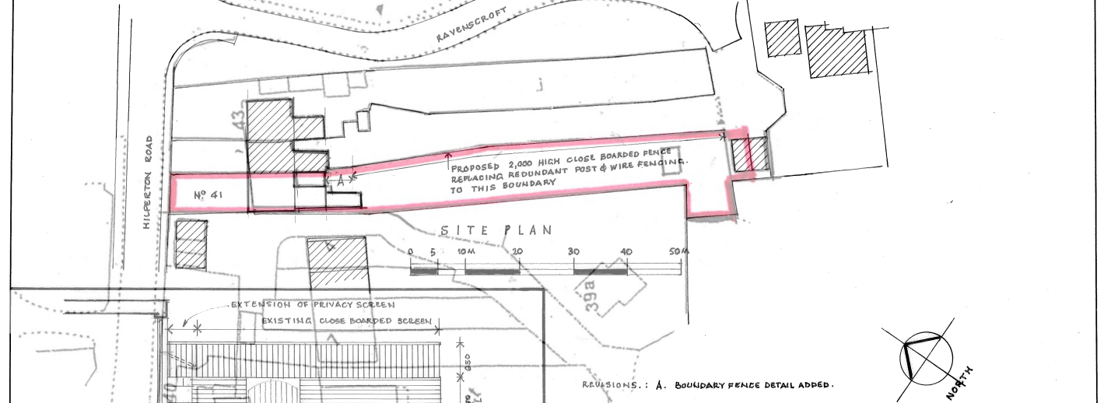
Overlay of Location Plan on top of Proposed Plans

CONCLUSION

The proposal represents a modest domestic boundary treatment within a rear garden. It results in no harm to heritage significance, no unacceptable impact on residential amenity, and raises no technical concerns. In the absence of identified harm, the proposal is considered to be acceptable and in accordance with the relevant policies and guidance outlined above.

RECOMMENDATION: That Planning Permission be GRANTED subject to the following conditions:

1.
The development hereby permitted shall be begun before the expiration of three years from the date of this permission.
REASON: To comply with the provisions of Section 91 of the Town and Country Planning Act 1990 as amended by the Planning and Compulsory Purchase Act 2004.

2.
The development hereby permitted shall be carried out in accordance with the following approved plans and documents:

Site Plan and Proposed Elevations 2825-10A (20 February 2026)
Location Plan 2825-03 (10 February 2026)

REASON: For the avoidance of doubt and in the interests of proper planning.

