HOUSEHOLDER PLANNING APPLICATION.
CASE OFFICER REPORT

APPLICATION REFERENCE: | PL/2026/001692
APPLICATION TYPE: | Householder
SITE ADDRESS: | 84 Monkton Farleigh, Bradford on Avon, BA15 2QJ.
DEVELOPMENT DESCRIPTION: | Proposed Two Storey Side Extension & Alterations
RECOMMENDATION: | Approve with Conditions.

PROPOSAL
The proposal seeks planning permission for the construction of a small sized two storey side extension that would serve as a utility room and a w.c. at ground floor level and a study and shower room at first floor level. Alterations to the existing dwelling are also proposed.

SITE DESCRIPTION/CONTEXT
The site consists of an attached two storey stone constructed house, set within its own grounds within the Small Village of Monkton Farley. The site is within the Conservation Area, Special Landscape Area, Cotswold National Landscape and Green Belt. The building is not listed, although the neighbouring dwelling at No.86 is grade II listed, as is No.67 opposite. The site is located within the Bath and Bradford on Avon Bat SAC.

RELEVANT PLANNING HISTORY
Proposal / Summary
15/05313/VAR Variation of condition 6 of 13/03863/FUL – To include a second dormer window on the rear elevation. Approve.
13/03863/FUL Division of property into two dwellings with proposed extension

RELEVANT POLICIES AND GUIDANCE

Wiltshire Core Strategy:

- Core Policy 7 Bradford on Avon Spatial Strategy
- Core Policy 57 Ensuring High Quality Design and Place Shaping
- Core Policy 50: Biodiversity and Geodiversity
- Core Policy 51: Landscape
- Core Policy 58: Ensuring the Conservation of the Historic Environment
- Core Policy 61: Transport and New Development
- Core Policy 64: Demand Management
- Core Policy 67: Flood Risk

Saved policy C3 of the WWDP 1st Alteration- Special Landscape Area

Conservation Area, Special Landscape Area, National Landscape, Green Belt.

Wiltshire Design Guide: Appendix D – Design Guidance for Householder extensions

The National Planning Policy Framework (NPPF)

The Planning Practice Guidance

National Design Guide

Emerging Wiltshire Local Plan:
The examination of the emerging Wiltshire Local Plan has been paused and the weight to be afforded to any part of the emerging plan can be no more than very limited. A decision on how to proceed will be made by the Council in May 2026.

CONSULTATION RESPONSES
Monkton Farleigh Parish Council: No objections and comment on the use of natural timber on the extension.

Highways: No objections.

REPRESENTATIONS
No comments were received.

PRINCIPLE OF THE PROPOSAL.
The principle of the proposed scheme is acceptable for the reasons as discussed below.

ASSESSMENT
Section 38(6) of the Planning and Compulsory Purchase Act 2004 states:

"If regard is to be had to the development plan for the purposes of any determination to be made under the planning Acts, the determination must be made in accordance with the plan unless material considerations indicate otherwise."

In accordance with this statutory requirement, this application has been assessed against the relevant policies of the Development Plan, including the adopted Wiltshire Core Strategy (2015).

Design and Impact upon the upon the character and context of the area

Core Policy 57 - Ensuring High Quality Design and Place Shaping of the Wiltshire Core Strategy seeks to ensure that all new development is of high design quality, reflecting local context, character, and distinctiveness.

The proposals can be viewed within the plan snippets taken from the submitted plans:

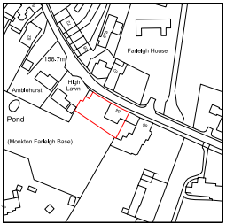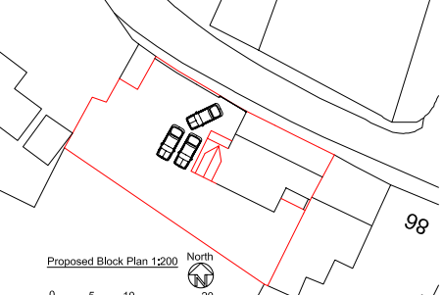
Location Plan Proposed Site Plan

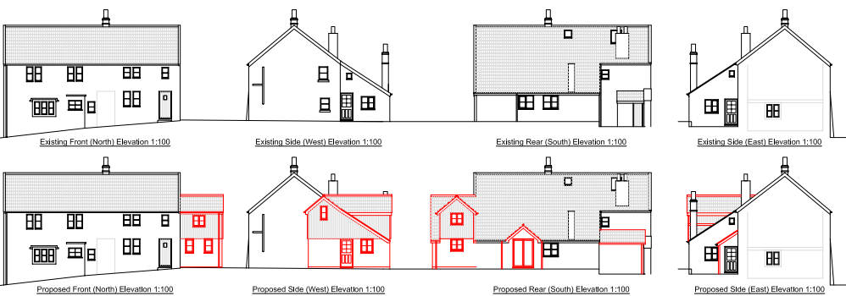

Existing & Proposed Elevations.

The proposal would see the construction of a small sized, two storey west facing side extension and equally the construction of a small sized rear facing dormer window, which would serve the proposed study. Within the rear south elevation at ground floor level, a new French door access would be created into the rear of the building and the relocated kitchen area would be slightly enlarged with the exiting small sized ‘lean to’ being slightly extended. The interior layout of the rooms would be altered.

The proposal would have matching natural clay roof tiles, natural stone exterior and an element of natural timber cladding, this would serve to compliment and visually break up the stone mass. This is acceptable because as the timber ages, it would offer a pleasant visual contrast against the stone. In terms of design, the proposed additions would in the main be located to the rear and so not visible from the public domain, with the side extension being set back and at a lower roof height, than the principal dwelling. Such design features would ensure a subservient addition to the principal dwelling.

Therefore, in summary, having regard to the above, the proposal complies with the design principles set out in Core Policy 57 of the Wiltshire Core Strategy and Appendix D of the Wiltshire Design Guide.

Amenity
Point vii of Core Policy 57 - Ensuring High Quality Design and Place Shaping of the Wiltshire Core Strategy seeks to ensure that developments do not adversely affect neighbouring properties. The National Planning Policy Framework (NPPF), particularly Paragraph 135(f), stresses that planning decisions should ensure developments provide a high standard of amenity for existing and future users.
The proposed extension would be two storey and would look out onto and face its front driveway and rear garden area, the building is located in a developed residential area where the principle of high level mutual overlooking is an established principle, in this instance however, due to the established fenestration within the building, there would not be the introduction of new overlooking, with the outlook from the high level windows remaining the same. Notwithstanding this, the new front facing high level window would serve the shower room and so would be obscure glazed to promote privacy, as would be the case for the proposed high level side window. The proposed study’s fenestration would look out onto the rear garden area and then onto the open grounds of the village school, there would not be harmful impact on the immediate neighbours at numbers 83b and 86.

Likewise, due to the location and orientation of the proposal, there would not be any significant overshadowing or loss of light to these two neighbours.
The proposal therefore accords with Core Policy 57 point vii. in respect of safeguarding residential amenity and Appendix D of the Wiltshire Design Guide.

Highway Matters.
Core Policy 57 (xiv) of the Wiltshire Core Strategy seeks to ensure that development must meet the requirements of Core Policy 61. This policy requires proposals to be capable of being served by safe access to the highway network. Core Policy 64 seeks to ensure compliance with parking standards set out in the Local Transport Plan.

The National Planning Policy Framework (NPPF), particularly Paragraph 115 and 116, requires that development proposals do not have an unacceptable impact on highway safety and that safe and suitable access to the site can be achieved for all users.

The proposed development would continue to use the established site access which would not be altered and would not have any adverse impact on highway safety. Adequate parking and turning provision is provided within the site and such access arrangements are acceptable. The council’s highways officer has been consulted who has not raised any objections.

The proposal is therefore considered to comply with Core Policies 57 (xiv), 61 and 64 of the Wiltshire Core Strategy, the NPPF, and the Wiltshire Local Transport Plan.

Impact on the setting of the nearby listed buildings and surrounding Conservation Area.
Section 66 of the Planning Listed Building and Conservation Area Act 1990 states that the local planning authority has a duty to pay special attention to the desirability of preserving the building or its setting or any features of special architectural or historic interest that it possesses.

Section 16 of the NPPF 'Conserving and enhancing the historic environment' sets out the Government's high-level policies concerning heritage and sustainable development. Paragraph 216 of the NPPF require a balanced approach with any harm which would be caused being weighed against the potential public benefits which might be achieved.

Paragraph 205 requires local planning authorities should take into account the desirability of sustaining and enhancing the significance of heritage assets and of new development making a positive contribution to local character and distinctiveness.

The Council’s Core Strategy Policy CP58 ‘Ensuring the conservation of the historic environment’ requires that “designated heritage assets and their settings will be conserved, and where appropriate enhanced, in a manner appropriate to their significance”.

The application site is located in close proximity numbers 86 and 67, which are Grade II listed buildings, as shown below in black hatch.

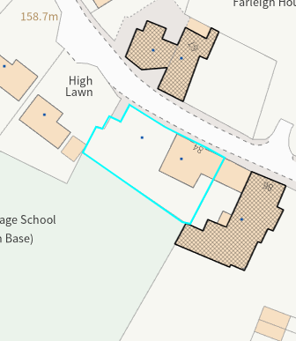

However, given the limited footprint of the proposed scheme that would be positioned on the side and rear elevation of the host dwelling, would not be readily visible from the public realm and contained within the built curtilage of the application site, it is assessed that the development proposal would cause no harm to the significance of the listed buildings or their settings and equally would not cause harm to the character of the surrounding Conservation Area, which is also a designated heritage asset. The development therefore complies with Core Policies, 57 and 58 of the Core Strategy.

Impact on the openness of the Green Belt. The site lies within Green Belt land and there are no relevant WCS development plan policies relating to the Green Belt, therefore the NPPF provides the policy direction. The NPPF sets out within paragraph 142 that “The Government attaches great importance to Green Belts. The fundamental aim of Green Belt policy is to prevent urban sprawl by keeping land permanently open; the essential characteristics of Green Belts are their openness and their permanence”. Openness is the absence of development and Paragraph 143 the NPPF sets out five key purposes of the Green Belt with one being to safeguard the open countryside from encroachment. The NPPF explains how to treat proposals within the Green Belt.

Paragraph 153 of the NPPF states inappropriate development is, by definition, harmful to the Green Belt and should not be approved except in very special circumstances. The two key characteristics of the Green Belt are its openness and its permanence.

Paragraph 154 sets out the categories of development which may be regarded as being ‘appropriate’ or exceptions in the Green Belt, such that in this instance sub-paragraph C allows for extensions as an exception. In this instance the extension consists of a small area of extended development within the side elevation and the ‘small lean’ to adjustment/extension to the rear of the dwelling. The proposed increase in area has been calculated as being a 14.1% increase in volume, which is a small overall increase, that would not result in a disproportionate addition.

Therefore, for the above stated reasons and because the site is not readily open or isolated due to the surrounding existing residential built form, the scheme serves to contribute to the character of the site and also to ensure the proportionality of the extension, fitting in and adhering within the context of the surrounding Green Belt.

Impact on the Special Landscape Area and Cotswold National Landscape.
The site is within a Special Landscape Area (SLA), whereby saved policy C3 of the WWDP 1st Alteration seeks to ensure that the landscape character is “conserved and enhanced and development will not be permitted which is considered to be detrimental to the high quality of these landscapes”. In this particular case, it is acknowledged that the proposal relates to a dwelling within an established residential setting and given the design and location of the proposed works relating to the small sized side extension, would not dominate the existing host dwelling and would serve to conserve the character of this special landscape area. For the same reasons it is appraised that the open character of the surrounding National Landscape is not harmed.

Ecology Impact CP50 requires no net loss of biodiversity on site. The site is located within the Bath and Braford on Avon Bat SAC. The proposed development because of its minor nature and high-density urban location is considered unlikely to result in harm to bats or their habitat. There is no mechanism for significant effects from recreational pressure since it does not result in the creation of a new dwelling. Accordingly, the proposal is acceptable in this regard. As such, the development complies with Core Policy 50 of the Wiltshire Core Strategy and the relevant provisions of the NPPF.

Biodiversity Net Gain. This application is exempt from the requirement to deliver Biodiversity Net Gain under Schedule 7A, Section 4(2)(a) of the Town and Country Planning Act 1990, as inserted by the Environment Act 2021, because the proposal is a householder extension.

CONCLUSION
The proposed development is acceptable in terms of its design, scale, and relationship with the surrounding area. It would not result in any unacceptable harm to the character of the locality, the amenities of neighbouring occupiers, or the interests of highway safety, heritage, or ecology.

The proposal is therefore considered to comply with the relevant policies of the Wiltshire Core Strategy, the Wiltshire Local Plan, and the National Planning Policy Framework. As such, the application is recommended for approval, subject to the conditions set out below.

RECOMMENDATION: Planning Permission be GRANTED subject to conditions.

