APPLICATION FOR A CERTIFICATE OF LAWFULNESS FOR PROPOSED DEVELOPMENT

APPLICATION REFERENCE: | PL/2026/01565
APPLICATION TYPE: | Lawful development: Proposed use
SITE ADDRESS: | Hospital Of St John, Newtown, Heytesbury, BA12 0HW
DEVELOPMENT DESCRIPTION: | Please refer to the supporting cover letter that explains why the proposed works constitute a lawful exercise of the aforementioned permission.
RECOMMENDATION: | Refuse

SITE DESCRIPTION AND PROPOSAL

This application is for a Certificate of Lawfulness for Proposed Development (CLPUD) under Section 192 of the Town and Country Planning Act 1990 (as amended). The applicant seeks to establish the lawfulness of a proposed development for the replacement of the existing Package Treatment Plant (PTP) with a modernised PTP at the application site.

The site had planning permission from application W/04/02439/FUL for the “Replacement of existing underground sewage treatment plant” approved on the 17th February 2005. It had a single condition that the development should be implemented within 5 years of the date of permission. The applicants confirm that the permission has been implemented.

The applicants submit in their supporting statement that:

The proposed modernised PTP would fall under the description of development and does not conflict with the operative part of the planning permission (that being the “Replacement of existing underground sewage treatment plant”). The updated design maintains full compliance with the original consent by operating within the same land use classification and preserving the intended function and operational parameters of the authorised infrastructure. As such, the development constitutes a lawful exercise of the extant planning permission and, in our view, does not require further planning consent.

The proposed PTP will be installed at a comparable depth to the existing PTP unit. Any difference in installation depth is anticipated to be marginal at less than 40cm. Critically, the proposed unit does not extend beyond the approved red line boundary, as confirmed by the submitted plans.

No new drainage runs are required outside of the redline, and the proposed unit will connect to the same existing discharge point and sampling chamber as shown on the approved plans. There are no changes required to the drainage pipes outside of the redline.

The proposed unit is designed to serve the same population equivalent (70 PE) and daily flow rate (~10.5 m³/day) as the approved and implemented system. Notably, the proposed PTP achieves significantly improved effluent quality compared to the existing plant, with BOD₅ of 5 mg/l (against the consented 20 mg/l), suspended solids of 13 mg/l (against the consented 30 mg/l), and ammoniacal nitrogen of 0.7 mg/l (against the consented 20 mg/l). The replacement therefore operates well within the parameters of the approved consent and represents a betterment in environmental performance.

The existing primary settlement tank, as shown on the approved plans, is to be retained. There has been no proposal to remove this structure, and it will remain as per the existing permission. Additionally, no new pumping station is required. The existing pumping station will remain in use as currently, within the same approved footprint. There is therefore no additional infrastructure works required beyond the like-for-like replacement of the PTP unit itself.

In light of the above, it is clear that the proposed development is entirely consistent with the approved description of development and the operational parameters of the extant permission ref: W/04/02439/FUL. The development constitutes a lawful exercise of that permission and, in our view, does not require further planning consent.

The applicant further adds that:

For the avoidance of doubt, the reason our client wishes to upgrade the PTP is entirely a matter of practical necessity and improved environmental performance. The existing unit is approaching the end of its serviceable life, and the proposed replacement offers significantly improved effluent quality, as set out above.

The applicant also contends:

It was confirmed at that time, verbally, that the Council would not have means to enforce against the development should the client proceed, on the basis that the extant permission does not carry a plans condition and the proposed works would be in accordance with the permission as granted.

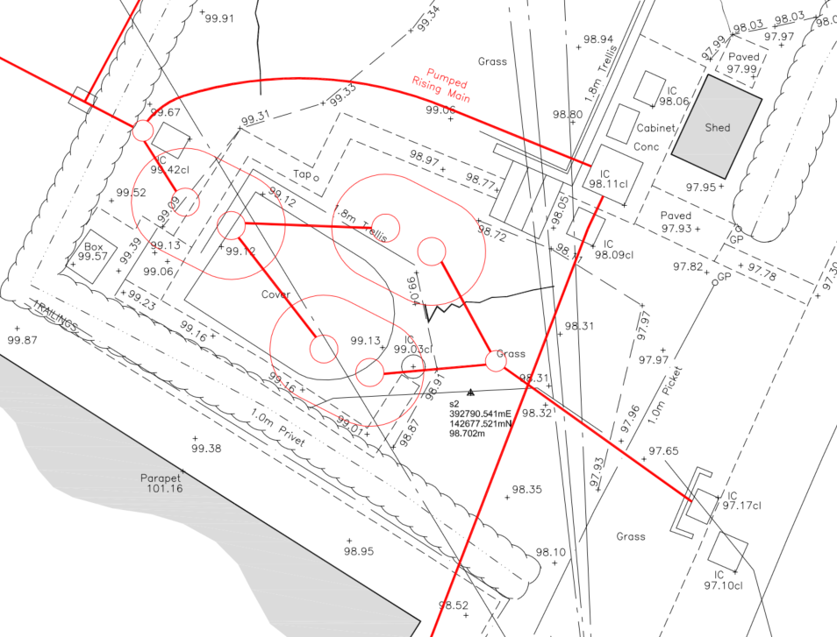

Extract of Proposed Site Plan

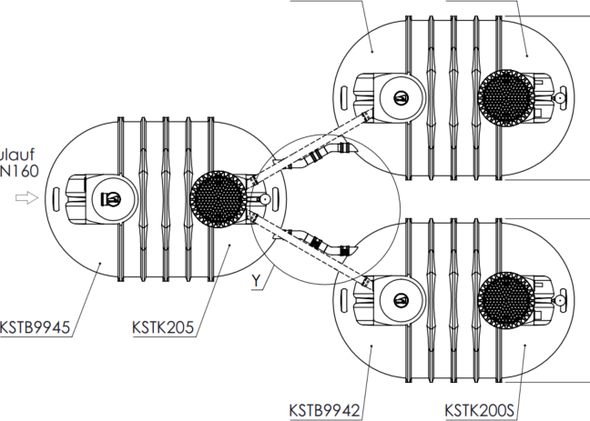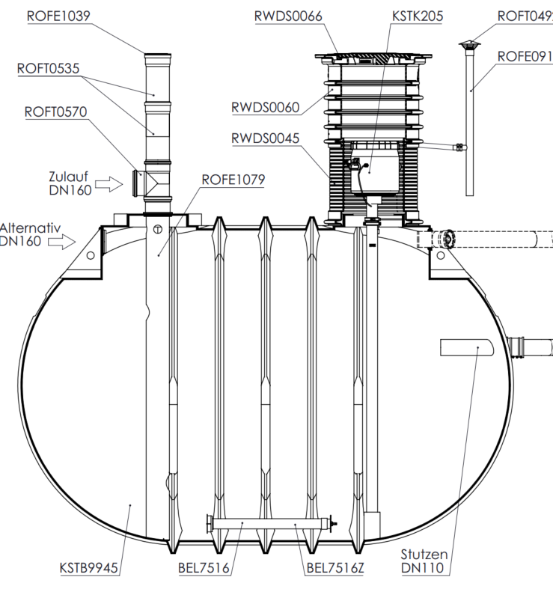

Plans of the proposed Package Treatment Plant

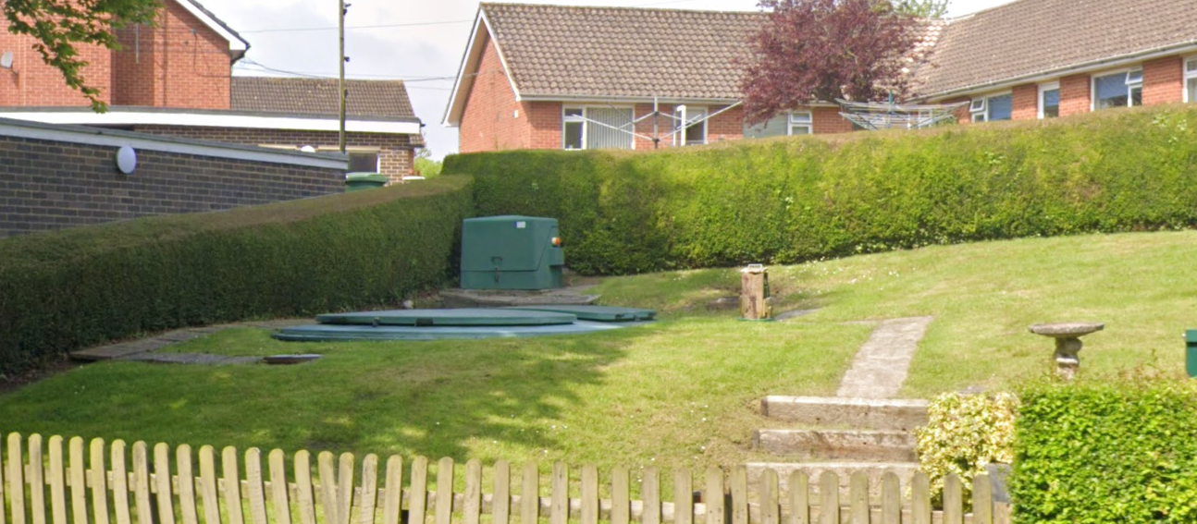

May 2023 Google Street View Image of the existing plant package

In email correspondence the applicants confirmed that the installation depth would actually be 10cm higher than the existing system, and therefore not up to 40cm lower.

RELEVANT LEGISLATION AND CONSIDERATIONS

The statutory framework governing Certificates of Lawfulness for Proposed Lawful Development (CLOPUD) is primarily set out in Section 192 of the Town and Country Planning Act 1990 (as amended). This section sets out that Local planning authorities are provided with information to establish whether the use or operations described in the application would be lawful if instituted or begun at the time of the application, and they shall issue a certificate to that effect; and in any other case they shall refuse the application.

Section 192(4) of the Town and Country Planning Act 1990 (as amended) further stipulates that the lawfulness of any use or operations for which a certificate is in force under this section shall be conclusively presumed unless there is a material change, before the use is instituted or the operations are begun, in any of the matters relevant to determining such lawfulness.
The Planning Practice Guidance (PPG) on Lawful development certificates clarifies that the burden of proof lies with the applicant. In the case of applications for proposed development, an applicant needs to describe the proposal with sufficient clarity and precision to enable a local planning authority to understand exactly what is involved.

It is important to note that when determining a CLOPUD application, the LPA must focus solely
on whether, based on the facts and applicable planning law, the proposed development is lawful. Planning merits or considerations relating to the quality or suitability of the development are not relevant.

Additionally, in determining an application for a prospective development under section 192 a local planning authority needs to ask “if this proposed change of use had occurred, or if this proposed operation had commenced, on the application date, would it have been lawful for planning purposes?”

REPRESENTATIONS

There is no legal obligation to consult third parties for this type of application, including Town/Parish Councils or neighbouring properties. However, the PPG recognises that it may be reasonable for a local planning authority to seek evidence from these sources, if there is good reason to believe they may possess relevant information about the content of a specific application.

In this instance it has not been considered necessary to consult with the Parish Council or Neighbours.

RELEVANT SITE HISTORY

The site has the following relevant planning history:

Proposal / Summary
PL/2025/09929 - Non-Material Amendment Decision - Refuse Date: 15/1/2026 – Non Material Amendment to W/04/02439/FUL - Replacement of existing underground sewage treatment plant
W/04/02059/FUL - Full planning permission Decision - Withdrawn Date: 22/11/2004 – Replacement of existing underground waste water treatment plant with WPL High Performance Aerated Filter or equal underground treatment plant in same location. The new plant will continue to utilise the existing Environment Agency Consent to Discharge Ref
W/04/02439/FUL - Full planning permission Decision - Approved Date: 17/2/2005 – Replacement of existing underground sewage treatment plant

ASSESSMENT
Evidence Submitted by the Applicant
The applicant has submitted a supporting statement, as set out in the introduction of this report.
Assessment

In determining this application, the sole issue for the Local Planning Authority is whether the proposed operations would be lawful for planning purposes if instituted at the date of the application, having regard to the scope of the planning permission ref. W/04/02439/FUL and the definition of development under section 55 of the Town and Country Planning Act 1990. Matters relating to planning merits, environmental performance or the desirability of the proposal are not relevant to this assessment.

The replacement of the plant is considered to be an engineering operation as it would require the removal of the old tank and the installation of 3 replacement tanks would cover a larger area than the existing tank meaning that excavation works of a materially different nature and extent to those associated with the existing installation would be required to accommodate the replacement unit. The proposed works therefore fall to be assessed as operational development for the purposes of section 55 of the Town and Country Planning Act 1990, rather than as repair or maintenance.

Although the site already contains a sewage treatment plant, the removal of the existing unit and installation of a new system with different dimensions, configuration and associated excavation cannot reasonably be characterised as repair or maintenance. Instead, the proposal constitutes a fresh engineering operation resulting in a new physical form of development.

The W/04/02439/FUL permission for the existing system, which itself was a replacement system that needed planning permission, does not automatically authorise future upgrades unless the original permission explicitly allowed for it. A planning permission authorises a specific act of development as described in the decision notice. Once that development has been carried out, the permission does not confer a continuing or rolling authorisation to undertake further replacement or upgrade works unless such works fall within the scope of what was originally permitted. The decision notice for W/04/02439 only grants planning permission for the ‘replacement of existing underground sewage treatment plant’ with a single time compliance condition. There were no conditions or legal agreement that allows for the system to be upgraded in the future without the need for planning permission.

The Council firmly submits that the replacement of a system, especially one that is larger than the one it replaces, and has a different external appearance, is a new engineering operation and is not part of the implementation of the W/04/02439/FUL consent. The applicant’s reliance on the word “replacement” within the description of development is not accepted. The description of development in ref. W/04/02439/FUL authorised the replacement of the sewage treatment plant as it existed at that time. It does not reasonably extend to authorising subsequent replacements of later systems many years after implementation, particularly where the proposal involves a materially different physical form and fresh engineering operations.

As the plant would serve a number of flats in the converted former Hospital, there are no permitted development rights that apply to flats and therefore a planning application is required.

The Council submits that the applicant’s justification for the certificate is not reasonable. The applicants rely on the word ‘replacement’ within the W/04/02439/FUL description of development to apply to a replacement of the approved system 21 years later – even though the proposal is not a direct like for like replacement of the system, and as set out involves new operational development. It is submitted that this argument cannot be lawfully replied upon to authorise a new treatment system.

It is therefore concluded that the planning permission ref. W/04/02439/FUL has been implemented and that the development now proposed does not fall within the scope of the development authorised by that permission. The W/04/02439/FUL permission only permitted one replacement at that time and once implemented, a planning permission authorises the development described and does not confer an ongoing or rolling permission to undertake further replacement or alteration unless expressly stated.

Therefore, the Council does not accept the principle submitted by the applicants.

The applicants own supporting statement acknowledges the proposal to be a “modernised” treatment plant, which is therefore a “new and different system” results in a new physical unit. It is submitted that the proposal is a new engineering operation, which fall outside the meaning of repair.

The Council does not accept the applicant’s submission that the proposal is “within the parameters” of the original consent, when planning law is concerned with what was actually given planning permission. The PPG guidance is clear in that certificates have to be based on the facts and applicable planning law and whether the proposed development is lawful. Planning merits or considerations relating to the quality or suitability of the development are not relevant.

The Council also submits that there is no ‘fall back’ position (or lack of enforcement should this development commence without prior consent) simply because there was no approved plans condition. The applicants assert that the Council would have no means to enforce because the extant permission does not carry an approved plans condition. The Council submits that this is not accurate because even without a plans condition (like many of the applications were determined before plans conditions became regular practice), the approved development is still defined by the description of the development. The lack of a plans condition does not allow unlimited future works. The W/04/02439/FUL application was subject to a 5 year implementation condition, or the permission lapses.

The physical differences between the existing installation and the proposed system, including its layout, scale and above-ground elements, are material insofar as they demonstrate that the proposal cannot reasonably be regarded as the same development as that authorised under ref. W/04/02439/FUL. These differences further support the conclusion that the proposal constitutes new operational development rather than a like-for-like replacement or repair.

The applicant’s references to improved environmental performance, practical necessity and effluent quality are not material to the determination of a Certificate of Lawfulness application, which must be decided solely on whether the proposed operations would be lawful for planning purposes.

CONCLUSION
The applicant has failed to demonstrate, on the balance of probabilities, that the proposed development would be lawful if carried out at the time of the application. It is therefore not lawful under the provisions of the Town and Country Planning Act 1990 (as amended).

The Council submits that replacing the existing multi property sewage treatment plant with a new system is development requiring planning permission, because it constitutes an engineering operation and is not a like for like repair, nor part of the original W/04/02439/FUL consent.

Applying the statutory test under section 192 of the Town and Country Planning Act 1990, the question is whether the proposed operations would have been lawful for planning purposes if commenced on the application date. For the reasons set out above, the Local Planning Authority concludes that they would not.

The W/04/02439/FUL permission has been implemented and does not extend to authorising the development now proposed. Although there was no approved plan list for the W/04/02439/FUL application, this is clearly a different system that requires more excavation and therefore falls outside the scope of the development authorised by that permission.

As the Local Planning Authority is not satisfied that the proposed operations would be lawful if begun at the time of the application, the duty under section 192(4) to issue a certificate does not arise.

RECOMMENDATION

It is recommended that the Certificate of Lawfulness be refused for the following reasons:

The Local Planning Authority is not satisfied that the proposed replacement of the sewage treatment plant would be lawful if carried out. Planning permission ref. W/04/02439/FUL authorised a specific instance of development, namely the replacement of the sewage treatment plant as it existed at that time. The current proposal involves the installation of a new and different treatment system requiring fresh engineering operations, including excavation and installation works, which constitute development as defined under section 55 of the Town and Country Planning Act 1990. The W/04/02439/FUL permission does not grant an ongoing entitlement to undertake further replacements beyond that originally approved, and the absence of a plans condition does not extend the scope of that permission. Accordingly, the proposed works would require a new grant of planning permission and cannot be considered lawful. A Certificate of Lawfulness of Proposed Development is therefore refused.

Reason for refusal: The Local Planning Authority is not satisfied, on the balance of probabilities, that the proposed operations would be lawful if begun at the date of the application, having regard to section 192 of the Town and Country Planning Act 1990 (as amended).

