APPLICATION FOR LISTED BUILDING CONSENT
DELGATED REPORT

APPLICATION REFERENCE: | PL/2026/00822
APPLICATION TYPE: | Listed Building Consent
SITE ADDRESS: | Moorfield Farm, 2 Church Street, Steeple Ashton, Trowbridge, BA14 6EW
DESCRIPTION OF WORKS: | Retrospective planning application for rear dormer/balcony alteration, solar panels, rooflights and variations to rear elevation construction.
RECOMMENDATION: | That Listed Building Consent be GRANTED

SITE DESCRIPTION/CONTEXT

The application site comprises Moorfield Farmhouse, a Grade II listed dwelling located on Church Street within the designated Steeple Ashton Conservation Area. The building occupies a prominent position within the historic village core and forms part of an important group of listed buildings, including Grade II listed properties opposite at 1 and 3 Church Street and the Grade I listed Church of St Mary to the north. The farmhouse dates from the late eighteenth century, with later extensions to the rear, and derives its significance primarily from its street-facing elevation, historic form and contribution to the character and appearance of the Conservation Area.

PROPOSAL

The proposal relates to works at Moorfield Farmhouse comprising alterations and additions to the rear of the dwelling, including the regularisation of previously undertaken works. These include the reinstatement of an approved rear dormer in place of an unauthorised balcony and door, the retention of rooflights and solar panels on rear-facing roof slopes, and associated minor variations to the rear elevation. The works are intended to support loft space living accommodation.

RELEVANT PLANNING HISTORY

Reference No. | Proposal / Summary | Decision
W/89/00956/LBC | Raise height of wall 1'6'' | Approved
W/89/00955/FUL | Raise height of wall 1'6'' | Approved
W/08/01241/LBC | Repairs to cowshed | Approved
W/08/02817/LBC | Proposed boundary walling | Approved
W/09/02433/FUL | Proposed demolition of existing sheds and replacement with double carport, and store/workshop/studio building | Approved
W/11/01484/LBC | Demolition of flat roof extension and lean-to garage Construction of new two storey wing to southwest corner | Approved
W/11/01483/FUL | Demolition of flat roof extension and lean-to garage, construction of two storey wing to southwest corner | Approved
14/04215/FUL | Partially retrospective outbuilding with double car port (Alteration to planning permission W/09/02433/FUL) | Approved
15/10171/FUL | Retrospective application for windows and roof lights already inserted and proposed flat roofed store addition at rear of car port ancillary outbuilding located at the rear of the dwellinghouse. | Approved
15/10271/LBC | Retrospective application for windows and roof lights already inserted and proposed flat roofed store addition at rear of car port ancillary outbuilding located at the rear of the dwellinghouse. | Approved
17/01611/LBC | Demolition of flat roof extension & lean to garage and construction of two storey wing to South West corner (Amendment to 11/01484/LBC) | Approved
17/01207/FUL | Demolition of flat roof extension & lean to garage and construction of two storey wing to South West corner (Amendment to 11/01483/FUL) | Approved

Planning permission 17/01207/FUL and the associated listed building consent 17/01611/LBC approved the re‑arrangement of the loft space to provide two separate storage rooms, an attic room and a small offshoot room from the attic space, together with the erection of a rear dormer. This is a material consideration as the current proposal relates directly to the form and use of the approved loft conversion and dormer.

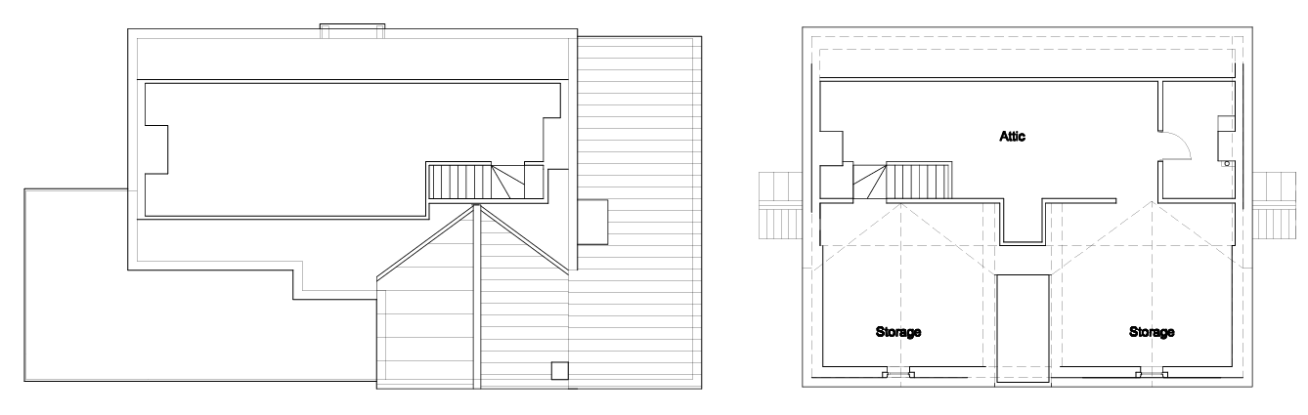
Approved Floor Plan
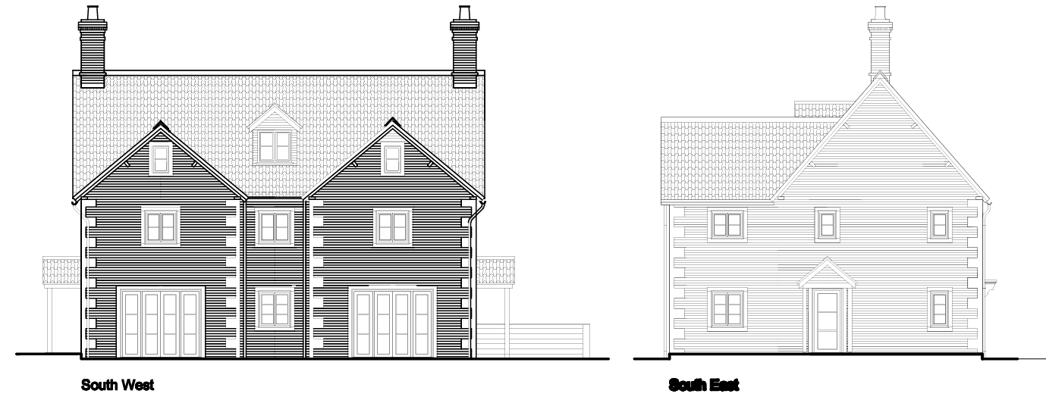
Approved Elevations

RELEVANT LEGISLATION, POLICIES AND GUIDANCE

Legislation

From the point of view of the historic environment the main statutory tests are set out within the Planning (Listed Building and Conservation Areas) Act 1990. Section 16 requires that special regard be given to the desirability of preserving listed buildings, their settings or any features of special architectural or historic interest which they possess.

Section 72(1) of the Planning (Listed Building and Conservation Areas) Act 1990 also requires the Council to pay special attention to the desirability of preserving or enhancing the character or appearance of designated Conservation Areas.

National Policy and Guidance

The National Planning Policy Framework (NPPF) sets out government policy, including in respect of the historic environment.

Section 16 of the NPPF ('Conserving and enhancing the historic environment') sets out the Government's high-level policies concerning heritage and sustainable development.

Paragraphs 213-215 of the NPPF require a balanced approach with any harm which would be caused being weighed against the potential public benefits which might be achieved. Paragraph 210 requires local planning authorities to take account of the desirability of sustaining and enhancing the significance of heritage assets and of new development making a positive contribution to local character and distinctiveness.

Section 14 of the NPPF addresses the challenge of climate change, flooding and coastal change.

Paragraph 167 advises that “Local planning authorities should also give significant weight to the need to support energy efficiency and low carbon heating improvements to existing buildings, both domestic and non-domestic (including through installation of heat pumps and solar panels where these do not already benefit from permitted development rights).

National Planning Practice Guidance provides guidance on interpreting the NPPF.

Historic England Advice Note 2: Making changes to Heritage Assets, illustrates the application of policies set out in the NPPF in determining applications for LBC (and planning permission).

Historic England’s publication ‘Traditional Windows – Their Care, Repair and Upgrading (2017)’ encourages the retention of windows that contribute to the significance of listed buildings but sets also out their approach to the alteration/replacement of windows where this is acceptable in principle:

- Where historic windows, whether original or later insertions, make a positive contribution to the significance of a listed building they should be retained and repaired where possible. If beyond repair they should be replaced with accurate copies.
- Where historic windows have already been replaced with windows whose design follows historic patterns, these usually make a positive contribution to the significance of listed buildings. When they do, they should therefore be retained and repaired where possible. If beyond repair they should be replaced with accurate copies.
- Where historic windows or replacement windows of historic pattern survive without historic glass it may be possible to introduce slim-profile double-glazing without harming the significance of the listed building. There are compatibility issues to consider as the introduction of double-glazing can require the renewal of the window frame to accommodate thicker glazing, thereby harming significance. These issues are covered in Section 4 of this guidance.
- Where historic windows have been replaced with ones whose design does not follow historic patterns, these are unlikely to contribute to the significance of listed buildings. Replacing such windows with new windows of a sympathetic historic pattern, whether single-glazed or incorporating slim-profile double-glazing, may cause no additional harm. It also provides an opportunity to enhance the significance of the building, which is the desired outcome under national policy.
- Where a new window or re-glazing is agreed, the reflective properties of secondary and double-glazing as compared to modern, polished single-glazing, do not usually harm the significance of the building. But when new multi-paned windows are proposed, the desirability of reproducing broken reflections by individually glazing each pane should be considered. Where the aesthetic value of the building is high, then the impact on the whole of the relevant elevation should be considered, including the desirability of accurately matching other windows.

Historic England Advice Note 18: Adapting Historic Buildings for Energy and Carbon Efficiency, provides advice in support of consistent decision making on approaches to improve the energy efficiency and support carbon reduction of historic buildings, whilst conserving their significance.

Wiltshire Core Strategy:
Whilst not directly relevant to listed building consent applications, the below policies give an indication of the Council’s approach to development affecting heritage assets:

- Core Policy 57 ‘Ensuring high quality design and place shaping’: A high standard of design is required in all new developments, including extensions, alterations, and changes of use of existing buildings. Development is expected to create a strong sense of place through drawing on the local context and being complementary to the locality.

- Core Policy 58 ‘Ensuring the conservation of the historic environment’ requires that “designated heritage assets and their settings will be conserved, and where appropriate enhanced, in a manner appropriate to their significance.”

ISSUES

Impact upon the preservation of the listed building or its setting or any features of special architectural and/or historic interest.

CONSULTATION RESPONSES

Steeple Ashton Parish Council – No Objection

Conservation Officer (Wiltshire Council) – No Objection (subject to conditions)
Initially, the Conservation Officer raised concerns regarding the use of the attic as habitable accommodation, noting that this use had not been consented and that the submitted Heritage Statement did not adequately assess the impact of the loft conversion works, including rooflights, partitions and services. Following the submission of additional detailed information and photographic evidence, the Officer concluded that the attic works had resulted in little to no adverse impact on the significance of the listed building, were largely reversible, and did not harm historic fabric. On this basis, and subject to a condition requiring removal of the solar panels at the end of their useful life, no objection was raised to the proposal.

REPRESENTATIONS

In accordance with the requirements of Section 5(1) of the Planning (Listed Buildings and Conservation Areas) Regulations 1990 (as amended) the application for listed building consent was publicised by way of:

- A site notice displayed near the site;
- An advertisement placed in the local press.

These methods were used to inform interested parties and to allow a statutory consultation period of 21 days for representations to be submitted.

No representations were received in respect of this listed building consent application. However, one representation was submitted in relation to the associated planning application, which did not raise an objection to the proposed works but commented on the presence of a separate group of solar panels on a converted barn that does not form part of either application. That representation sought clarification as to whether those panels benefit from planning permission and made reference to their visibility and the need for removal at the end of their operational life.

ASSESSMENT
In accordance with Section 16(2) of the Planning (Listed Buildings and Conservation Areas) Act 1990, special regard has been given to the significance of the listed building, including its architectural and historic interest, and the desirability of preserving both the building and its setting. Relevant policies within the National Planning Policy Framework (NPPF), particularly Section 16: Conserving and Enhancing the Historic Environment, have also been taken into account. These policies require that any harm to the significance of a designated heritage asset must be clearly justified and weighed against the public benefits of the proposal.

In order to be acceptable, the application needs to be assessed against the following criteria:

Information considered/submitted
Paragraph 207 requires that applicants describe the significance of any heritage assets affected, including any contribution made by their setting. This should include sufficient information to provide a clear understanding of the significance of the heritage asset and its setting and the potential impact of any proposals on that significance.

The application has been supported by a Design and Access Statement and a Heritage Statement, together with an updated Heritage Statement Addendum, which together describe the significance of the listed building and its setting and assess the impact of the proposed works. The submitted information identifies that the significance of Moorfield Farmhouse is derived principally from its street‑facing elevation and contribution to the Conservation Area, with the rear elevation and internal fabric having undergone substantial historic alteration. The documentation provides sufficient detail to understand the nature and extent of the proposed works, including both the external alterations and the internal attic interventions, and demonstrates that the changes would result in little to no harm to the significance of the designated heritage assets.

Paragraph 208 of the NPPF also allows the local planning authority to make its own assessment of impact. Having reviewed the submitted information, undertaken a site visit, and had regard to the advice of the Conservation Officer, it is agreed that the proposed works would preserve the special architectural and historic interest of the listed building and the character and appearance of the Conservation Area, with any internal alterations being largely reversible and of limited heritage impact.

Assessment of significance:
According to the National Planning Policy Framework (NPPF), significance is defined as:

“The value of a heritage asset to this and future generations because of its heritage interest. The interest may be archaeological, architectural, artistic or historic. Significance derives not only from a heritage asset’s physical presence, but also from its setting.”

Historic England further categorises significance into four key values:

- Evidential – the potential of the asset to yield evidence about past human activity.
- Historic – the ways in which the asset illustrates aspects of history.
- Aesthetic – the sensory and design qualities of the asset.
- Communal – the meanings and associations attached to the asset by people.

The significance of Moorfield Farmhouse derives primarily from its architectural and historic value, with the greatest contribution coming from its street‑facing elevation and role in the historic streetscene of Church Street within the Steeple Ashton Conservation Area. Internally, the building has been subject to extensive alteration prior to listing, resulting in limited surviving historic fabric, with the principal evidential interest confined largely to elements of the roof structure. The rear elevation and attic space affected by the proposal are of lower heritage significance, and this distribution of significance is central to assessing the impact of the proposed works on the listed building as a whole.

Impact of proposals on the significance and setting of the building/structure:

Understanding the impact of proposed works on a listed building requires a careful and proportionate assessment of how those changes affect the asset’s heritage significance and its setting. This includes both the physical alterations to the building itself and any changes to its spatial or visual relationship with surrounding structures or spaces.

The significance of a heritage asset is not static; it is shaped by its architectural, historic, and communal values, and by how these are experienced in context. Therefore, any intervention must be considered in light of the asset’s identified significance, with attention given to both potential harm and benefits. Benefits may include repairs that support the long-term conservation of the building, improved energy performance, or enhanced public access and understanding.

This assessment is grounded in the statutory duty under Section 16 of the Planning (Listed Buildings and Conservation Areas) Act 1990, which requires special regard to be given to the desirability of preserving the building and its features of special interest. It is also informed by national policy, particularly paragraphs 199–208 of the National Planning Policy Framework (NPPF), and relevant local heritage policies and guidance.

The proposed works primarily relate to the rear elevation and attic space of the listed building, which have been identified as areas of lower heritage significance compared to the principal street-facing elevation. Externally, the scheme largely reinstates development previously approved under the 2017 planning and listed building consents, including the approved rear dormer, which was assessed at that time as sympathetic to the character of the building and its contribution to the Conservation Area. The removal of the unauthorised balcony and reinstatement of the approved dormer form results in a more appropriate and historically consistent arrangement and does not give rise to harm to the listed building or its setting.

The retention of rear-facing rooflights has been assessed as acceptable, given their limited scale, conservation-style appearance and discreet positioning on the rear roof slope. These features do not detract from the architectural interest of the building and do not result in the loss of historic fabric. Similarly, the solar panels are located on internally facing roof slopes, significantly limiting visibility, and do not harm the special architectural or historic interest of the building. Their presence is considered to have a neutral impact on significance, subject to their removal when no longer operational.

Internally, although initial concerns were raised regarding the extent of attic alterations, further information confirmed that the works comprise lightweight, largely reversible interventions, including partitions and services, with no material loss of historic fabric. On this basis, and having regard to the advice of the Conservation Officer, the works are considered to result in little to no harm to the significance of the listed building. Overall, the proposals preserve the special architectural and historic interest of the building and comply with the statutory duty under Section 16 of the Planning (Listed Buildings and Conservation Areas) Act 1990, the relevant provisions of the NPPF, and Core Policy 58 of the Wiltshire Core Strategy.

CONCLUSION

Having had special regard to the statutory duties set out in Section 16(2) of the Planning (Listed Buildings and Conservation Areas) Act 1990, it is concluded that the proposed works would preserve the special architectural and historic interest of the listed building and its setting. The proposals largely reinstate previously approved development, relate to areas of lower heritage significance, and do not result in harm to historic fabric or character. Any internal alterations are lightweight and reversible, and the external works are discreet and sympathetic in form. Overall, the impact of the proposals on the significance of the listed building is considered neutral, and the works are consistent with the objectives of the NPPF and Core Policy 58 of the Wiltshire Core Strategy.

RECOMMENDATION:
That Listed Building Consent be GRANTED, subject to the following conditions:

1.
The development hereby permitted shall be begun before the expiration of three years from the date of this permission.

REASON: To comply with the provisions of Section 18 of the Planning (Listed Building and Conservation Areas) Act 1990 as amended by the Planning and Compulsory Purchase Act 2004.

2.
The development hereby permitted shall be carried out in accordance with the following approved plans and documents:

Design and Access Statement 26-1055-DAS (27 January 2026)
Proposed Ground Floor and First Floor Plans 26-1055-202 (2 February 2026)
Location Plan 26-1055-LOC1 (2 February 2026)
Proposed Elevations 26-1055-204-A
Proposed Site Plan 26-1055-201-A (3 February 2026)
Proposed Second Floor and Roof Plans 26-1055-203-B (8 April 2026)

REASON: For the avoidance of doubt and in the interests of proper planning.

3.
The solar panels hereby approved shall be removed from the building as soon as reasonably practicable when they are no longer operational or are no longer required, and the affected roof slopes shall be made good to match the appearance of the existing roof in terms of materials, colour, texture and detailing.

REASON: In order to ensure the long‑term preservation of the character and appearance of the listed building and the Steeple Ashton Conservation Area, in accordance with Section 16 of the Planning (Listed Buildings and Conservation Areas) Act 1990, the National Planning Policy Framework, and Core Policy 58 of the Wiltshire Core Strategy.

