APPLICATION FOR HOUSEHOLDER PLANNING PERMISSION
DELEGATED REPORT

APPLICATION REFERENCE: | PL/2026/00550
APPLICATION TYPE: | Householder Planning Permission
SITE ADDRESS: | Moorfield Farm, 2 Church Street, Steeple Ashton, Trowbridge, BA14 6EW
DEVELOPMENT DESCRIPTION: | Retrospective planning application for rear dormer/balcony alteration, solar panels, rooflights and variations to rear elevation construction.
RECOMMENDATION: | That Planning Permission be GRANTED

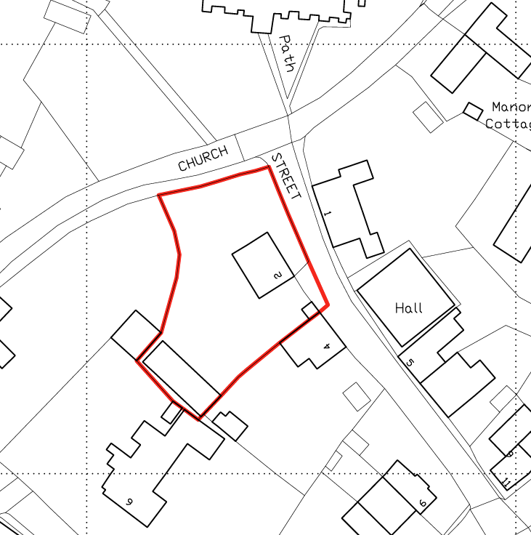
PROPOSAL

The proposal relates to works at Moorfield Farmhouse comprising alterations and additions to the rear of the dwelling, including the regularisation of previously undertaken works. These include the reinstatement of an approved rear dormer in place of an unauthorised balcony and door, the retention of rooflights and solar panels on rear-facing roof slopes, and associated minor variations to the rear elevation. The works are intended to support loft space living accommodation.

SITE DESCRIPTION / CONTEXT

The site comprises Moorfield Farmhouse, a Grade II listed dwelling situated on Church Street within the Steeple Ashton Conservation Area. The site lies opposite other Grade II listed buildings at 1 and 3 Church Street and approximately 25 metres south of the Grade I listed Church of St Mary and its associated Grade II listed gate piers and gates. The surrounding area is characterised by historic village development and designated heritage assets. The site lies within the 6.4km buffer of the Salisbury Plain Special Protection Area, is located within the Trowbridge and Westbury Bat Mitigation Strategy grey zone, and is adjacent to a public right of way (SASH24) to the north. While the site is within Flood Zone 1, the Strategic Flood Risk Assessment identifies a potential risk of groundwater flooding, which represents an additional environmental constraint to be considered.

PLANNING HISTORY

Reference No. | Proposal / Summary | Decision
W/89/00956/LBC | Raise height of wall 1'6'' | Approved
W/89/00955/FUL | Raise height of wall 1'6'' | Approved
W/08/01241/LBC | Repairs to cowshed | Approved
W/08/02817/LBC | Proposed boundary walling | Approved
W/09/02433/FUL | Proposed demolition of existing sheds and replacement with double carport, and store/workshop/studio building | Approved
W/11/01484/LBC | Demolition of flat roof extension and lean-to garage Construction of new two storey wing to southwest corner | Approved
W/11/01483/FUL | Demolition of flat roof extension and lean-to garage, construction of two storey wing to southwest corner | Approved
14/04215/FUL | Partially retrospective outbuilding with double car port (Alteration to planning permission W/09/02433/FUL) | Approved
15/10171/FUL | Retrospective application for windows and roof lights already inserted and proposed flat roofed store addition at rear of car port ancillary outbuilding located at the rear of the dwellinghouse. | Approved
15/10271/LBC | Retrospective application for windows and roof lights already inserted and proposed flat roofed store addition at rear of car port ancillary outbuilding located at the rear of the dwellinghouse. | Approved
17/01611/LBC | Demolition of flat roof extension & lean to garage and construction of two storey wing to South West corner (Amendment to 11/01484/LBC) | Approved
17/01207/FUL | Demolition of flat roof extension & lean to garage and construction of two storey wing to South West corner (Amendment to 11/01483/FUL) | Approved

Planning permission 17/01207/FUL and the associated listed building consent 17/01611/LBC approved the re‑arrangement of the loft space to provide two separate storage rooms, an attic room and a small offshoot room from the attic space, together with the erection of a rear dormer. This is a material consideration as the current proposal relates directly to the form and use of the approved loft conversion and dormer.

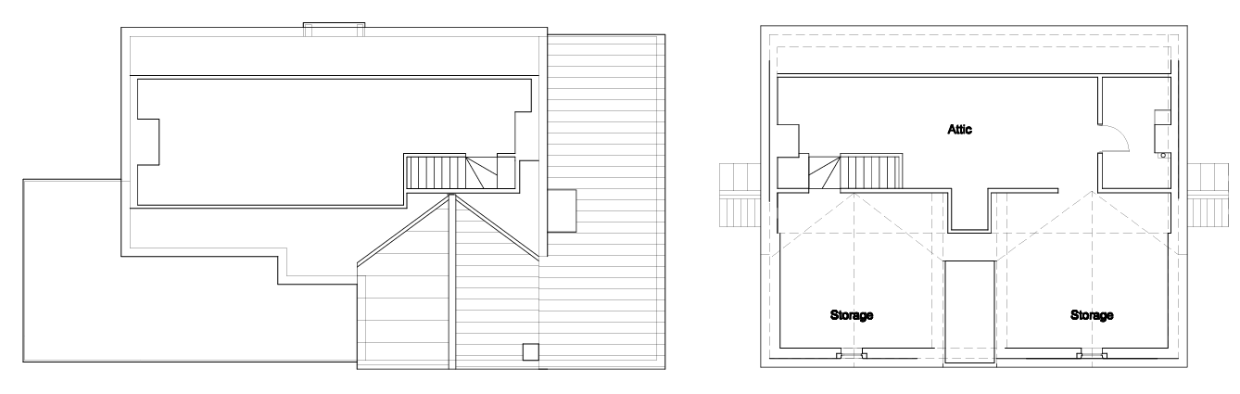
Approved Floor Plan
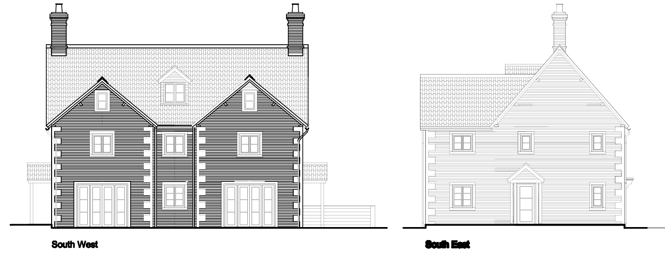
Approved Elevations

RELEVANT LEGILSATION, POLICIES AND GUIDANCE

Wiltshire Core Strategy:

Core Policy 1 Settlement Strategy;
Core Policy 2 Delivery Strategy;
Core Policy 15 Spatial Strategy: Melksham Community Area;
Core Policy 50 Biodiversity and Geodiversity;
Core Policy 51 Landscape;
Core Policy 57 Ensuring High-Quality Design and Place Shaping;
Core Policy 58 Ensuring Conservation of the Historic Environment;
Core Policy 60 Sustainable Transport;
Core Policy 61 Transport and Development;
Core Policy 64 Demand Management;
Core Policy 67 Flood Risk;

The National Planning Policy Framework (NPPF) and The Planning Practice Guidance (PPG)

Wiltshire Design Guide - Appendix D – Design Guidance for Householder extensions

The Wiltshire Local Transport Plan 2011 – 2026: Car Parking Strategy (March 2015).

The Wiltshire Local Transport Plan 4 (LTP4) (March 2025)

Emerging Policy – Wiltshire Local Plan Review

The examination of the emerging Wiltshire Local Plan has been paused and the weight to be afforded to any part of the emerging plan can be no more than very limited. A decision on how to proceed will be made by the Council in May 2026.

CONSULTATION RESPONSES

Steeple Ashton Parish Council – No Objection

Conservation Officer (Wiltshire Council) – No Objection (subject to conditions)
Initially, the Conservation Officer raised concerns regarding the use of the attic as habitable accommodation, noting that this use had not been consented and that the submitted Heritage Statement did not adequately assess the impact of the loft conversion works, including rooflights, partitions and services. Following the submission of additional detailed information and photographic evidence, the Officer concluded that the attic works had resulted in little to no adverse impact on the significance of the listed building, were largely reversible, and did not harm historic fabric. On this basis, and subject to a condition requiring removal of the solar panels at the end of their useful life, no objection was raised to the proposal.

REPRESENTATIONS

One neighbour representation was received which did not raise an objection to the proposed development but commented on the presence of a separate group of approximately 30 solar panels on a converted barn, which do not form part of the current application. The representation queried whether those panels had the benefit of planning permission, noted their visibility from neighbouring properties within the conservation area, and sought clarification on the Council’s position, including reference to the Conservation Officer’s comments regarding the need for solar panels to be removed at the end of their operational life.

ASSESSMENT

Section 38(6) of the Planning and Compulsory Purchase Act 2004 states:

"If regard is to be had to the development plan for the purposes of any determination to be made under the planning Acts, the determination must be made in accordance with the plan unless material considerations indicate otherwise."

In accordance with this statutory requirement, this application has been assessed against the relevant policies of the Development Plan, including the adopted Wiltshire Core Strategy (2015) and, where applicable, any made Neighbourhood Plans.

Householder extensions are generally acceptable in principle, as they typically fall within the established residential curtilage of a property and do not result in new residential development in the open countryside. In this case, the proposal also lies within the defined limits of development set out in the Core Strategy, further reinforcing its acceptability in principle.

Design and Impact upon the upon the character and context of the area

Core Policy 57 Ensuring High Quality Design and Place Shaping of the Wiltshire Core Strategy requires all new development to achieve a high standard of design that responds positively to its local context. Proposals must reinforce and enhance local character and distinctiveness, relate appropriately to the surrounding landscape, and demonstrate a thoughtful response to existing townscape features. This includes careful consideration of elements such as building height, scale, massing, building line, materials, and overall appearance, ensuring new development integrates harmoniously with its setting.

The proposal largely reverses unauthorised works and reinstates the development to the form previously approved under planning permission 17/01207/FUL, including the removal of the balcony and reinstatement of the flat roof and approved rear dormer. As the external form has already been found acceptable in principle, it is reasonable to assess the proposal on the same basis, noting that the submitted plans confirm the roof infill will align with the existing roof profiles and that the dormer will be reinstated exactly as approved. The original officer assessment concluded that the pitched roof dormer was more traditional in form, sympathetic to the historic character of the building, and sat comfortably within its overall design.

The proposal also includes the retention of rear-facing rooflights, which are small in scale, conservation‑style in appearance, and use materials that are sympathetic to the host dwelling. These are confined to the rear roof slope, have limited public visibility, and have not raised any objection from the Conservation Officer.

The Design and Access Statement confirms that all materials will match or complement the existing dwelling, including red facing brick, stone window surrounds, triple Roman clay tiles and cast‑iron rainwater goods, ensuring visual consistency. The omission of quoin stones to the inner corners of the rear wings and the absence of recessed brickwork between the gables have also been assessed as a more appropriate treatment for this secondary elevation.

In respect of the solar panels, while such features are not inherently the most sympathetic additions to a historic dwelling, their siting on the two internally facing roof slopes significantly limits their visibility. They do not harm historic fabric and, when balanced against their contribution to climate change objectives, are considered to result in a neutral impact on the significance of the listed building, subject to a condition requiring their removal when no longer operational. Overall, the development demonstrates a high standard of design that responds positively to its context and accords with the aims of Core Policy CP57.

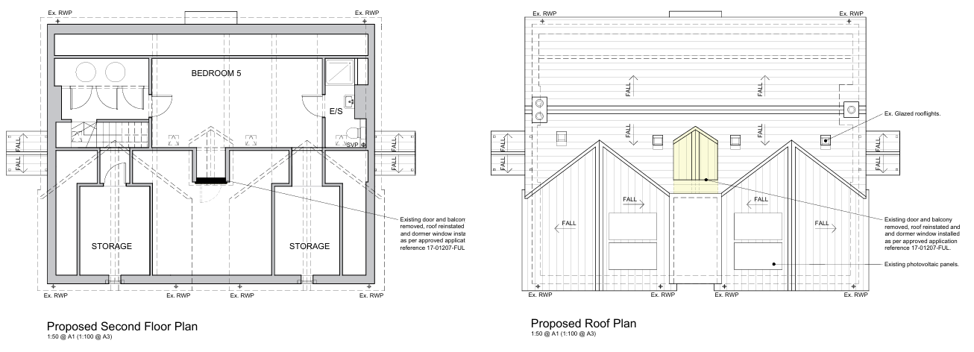

Proposed Floor Plans
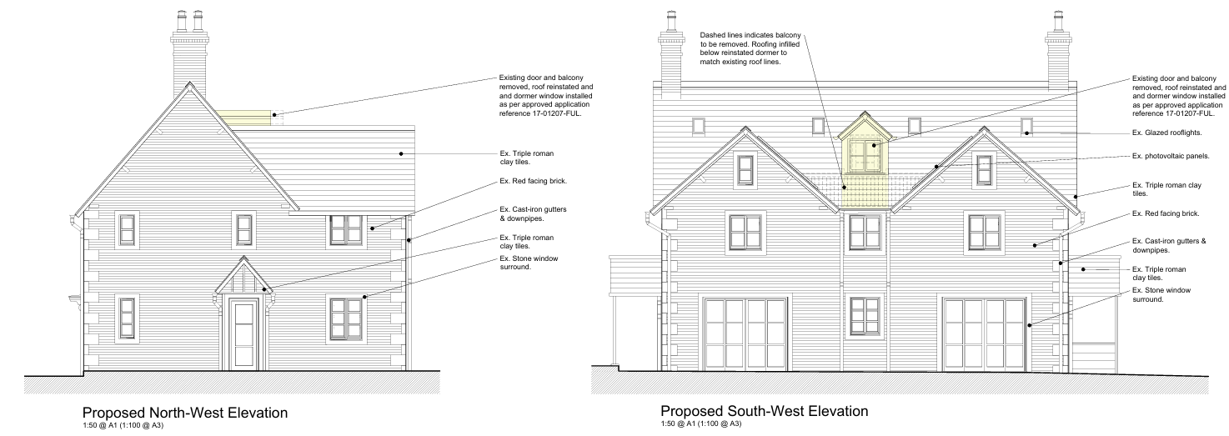
Proposed Plans

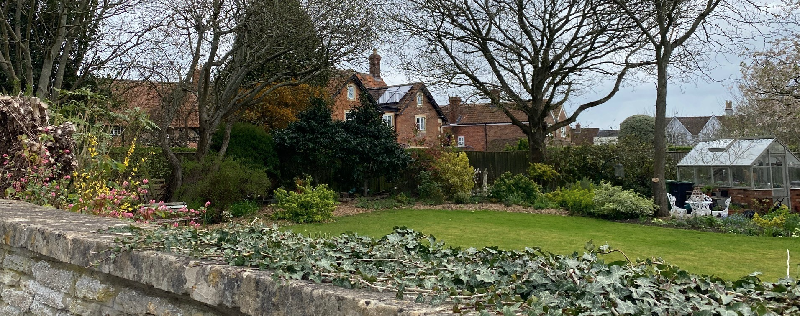
Site Visit Rear Elevation

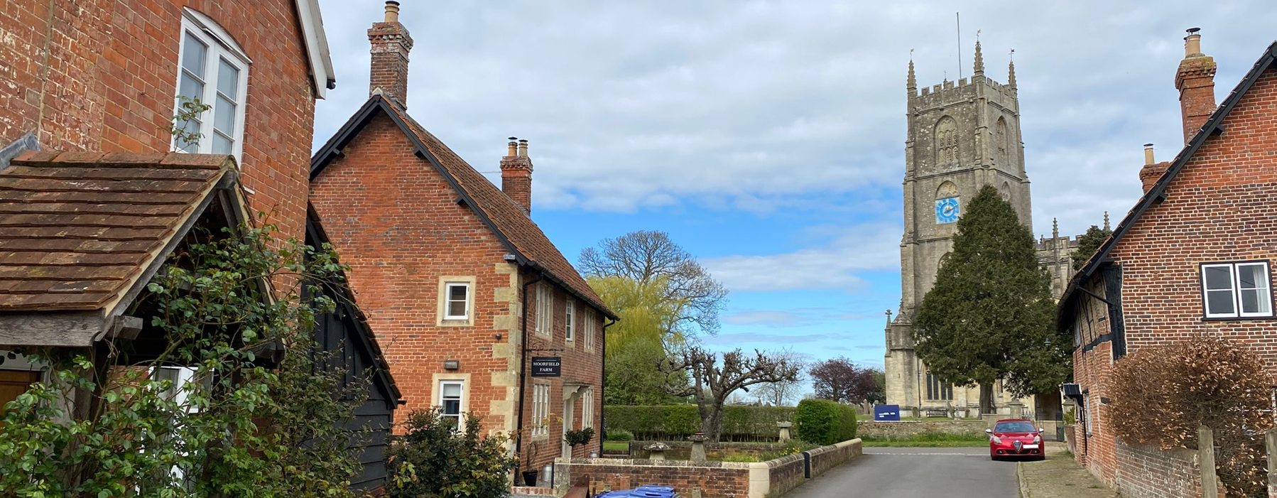
Site Visit Front Elevation

Having regard to the above, the proposal complies with the design principles set out in Core Policy 57 of the Wiltshire Core Strategy and Appendix D of the Wiltshire Design Guide.

Conservation and Heritage

Core Policy 58 outlines development consideration with regard to the historic environment. The policy states that heritage assets and their settings must be conserved and, where appropriate, enhanced through any proposed development.

In assessing works to a listed building, Section 16(2) of the Planning (Listed Buildings and Conservation Areas) Act 1990 requires the Local Planning Authority to have special regard to the desirability of preserving the building, its setting, and any features of special architectural or historic interest it possesses. Likewise, Section 72 places a statutory duty to give special attention to the desirability of preserving or enhancing the character or appearance of the Conservation Area.

The principal external elements of the scheme largely reinstate development previously approved under the 2017 planning and listed building consents, including the approved dormer, which was found to be sympathetic to the historic character of the building and its contribution to the Conservation Area. While the Conservation Officer initially raised concerns regarding the extent of internal attic alterations, further information confirmed that these works comprise lightweight and largely reversible subdivisions and services with no material loss of historic fabric. On this basis, the Conservation Officer raised no objection and concluded that the works result in little or no adverse impact on the significance of the listed building. Overall, the development preserves the special architectural and historic interest of the building and its setting, and satisfies the statutory and policy requirements for the historic environment.

Amenity

Point vii of Core Policy 57 Ensuring High Quality Design and Place Shaping of the Wiltshire Core Strategy seeks to ensure that developments do not adversely affect neighbouring properties.

The National Planning Policy Framework (NPPF), particularly Paragraph 135, stresses that planning decisions should ensure developments provide a high standard of amenity for existing and future users.

The proposal would improve the existing situation by removing the unauthorised balcony and reinstating the previously approved dormer, thereby reducing any potential overlooking compared to the current arrangement. The dormer has already been assessed and found acceptable in terms of residential amenity under the earlier permission, and the scheme does not introduce any new built form or increase the scale or massing of the building. As such, there are no concerns in relation to overlooking, overshadowing or an overbearing impact on neighbouring properties.

The proposal is appropriately sited, designed, and oriented to ensure that it would not result in unacceptable impact upon/to the amenities or living conditions of neighbouring residential occupiers, particularly in terms of outlook, privacy, or access to natural light.

The proposal therefore accords with Core Policy 57 point vii in respect of safeguarding residential amenity and Appendix D of the Wiltshire Design Guide.

Other Issues

Core Policy 50 of the Wiltshire Core Strategy seeks to avoid harm to sensitive species and habitats, while Biodiversity Net Gain (BNG) is secured through Schedule 7A of the Town and Country Planning Act 1990 (as amended). However, the proposal constitutes householder development and is therefore exempt from mandatory BNG requirements. Notwithstanding the ecological constraints previously identified, the development is entirely contained within the existing footprint of the dwelling and relates largely to external fabric changes. The attic space has already been in use as habitable accommodation, and the reinstatement of the approved dormer would not create new impacts or additional disturbance capable of affecting protected species, including roosting bats. As such, the proposal is unlikely to result in ecological harm.

The proposal does not alter the existing vehicular access arrangements or the on‑site parking provision associated with the dwelling. The property benefits from a generous established parking area, and the development would not result in additional traffic generation or changes to movement patterns. Accordingly, there are no highway safety or capacity concerns arising from the proposal.

Core Policy 67 of the Wiltshire Core Strategy requires development to minimise flood risk and ensure surface water is managed safely and sustainably. The application site lies within Flood Zone 1 and, although the Strategic Flood Risk Assessment identifies a potential risk of groundwater flooding, the proposal does not involve any increase in built footprint or impermeable area. In line with paragraph 176 of the NPPF, householder development of less than 250sqm is exempt from the sequential and exception tests. Given the limited nature of the works and the absence of changes to drainage arrangements, the proposal would not increase flood risk on‑site or elsewhere and is therefore acceptable in flood risk and drainage terms.

CONCLUSION

The proposal is considered to be acceptable and in accordance with the relevant policies and guidance outlined above.

RECOMMENDATION: That Planning Permission be GRANTED subject to the following conditions:

1.
The development hereby permitted shall be begun before the expiration of three years from the date of this permission.
REASON: To comply with the provisions of Section 91 of the Town and Country Planning Act 1990 as amended by the Planning and Compulsory Purchase Act 2004.

2.
The development hereby permitted shall be carried out in accordance with the following approved plans and documents:

Design and Access Statement 26-1055-DAS (27 January 2026)
Proposed Ground Floor and First Floor Plans 26-1055-202 (2 February 2026)
Location Plan 26-1055-LOC1 (2 February 2026)
Proposed Elevations 26-1055-204-A
Proposed Site Plan 26-1055-201-A (3 February 2026)
Proposed Second Floor and Roof Plans 26-1055-203-B (8 April 2026)

REASON: For the avoidance of doubt and in the interests of proper planning.

3.
The solar panels hereby approved shall be removed from the building as soon as reasonably practicable when they are no longer operational or are no longer required, and the affected roof slopes shall be made good to match the appearance of the existing roof in terms of materials, colour, texture and detailing.

REASON: In order to ensure the long‑term preservation of the character and appearance of the listed building and the Steeple Ashton Conservation Area, in accordance with Section 16 of the Planning (Listed Buildings and Conservation Areas) Act 1990, the National Planning Policy Framework, and Core Policy 58 of the Wiltshire Core Strategy.

