APPLICATION FOR HOUSEHOLDER PLANNING PERMISSION
DELEGATED REPORT

APPLICATION REFERENCE: | PL/2026/01594
APPLICATION TYPE: | Householder planning permission
SITE ADDRESS: | 5 The Tynings, Corsham, SN13 9DE
DEVELOPMENT DESCRIPTION: | First floor extension over garage, at side of house
RECOMMENDATION: | That Planning Permission be GRANTED

SITE DESCRIPTION/CONTEXT

The subject property is a semi-detached, two storey dwelling, in an area characterised by similar C20 dwellings. The area was once part of the historic core of Corsham, with the Corsham Conservation Area ending at the side boundary. GII listed The Mansion House lies to the rear, separated by Public Right of Way CORM84, such that all historic assets are visually distant and isolated from the subject modern property.

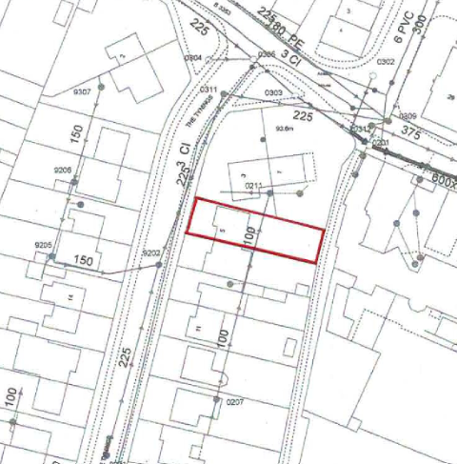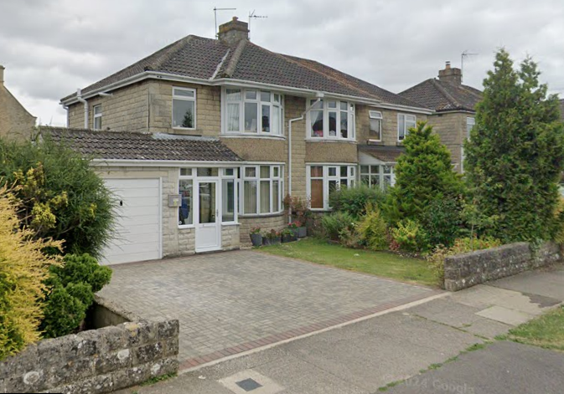

Location Plan and Google Earth Site Photo

The application site is within buffer zones of various bat roosts but outside of any statutory protected areas.

PROPOSAL

The proposal seeks planning permission for a first-floor extension over an attached garage/external store which would be converted. This would enable the creation of a study on the GF and an ensuite bathroom at FF level.

Proposed materials include grey rock face stone, concrete double roman tiles and white uPVC windows, all to match existing. All as per plans and elevations below.

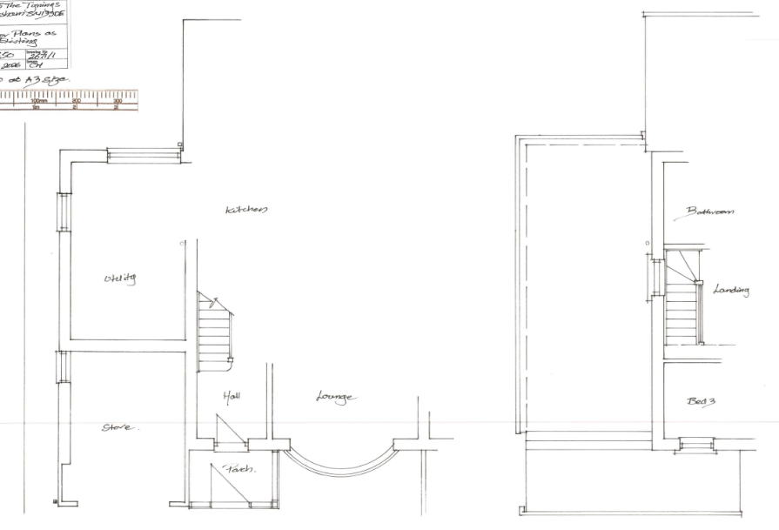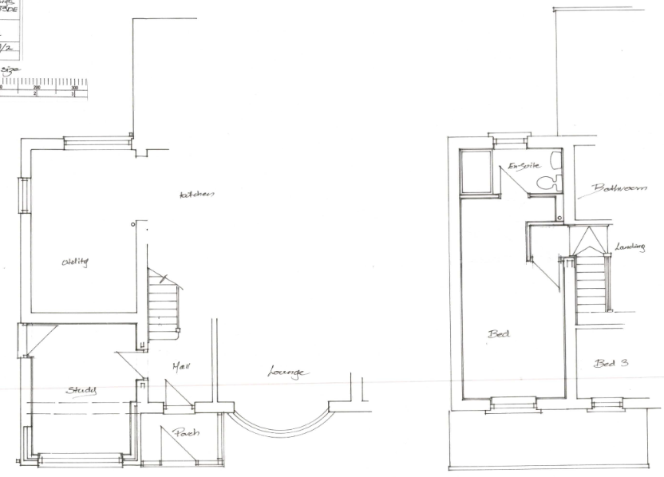

Existing and Proposed Ground Floor Plan

Existing and Proposed First Floor Plan

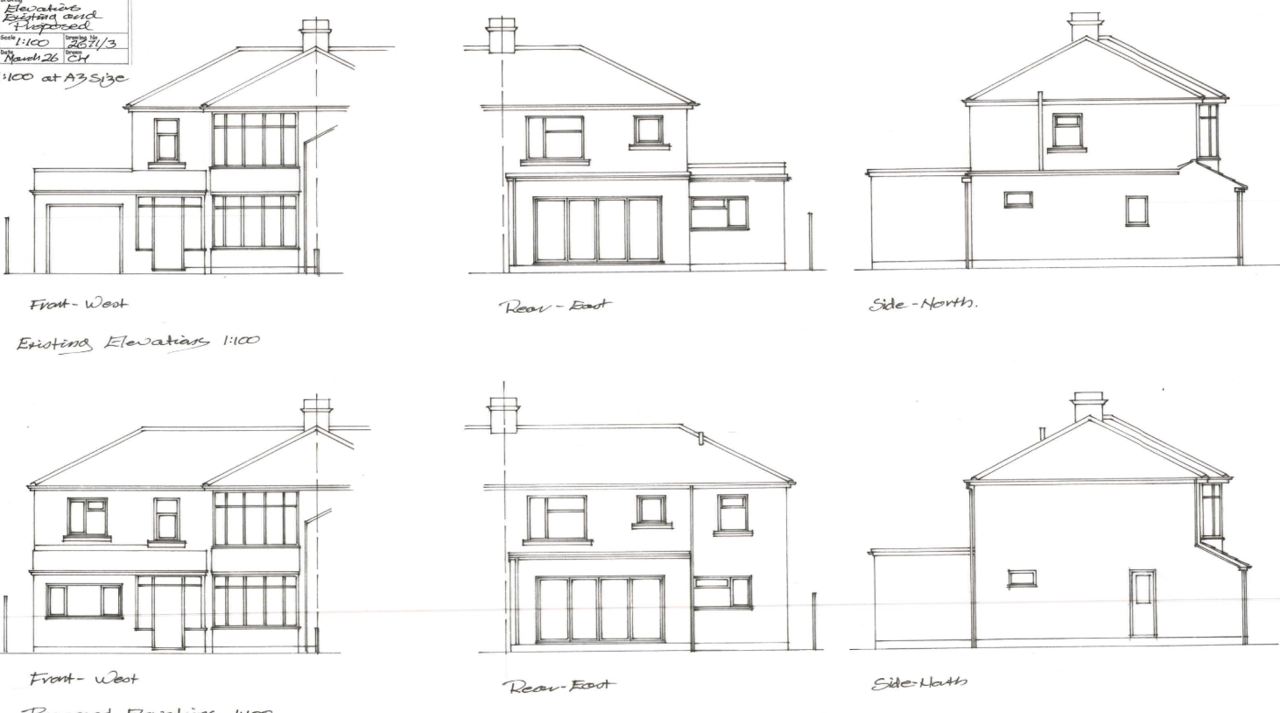

Existing and Proposed Elevations

PLANNING HISTORY
N11/01595 – demolition of detached garage and erection of side extension – approve with conditions – no.7 The Tynings.

RELEVANT POLICIES AND GUIDANCE
The National Planning Policy Framework (NPPF)
The Planning Practice Guidance
National Design Guide
Wiltshire Design Guide: Appendix D – Design Guidance for Householder extensions

Wiltshire Core Strategy:
- Core Policy 57 Ensuring High Quality Design and Place Shaping
- Core Policy 61: Transport and New Development
- Core Policy 64: Demand Management

Corsham Neighbourhood Plan, made 2019

CONSULTATION RESPONSES
Corsham Town Council: No objection, subject to Wiltshire Council’s Parking Standards being met.

REPRESENTATIONS
One comment received highlighting the proximity of the proposed 2-storey extension beside the neighbouring property to the north; no.3 The Tynings, and concerns regarding impact to light levels via kitchen and Velux windows.

ASSESSMENT
Section 38(6) of the Planning and Compulsory Purchase Act 2004 states:

"If regard is to be had to the development plan for the purposes of any determination to be made under the planning Acts, the determination must be made in accordance with the plan unless material considerations indicate otherwise."

In accordance with this statutory requirement, this application has been assessed against the relevant policies of the Development Plan, including the adopted Wiltshire Core Strategy (2015) and, where applicable, any made Neighbourhood Plans.

Design and Impact upon the character and context of the area
Core Policy 57 - Ensuring High Quality Design and Place Shaping of the Wiltshire Core Strategy seeks to ensure that all new development is of high design quality, reflecting local context, character, and distinctiveness.

There are various precedent extensions over attached garages in the area, in particular, immediate neighbour no.7 to the south and no.8 immediately opposite.

The proposed extension would include matching materials that would enable successful integration with the host dwelling, with the style and size of fenestration and roof form also matching.

Having regard to the above, the proposal complies with the design principles set out in Core Policy 57 of the Wiltshire Core Strategy and Appendix D of the Wiltshire Design Guide.

Amenity
Point vii of Core Policy 57 - Ensuring High Quality Design and Place Shaping of the Wiltshire Core Strategy seeks to ensure that developments do not adversely affect neighbouring properties.

The National Planning Policy Framework (NPPF), particularly Paragraph 135(f), stresses that planning decisions should ensure developments provide a high standard of amenity for existing and future users.

The proposed development has been assessed in terms of its potential impact on the residential amenity of neighbouring properties, with particular regard to loss of light, overshadowing, loss of privacy, and overbearing effects.

The proposed extension would be above the existing garage which according to WCC mapping is approx. 2.5m from the rear corner of a rear wrap around extension to no.3 which lies to the north.

Neighbouring no.3 is not aligned to the subject property as it fronts the corner with the B3353, and as such has a large front and side garden and smaller private rear garden beside its rear/side extension, facing the subject dwelling.

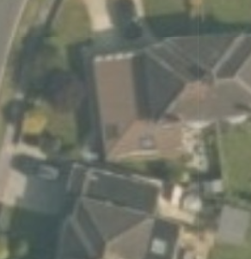
No.5
No.3

The proposed extension would entail a short increase of roof ridge, whilst retaining the hipped roof form, which reduces impact of massing.

The existing roof causes some overshadowing, lying directly south of no.3. The proposed extension would only moderately extend this roof ridge, making very little material difference to the existing situation.

The proposal includes windows of non-habitable rooms becoming windows to habitable spaces; front GF, and a window and a door to become a window, on the side elevation.

An additional FF window to the front elevation is proposed, as is one to the rear at FF.

There are no concerns for neighbouring privacy by any proposed windows facing down the front or rear gardens, nor the proposed ground floor windows to the side elevation whose impact is easily managed by standard boundary treatments.

An existing FF window on the side window would be removed, so improving neighbouring privacy.

The proposal therefore accords with Core Policy 57 point vii in respect of safeguarding residential amenity and Appendix D of the Wiltshire Design Guide.

Highways Impact
Core Policy 57 (xiv) of the Wiltshire Core Strategy seeks to ensure that development must meet the requirements of Core Policy 61. This policy requires proposals to be capable of being served by safe access to the highway network. Core Policy 64 seeks to ensure compliance with parking standards set out in the Local Transport Plan.

The National Planning Policy Framework (NPPF), particularly Paragraph 115 and 116, requires that development proposals do not have an unacceptable impact on highway safety and that safe and suitable access to the site can be achieved for all users.

The proposed extension would enable the creation of a 4th bedroom and so could entail an associated parking demand. Accordingly, Wiltshire’s Local Transport Plan 2011-2026 and Car Parking Strategy dictates that 4+ bedroom properties require 3 off-street parking spaces.

The existing garage does not provide garaged parking for modern cars such that its loss does not alter the available parking provision of 2 off-street parking spaces.

Whilst there is restricted on-street parking immediately in front of the subject property, there is unrestricted parking on the other side.

There is precedent development on the street, where the entire garden has been devoted to off-street parking of 3 cars, showing that 3 off-street parking spaces could be available if the entire front garden was sacrificed.

Given the need to ensure future climate change resilience, it is noted that gardens provide significant benefits including sustainable drainage solutions.

Given the Highways Officer submitted no objection, it is considered on balance, that the proposed development is served by appropriate levels of parking close to the town centre, and the wider area would not benefit from the loss of the existing garden to additional off-street parking.

The proposal is therefore considered to comply with Core Policies 57 (xiv), 61 and 64 of the Wiltshire Core Strategy, the NPPF, and the Wiltshire Local Transport Plan.

Ecology Impact:
Core Policy 50 of the Wiltshire Core Strategy seeks to protect and enhance biodiversity and geodiversity, including through ensuring that development avoids harm to protected species and habitats.

The National Planning Policy Framework (NPPF), in Paragraphs 193, requires that development minimises impacts on and provides net gains for biodiversity, including ensuring mitigation is secured where harm cannot be avoided.

The proposals pose no loss of biodiversity, and the application does not meet the threshold set out in legislation to demonstrate BNG.

All UK bat species are protected by European and UK legislation; the Conservation of Habitats and Species Regulations and the Wildlife and Countryside Act. Considering the scale and form of proposed development, as a first floor extension to an existing single storey structure, within a suburban area, no substanitave ecology impact is raised and as such does not meet the threshold for a habitat regulations assessment.

An informative is included as a precautionary measure, raising the profile of the Bat SAC, including that if any evidence of bat activity is detected, that the applicant should follow the advice of a professional ecologist or contact Natural England.

As such, the development complies with Core Policy 50 of the Wiltshire Core Strategy and the relevant provisions of the NPPF.

Biodiversity Net Gain
Householder planning applications are exempt from the requirement to deliver Biodiversity Net Gain under Schedule 7A, Section 4(2)(a) of the Town and Country Planning Act 1990, as inserted by the Environment Act 2021.

CONCLUSION
The proposed development is considered to be acceptable in terms of its design, scale, and relationship with the surrounding area. It would not result in any unacceptable harm to the character of the locality, the amenities of neighbouring occupiers, or the interests of highway safety, heritage, or ecology.

The proposal is therefore considered to comply with the relevant policies of the Wiltshire Core Strategy, the Wiltshire Local Plan, and the National Planning Policy Framework. As such, the application is recommended for approval, subject to conditions.

RECOMMENDATION: That Planning Permission be GRANTED subject to conditions.

