APPLICATION FOR VARIATION/REMOVAL OF CONDITION
CASE OFFICER REPORT

APPLICATION REFERENCE: | PL/2026/01212
APPLICATION TYPE: | Removal/variation of conditions
SITE ADDRESS: | Pound Farmhouse, Eastcourt, Malmesbury, SN16 9HN
DEVELOPMENT DESCRIPTION: | Variation of Condition 2 (Oak Truss detail) of PL/2025/05854 (Oak Garden Room, Oak Conservatory to replace existing, demolition of modern bin store, and relocation of oil tank)
RECOMMENDATION: | Approve with Conditions

SITE DESCRIPTION/CONTEXT

The subject building is a GII listed, late C17 farmhouse, built of stone under a stone slate roof. The dwelling benefits from minor curtilage outbuildings and lies to the southeast of GII listed, late C17, ‘Great Barn,’ now in separate ownership.

The site is located to the south east corner of the village of Eastcourt, surrounded by a loose scattering of small farmsteads.

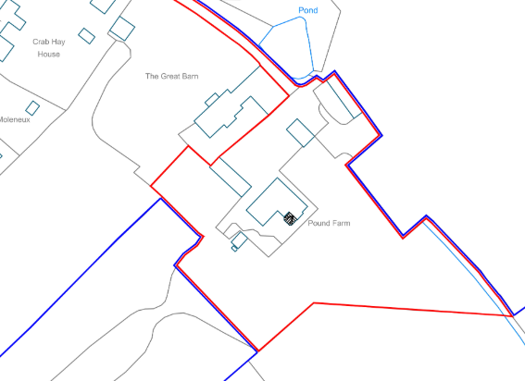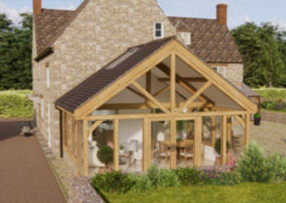

Location Plan and Rendering of proposed Garden Room as per approved PL/2025/05854.

PROPOSAL

This report considers a Section 73 application for the variation of a condition imposed on planning permission PL/2025/05854. The application relates to the site at Pound Farmhouse and seeks to vary condition 2 in relation to alteration of approved plans, and alteration of proposed oak truss type within the approved garden room.

This is also reflected by the submission of an amendment application to the sister LBC PL/2026/01212.

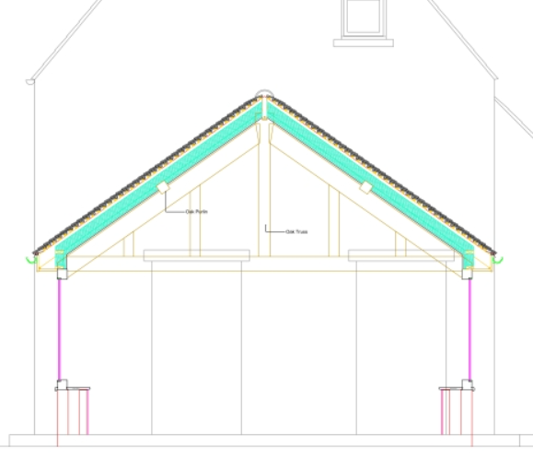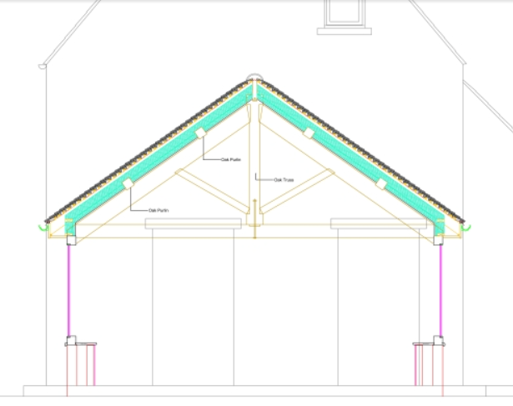

Approved and Proposed Section

RELEVANT PLANNING HISTORY
PL/2025/05854 - Householder planning permission Decision - Approve with Conditions Date: 18/12/2025 – Oak Garden Room, Oak Conservatory to replace existing, demolition of modern bin store, and relocation of oil tank
PL/2026/01212 - Removal/variation of conditions – Variation of Condition 2 (Oak Truss detail) of PL/2025/05854 (Oak Garden Room, Oak Conservatory to replace existing, demolition of modern bin store, and relocation of oil tank)
PL/2025/05925 - Listed building consent (Alt/Ext) Decision - Approve with Conditions Date: 18/12/2025 – Oak Garden Room, Oak Conservatory to replace existing, demolition of modern bin store, and relocation of oil tank –
PL/2026/01490 - Listed building consent (Alt/Ext) – Oak Garden Room - Amendment to Truss Details only of the application PL/2025/05925 - Approved 18/12/2025

RELEVANT LEGISLATION, POLICIES AND GUIDANCE

Town and Country Planning Act. 1990 (as amended)
Section 73 of the Town and Country Planning Act. 1990 (as amended) relates to the determination of applications to develop land without compliance with conditions previously attached. It states that:

(2) On such an application the local planning authority shall consider only the question of the conditions subject to which planning permission should be granted, and—

- if they decide that planning permission should be granted subject to conditions differing from those subject to which the previous permission was granted, or that it should be granted unconditionally, they shall grant planning permission accordingly, and

- if they decide that planning permission should be granted subject to the same conditions as those subject to which the previous permission was granted, they shall refuse the application.

The National Planning Practice Guidance (PPG) states the following:

- Nature of the Application: A Section 73 application is treated as a new planning permission, although it does not alter the original permission itself. The original permission remains intact and can still be implemented unless it has expired or been superseded.
- Limitations:
  - Section 73 cannot be used to change the description of development or the operative part of the permission (e.g. the nature or extent of the approved use).
  - It cannot be used to extend the time limit for implementing the original permission.
  - If the proposed changes go beyond what can reasonably be considered under Section 73, a new planning application under Section 70 would be required.
- Decision-making: The local planning authority must consider the application only in relation to the conditions subject to which the original permission was granted. However, it may impose new or revised conditions if granting a new permission.
- Legal Agreements: Because a Section 73 application results in a new permission, any existing Section 106 agreement may need to be varied or replaced via a deed of variation to ensure obligations continue to apply to the new permission.

National Planning Policy:
- National Planning Policy Framework (NPPF)
- Planning Practice Guidance (PPG)
- National Design Guide
Development Plan:
The development plan for Wiltshire comprises the Wiltshire Core Strategy (WCS) (adopted January 2015) and any made neighbourhood plans, which remains the principal statutory planning document guiding development across the county. In line with Section 38(6) of the Planning and Compulsory Purchase Act 2004, planning decisions must be made in accordance with the development plan unless material considerations indicate otherwise.

Though the development plan is considered as a whole, those parts deemed to be particularly relevant to this application are listed below:

The adopted Wiltshire Core Strategy (WCS), with particular regard to:
- Core Policy 57 Ensuring High Quality Design and Place Shaping;
- Core Policy 58 Ensuring the Conservation of the Historic Environment;

Crudwell Neighbourhood Plan, made 2021

ISSUES
The key considerations in the assessment of this application are as follows:

- Determining whether the proposed amendments fall within the scope of Section 73 of the Town and Country Planning Act 1990 which allows for the variation or removal of conditions attached to an existing planning permission.
- Assessing whether the development, as amended, remains in accordance with the relevant policies and provisions of the development plan, and whether the changes materially alter the nature or impacts of the approved scheme.

CONSULTATION RESPONSES
Parish/Town Council: states it has no comment to make.
Conservation: commented, noting their earlier objections to the approved scheme, but highlighting that the proposed revisions of truss raise no concerns, the kingpost truss being a common feature in residential and agricultural buildings from the C19 so is an acceptable minor alteration.

REPRESENTATIONS
No third-party comments received.

ASSESSMENT
Section 38(6) of the Planning and Compulsory Purchase Act 2004 states:

"If regard is to be had to the development plan for the purposes of any determination to be made under the planning Acts, the determination must be made in accordance with the plan unless material considerations indicate otherwise."

In accordance with this statutory requirement, this application has been assessed against the relevant policies of the Development Plan, including the Wiltshire Core Strategy (2015) and, where applicable, any made Neighbourhood Plans. Consideration has also been given to the policies of the National Planning Policy Framework (NPPF) as a material consideration in the assessment.

Principle of the Development – Do the proposed amendments fall within the scope of s73?
The proposed amendments have been reviewed and are considered to fall within the scope of Section 73 of the Town and Country Planning Act 1990. The changes do not result in a fundamentally different development from that originally approved, nor do they seek to alter the description of development or extend the time limit for implementation. As such, the application is valid under Section 73 and can be determined as a variation of condition attached to the original planning permission.

Compliance with the Development Plan
The proposal remains in accordance with the adopted development plan and national policies:
- Wiltshire Core Strategy (WCS) policies;
- Neighbourhood Plans (where applicable);
- The National Planning Policy Framework (NPPF).

Design and Visual Impact upon the Character and Context of the Area:
Pound Farmhouse is a Grade II listed, late C17th/early C18 century farmhouse of notable vernacular character built of local materials, with retained plan form, layout and architectural expression/detailing, providing aesthetic and architectural interest.

The farmhouse sits within a generous domestic curtilage, with associated outbuildings and a separately listed barn to the northwest, which together form a coherent historic farmstead setting.

The approved garden room is a modern addition to the listed dwelling. The alteration of truss type would not further impact the visual impact of the proposed Garden Room.

The reason for alteration of truss type is not explained, and the proposed plans do not include an increase of ridge height. The proposed rendering of the Garden Room submitted in a previous application and included above for ease, shows a kingpost truss.

The development is therefore considered to comply with Core Policy 57 and 58 of the Wiltshire Core Strategy as well as the relevant provisions of the NPPF.

Amenity:
The proposed amendment would have no impact upon neighbouring amenity.

Conclusion:
The proposed development is assessed to remain in accordance with the relevant policies and provisions of the development plan, and the changes do not materially alter the nature or impacts of the approved scheme.

